Comparative Analysis of Machine Learning Models for Network Intrusion Detection

Name | ID
Mohammed ahmed saeed
muneer ali naji salman

Introduction
This project aims to build a predictive model using machine learning techniques to determine an individual's likelihood of developing diabetes based on a range of medical and physical characteristics. This type of model helps support medical decision-making by providing early predictions that can contribute to prevention or early treatment, especially in cases with high risk factors. The project relies on data analysis, cleaning, pattern discovery, and relationship analysis, followed by training classification models such as Logistic Regression, Decision Tree, or KNN to predict the disease with high accuracy.
Methodology
Dataset Pima Indians Diabetes
This dataset is originally from the National Institute of Diabetes and Digestive and Kidney Diseases. The objective of the dataset is to diagnostically predict whether or not a patient has diabetes, based on certain diagnostic measurements included in the dataset. Several constraints were placed on the selection of these instances from a larger database. In particular, all patients here are females at least 21 years old of Pima Indian heritage.
Column Structure
The datasets consist of several medical predictor (independent) variables and one target (dependent) variable, Outcome. Independent variables include the number of pregnancies the patient has had, their BMI, insulin level, age, and so on.
- Pregnancies
- Glucose
- BloodPressure
- SkinThickness
- Insulin
- BMI
- DiabetesPedigreeFunction
- Age
- Outcome

Dataset Composition:
- Total samples: 780
- Number of columns: 9
- Type: Numeric (All values ​​are numeric)
- Target: Outcome column (Binary Classification)
Preprocessing
Data preprocessing constitutes a critical step for preparing raw network flow data for machine learning algorithms. Several preprocessing operations were applied systematically:
Missing Value and Anomaly Handling and duplicated data:
- Infinite values (positive and negative) were identified and converted to NaN
- Rows containing missing values after conversion were removed
- Final dataset retained 1,991,299 samples after cleaning (20.2% reduction)
Feature Engineering:
- Constant features (single unique value across all samples) were removed as they provide no discriminative information
- Features unrelated to core network characteristics were eliminated
- Selection prioritized packet counts, flow metrics, connection durations, port information, and protocol characteristics
- Final feature count: 18 network-relevant features
Data Encoding:
- Target variable (Label) was converted from categorical to numeric: Benign = 0, Attack = 1
- All feature values were converted to numeric type
- Rows with unconvertible values were excluded from analysis
Train-Test Split:
- Test proportion: 30% (597,390 samples)
- Training proportion: 70% (1,393,909 samples)
- Stratified sampling-maintained class distribution in both sets
- Class distribution: 72.95% benign, 27.05% attack in both training and test sets
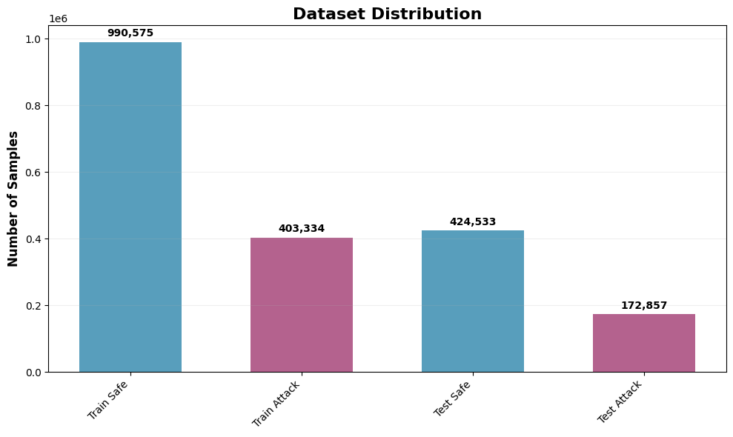
Number of samples
Models and Algorithms
Random Forest
Random Forest is an ensemble machine learning algorithm that constructs multiple decision trees and aggregates their predictions to improve accuracy and reduce overfitting. Each tree is trained on a random subset of features and samples, introducing diversity that strengthens generalization. For this project, Random Forest was configured with conservative hyperparameters to achieve realistic performance:
- Number of trees (n_estimators): 50
- Maximum tree depth: 15 layers
- Minimum samples for split: 50
- Minimum samples per leaf: 25
- Maximum features per split: 30% of total features
- Class weighting: Balanced (adjusted for class imbalance)
Random Forest provides inherent interpretability through feature importance metrics, making it valuable for understanding which network characteristics distinguish attacks from legitimate traffic. The balanced class weighting compensates for the 3:1 benign-to-attack ratio in the dataset.
- Results:
Accuracy is 0.9996, meaning 99.96% of all flows are classified correctly as benign or attack.​
- Precision is 0.9993, so almost every flow predicted as attack is truly malicious.​​
- Recall is 0.9993, so the model successfully detects almost all real attacks.​​
- F1-score is 0.9993, showing a very good balance between precision and recall.​​
- AUC is 1.0000, indicating an almost perfect separation between benign and malicious traffic over all thresholds.​​
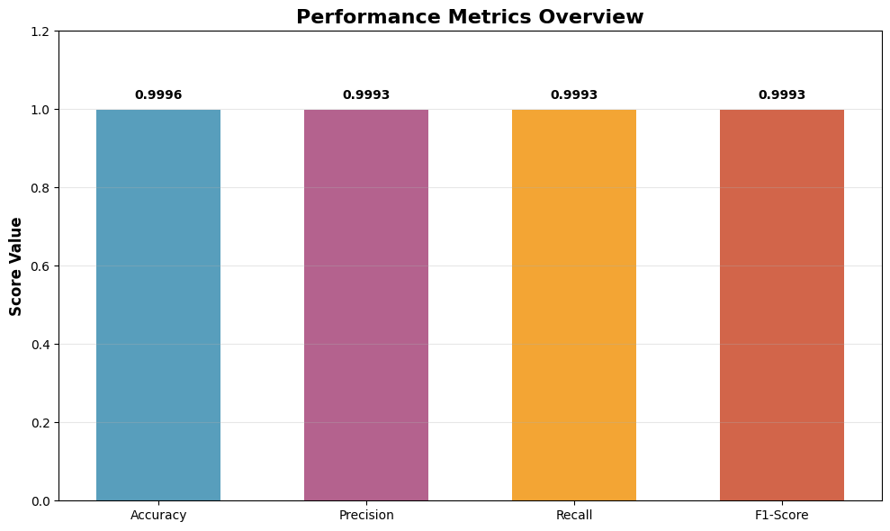
- From the confusion matrix, only a very small number of benign flows are wrongly flagged as attacks (false positives).​
- Also, only a very small number of attack flows are missed and predicted as safe (false negatives).​
- These results mean the Random Forest is highly reliable for intrusion detection on the CSE-CIC-IDS2018 dataset.​
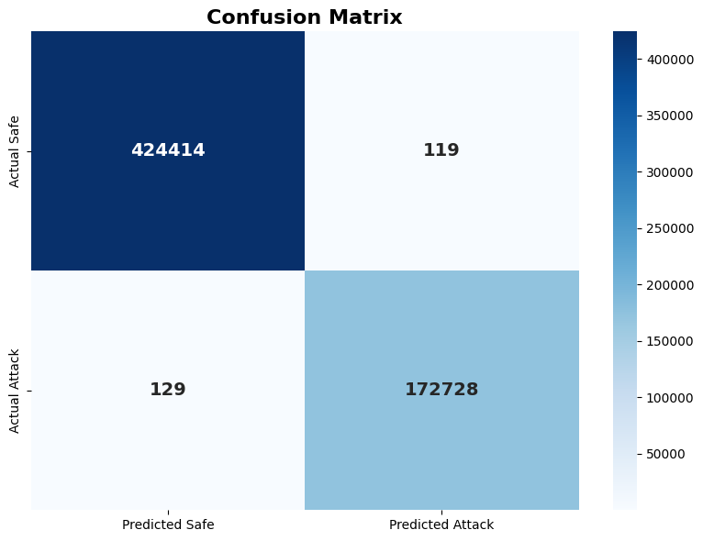

Convolutional Neural Networks (CNN)
CNNs represent deep learning architectures originally designed for image analysis but increasingly applied to sequential and structured data including network traffic. CNNs utilize local connectivity patterns and weight sharing to extract hierarchical features through multiple convolutional layers. The architecture employed in this study:
- It takes input of shape (18,1)(18,1), so it uses the same 18 basic flow features as a 1-D sequence.​
- The feature extractor part has two Conv1D layers (64 then 128 filters) with batch normalization and max-pooling in between to learn local patterns in the feature sequence.​
- A global average pooling layer compresses the feature maps into a 128-dimensional vector, followed by a Dense layer (128 units) and Dropout for regularization.​
- The final Dense layer with 1 neuron outputs the binary prediction (safe vs. attack) using a sigmoid activation.​
The CNN was trained using binary cross entropy loss with Adam optimizer over 20 epochs with batch size 32. Dropout regularization (0.5) was applied to dense layers to prevent overfitting on the large dataset. This architecture balances depth for feature extraction with regularization to maintain generalization.
Results:
- Training accuracy is about 99.51%, showing the CNN learns the training patterns very well.​
- Test accuracy is about 99.52%, which means it generalizes strongly to unseen network flows.​
- For the Normal (class 0) traffic, precision, recall, and F1-score are all approximately 1.00, so almost all benign flows are correctly identified and rarely confused with attacks.​
- For the Attack (class 1) traffic, precision, recall, and F1-score are around 0.99, indicating that most attacks are detected and there are few false alarms or misses for this class.​
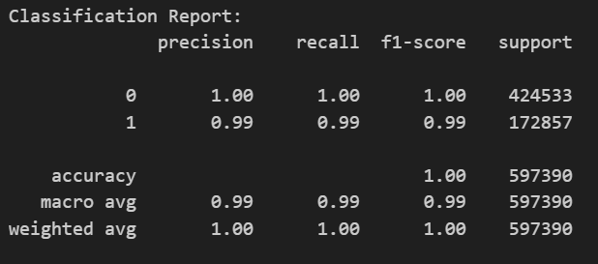
- The confusion matrix shows:
  - 423,189 normal flows correctly predicted as normal (true negatives).​
  - 171,340 attack flows correctly predicted as attack (true positives).​
  - 1,344 normal flows wrongly predicted as attack (false positives).​
  - 1,517 attack flows wrongly predicted as normal (false negatives).​
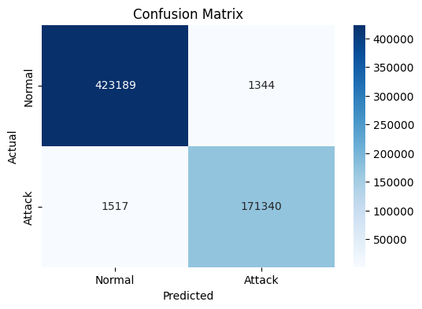

- Overall, the CNN provides highly accurate intrusion detection, with slightly more errors than the Random Forest but still very strong performance for both normal and attack classes.​
Isolation Forest
Isolation Forest is an unsupervised anomaly detection algorithm that operates through a fundamentally different principle than supervised methods. Rather than explicitly modeling normal behavior, Isolation Forest isolates anomalies by randomly selecting features and split values. Anomalies require fewer isolations and thus have shorter average path lengths in isolation trees. Configuration:
- Number of trees (n_estimators): 100
- Contamination parameter: 0.27 (matching dataset attack proportion)
- Maximum samples: 256 per tree
- Random state: 42 for reproducibility
Isolation Forest requires no labeled training data, making it applicable to zero-day attack detection where attack patterns are unknown. However, performance depends on setting the contamination parameter appropriately for the specific network environment.
Results:
- Overall accuracy is about 61.81%, so the model correctly labels only around two-thirds of flows.​
- For Safe traffic, precision is 0.6828 and recall is 0.8638, meaning most predicted safe flows are truly safe, and most real safe flows are detected.​
- For Attack traffic, precision (0.0419), recall (0.0146), and F1-score (0.0217) are very low; the model rarely identifies attacks correctly.​
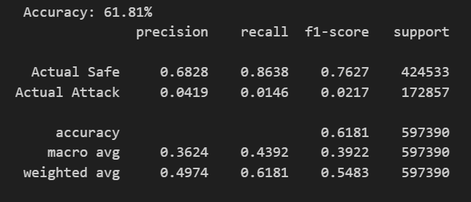
- From the confusion matrix:
  - 366,696 safe flows are correctly predicted as safe (true negatives).​
  - 2,531 attack flows are correctly predicted as attack (true positives).​
  - 57,837 safe flows are wrongly flagged as attacks (false positives).​
  - 170,326 attack flows are missed and predicted as safe (false negatives).​
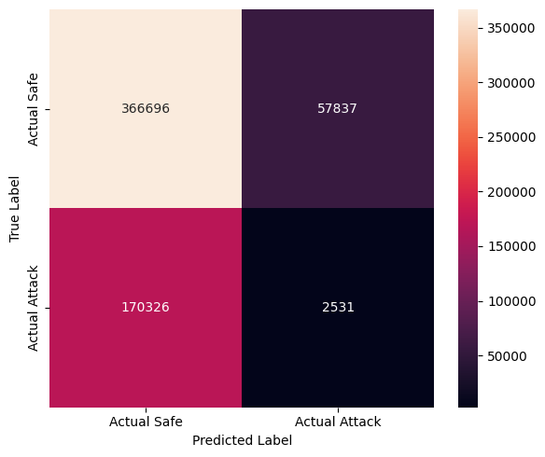

Discussion
- Both Random Forest and CNN give very strong results, with test accuracy above 99.5% and high precision/recall for both Safe and Attack traffic.
- Random Forest is slightly better and more stable: it makes only a few hundred mistakes and almost perfectly separates benign and malicious flows.
- Isolation Forest performs much worse: it correctly detects many Safe flows but misses most Attack flows and produces many false alarms, so it is not suitable as a main IDS model for this dataset.
Model results comparison
Model | Type | Accuracy | Attack precision | Attack recall | Main comment
Random Forest | Supervised | 0.9996 | ≈0.9993 | ≈0.9993 | Best performance, very few errors
1D-CNN | Supervised DL | ≈0.9952 | ≈0.99 | ≈0.99 | Very strong, slightly below RF
Isolation Forest | Unsupervised | 0.6181 | 0.0419 | 0.0146 | Misses most attacks, many false alarms

