**Output :**

After Running the application:

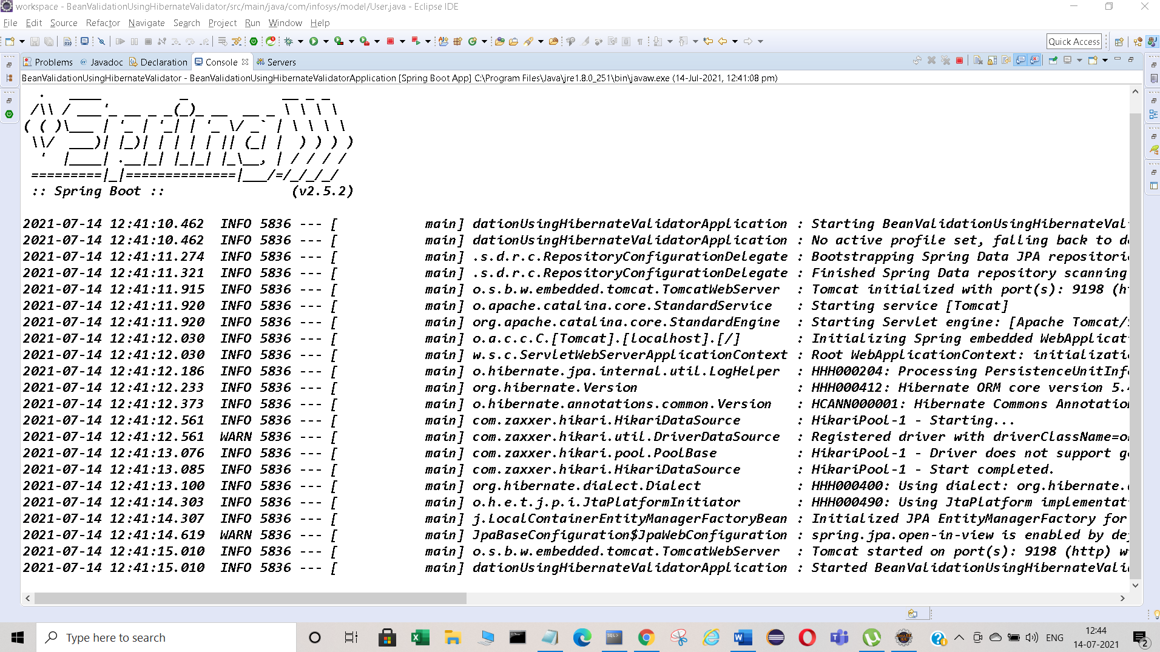

Spring Boot application is running successfully without any error.

Table has been created automatically in the database:

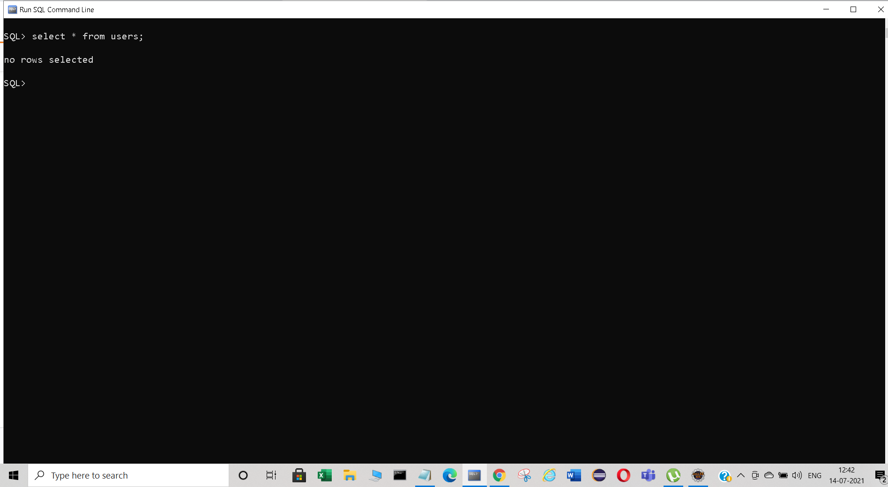

Validated the Http Response using Postman

***Case:1*** If all the fields are entered correctly. We can see Success Code(201 Created)

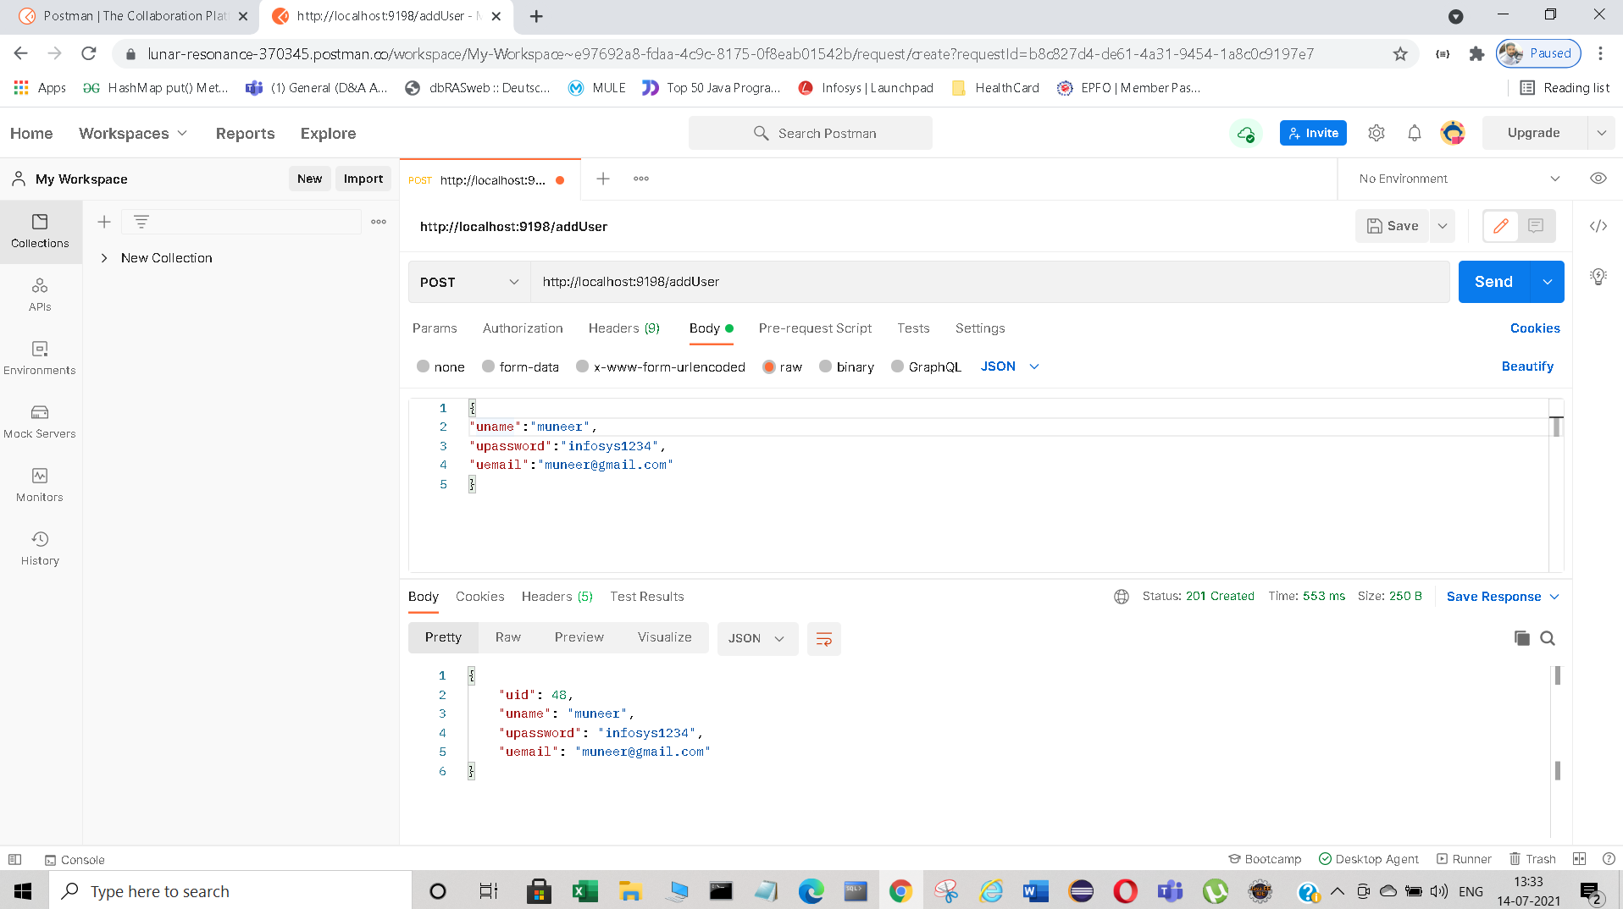

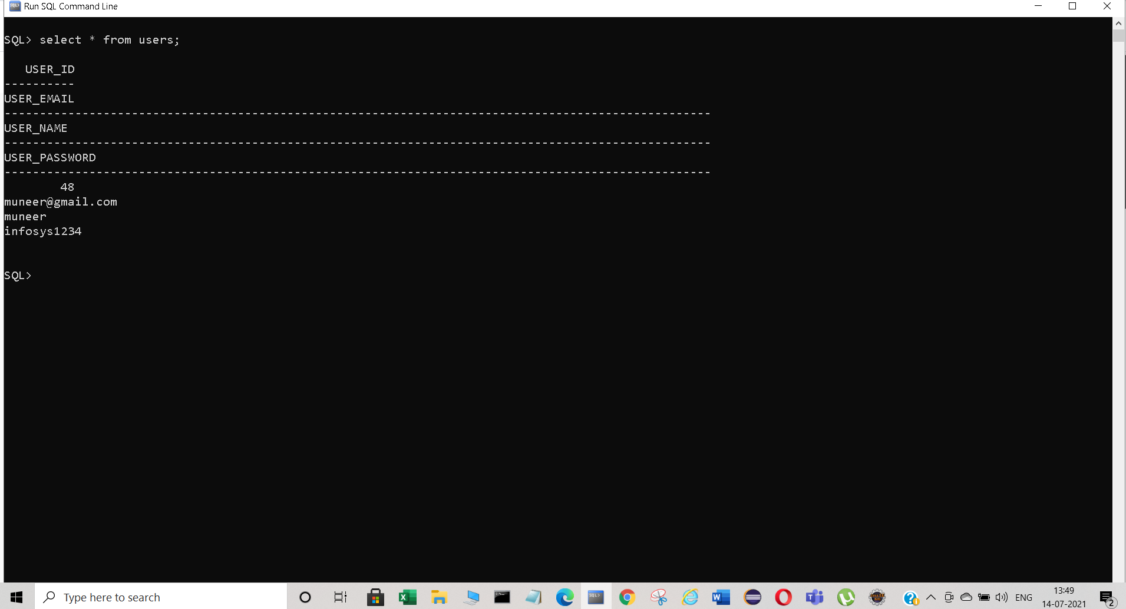

***Case 2:*** Entered Incorrect User name: (400:BadRequest)

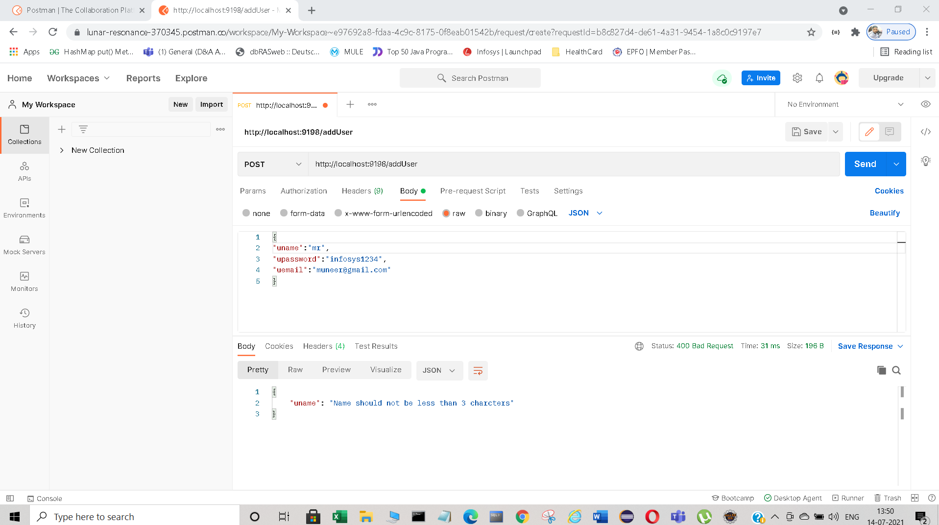

***Case3:*** Entered Incorrect PASSWORD:(400:BadRequest)

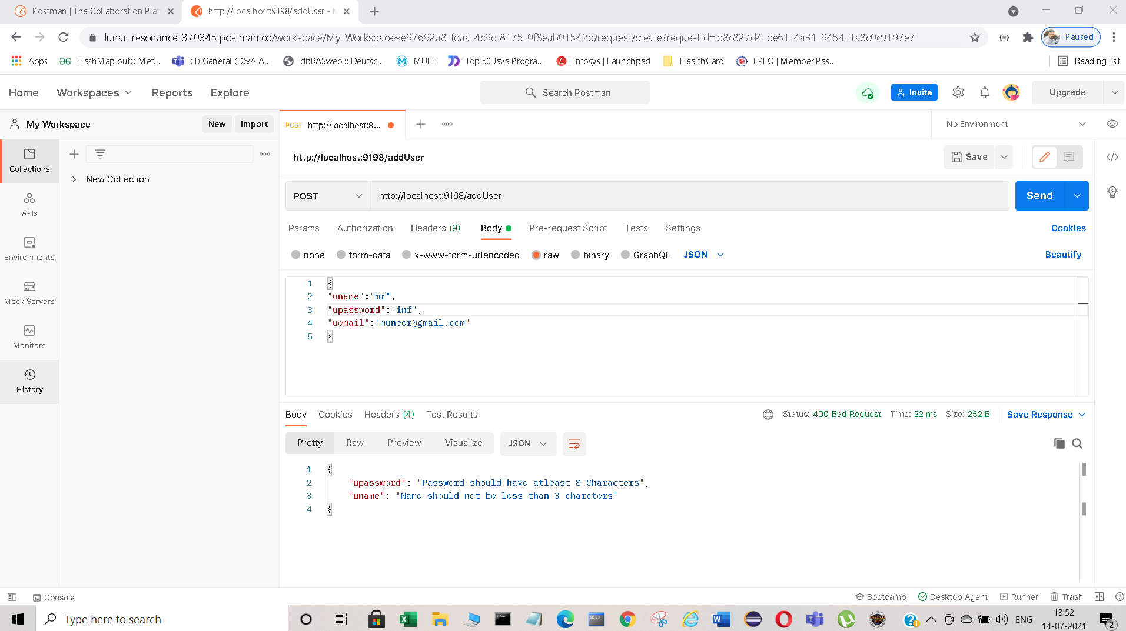

***Case4:*** Incorrect email(400:BadRequest)

