***Case:1*** If the data is correctly entered:

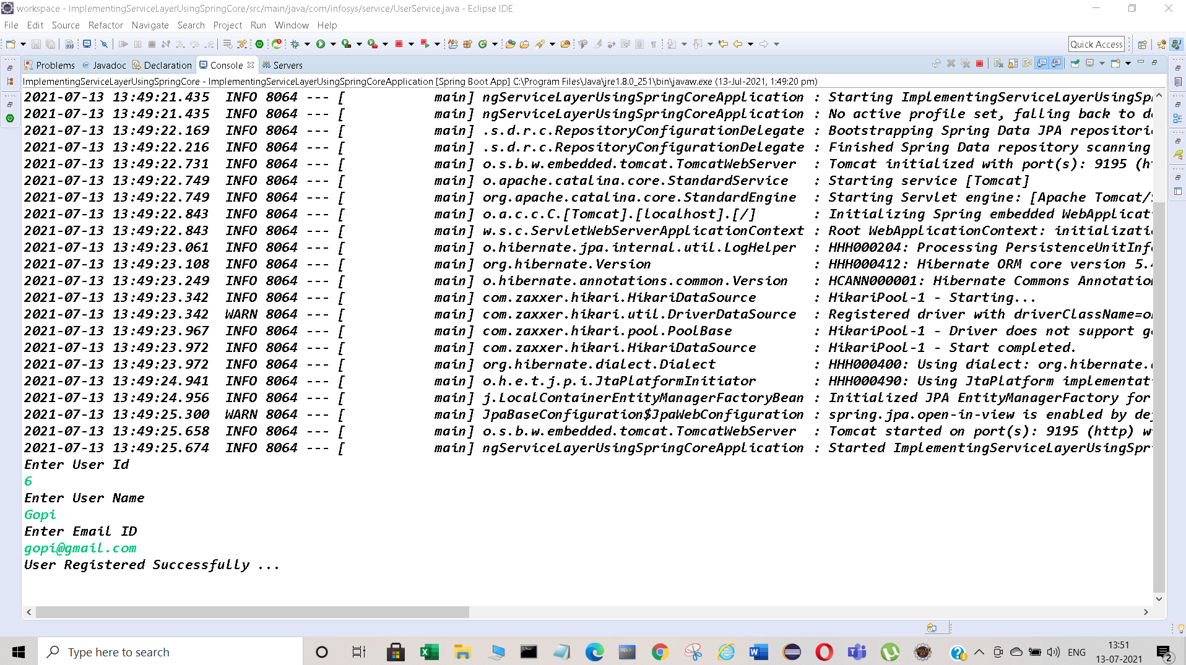

***Database:*** Data saved in the user_table.

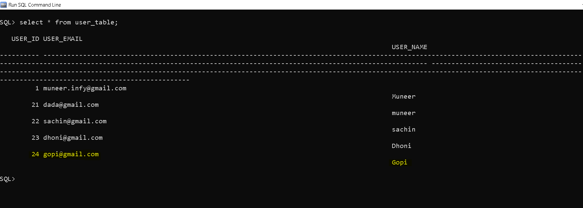

***Case 2:*** If we enter existing user Id.(Exception raised saying that user id already exist).

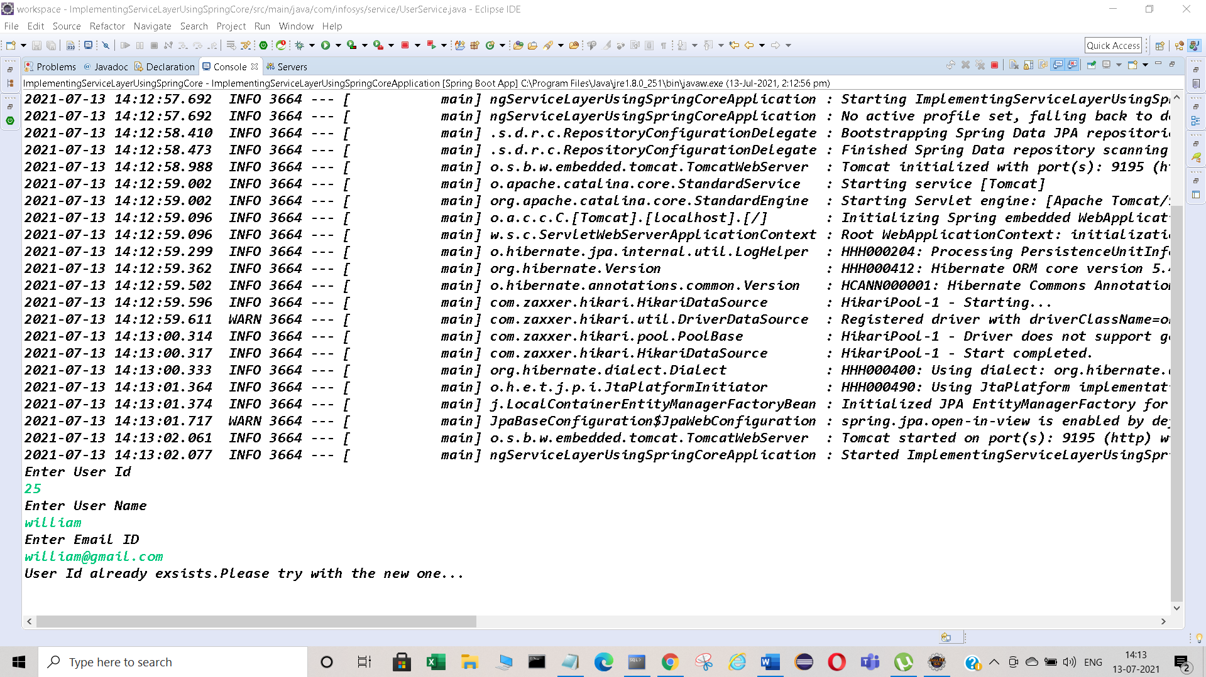

***Case 3:*** If we enter invalid UserName.

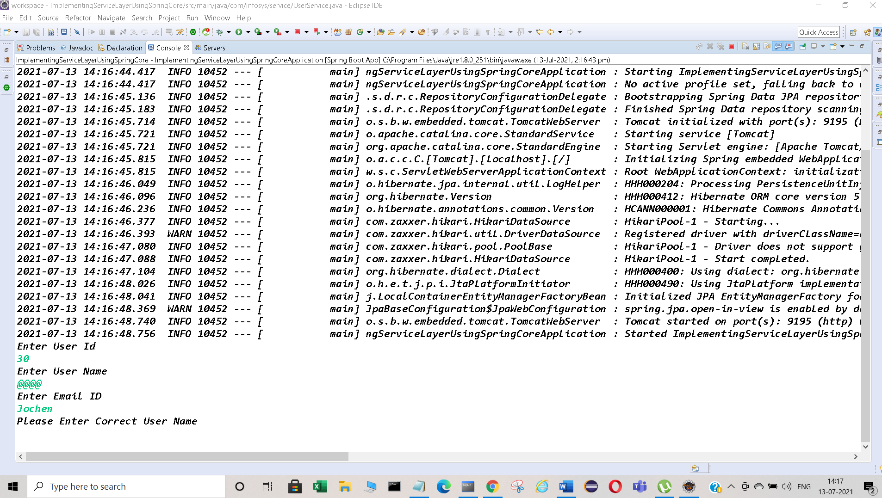

***Case 4:*** If we enter incorrect Mail Id :

