**Fake News Detection Using NLP**

**Introduction**

Fake news and real news are two distinct categories of information disseminated through various media channels. Real news is factual, verified information that adheres to journalistic standards, reporting events, developments, and facts accurately. In contrast, fake news, also known as disinformation or misinformation, consists of false or misleading information presented as fact. It can be created and spread with the intent to deceive or manipulate public opinion. Distinguishing between these two types of news is crucial for informed decision-making and maintaining the integrity of our information ecosystem.



**Data Set:**

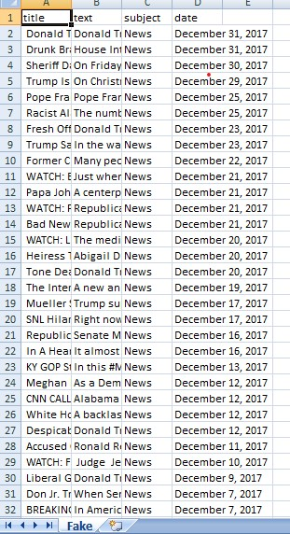 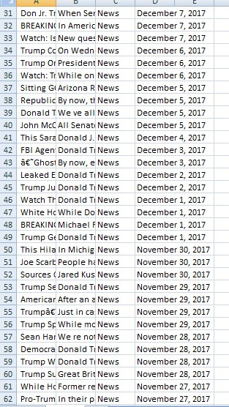

**OVERVIEW OF THE PREDICTION:**

**Fabricated information:**

Fake news consists of entirely false or fabricated information presented as if it were true.

**Misleading Content:**

It often includes misleading headlines, quotes, or images to grab attention or support a particular agenda.

**Clickbait:**

Fake news articles are designed to attract clicks and shares, contributing to their virality.

**Spreading Falsehoods:**

Fake news can spread quickly through social media and other online platforms, leading to misinformation and confusion.

**Motivation:**

It is often created for financial gain, to manipulate public opinion, or for sensationalism.

**Real News:**

Factual Reporting: Real news is based on verified facts and events that have occurred.

Journalistic Standards: It adheres to journalistic principles such as accuracy, fairness, and objectivity.

Attribution: Reliable news sources attribute information to credible sources and provide citations.

Editorial Oversight: Real news is subject to editorial review and fact-checking to ensure accuracy.

Informed Citizenry: It serves the important role of informing the public about current events and issues.

It's essential to critically evaluate information sources and be discerning in differentiating real news from fake news to make informed decisions and opinions**.**

Data Collection: Gather a dataset of labeled news articles, where each article is labeled as either "fake" or "real."

Preprocessing:

Preprocess the text data, which may include lowercasing, removing punctuation, tokenization, and stemming or lemmatization.

Feature Extraction:

Convert the text data into numerical features. Common techniques include TF-IDF (Term Frequency-Inverse Document Frequency) or word embeddings like Word2Vec or GloVe.

Split the Data:

Split your dataset into a training set and a testing set to evaluate the model's performance.

Model Selection and Training:

Use machine learning algorithms like Naive Bayes, Logistic Regression, or more advanced models like Recurrent Neural Networks (RNNs) or Transformers.

Train your chosen model on the training data.

Model Evaluation:

Use evaluation metrics like accuracy, precision, recall, F1-score, and confusion matrix to assess the model's performance on the test data.

Consider using techniques like cross-validation for more robust evaluation

MODEL TRAINING:

import pandas as pd

from sklearn.model_selection import train_test_split

from sklearn.feature_extraction.text import TfidfVectorizer

from sklearn.naive_bayes import MultinomialNB

from sklearn.metrics import accuracy_score, classification_report

# Load your dataset (e.g., CSV file with 'text' and 'label' columns)

data = pd.read_csv('news_dataset.csv')

# Preprocessing (tokenization, lowercasing, etc.) can be done here.

# Split the data

X = data['text']

y = data['label']

X_train, X_test, y_train, y_test = train_test_split(X, y, test_size=0.2, random_state=42)

# Feature extraction

tfidf_vectorizer = TfidfVectorizer(max_features=5000) # You can adjust the number of features

X_train_tfidf = tfidf_vectorizer.fit_transform(X_train)

X_test_tfidf = tfidf_vectorizer.transform(X_test)

# Train a classifier (e.g., Naive Bayes)

clf = MultinomialNB()

clf.fit(X_train_tfidf, y_train)

# Make predictions

y_pred = clf.predict(X_test_tfidf)

# Evaluate the model

accuracy = accuracy_score(y_test, y_pred)

report = classification_report(y_test, y_pred)

print(f'Accuracy: {accuracy}')

print(report)