**High-Level Design (HLD)**

**Stores Sales Prediction**

|  |  |
| --- | --- |
| Written By | SACHIN |
| Version | 1.0 |
| Date | 09-09-2021 |

|  |  |  |  |
| --- | --- | --- | --- |
| **Version** | **Date** | **Author** | **Comments** |
|  |  |  |  |
|  |  |  |  |
|  |  |  |  |
|  |  |  |  |
|  |  |  |  |
|  |  |  |  |
|  |  |  |  |
|  |  |  |  |
|  |  |  |  |
|  |  |  |  |
|  |  |  |  |
|  |  |  |  |
|  |  |  |  |
|  |  |  |  |
|  |  |  |  |

**DocumentChange Control Record**

Review

|  |  |  |  |
| --- | --- | --- | --- |
| **Version** | **Date** | **Reviewer** | **Comments** |
|  |  |  |  |

**Approval**

|  |  |  |  |  |
| --- | --- | --- | --- | --- |
| **Version** | **Review date** | **ReviewedBy** | **ApprovedBy** | **Comments** |
|  |  |  |  |  |

**Abstract**

The extend is almost building a framework that can anticipate future client request for specific items in stores. By analyzing past offering records of a specific item. Huge Shopping shopping centers are kept records of offering their item to estimate future request. It makes a difference to fabricate and item distribution center for putting away a amount of items. The most objective here is to analyze the past record and discover a significant relationship between distinctive traits and build a framework that's competent of doing expectations of how much a specific item will be in request. This framework will offer assistance to oversee to store capacity of distribution centers.

1. Introduction

**1.1 Why these High-Level Design Documents?**

The purpose of this High-Level Design(HLD) Documents is to add necessary details to the current project description to represent a suitable for coding. This document is also intended to help detect contradictions before coding. And can be used as a reference manual for how the modules interact at a high level.

The HLD will be :

* Present all of the design aspects and define them in detail.
* Describe the user interface being implemented.
* Describe the needed Python libraries for the coding.
* Describe the performance requirements.
* Include design features and the architecture of the project.
* List and describe the non-functional attributes like:
  + Security
  + Reliability
  + Maintainability
  + Portability
  + Reusability
  + Application Compatibility
  + Resource Utilization
  + Serviceability

**1.2 Scope**

The HLD documentation presents the structure of the system, such as the database architecture, application architecture(layers), application flow (Navigation), and technology architecture, The HLD uses non-technical and mildly-technical terms which should be understandable to the administrators of the system

**1.3 Definition**

|  |  |
| --- | --- |
| TERM | Description |
| DB | Database, the cloud platform where the data will be stored. Can be considered  cloud storage. |
| ML | Machine Learning |
| API or APIs | Application Programming Interface can be considered a website link from there we can extract information. |

**2. Common Description**

**2.1 Item Perspective**

The Store Salse Forecast is an ML-based Web Application that's able to anticipate future item request by analyzing past records. It'll grant the number that will be the degree of item sales.

2.2 Issue Statement

To builds a system the will be able to require information almost a product and can anticipate how much it'll be requested within the future. We ought to construct an application which will be able to create results. 2.3 Proposed Solution We will utilize performe EDA to discover the imperative connection between different properties and will utilize a machine-learning calculation to predict long term sales demand. The client will be filled the specified feature as input and will get comes about through the internet application. The framework will get highlights and it'll be passed into the backend where the highlights will be approved and preprocessed and after that it'll be passed to a hyperparameter tuned machine learning show to foresee the ultimate result.

**2.5 Tool Used**

The programming language is Python that is used here, also we will use some other python-based libraries like, for ml, we will use Scikit-Learn library, for data manipulation we will use pandas, for numerical computation Numpy, for custom APIs creation Flask web frameworks. Visual Studio Code is used as python IDE for all modular coding and custom APIs creation. And storing all code files for publically available we will use GitHub.





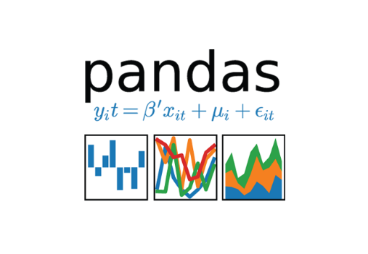



**2.6 Constraints**

The System should be user-friendly, the user should get all proper messages while using the web app. He/she also should get a proper error message if he/she has done something wrong On the web-app page. All the errors and results should be delivered in the easiest possible way and all the buttons are going to insert on the webpage should be labeled properly, so the user did not get confused to use the system.

**2.7 Assumptions**

The main objective is to implement a system that will produce approximate future demand for a product in stores.

**3. Design Details**

**3.1 Process Flow**

We will be using following process flow for this project. The process will be based on modular coding i.e. use of oops concepts to build the entire project from start to end.

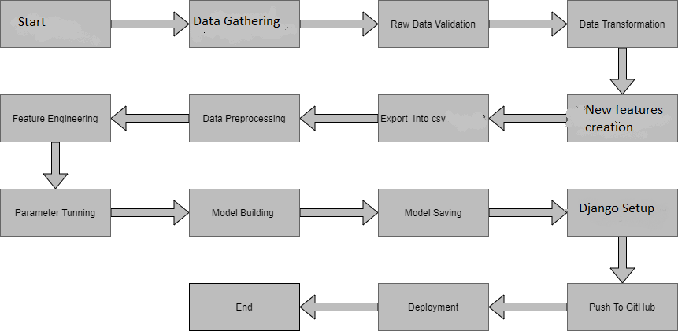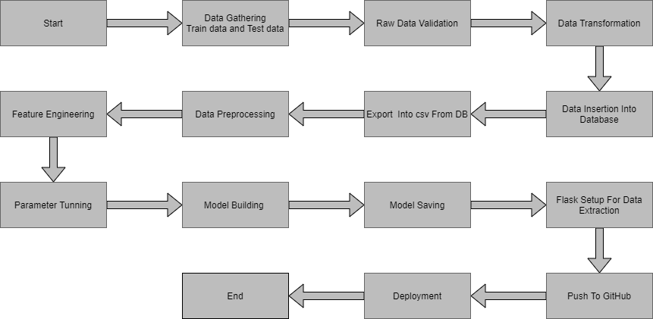

**3.2 Deployment Process**

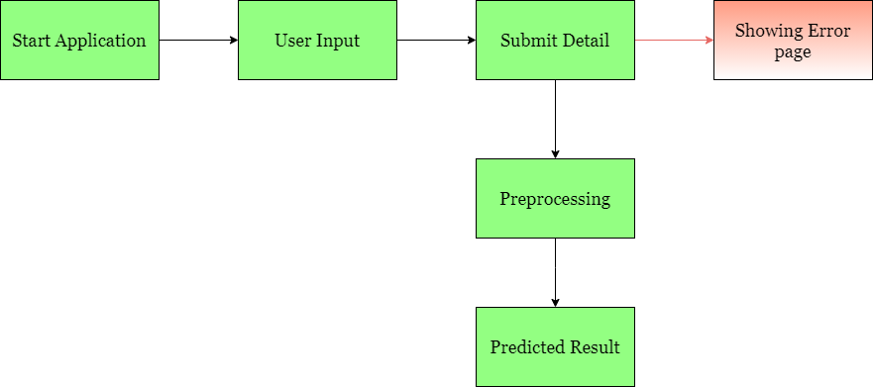

**3.3 Error Handling**

On the off chance that any blunder happened within the handling way at that point the blunder message ought to be appeared to the client in a totally non-technical way that can be justifiable by any individual. And Significant blunder message ought to be appeared, so the client can spot his mistake and rerun the method with enhancement. All the blunders that are will occur ought to be dealt with appropriately. And we need to log each blunder for our application and ought to oversee the same.

**4. Performance**

The Salse Cost Forecast is subordinate on machine-learning calculations. We'll prepare different ml calculations and will discover the leading fitting calculation for foreseeing the target. Our framework execution will be based on the information we are progressing to nourish to the calculations. And the execution will depend on the finalized show. and the internet application and the arrangement server. With all of these components, our program ought to run properly.

**4.1 Reusability**

The code and the module are created during the time of building the project should maintain all coding guidelines and full project code is written in a Modular fashion. Our system should have the flexibility to work properly from any location. And it should handle any improper input value from the user and should give a meaningful error message so the user can correct his/her mistake and enter valid input to get the result. And the system should be reusable in every manner with different types of inputs values that are all are it has been trained.

**4.2 Application Compatibility**

The different libraries and python programming languages are used to build the system. Every library has its own functionality and it should work properly with our fluctuate system. Flask will be used for making the web APIs and HTML/CSS will be used to make the web application. All the components of the application should work properly and it should produce a result without any interpretation.

**4.3 Resource Utilization**

Our application should utilize the given resource properly and it should use a minimal amount of internet to work and call the APIs on the Web page. Our system should not use much amount of computational resources hence it will make the application slow. Our application will be deployed cloud platform and it should utilize the resource given on the cloud and work properly.

**5. Deployment**

For the arrangement prepare, we'll utilizing Heroku cloud stages for facilitating our application. The cloud platform will run the framework and it'll deliver the adaptability to utilize our application globally

**. 6. Conclusion**

The Salse Store Expectation is almost to assist commerce proprietors and fabricating companies can foresee of there item demand within the future. It can offer assistance them to develop the commerce moreover it'll offer assistance the supply chain for items. We have a past record around items, item deals records at the side store data. We'll analyze the past information and will construct an ml demonstrate that can recognize the inside design and be able to foresee the target esteem or the deals request of the item within the future.

**7. Reference**

Google picture for collection the logos and images. Sketch graph for drawing the diagrams.