TECHNICAL REPORT
flAWS.cloud
AWS Cloud Security Misconfiguration Walkthrough - Technical Findings & Evidence
Prepared by: George Munene Ng'ang'a
Cybersecurity & Cloud Security Practitioner
Target: flaws.cloud (Public AWS Training Environment by Scott Piper / Summit Route)
Assessment Window: June – July 2026
Classification: TLP:CLEAR - Educational / Training Use Only
Companion document to the Executive Summary Report and the Remediation & Action Plan. Contains full technical evidence, commands, and exploitation detail for Levels 1–5.

1. Scope, Authorization, and Methodology

1.1 Scope
- Target: flaws.cloud and all associated sub-resources (S3 buckets, EC2 instances, EBS snapshots, IAM identities) reachable via the challenge, as explicitly authorized by the platform owner for public security training.
- In scope: Levels 1 through 5 of the flAWS.cloud challenge.
- Out of scope: any AWS infrastructure not owned by, or explicitly authorized by, Summit Route / the flAWS.cloud project.

1.2 Authorization
flaws.cloud is explicitly published as a legal, public training target. The site's own landing page states the challenge is designed to teach common AWS mistakes through a guided series of levels, with no destructive testing required. This assessment stayed within that intended use case throughout.

1.3 Methodology
The assessment followed a standard external cloud-recon → enumeration → exploitation → post-exploitation flow, consistent with frameworks such as the AWS Security Maturity Model and general black-box penetration testing methodology (PTES / OWASP-style phased approach):
- Reconnaissance — DNS resolution and passive enumeration of the target domain and its CNAME/record structure.
- Enumeration — Identification of underlying AWS services (S3, EC2) backing each subdomain, and unauthenticated inspection of bucket policies and object listings.
- Exploitation — Retrieval of objects, source history, and credentials from misconfigured resources.
- Privilege / Lateral Movement — Use of recovered IAM credentials to enumerate further AWS resources (S3, EC2, EBS) within the account.
- Post-Exploitation / Data Recovery — Reconstruction of an EBS volume from a public snapshot to recover locally-stored application secrets.

1.4 Tools Used
- dig, nslookup - DNS enumeration
- AWS CLI v2 (--no-sign-request and authenticated profiles) - S3, EC2, STS, and IAM interaction
- git (log, diff) source history analysis on a recovered .git directory
- Firefox (Kali Linux) -manual web inspection
- wget -attempted recursive retrieval (unsuccessful, documented for completeness)
- Kali Linux (VMware guest) - primary testing platform

2. Findings Reference Table
Level | Finding | Severity
Level 1 | Publicly Readable S3 Bucket (World-List/Read ACL) | High
Level 2 | S3 Bucket Accessible via Leaked/Guessable AWS Credentials & Open ACLs | High
Level 3 | AWS Access Keys Committed to Git History Inside a Public Bucket | Critical
Level 4 | Publicly Accessible, Unencrypted EBS Snapshot Exposing Server Secrets | Critical
Level 5 | Server-Side Request Forgery (SSRF) via Proxy Reaching Internal/Other Account Resources | High

3. Detailed Technical Findings

3.1 Level 1 - Publicly Readable S3 Bucket
Severity: High | Category: Broken Access Control (S3 Bucket ACL / Policy)

Description
The assessment began with basic DNS reconnaissance of flaws.cloud using dig, which returned eight IP addresses instead of a single host record a strong indicator that the domain is being served from a highly-available, multi-endpoint AWS service rather than a single server.
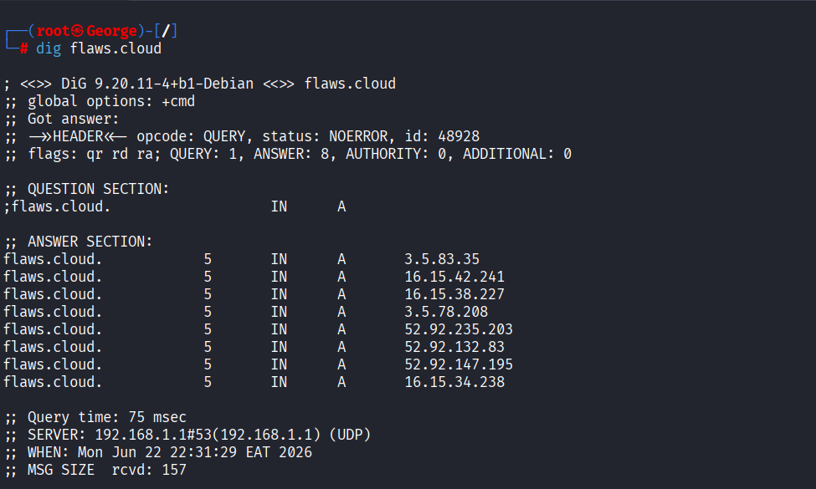
figure 1 — dig flaws.cloud returning multiple A records associated with AWS infrastructure.

A reverse DNS lookup (nslookup) against one of the returned addresses confirmed the domain resolves through an Amazon S3 static website hosting endpoint (s3-website.us-west-2.amazonaws.com), immediately identifying S3 as the backing technology and the correct attack surface to enumerate.
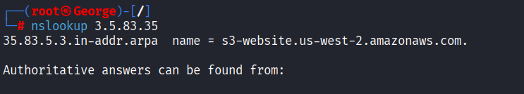

Browsing to the resolved S3 website endpoint rendered the flAWS.cloud landing page, confirming the bucket is configured for public static website hosting. Using the AWS CLI with the --no-sign-request flag (i.e., fully unauthenticated), the bucket's full object listing was retrieved: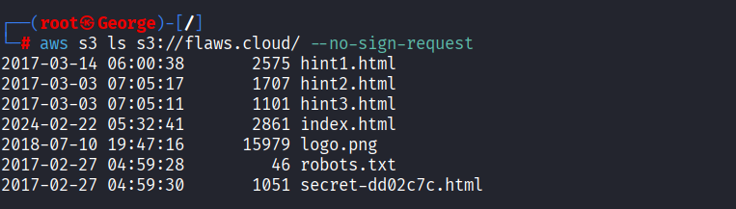
Figure 2 — aws s3 ls s3://flaws.cloud/ --no-sign-request returning a full, unauthenticated object listing.
The listing revealed a file named secret-dd02c7c.html that was not linked from the site's navigation — an example of "security by obscurity" that fails once the bucket itself is enumerable. Retrieving it directly disclosed the URL for Level 2.
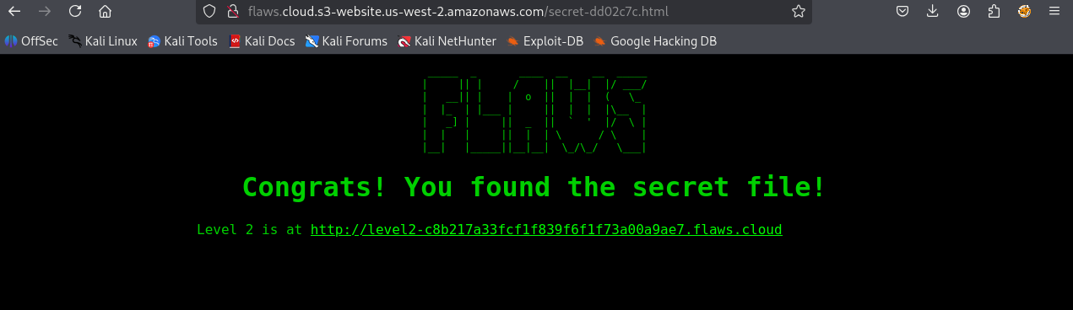
Figure 3 — The hidden secret file, directly reachable because the bucket permits public listing and object read.

Root Cause
The S3 bucket's ACL/bucket policy grants the AllUsers (public) group both s3:ListBucket and s3:GetObject permissions. Public list access is the critical error here: even non-linked, "hidden" objects become trivially discoverable once the bucket contents can be listed by anyone.

Business Impact
In a production account, a public-list bucket routinely exposes internal file naming conventions, unlinked administrative pages, backups, or draft content — turning an intended "public website" bucket into an information-disclosure vector far beyond its intended scope.

Remediation
- Disable public ListBucket permission; retain only the minimum GetObject grant required for the specific objects meant to be public (e.g., via a scoped bucket policy resource ARN, not a wildcard).
- Enable S3 Block Public Access at the account and bucket level wherever public hosting is not explicitly required.
- Where static website hosting is required, front the bucket with CloudFront and Origin Access Control (OAC) rather than exposing the S3 website endpoint directly.
- Enable S3 Access Analyzer / IAM Access Analyzer to continuously flag buckets with public exposure.

3.2 Level 2 -Public Bucket Enumeration via Open ACL
Severity: High | Category: Broken Access Control (S3 Bucket ACL)

Description
Level 2's bucket was similarly enumerable without valid AWS credentials, confirming that the same class of misconfiguration (public bucket listing) had been repeated on a second, distinct bucket:
Figure 4 — Unauthenticated listing of the Level 2 bucket, again exposing an unlinked secret file.
Requesting the disclosed secret-e4443fc.html file directly returned the Level 3 URL, continuing the chain.
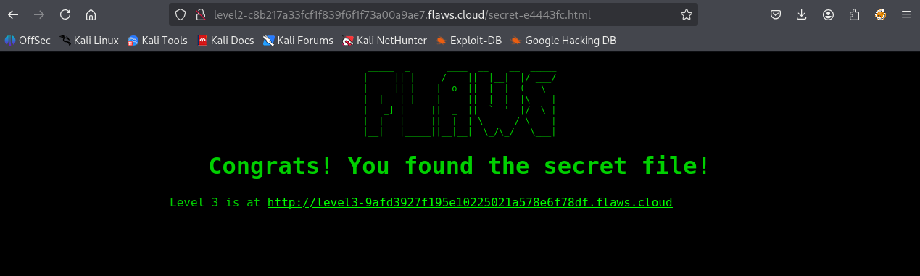
Figure 5 — Level 2 secret file disclosing the Level 3 target.

Root Cause
Identical to Level 1: the bucket policy/ACL grants public s3:ListBucket, allowing full enumeration of bucket contents regardless of whether objects are linked from the website.

Remediation
- Apply the same controls as Level 1 (Section 3.1) - restrict ListBucket to authorized principals only.
- Adopt a standard, organization-wide S3 bucket policy template / Service Control Policy (SCP) that denies public ACLs by default across all accounts, preventing this pattern from being re-introduced bucket by bucket.

3.3 Level 3 - AWS Credentials Exposed via Public .git Directory
Severity: Critical | Category: Sensitive Data Exposure / Secrets in Version Control

Description
An initial attempt to retrieve the Level 3 site's Git history with wget failed with an HTTP 404, indicating the .git directory could not be fetched via simple recursive download over the web server directly.

Pivoting to Direct Bucket Access
Because Level 3 was, like the prior levels, backed by an S3 bucket, the exposed .git directory objects were instead retrieved directly from the bucket using aws s3 sync, bypassing the web server entirely and pulling down the full Git object database:
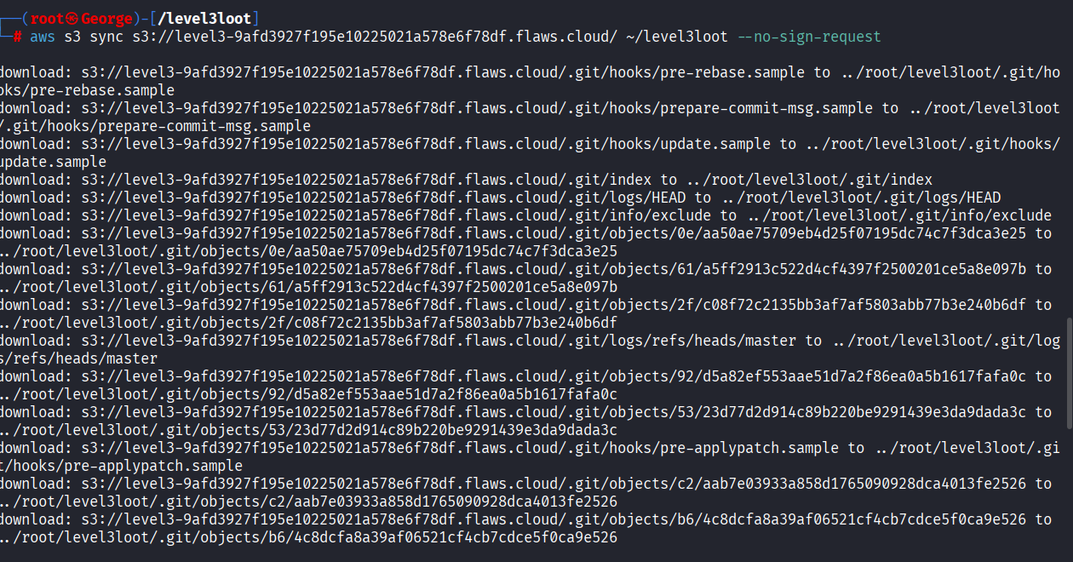
Figure 6 — aws s3 sync pulling the full .git object database directly out of the S3 bucket.

Reconstructing History
With a working local Git repository, git log revealed two commits, the most recent of which was suggestively titled "Oops, accidentally added something I shouldn't have" — a strong signal that the prior commit contains sensitive material later removed.
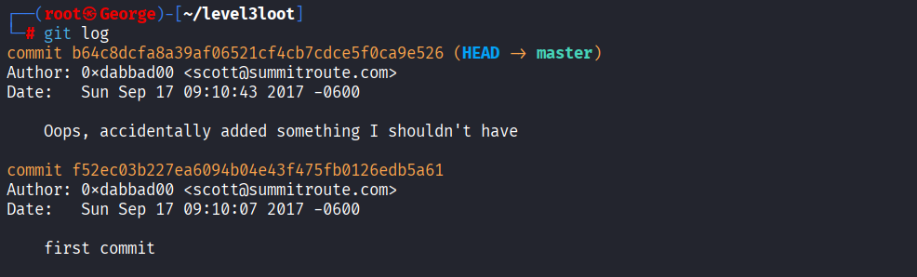
Figure 7 — git log showing the suspiciously-worded cleanup commit.

Recovering the Deleted Secret
Running git diff against the two commits confirmed the suspicion: a file named access_keys.txt had been deleted in the most recent commit, but Git's history retains the deleted content in full, including a live AWS Access Key ID and Secret Access Key:
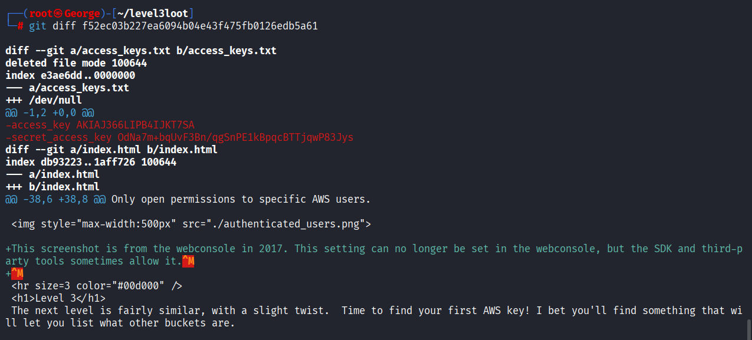
Figure 8 — git diff recovering the deleted access_keys.txt content, including a live AWS key pair.

Using the Recovered Credentials
The recovered key pair was loaded into a dedicated AWS CLI profile (aws configure --profile flawslevel3) and validated with sts get-caller-identity, confirming the credentials belonged to an active IAM user (arn:aws:iam::975426262029:user/backup) within the target's AWS account providing authenticated access for all subsequent levels.
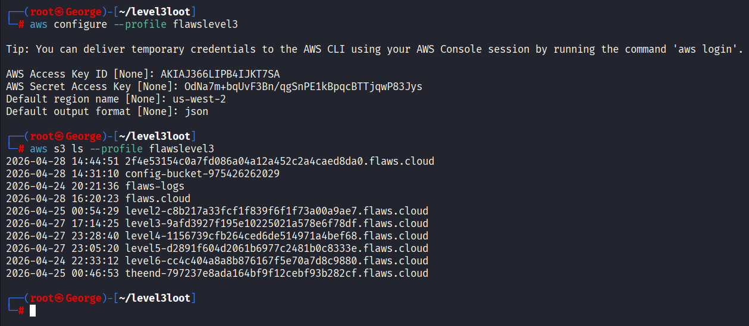
Figure 9 — Configuring a dedicated CLI profile with the recovered key pair and listing all buckets in the account.
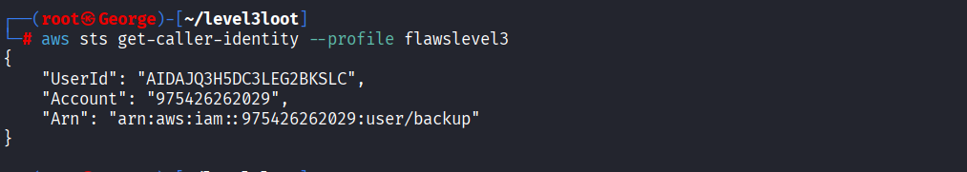
Figure 10 — sts get-caller-identity confirming valid, active credentials for IAM user 'backup'.

Root Cause
Credentials were committed to source control and later "deleted" only in a subsequent commit, without regenerating (rotating) the exposed keys and without purging the sensitive blob from Git's object history. Because the .git directory itself was stored inside a public S3 bucket, the entire commit history .. including the deleted-but-still-present blob remained retrievable indefinitely.

Business Impact
This is the most severe finding in the assessment. Long-lived IAM access keys provide persistent, programmatic access to an AWS account. Once such a key is committed to a repository, deleting the file in a later commit does not remove it from history automated scrapers and bots continuously scan public S3 buckets and public GitHub repositories for exactly this pattern, and exposed keys are frequently abused within minutes for cryptomining or further account compromise.

Remediation
- Immediately deactivate and rotate any credential that has ever appeared in version control, regardless of whether the file was later deleted.
- Never store .git directories (or any development artifacts) inside publicly accessible S3 buckets; keep source control repositories in a dedicated, access-controlled Git hosting platform.
- Adopt pre-commit secret scanning (e.g., git-secrets, gitleaks, truffleHog) to block credentials from being committed in the first place.
- Use short-lived credentials (IAM roles, STS AssumeRole, or AWS SSO) instead of long-lived IAM access keys wherever possible.
- Enable AWS IAM Access Analyzer and CloudTrail alerting on unusual API activity from newly-seen access keys.

3.4 Level 4 - Publicly Shared, Unencrypted EBS Snapshot
Severity: Critical | Category: Sensitive Data Exposure (Cloud Storage / Backup Misconfiguration)

Description
Level 4 pointed to a web application running on an EC2 instance protected by HTTP Basic Authentication, which could not be bypassed directly:
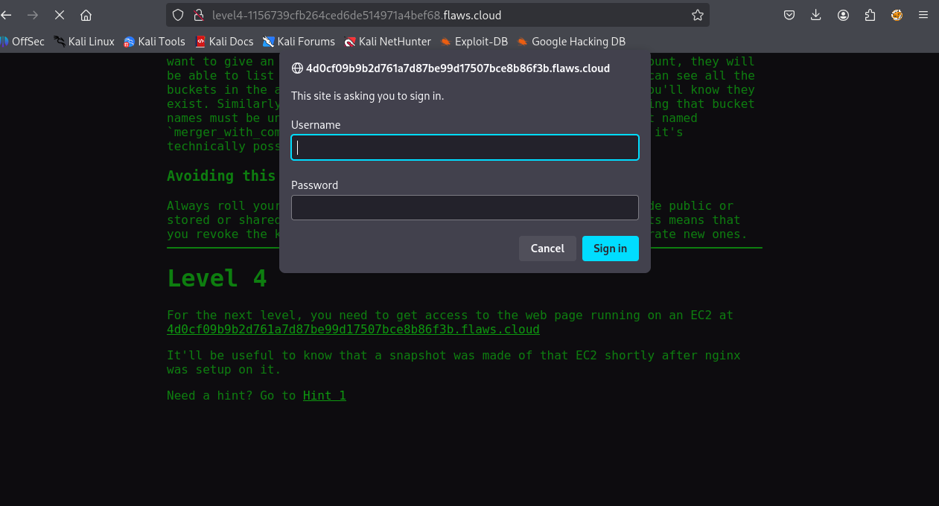
Figure 11 — HTTP Basic Authentication prompt guarding the Level 4 EC2-hosted application.

Enumerating the Account with Recovered Credentials
Using the IAM credentials recovered in Level 3, the account's EC2 snapshots were enumerated directly via the API rather than attacking the login prompt. This returned a snapshot explicitly tagged "flaws backup 2017.02.27", created shortly after the target EC2 instance was originally provisioned exactly the scenario described in the level's own hint that a snapshot was made shortly after the web server was configured.
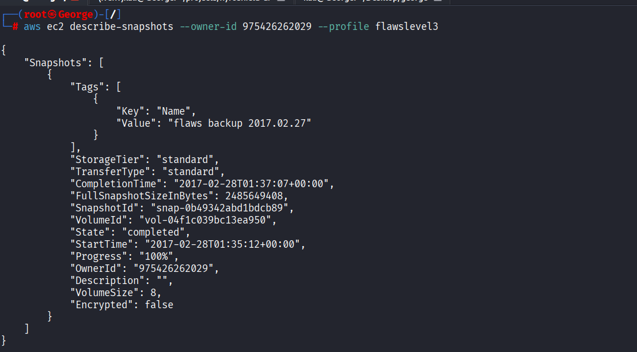
Figure 12 — ec2 describe-snapshots revealing a backup snapshot tagged 'flaws backup 2017.02.27'.

A new EBS volume was then created from that snapshot in the assessor's own AWS account, without needing any permission from or interaction with the snapshot owner beyond the snapshot having been shared:
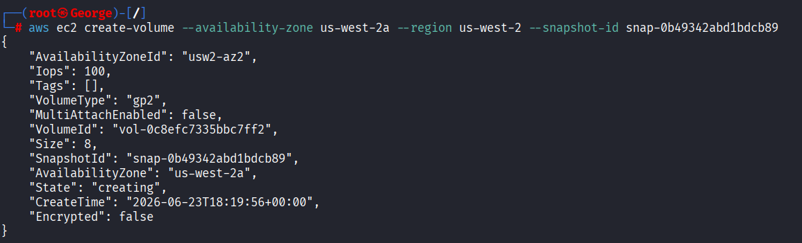
Figure 13 — ec2 create-volume restoring a fresh, writable volume from the public snapshot.

Recovering Credentials from the Restored Volume
The restored volume was attached to an EC2 instance and mounted, allowing the full original filesystem including configuration files to be inspected offline:

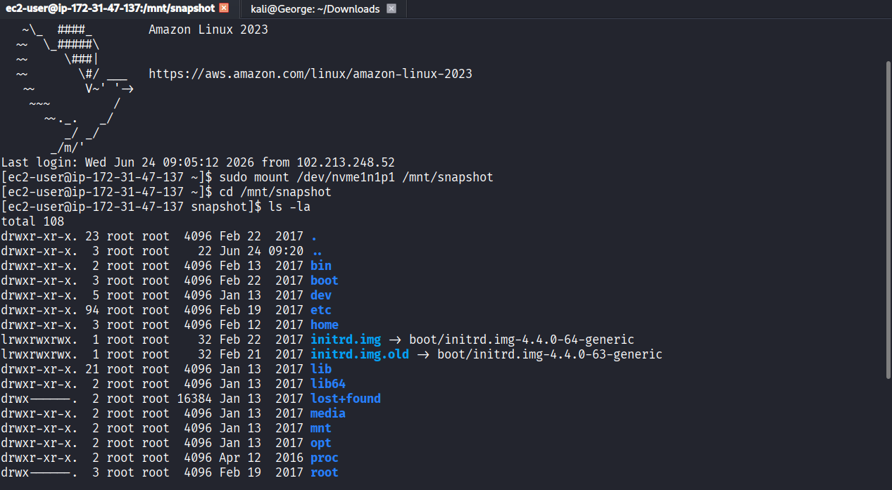
Figure 14 — Mounting the restored snapshot volume and browsing its filesystem, identical to the original server's disk.
Within the ubuntu home directory, a setup script (setupNginx.sh) was found containing the exact htpasswd command used to originally provision the site's Basic Authentication credentials, in cleartext:
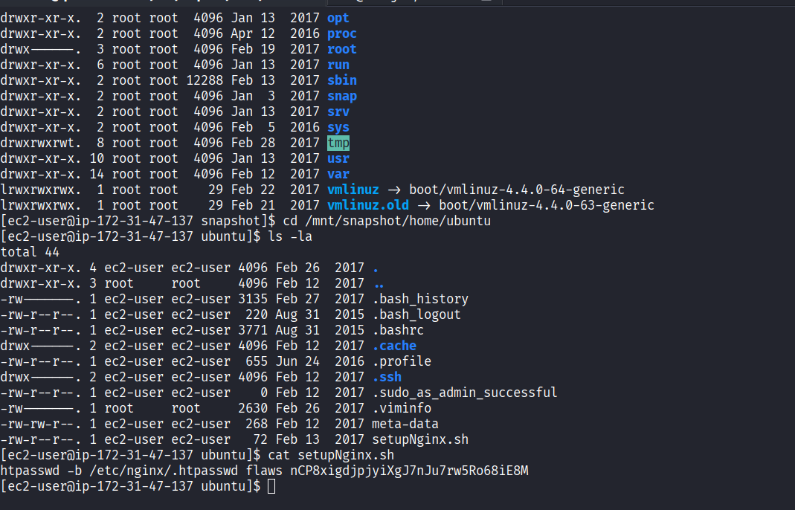
Figure 15 — setupNginx.sh recovered from the mounted volume, exposing the site's Basic Auth username and password in plaintext.
This yielded a valid username/password pair for the Level 4 site's login prompt, granting access and confirming the flaw.

Root Cause
The EBS snapshot's permissions were set to allow access by other AWS accounts (or public access), the volume was not encrypted, and most critically the original server's provisioning script stored a plaintext administrative password directly in a file on disk instead of using a managed secrets store.

Business Impact
Backups and snapshots are frequently overlooked in access-control reviews because they are not "live" running infrastructure. In practice, a snapshot is a complete forensic copy of a server's disk at a point in time , anyone who can restore it gains full read access to every file that ever existed on that volume, including credentials, private keys, application configuration, and customer data, entirely bypassing any network-layer controls (security groups, authentication prompts) protecting the live instance.

Remediation
- Never share EBS snapshots or AMIs publicly or with untrusted accounts; use AWS Backup Vault Lock and resource-based policies to restrict snapshot sharing to explicitly authorized account IDs only.
- Enable default EBS encryption account-wide (aws ec2 enable-ebs-encryption-by-default) so all future volumes and snapshots are encrypted by default.
- Never write plaintext secrets into provisioning scripts, user-data, or configuration files; use AWS Secrets Manager, SSM Parameter Store (SecureString), or an equivalent managed secrets service, injected at runtime.
- Periodically audit all snapshots and AMIs account-wide for public or cross-account sharing using AWS Config rules (e.g., ebs-snapshot-public-restorable-check).

3.5 Level 5 - Reached via Proxy / Server-Side Trust Relationship
Severity: High | Category: Server-Side Request Forgery (SSRF) / Excessive Trust Between Resources

Description
Having authenticated to the Level 4 EC2-hosted site using the recovered credentials, the assessment reached the Level 5 landing page, which is served through the Level 4 instance acting as a proxy into a separate resource — a classic setup for demonstrating SSRF-style trust abuse between a public-facing server and internal or third-party AWS resources.
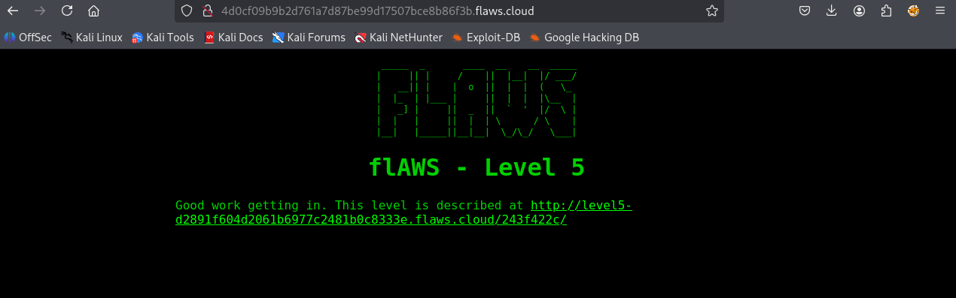
Figure 16 — Level 5 landing page, reached via the Level 4 host acting as a proxy/pivot point.

Root Cause
The Level 4 web server is configured to proxy requests onward to another resource without adequate validation of the destination or the caller's authorization to reach it, illustrating how a single compromised front-end host can be used as a pivot point deeper into an environment.

Business Impact
SSRF and unrestricted proxy trust relationships are consistently ranked among the highest-impact web application risks (OWASP Top 10 - A10: Server-Side Request Forgery) precisely because they let an attacker who compromises one host "borrow" that host's network position and, in AWS specifically, its Instance Metadata Service (IMDS) credentials to reach otherwise unreachable internal services.

Remediation
- Enforce IMDSv2 (token-required) on all EC2 instances to prevent trivial SSRF-to-credential-theft chains.
- Apply strict allow-lists for any server-side proxying or outbound request functionality; never forward arbitrary destination URLs.
- Segment networks with security groups / NACLs so a compromised public-facing host cannot reach sensitive internal endpoints by default.

4. Cross-Cutting Root Causes
Although each level presents a distinct technical vulnerability, three systemic themes recur throughout the assessment and are the most valuable takeaways for any organization operating in AWS:

4.1 Overly Permissive S3 Bucket Permissions
Three of the five levels (1, 2, and 3) trace back directly to S3 buckets granting public list and/or read access beyond what was intended. This remains one of the single most common and highest-impact cloud misconfigurations reported industry-wide.

4.2 Secrets Management Failures
Both the Level 3 (Git history) and Level 4 (provisioning script) findings stem from credentials being stored in plaintext, in the wrong location, without rotation. No amount of network-layer or IAM-layer control fully compensates for secrets that are stored insecurely at rest.

4.3 Insufficient Backup and Snapshot Governance
The EBS snapshot exposure in Level 4 demonstrates that backup artifacts require the same , if not greater access-control rigor as live production resources, since they represent a complete, offline-readable copy of a system's data.

5. Appendix A — Recovered Level Sub-Domains
- Level 2: level2 flaws.cloud
- Level 3: level3 flaws.cloud
- Level 4: level4.flaws.cloud (EC2 endpoint: 4d0cf09b9b2d761a7d87be99d17507bce8b86f3b.flaws.cloud)
- Level 5: level5-flaws.cloud
Companion documents: flAWS Executive Summary Report.docx (business-level overview) and flAWS Remediation Action Plan.docx (control-by-control remediation guidance).

