Transforming waste management
Define the Statements

Date | 30 june 2025
Team ID | LTVIP2025TMID38774
Project Name | clean teach: transforming waste management with transfer learning
Maximum Marks | 2 Marks
Customer Persona:

Name: Mahesh, 50years old

Profession: Teacher

Location: Semi-urban area in India

Transforming waste management: Type 2 Diabetes, cleaning

Pain Point: Has difficulty regularly visiting clinics for cleaning and waste management clearance

Example:
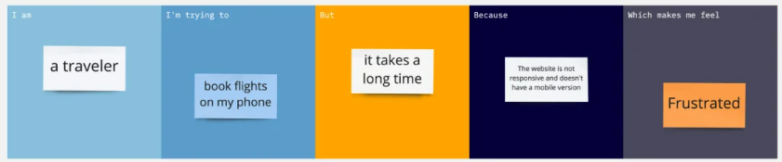
Problem Statement (PS) | I am (Customer) | I’m trying to | But | Because | Which makes me feel
PS-1
PS-2

