**ICP -3**

**Task 1:**

Building a Rock Paper Scissors game using the JavaScript. In this game you would choose one option and computer would choose option randomly and score is updated whoever wins and we have a restart button.it would restart the game and both the players and the computer score will come to 0 When pressed and we can text displaying who wins every time.

The page is displayed as below.

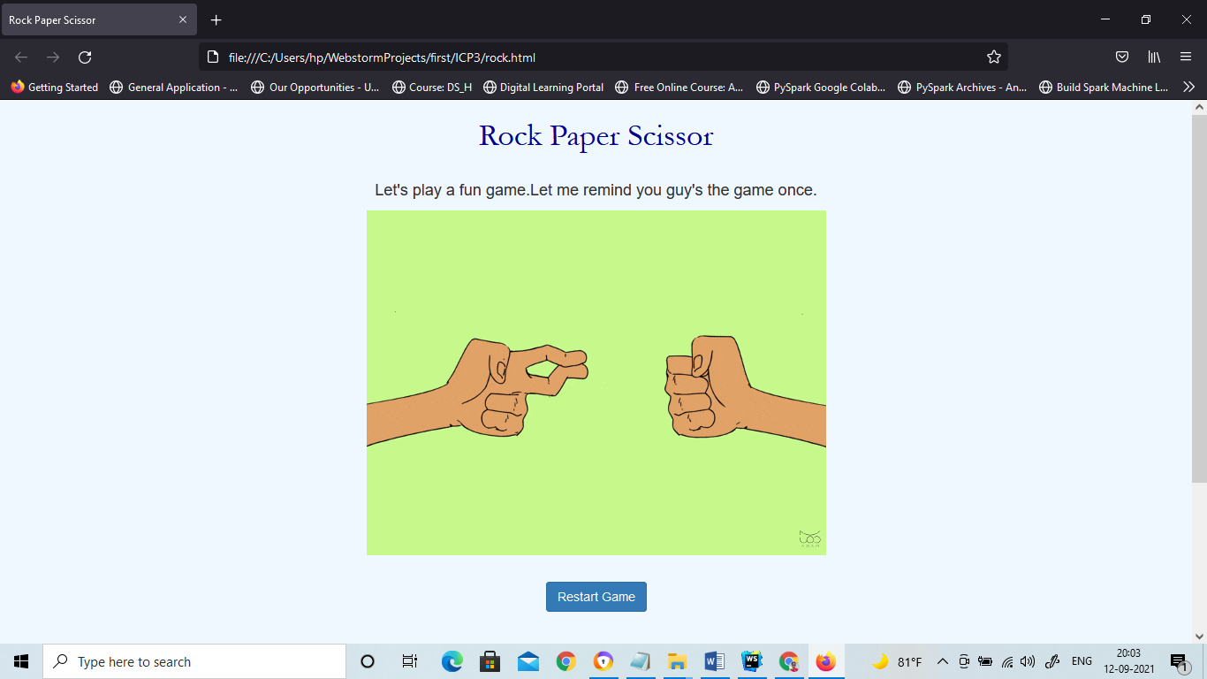

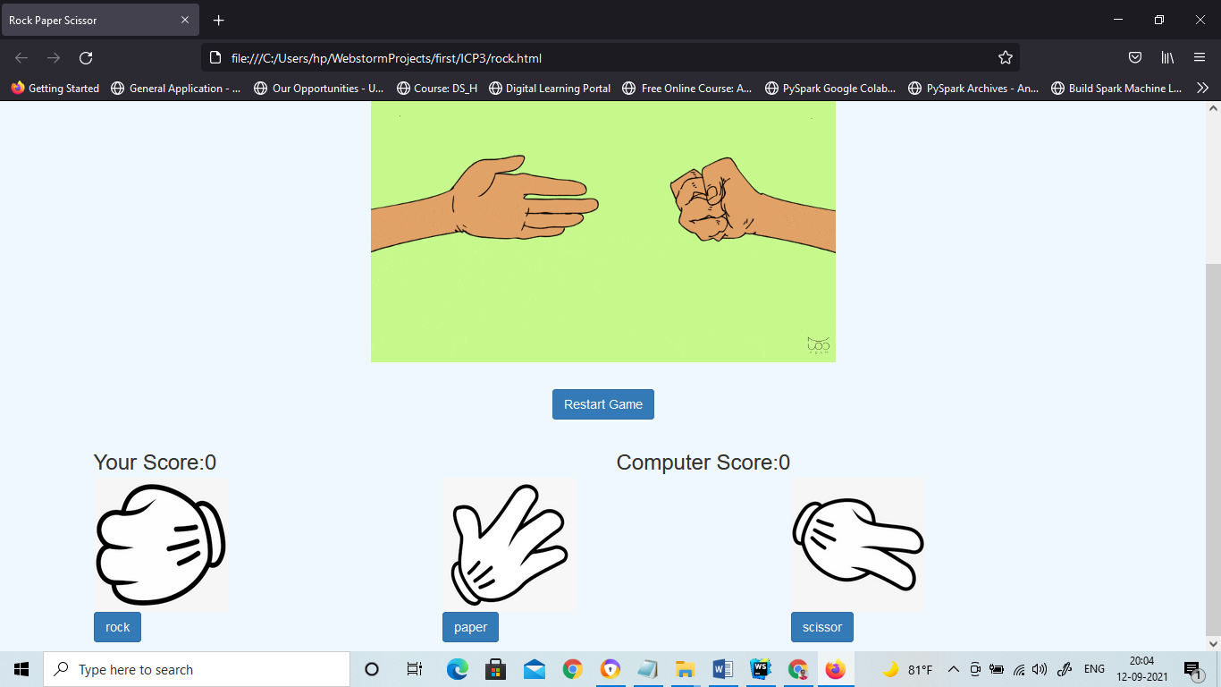

We can see the player can choose his option by pressing on button of his choice

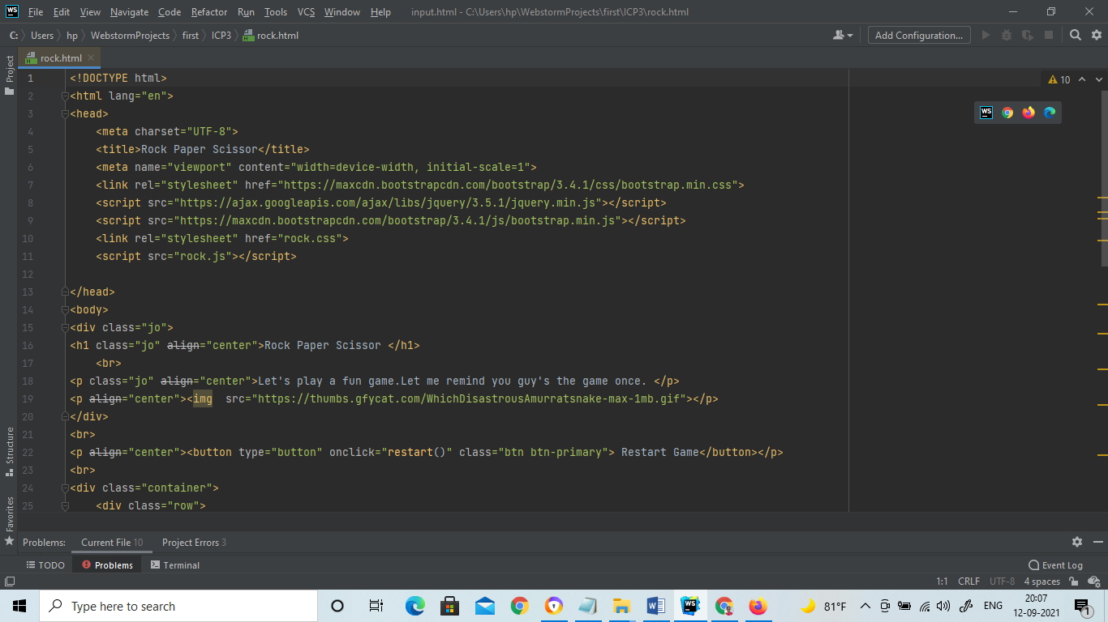

All the bootstrap CDN loaded and css files and the JavaScript files are attached and different tags like the header and paragraph are used to display the texts and all of them are placed in the division tag.

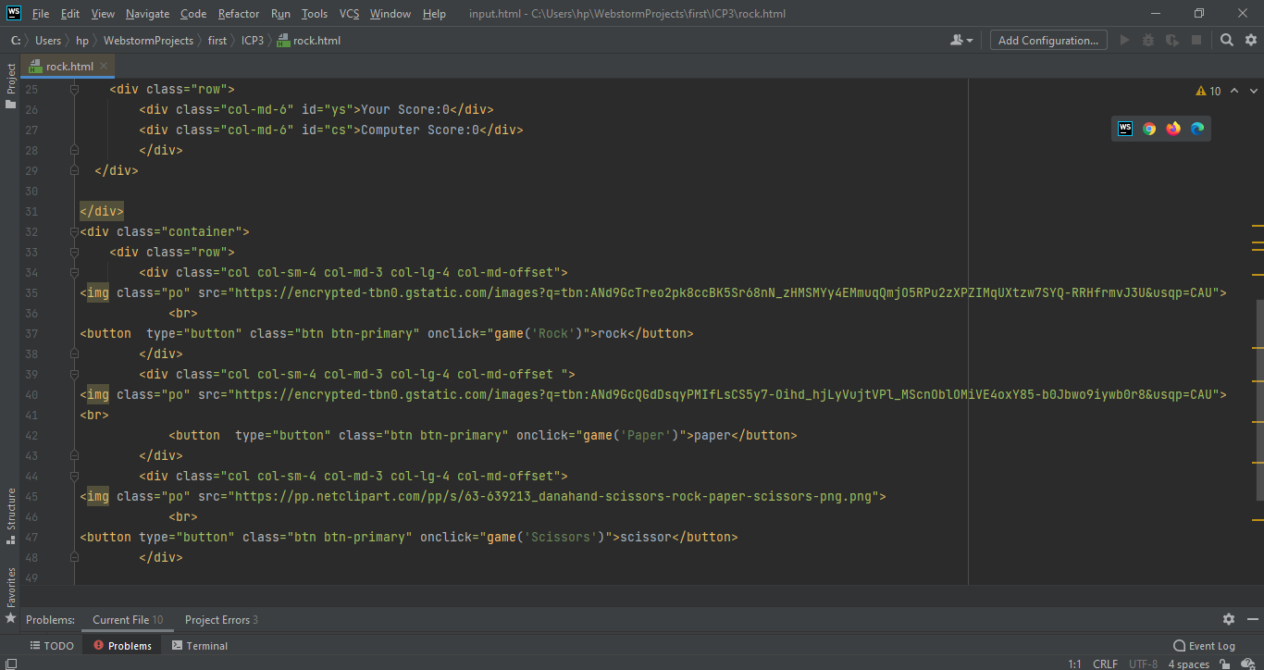

Bootstrap grid for arranging of the images and button and each button has the functionality.

CSS file:

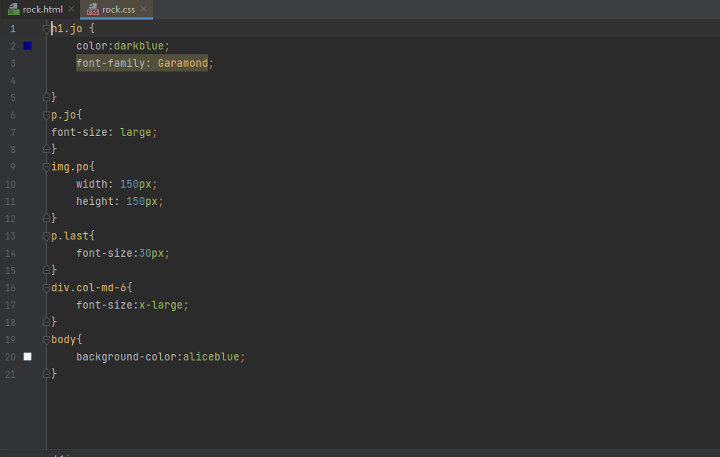

Styling of the different elements is done in the above format.

JavaScript File:

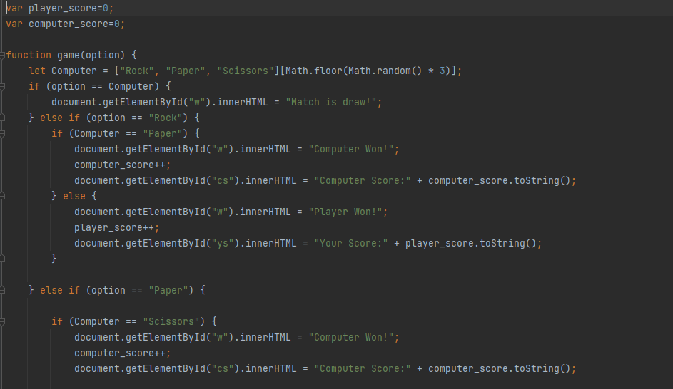

Your choosed option is compared with the computers option and whoever is won the score is updated and the winner is displayed

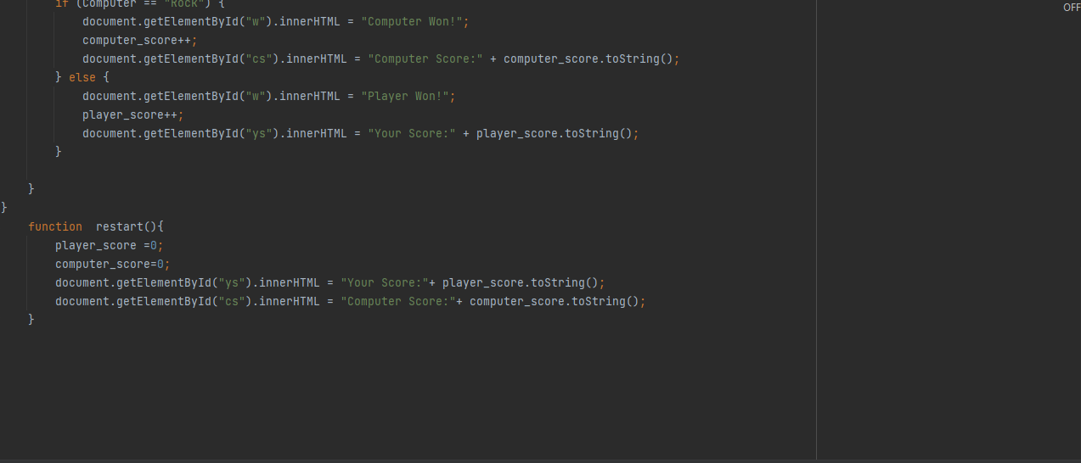

Restart function is used in an order to start the game from beginning and scores are cleared.

**Task-2:**

Building a Responsive web page

The responsive web page looks as below

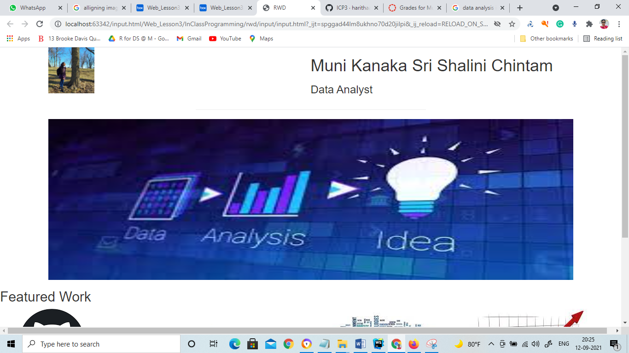

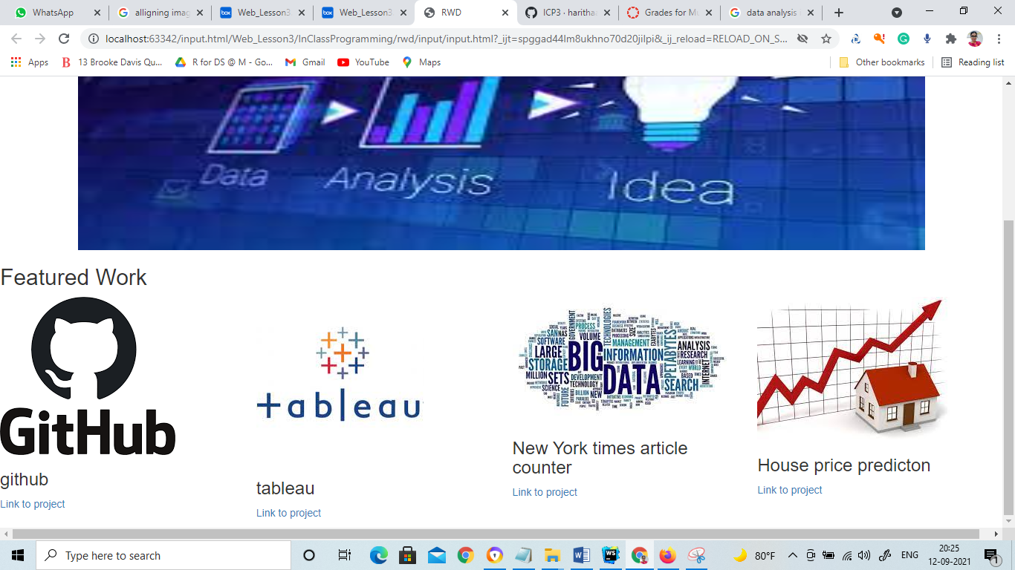

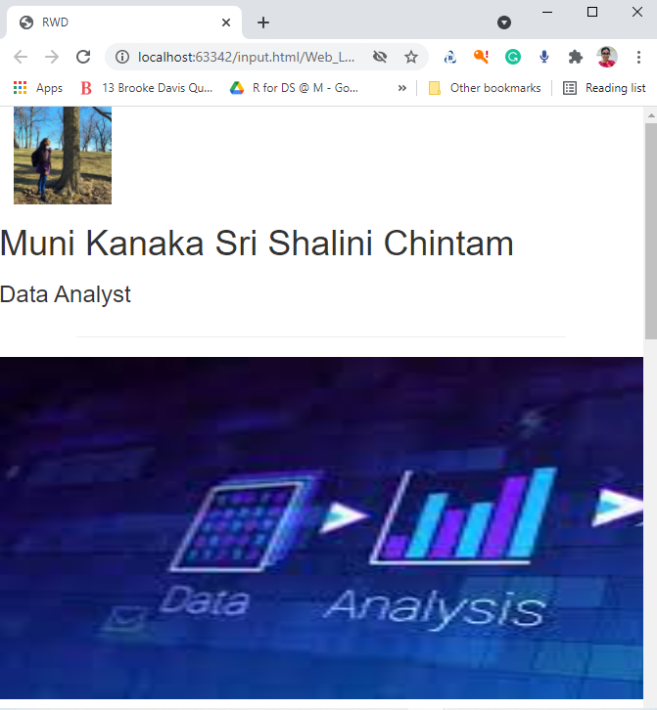

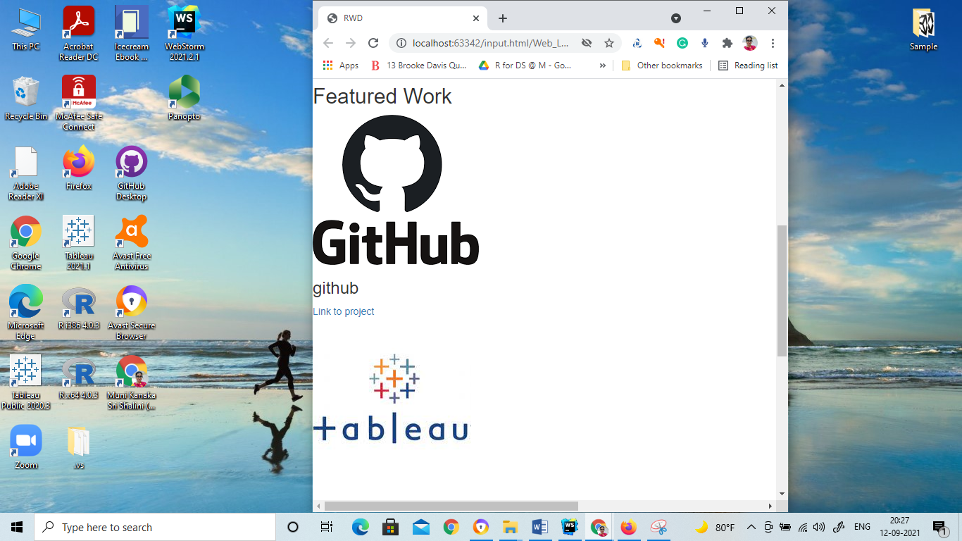

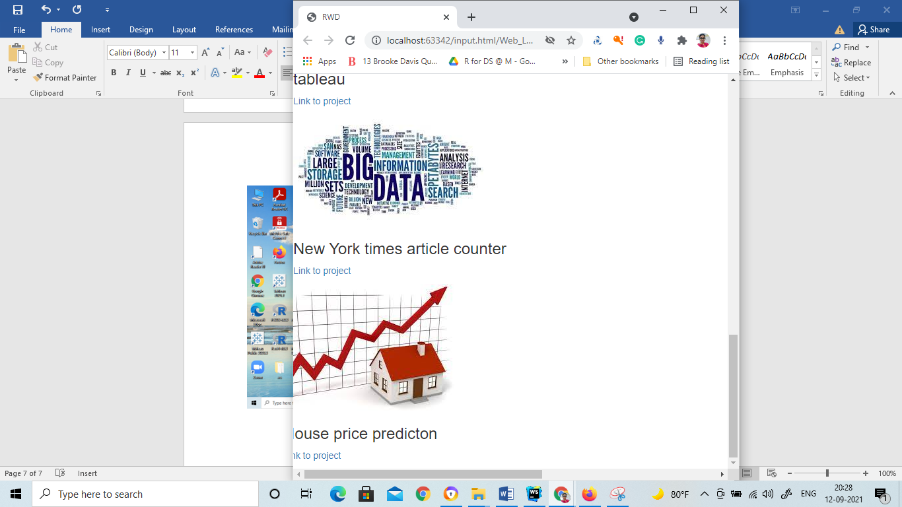

Now html file:

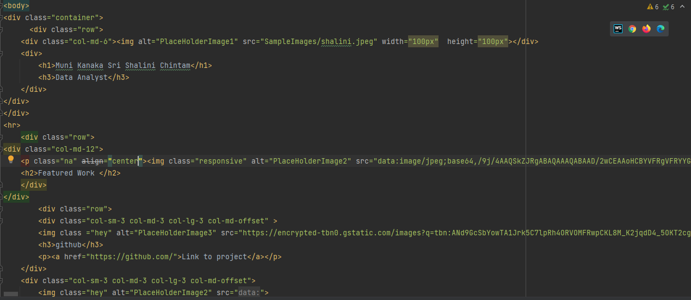

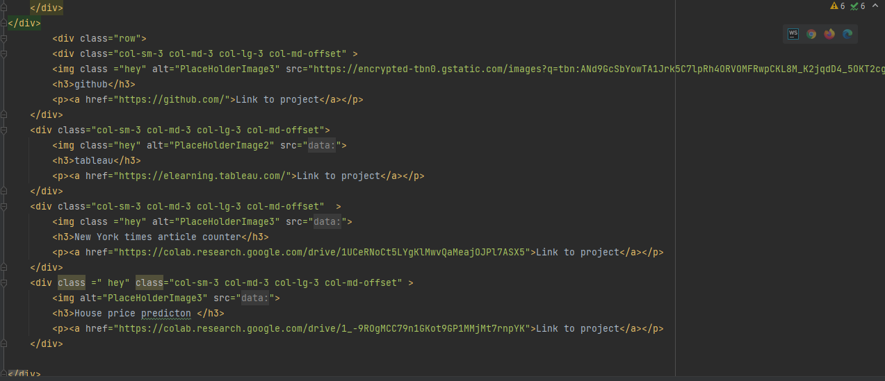

Bootstrap grids are used to make this responsive webpage where in the first row the img tag and the paragraph and heading tags and in total 3 rows are used and in these rows different columns are used to form the grids and they store different image tags and link tags and many more.