**ICP -4**

**Task 1:**

Hover Image: In this task html page is given as below 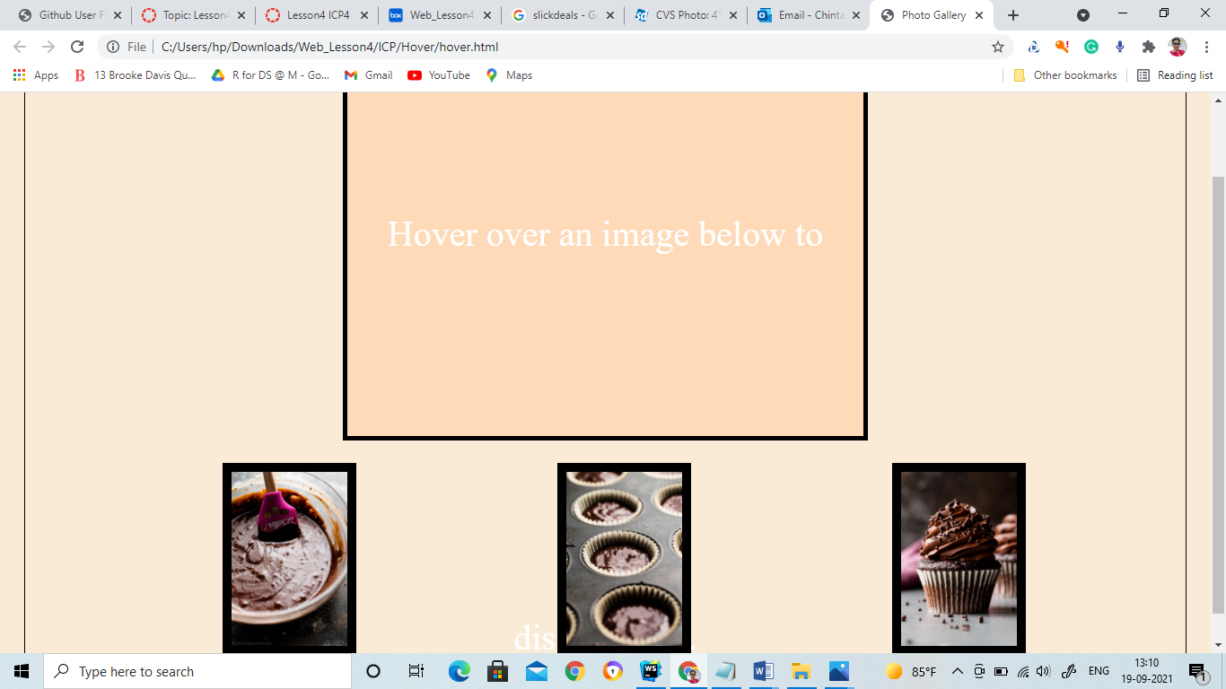

By the image you can see the top layout is empty and whenever you hover over the below images it should display this image along with that it should also display the text of that image.

**The output of the task:**

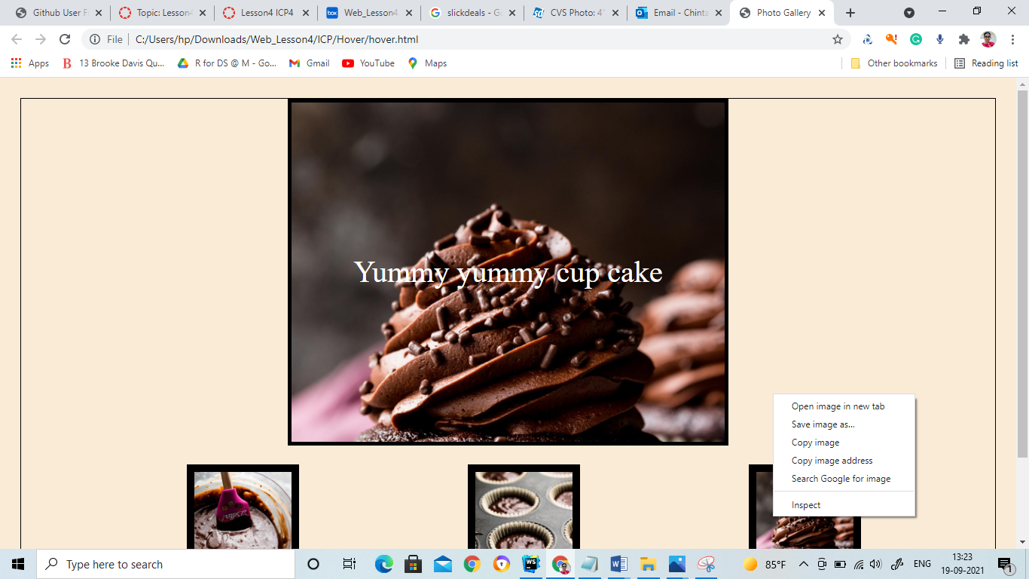

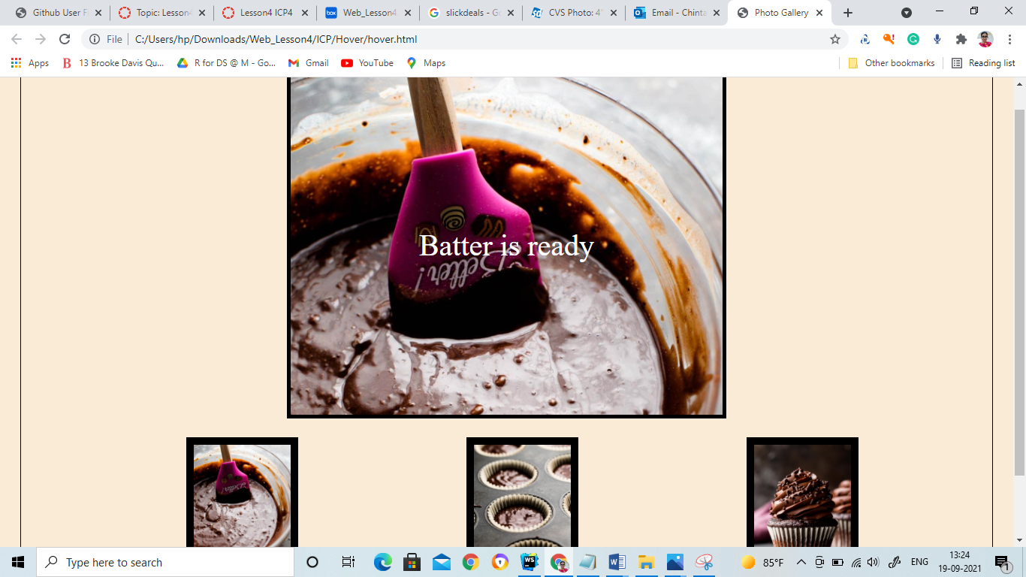

**The code for the task:**

**The html page**

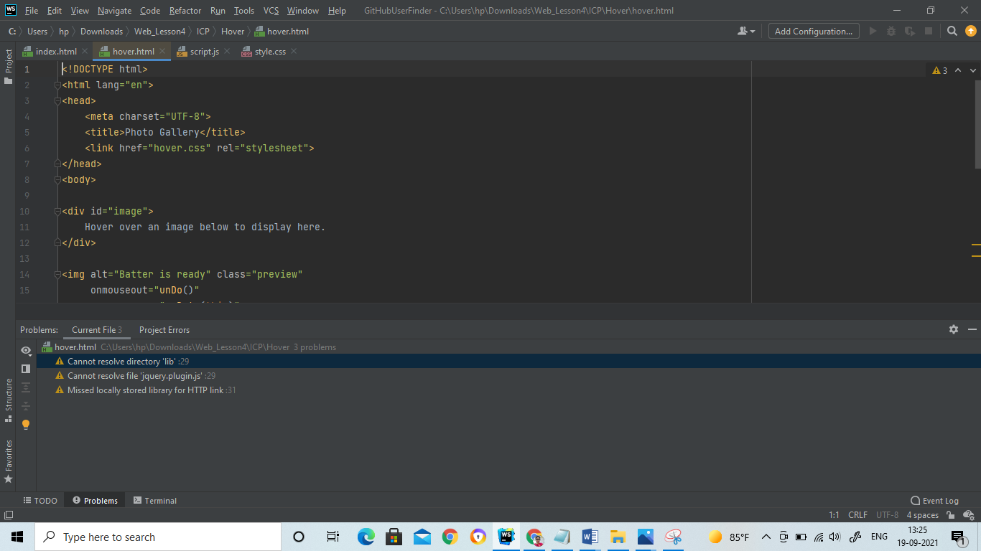

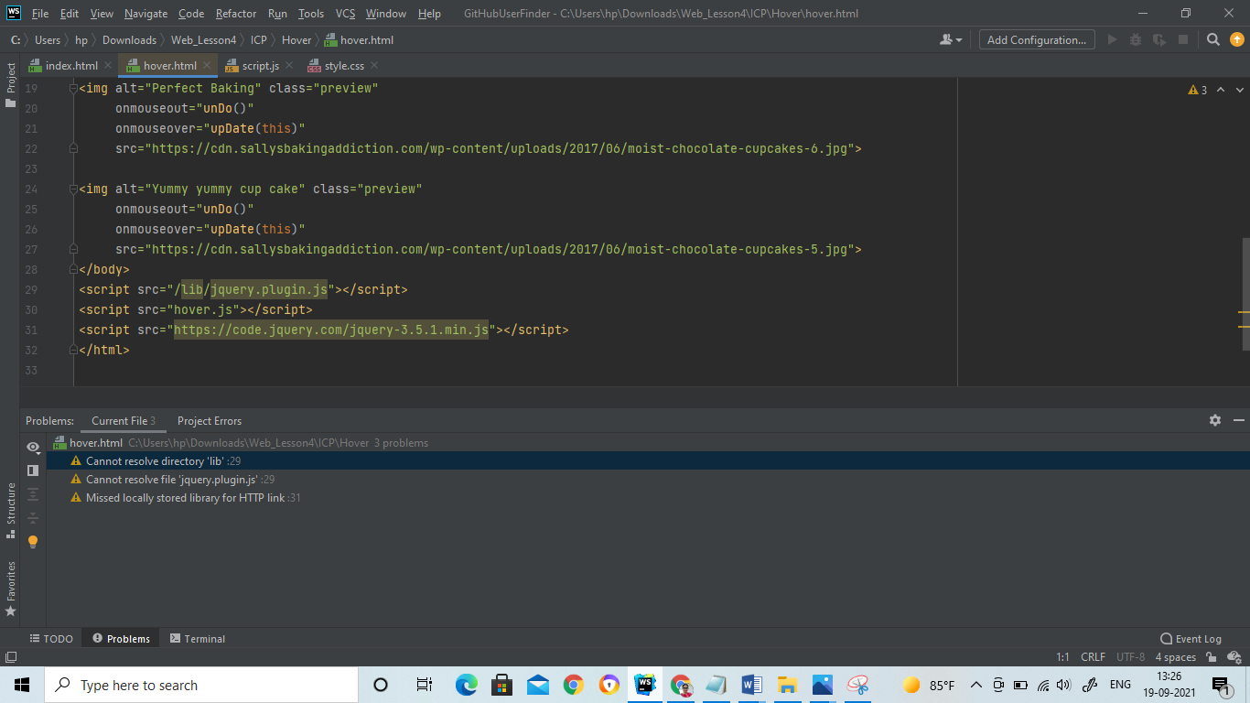

Css :

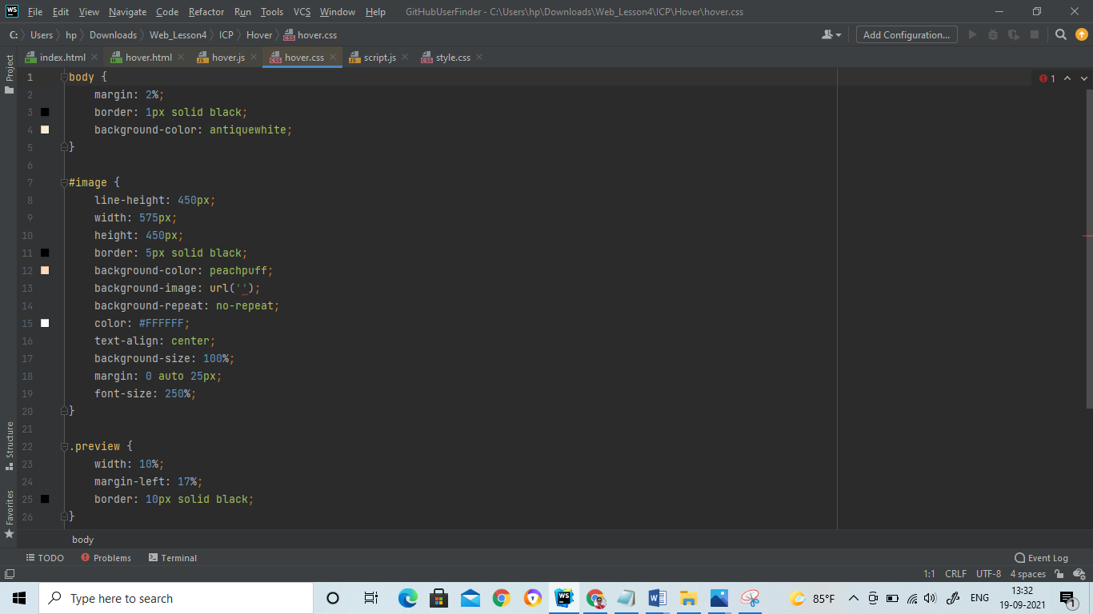

The JavaScript file :

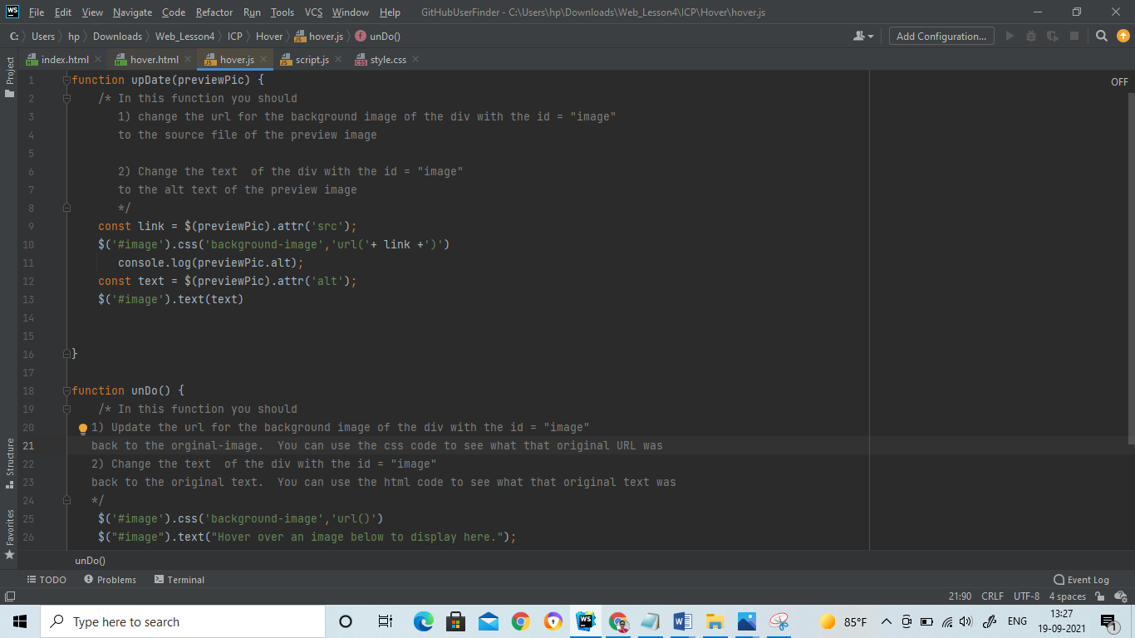

In the update(PreviewPic) function we are replacing the background image with the current image it is hover over first line we are creating a variable link and assigning the current hover image and along with that we are also changing the text with the alt value of the current hover image.

**TASK-2**

In this task we are finding the GitHub user finder application. In this when you search for the GitHub user you are able to find the user details.

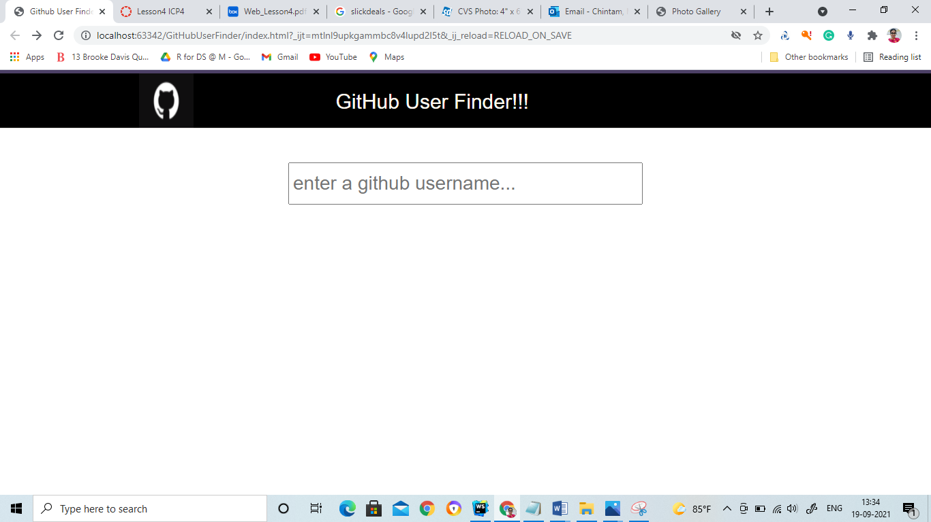

**The Output of the task:**

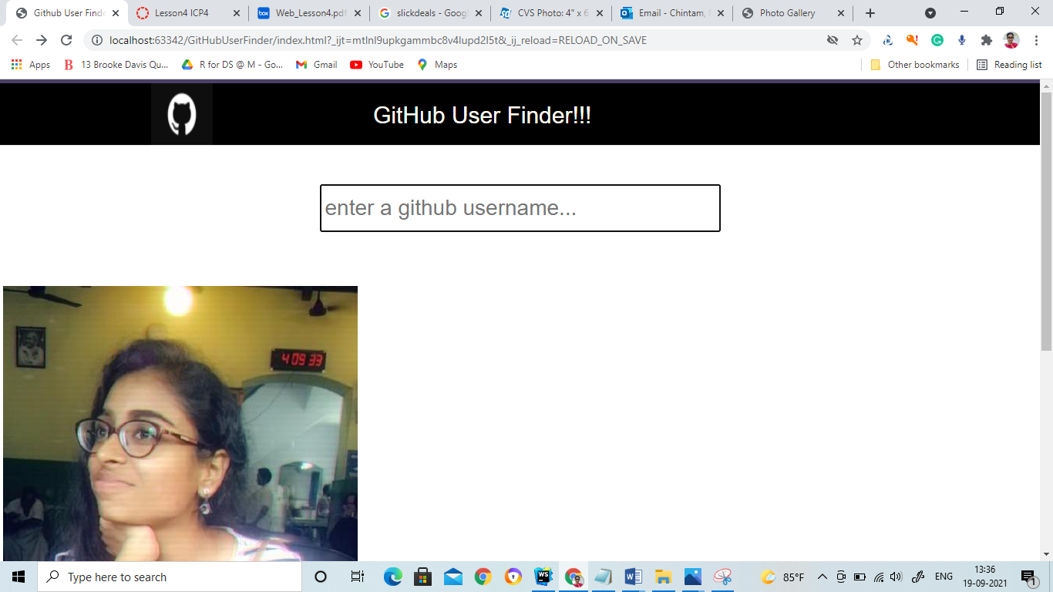

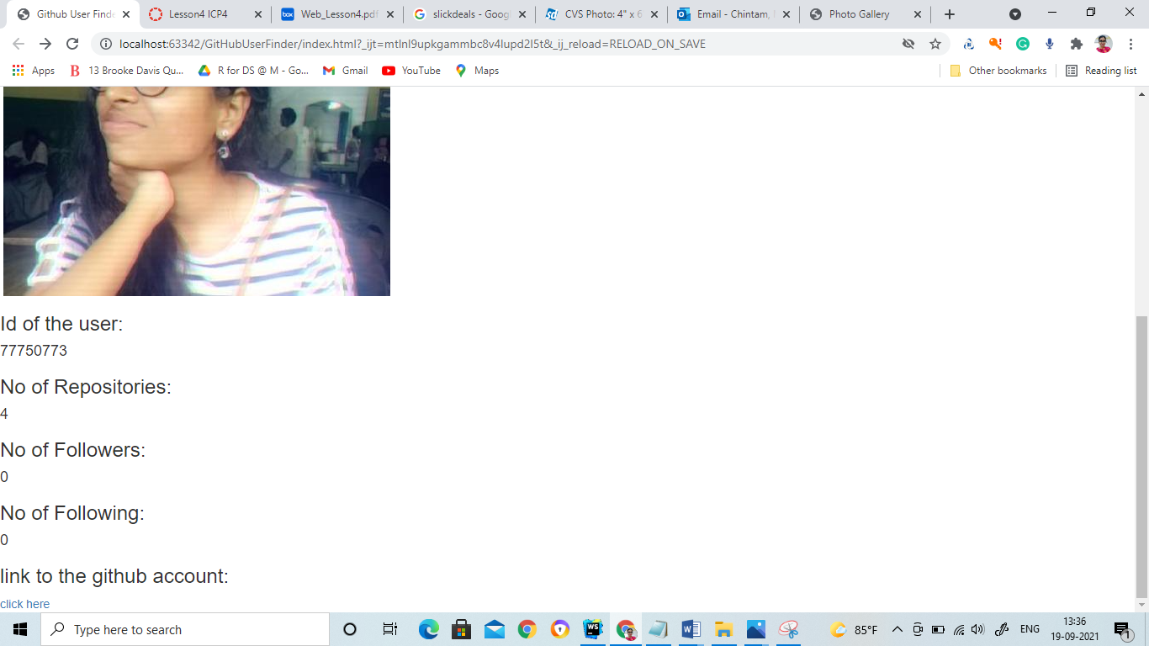

**The code explanation:**

**Html file:**

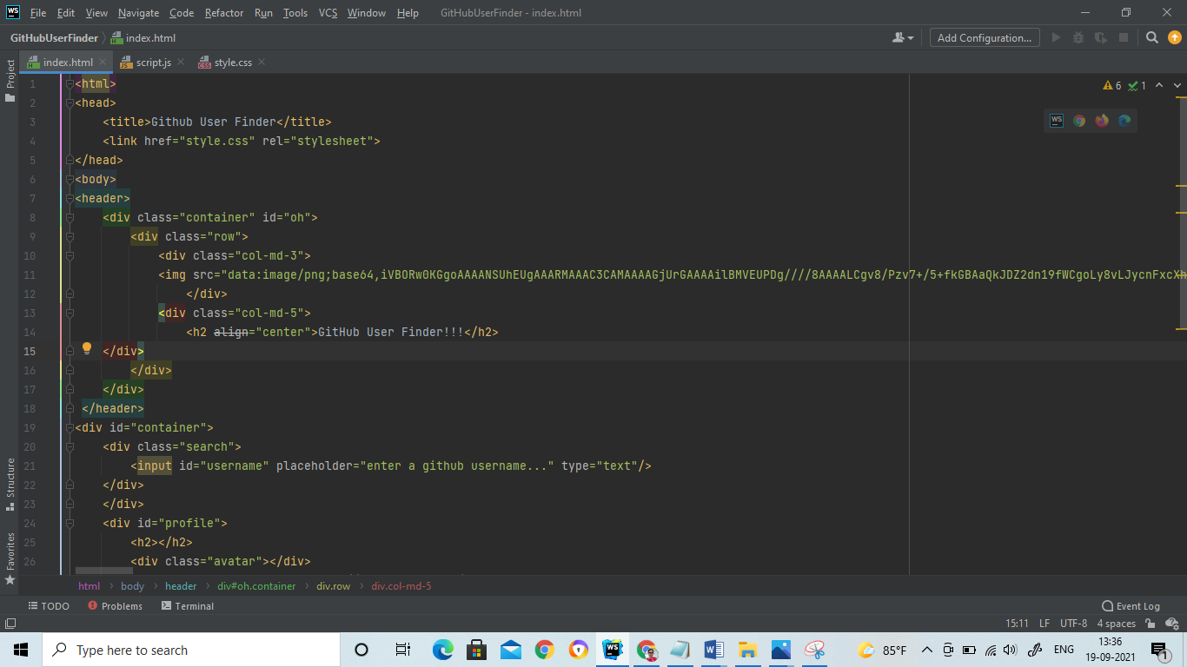

**In this header**

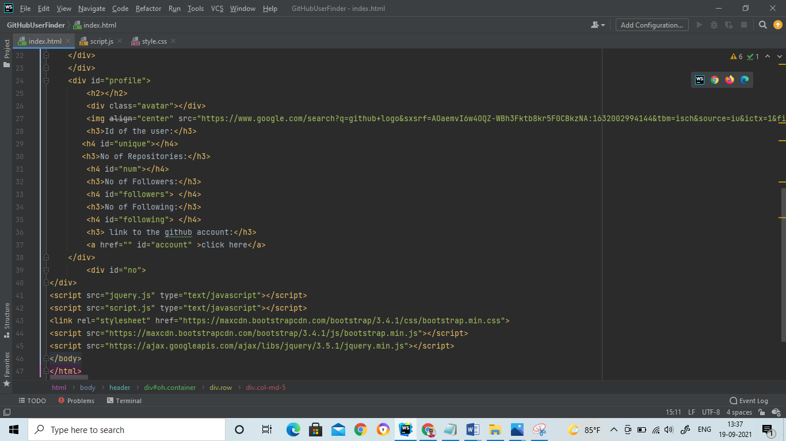

**CSS File:** different styling of various html elements are shown below.

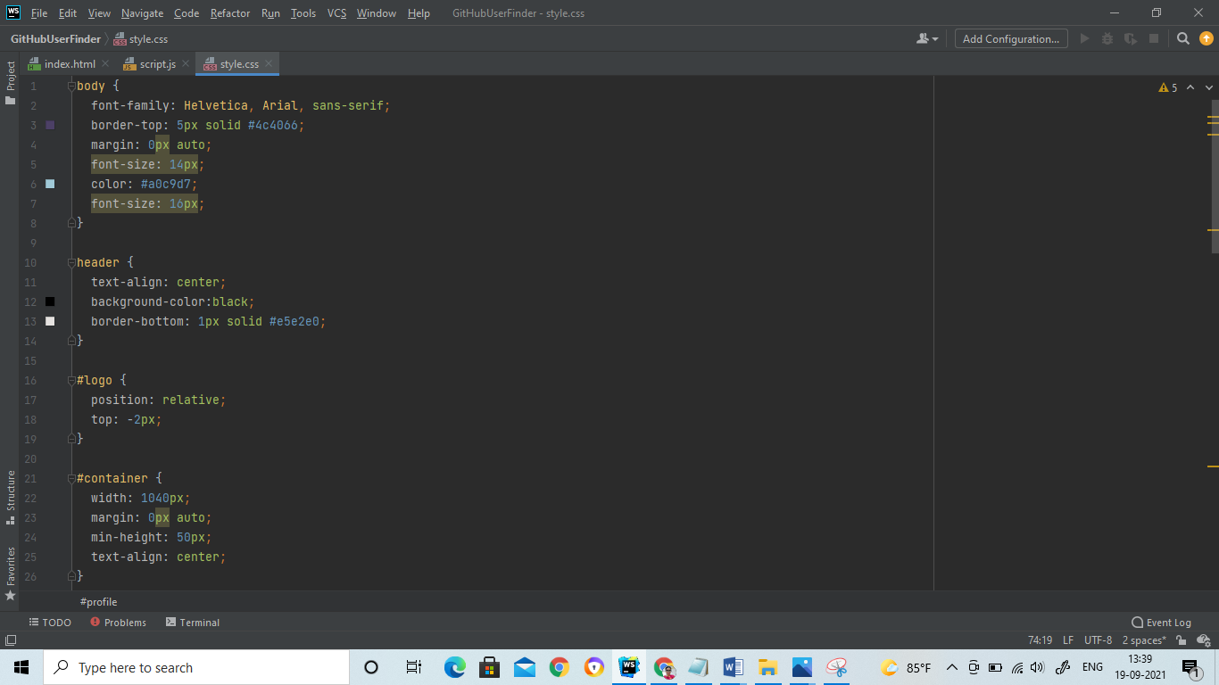

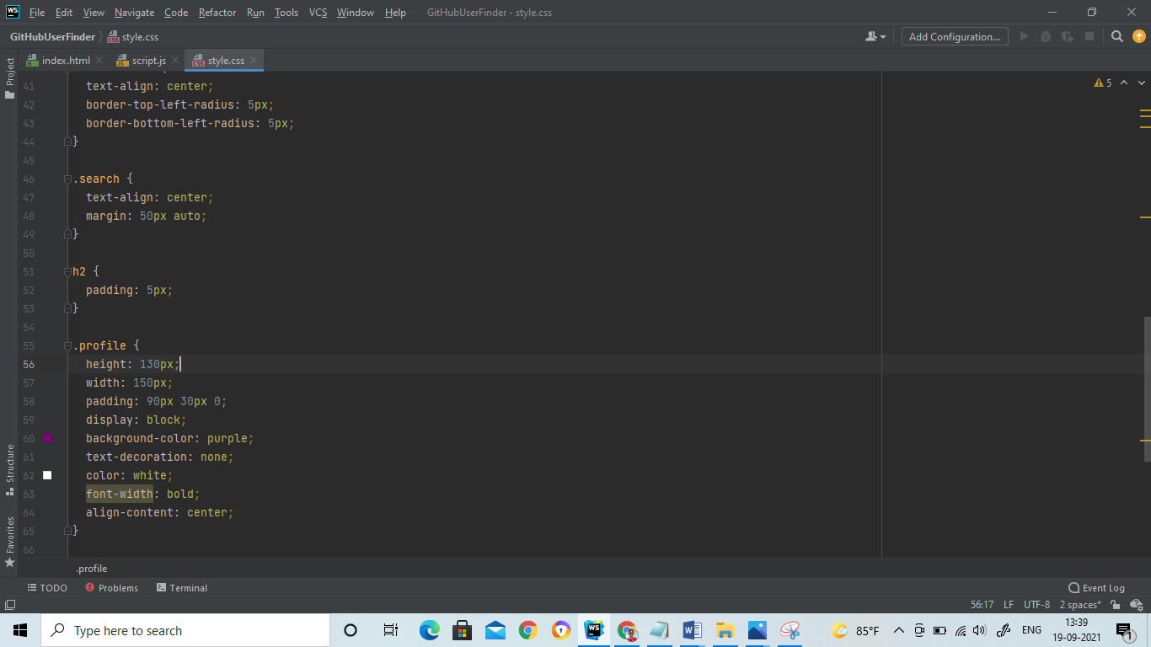

**The JavaScript File:**

The functionality of the whole task lies below and in the getGithubInfo() function first we are creating a XmlHttpRequest class and we are checking the status of the request if this.readystate==4 means that the request has been accepted and response is ready and if this.readystate==200 it basically means that the status of the request is ok it satisfies.

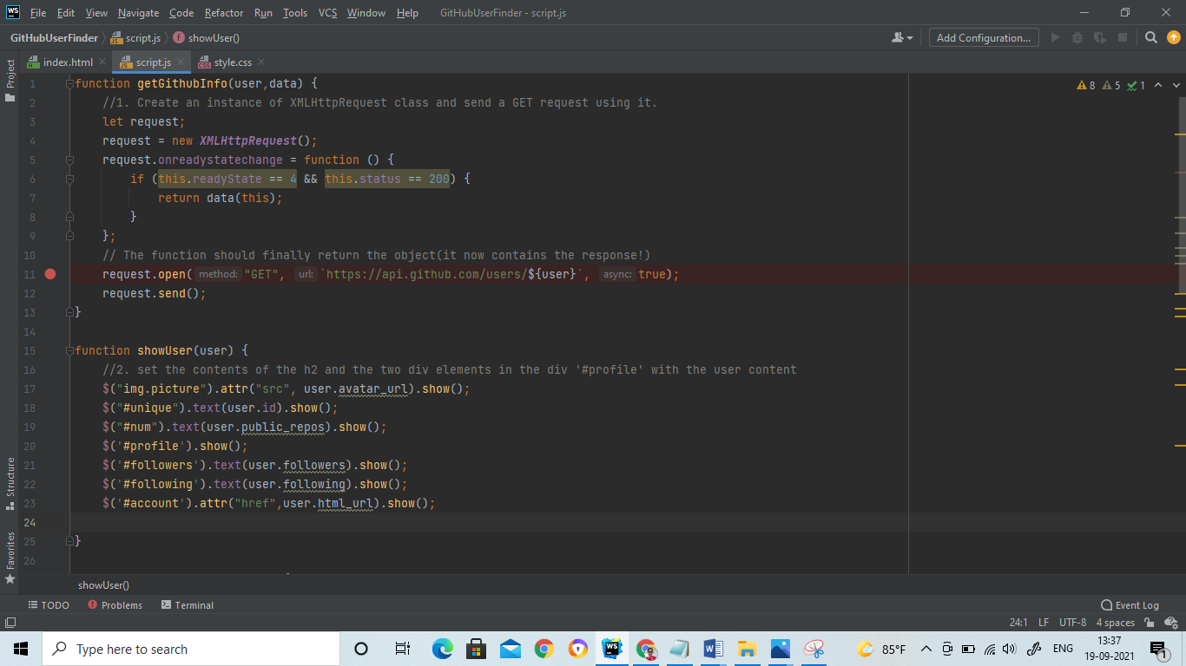

**Now for returning the object we are using the below two lines of**

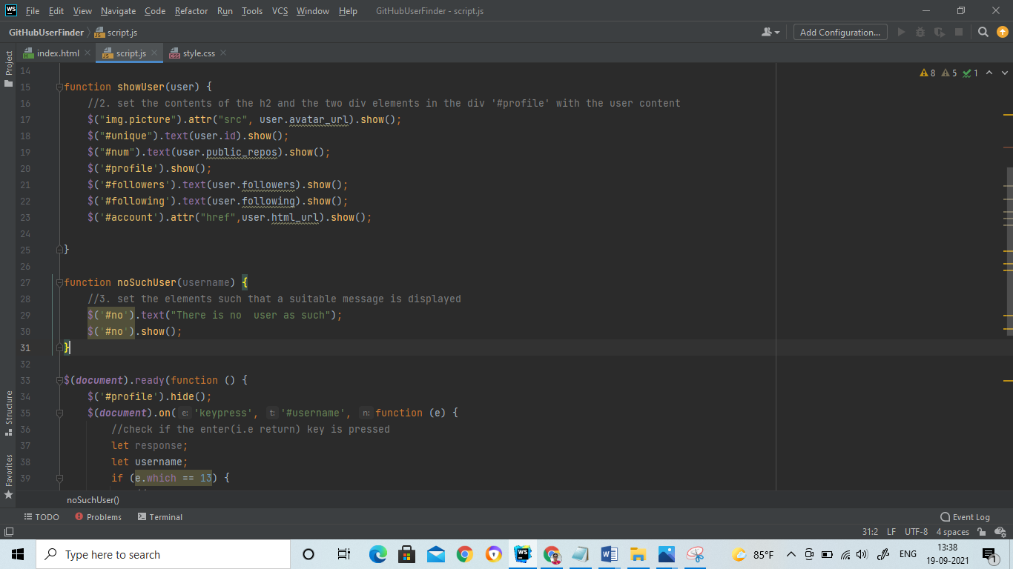

**In Show user () function**

First we are showing the div element that we have hided and in image tag of the picture class we are replacing the src value to the GitHub user’s avatar and we are replacing html elements contents with the user details.

If there are no users with that username.it would display the No users found

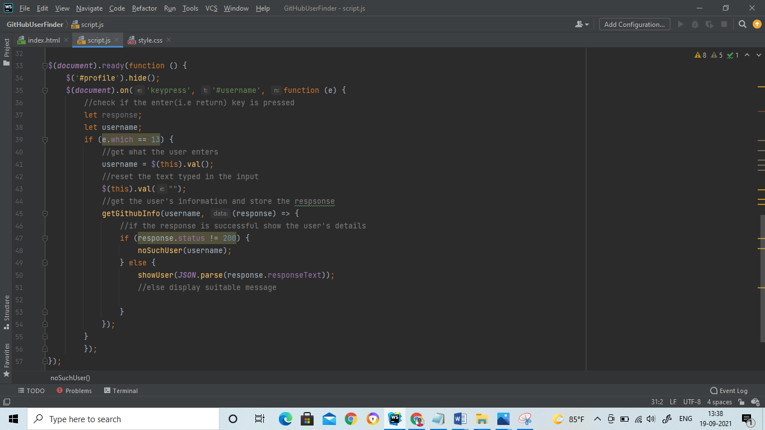

**We are hiding the profile class**