**Chapter-2**

**Exercise 2:**

#include<iostream>

#include<iomanip>

using namespace std;

int main()

{

int a[100],b[100],i,n;

cin>>n;

for(i=1; i<=n; i++)

{

cin>>a[i]>>b[i];

}

for(i=1; i<=4; i++)

{

cout<<setw(8)<<a[i]<<setw(12)<<b[i]<<endl;

}

return 0;

}

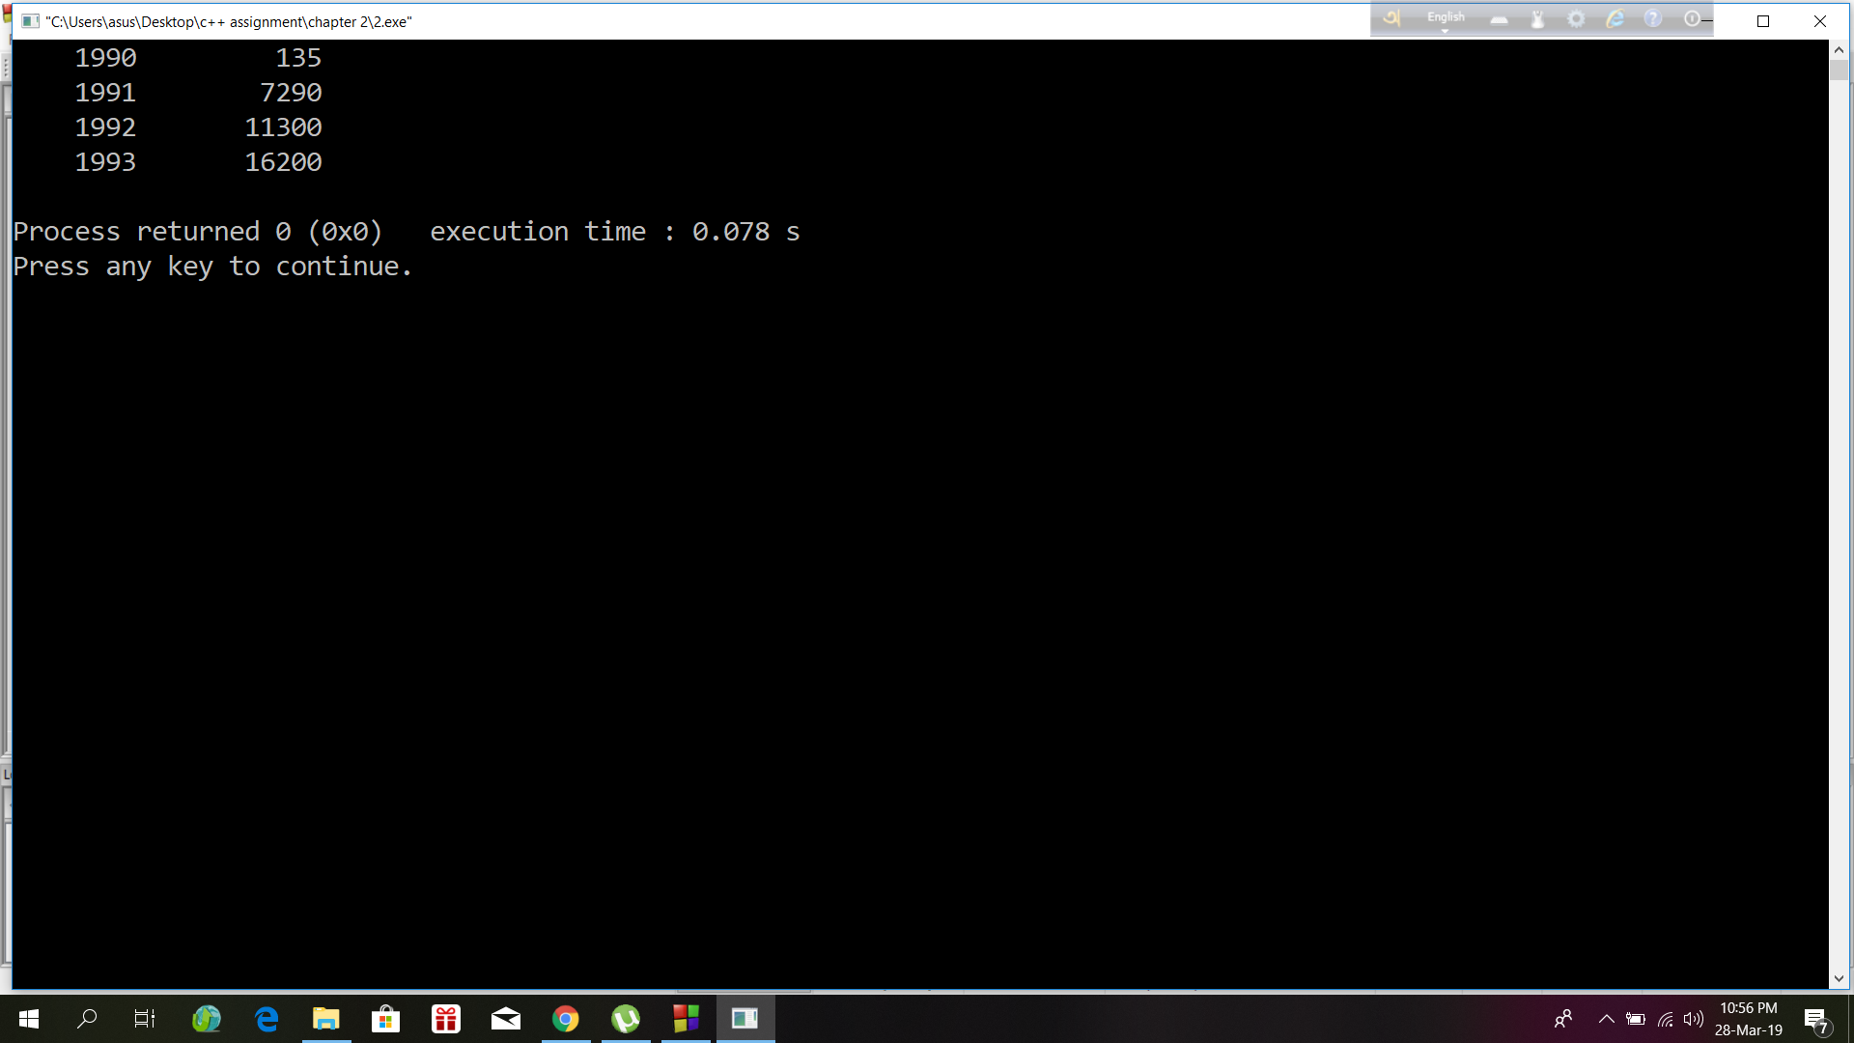**Exercise 3:**

#include<iostream>

using namespace std;

int main()

{

cout<<"Candy is dandy,\n";

cout<<"But liquor is quicker."<<endl;

return 0;

}

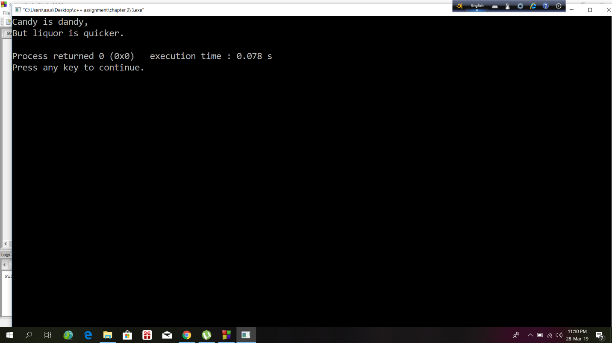

**Exercise 6:**

#include<iostream>

#include<iomanip>

using namespace std;

int main()

{ float br,fr,gr,jp,input;

cout<<"Enter an amount in dollars\n";

cin>>input;

br=(input/1.487);

fr=(input/0.172);

gr=(input/0.584);

jp=(input/0.00955);

cout<<setw(8)<<"British pound"<<setw(16)<<br<<endl;

cout<<setw(8)<<"French Franc "<<setw(16)<<fr<<endl;

cout<<setw(8)<<"German deutsh"<<setw(16)<<gr<<endl;

cout<<setw(8)<<"Japanese yen "<<setw(16)<<jp<<endl;

return 0;

}

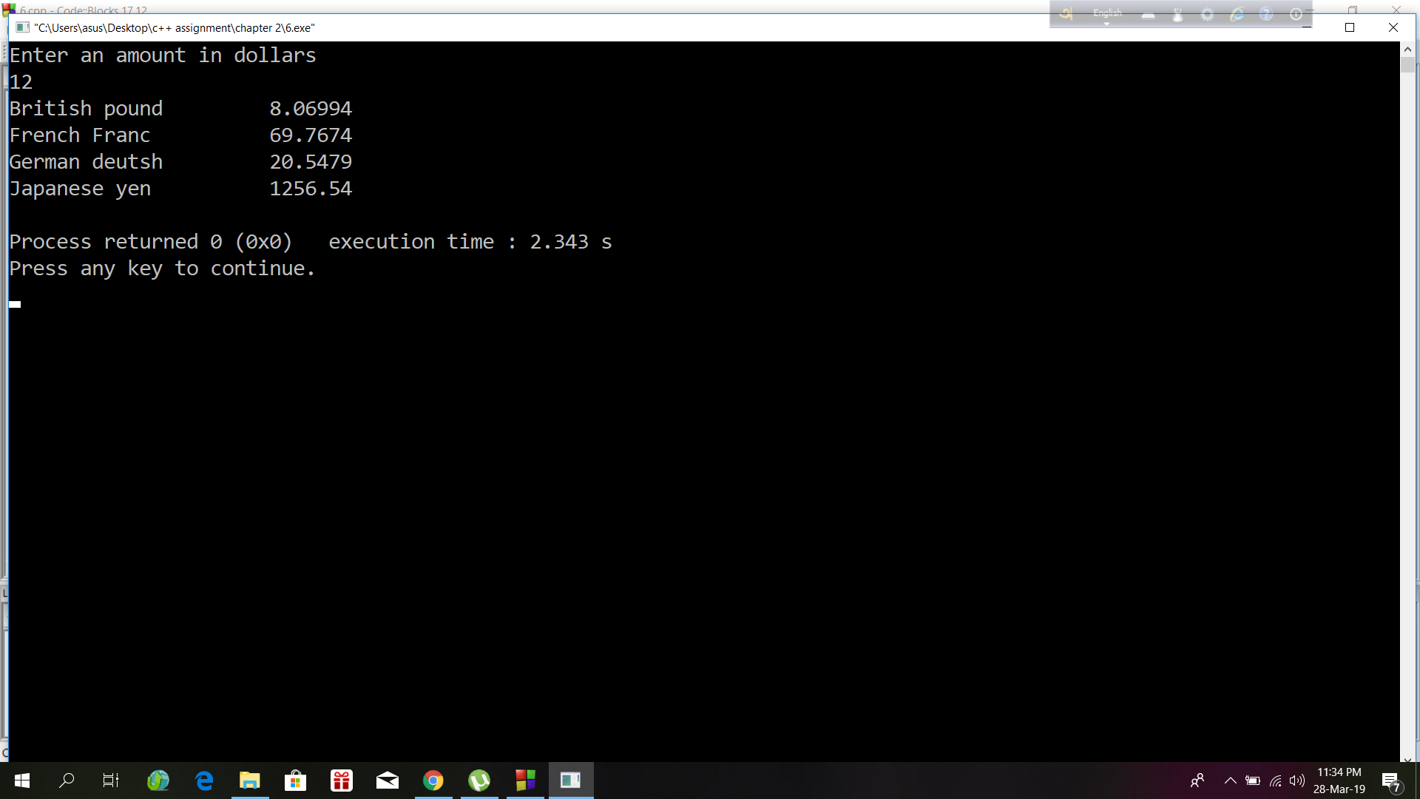

**Exercise 8:**

#include<iostream>

#include<iomanip>

using namespace std;

int main()

{

int p1 = 2425785, p2 = 12344, p3=909;

cout<<endl;

cout<<setfill('.')

<<setw(8)<<"Location "<<setw(12)<< "population"<<'\n'

<<setw(8)<<"Portcity "<<setw(12)<<p1<<'\n'

<<setw(8)<<"Hightown "<<setw(12)<<p2<<'\n'

<<setw(8)<<"Lowville "<<setw(12)<<p3<<'\n';

return 0;

}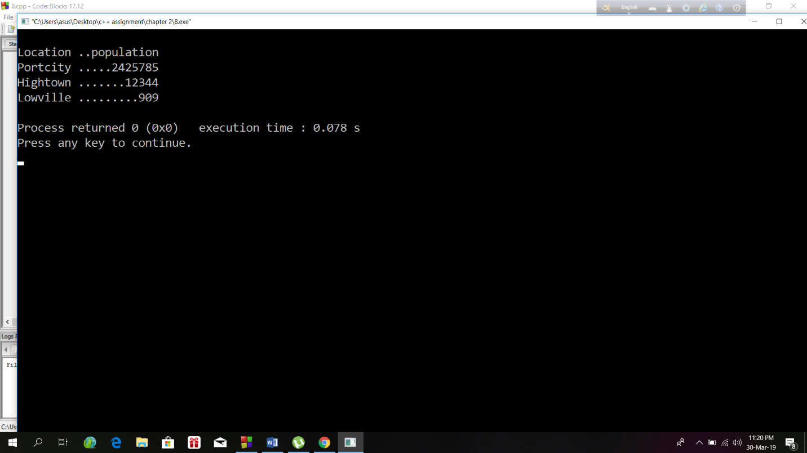

**Exercise 10:**

#include<iostream>

#include<iomanip>

using namespace std;

int main()

{

double pounds ,decimal_pounds,shillings,pence ;

cout<< " \nEnter Pounds:";

cin>> pounds;

cout<< " \nEnter Sillings:";

cin>>shillings;

cout<< " \nEnter Pence:";

cin>>pence;

decimal_pounds= pounds+ (shillings/20) + (pence/240);

cout<< " \nDecimal pounds: "<<setprecision(3)<<decimal_pounds<<endl;

return 0;

}

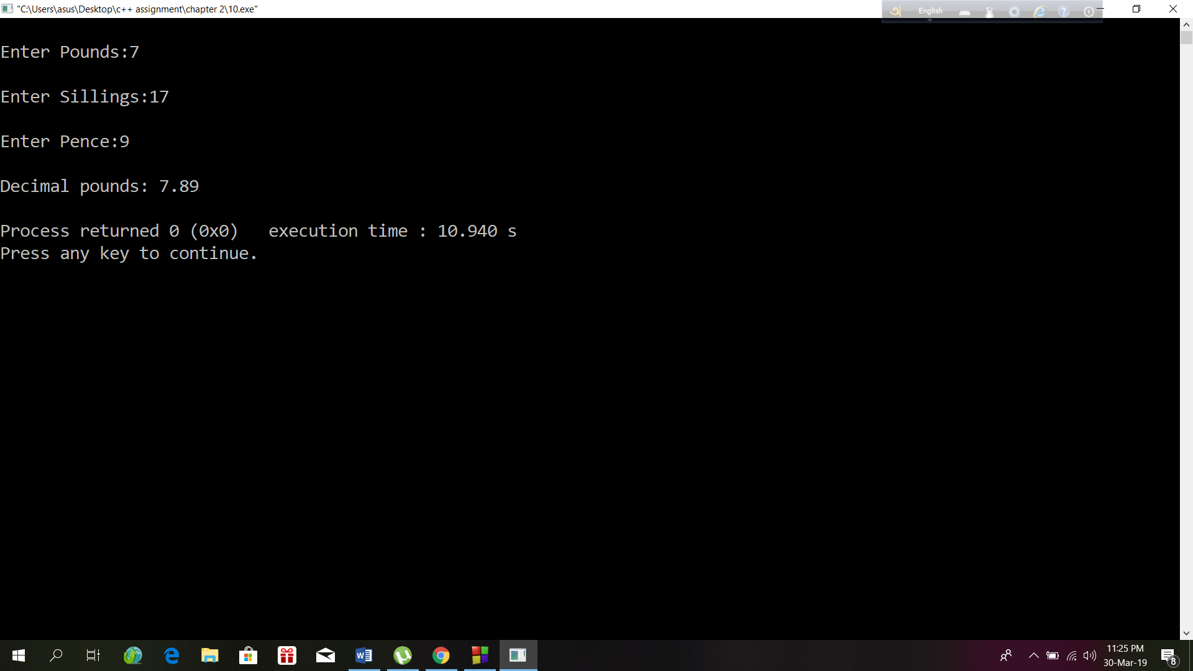

**Exercise 12:**

#include<iostream>

#include<iomanip>

using namespace std;

int main()

{

int pounds,shillings,pence;

double decPounds,decFraction,temp;

cout<< " Enter Decimal Pounds :";

cin>> decPounds;

cout<<endl;

pounds = static_cast<int>(decPounds);

decFraction = decPounds - pounds;

temp =decFraction*20;

shillings = decFraction*20;

pence = (temp-shillings)*12;

cout<< " Equivalent in old notation = "

<<pounds<< "."<<shillings<< "."<<pence<<endl ;

return 0;

}

