# 

KEA_STUD CHAT MESSENGER

Solution description and baseline cost

Document information

Document version

Approval List

Confidentiality Rating

General

Solution summary

Deliverables summary

Cost summary

Recommendation and next steps

Detailed solution description

Technical dictionary

Architecture overview

Server setup

Functional requirements

Non-functional requirements

Capacity recommendations

Impact on other system

Failover and scalability

Technical Implementation

Solution implementation components

Cost

Platform cost

License and support

Operational Cost

Risks

# Document information

## Document version

|  |  |  |
| --- | --- | --- |
| Version | Author e-mail | Description |
| 1.0 | Nikolaj B. Hemmeshøj, [nibh@kea.dk](mailto:nibh@kea.dk)  Head of Enterprise Architecture | Initial draft |
|  |  |  |

## Approval List

|  |  |  |
| --- | --- | --- |
| Who | Function | E-mail |
| Nikolaj B. Hemmeshøj | Head of Enterprise Architecture | [nibh@kea.dk](mailto:nibh@kea.dk) |
| Jarl Tuxen | Chief Information Security Officer | [jart@kea.dk](mailto:jart@kea.dk) |

## Confidentiality Rating

|  |  |
| --- | --- |
| Rating |  |
| Company Confidential | X |
| Non Confidential |  |

# General

KEA_STUD Chat messenger will provide the possibility of using a chat within an institute. It will provide the user with the facility to communicate in-group or private, to exchange small/medium files during conversation and save the chat history. In order to run, the chat system will be using a Local Area Network (LAN) connection.

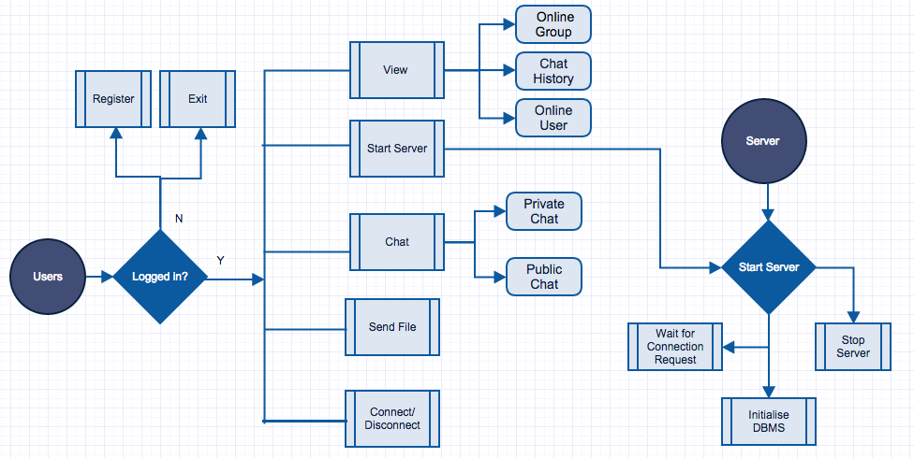

Fig-1

## Solution summary

KEA_STUD LAN chat messenger will provide ease to users in terms of connection, as it will enable users inside the organisation’s firewall in order to connect and communicate to each other using existing resources without having to be connected to the Internet. The communication will be platform independent. Moreover, it will reduce the cost of communication (by minimising mobile/text usage) and the maintenance costs. No centralised server or active internet connection is required for communication.

## Deliverables summary

KEA_CHAT LAN messenger will deliver following results that can be measured afterwards:

* User Login & Signup options.
* Internet less connection between users.
* Facility to send group and private messages.
* Ability to exchange files during conversation.
* Option to save message history for future referral.
* Ease of communication between KEA students and staff.
* Setup manual

1. How to install server
2. How to setup Database
3. How to get the system going and maintaining

## Cost summary

High level cost elements that the project will carry once implemented or will be running:

* Software development hours - in case of further extension of the software.
* Maintenance cost - in case of system breakdown.

The initial development of KEA_STUD LAN chat messenger didn’t incur any cost because we utilised already available resources and open source software. High-level cost elements that the project will not carry as it can use existing architecture.

* The Server can run on any existing machines, so it saves the hosting costs.
* Open source software was used for development, so no licence costs.
* Operation cost, as it can be set up using existing resources from KEA and does not require any additional equipment.

# Recommendation and next steps

KEA_STUD LAN chat messenger can be implemented by using one dedicated machine, which will run the Server. Further improvements can be done concerning the implementation of the centralized Database Management System, which could not be done due to shortage of time. The system will help with communication between people during university hours as all the users within the campus can interact with each other without using Internet/Phone calls. The online students can help each other instantly, and administration or teachers can respond to student queries quicker.

Although the private chat option is already available, privacy could be improved, by having an administrator be assigned for authorizing and assigning access privileges to particular users in specific chat groups. Furthermore, the other features like voice/video call could be implemented for enhanced user experience.

As the load increases, more servers and a load balancer could be added to handle the load without compromising user experience.

# Detailed solution description

Normally when a student or a staff member at KEA needs to talk to each other within the campus, they call the person in question. This however acquires costs, or by leaving an email then the student/staff member will need to wait for a reply and sometimes it can take up to a day or two to get a reply, which wastes a lot of time and can possibly delay important matters or decisions. In order to prevent this, our KEA_STUD LAN chat messenger will provide a solution to various communication problems within the institute and save resources, like time.

The strength of the system lies in enabling users to communicate without having internet access. The system allows the users to save their chat histories and allows them to exchange files when required, hence no need to hassle about composing a separate e-mail with an attachment to transfer the file. KEA_STUD LAN chat messenger supports centralized server mode. The user information and the history will be saved in a MySQL database, which makes the system more optimized and secure as compared to a traditional file system.

## Technical dictionary

**Socket:** A socket is an object that represents the low level access to the IP stack. A socket is a simulated medium that allows sending and receiving of data in an application.

## Architecture overview

KEA_STUD LAN chat messenger is based on the Model View Controller (MVC) architecture in order to make further extension of the application easy and making code reusable. The processing and logic part has been kept separate from the graphical user interface and controllers. The application handling for database queries is implemented separated while the user interface presentation or the logic processing is implemented separately. The whole application is furtherly divided into sub applications i.e. client side app and server app. The client application runs on the user’s computer and the server can run on any computer on a network. To send/receive a message the user should be connected to the server. The user can broadcast a message to all the users online (Public Chat) or can send it to any particular user (Private Chat).

The application is developed using Object Oriented Programming in Java Language. To establish the communication link between the systems on the network we need socket connections. A socket enables the application/users to connect to the network and communicate with other applications/users connected to the same network. On a particular machine the socket is composed of an IP address and a port number.

As mentioned above there will be two applications, one for the client and one for the server, so two sockets are made. The client application will execute the client socket, while the server application will run the server socket. To connect to the server socket, the client requires its IP and the port number. The client and server need to share the same port number in order to achieve the connection. Moreover they need to agree upon the protocol used that could be TCP, UDP or RAW. In our case it will use TCP/IP protocol for connection.

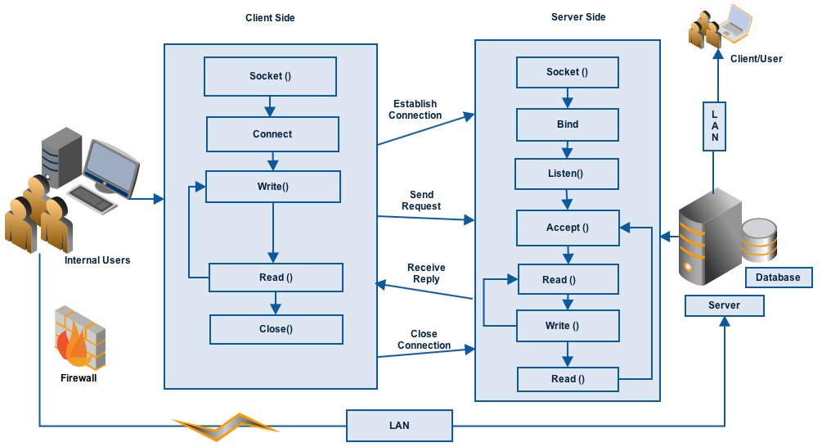

Fig-2

## Server setup

Many computers on the network have the capabilities to run the server side of the application while they are executing or running the other services. But it can always be executed on a dedicated workstation to handle the load in a better way. The client knows the IP address and the port of the system on which the server is running. In IP networking context, the server is a program that listens for the socket requests. The client sends the connection request, which the server accepts. Hence, a communication link between client and server is established.

If the number of users increase then additional servers can be added in the architecture, the load balancing can be implemented, which can distribute the connection requests among the servers to handle the requests efficiently.

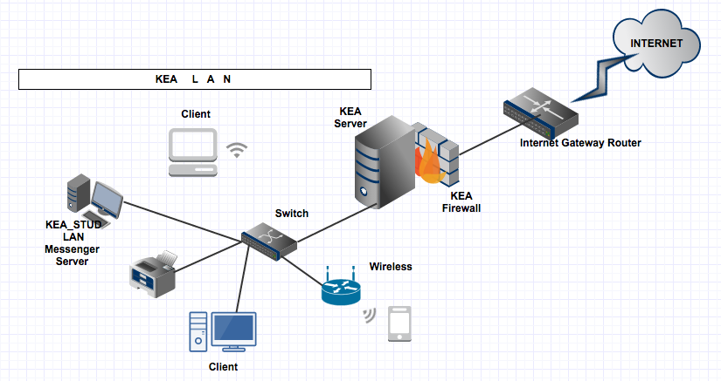

## Functional requirements

The KEA_STUD LAN chat messenger will exhibit following functional requirements:

* Register User.
* Login to the System.
* Display list of online contacts.
* Communicate without Internet access.
* View the Online users and groups.
* View chat history.
* User can chat in a group.
* Save chat history.
* Send/Receive small-medium sized files.
* Notification on receiving new message.
* The system must display the notification on receiving reply/new message.

## Non-functional requirements

Here is the list of non-functional requirements that our system should meet:

|  |  |
| --- | --- |
| **Security** | * It is a secure LAN messenger. * The data is stored on MySQL database, which makes it, secure than traditional file system. * Doesn’t support Encryption. |
| **Reliability** | * It cannot accommodate the failure in case the server fails. But the server can be restarted to make it work. * The system should be up and working 95% of the time. |
| **Usability** | * It has user-friendly graphical interface. * It supports English language. |
| **Supportability** | * The complete operation document and installation manual will be provided for the customer support. |
| **Performance** | * The system performs well and the normal response time is less than a second. Even in peak hours, the system should not take more 4-5s to respond. |

## Capacity recommendations

How does the system scale and how do we measure it under SPT.

# Impact on other system

How does the new system impact other system or infrastructure as the company.

# Failover and scalability

How does the system scale and how does it handle failover.

# Technical implementation plan

How should the system be implemented with timeline.

## Solution implementation components (work breakdown structure)

What steps do you need to do to implement the product or project

eg.

### Preparation

1. Analysis of requirements
2. ...
3. Create installation manuals
4. Performance testing

### Development of software

1. Web service development
2. ...
3. Frontend development

### Hardware setup

1. Install Hypervisor
2. Create VM’s for project
3. Install webservers and databases
4. SPT test of basic setup
5. ...

# Cost

What does the system cost to implement.

## Platform cost

## License and support

## Operational Cost

# Risks

What risks are there in the project.

|  |  |  |  |  |  |
| --- | --- | --- | --- | --- | --- |
| Item # | Area | Description | Rank (RF=i*p) | Mitigation | Solution |
| #1 | HW | Low capacity | 15=3*1 | evaluate upgrade options | port application to other host |
|  |  |  |  |  |  |