**PROJECT INITIATION DOCUMENT (PID)**

|  |  |
| --- | --- |
| **Project: KEA_STUD CHAT Messenger** |  |
| Release: 1 |  |
| Date: 9 April 2015 |  |
|  |  |
| **PRINCE2** |  |
|  |  |
| Author: Carina Lamb, Lina Alhajar, Muniba Talha |  |
| Owner: Carina Lamb, Lina Alhajar, Muniba Talha |  |
| Client: Copenhagen School of Design & Technology |  |
| Document Ref: 2tool_PID |  |
| Version No: 1.0 |  |

# 1 Project Initiation Document History

## 1.1 Document Location

This document is only valid on the day it was printed.

The source of the document will be found at this location (need to be logged in)

<http://fronter.com/kea/links/structureprops.phtml?treeid=190539>

## 1.2 Revision History

**Date of this revision:**

**Date of next revision:**

|  |  |  |  |
| --- | --- | --- | --- |
| **Revision date** | **Previous revision date** | **Summary of Changes** | **Changes marked** |
|  |  | First issue |  |

## 1.3 Approvals

This document requires the following approvals.

Signed approval forms should be filed appropriately in the project filing system.

|  |  |  |  |  |
| --- | --- | --- | --- | --- |
| **Name** | **Signature** | **Title** | **Date of Issue** | **Version** |
| Jarl Tuxen |  | Head of Steering Committee | 9 April 2015 | 1.0 |
| Marianne Nielsen |  | Member of Steering Committee | 9 April 2015 | 1.0 |

## 1.4 Distribution

This document has been distributed to:

|  |  |  |  |
| --- | --- | --- | --- |
| **Name** | **Title** | **Date of Issue** | **Version** |
| Carina  Lina  Muniba | Developers, Project Managers | 9 April 2015 | 1.0 |

# 2 Table of Contents

**Page**

### 1 Project Initiation Document History 1

1.1 Document Location 1

1.2 Revision History

1.3 Approvals

1.4 Distribution

### 2 Table of Contents

### 3 Project Definition

### 4 Project Approach

### 5 Business Case

### 6 Project Management Team Structure

### 7 Role Descriptions

### 8 Quality Management Strategy

### 9 Configuration Management Strategy

### 10 Risk Management Strategy

### 11 Communication Management Strategy

### 12 Project Plan

### 13 Project Controls

### ~~14 Tailoring of PRINCE2~~

## 3 Project Definition

**3.1. Background:**

Normally when a student or a staff member at KEA needs to talk to each other within the campus, they call the person in question. This however acquires costs, or by leaving an email then the student/staff member will need to wait for a reply and sometimes it can take up to a day or two to get a reply, which wastes a lot of time and can possibly delay important matters or decisions. In order to prevent this, our KEA_STUD LAN chat messenger will provide a solution to various communication problems within the institute and save resources, like time.

**3.2. Project Objectives:**

Project objectives (covering time, cost, quality, scope, risk and benefit performance goals)

* User friendly GUI for Login/Signup.
* Internet less connection between users.
* Facility to send group and private messages.
* Ability to exchange files during conversation.
* Option to save message history for future referral.
* Ease of communication between KEA students and staff.

**3.3. Desired Outcomes:**

Using this system the students, teachers and staff at KEA can communicate to each other free of cost, moreover the service will enable to save the resources like time.

We expect the length of the response time to decrease by 50% assuming that on average communication response time is 2 days then by using KEA_STUD LAN CHAT Messenger most of the communications should be responded within the same working day.

Similarly the system will prove to be cost effective as well and a Pre-pay mobile user can save up to 10% of his money consumed on communication within KEA depending on his monthly usage. After implementation we expect the further 5% decrease in the cost utilized for billing.

With the use of the system we expect to eliminate students’ complaints about administration/teacher responsiveness upto 50%.

**3.4. Project Scope and Exclusions:**

Right now the service will be implemented just for Laptop and Desktop users while mobile devices are excluded from the scope of the project but in future it can be implemented for the mobile users. Similarly the service will enable users to communicate via text messages but in future Voice/Video Option can also be provided.

**3.5. Constraints and Assumptions:**

There is a time constraint involved in the project, as we have to meet the deadline of **21 April 2015**. There is no sponsor/venture available to provide capital for the project so the budget of project is Zero. The users will be using only present resources and communication will be restricted to LAN users only.

**3.6. The Users:**

The users of the systems will be students, teachers, administration and other staff present at KEA.

**3.7. Interfaces:**

Our project will be stand-alone and there aren’t any chances of it overlapping with any existing projects.

## 4 Project Approach

Students are generally not happy with the response time involved in the student teacher communication. Similarly if students have to access any other member of staff or administration to resolve an issue or query they have to call several times or write multiple e-mails to get the final response. So to resolve the issue the KEA_STUD LAN CHAT Messenger provides a solution, which saves both the money and time.

When all the teachers and students will be connected to the same system students can leave an instantaneous message to the required person and get the response at the same time.

The users will also be provided with the private chat option so to discuss the private issues with the desired person.

## 5 Business Case

[Describing the justification for the project based on estimated costs, risks and benefits]

## 6 Project Management Team Structure

## 7. Role Descriptions

**Steering Committee:**

Jarl Tuxen

Marianne Nielsen

**Project Manager:**

Carina Lamb is the project manager for this phase of project. And then the role will be rotated during upcoming scrum iterations.

**Architecture Team:**

Carina Lamb

Lina Alhajar

Muniba Talha

**Development** **Team:**

Carina Lamb

Lina Alhajar

Muniba Talha

**Database Management Team:**

Carina Lamb

Lina Alhajar

Muniba Talha

## 8 Quality Management Strategy

|  |  |  |  |
| --- | --- | --- | --- |
| Quality Techniques | Description | Activities | Responsibilities |
| Testing | Whether the system is successfully performing or not | Units testing | Developers |
| Formal review | Request for review | Planning  Preparation  Review meeting  Rework  Kick of  Follow-up | Quality manager |
| Standards | Software engineering standards | A set of processes, which are in turn defined in terms of activities. | Developers |

## 9. Configuration Management Strategy

We will be using version control, specifically GitHub Repository, to save all documentation (reports, meetings logs and emails) along with source code for the system.

Any changes in the requirements of the system will be agreed upon at meetings with the Steering Committee and queries regarding the system can be asked during these meetings. These changes or questions will be recorded to the logs, and stored on the Git Repository for future reference.

Emails will be backed up and stored on the repository to ensure that understanding between team and stakeholders is uniform.

Reports will be updated regularly on the repository to show progress in the project.

## 10. Risk Management Strategy

After various brainstorming meetings, multiple team based assessments and keeping in view the history we have identified the listed the risks in separate log along with their Risk Factor scaling (1-5) where 5 is the Highest Risk Factor. The Risk Log can be found here after being logged in:

<http://fronter.com/kea/links/structureprops.phtml?treeid=190539>

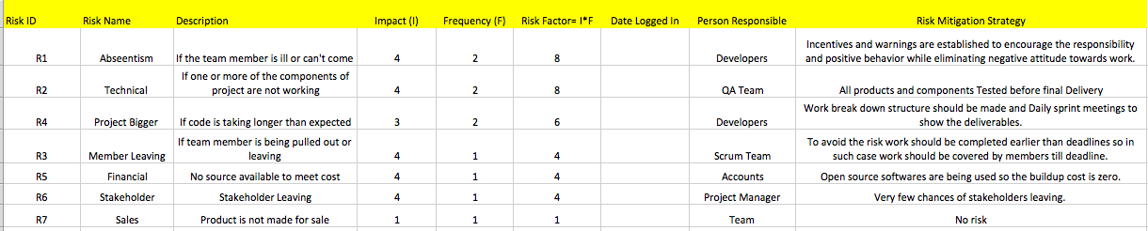

## 11. Communication Management Strategy

Communication Management strategy has been separately documented in Communication Management Strategy document and will be delivered with PID and can be found on following link after logging in.

<http://fronter.com/kea/links/structureprops.phtml?treeid=190539>

## 12 Project Plan

Here is a gantt chart and network diagram figure to show our progress and details about how and when the project will be delivered:

**Gantt Chart**

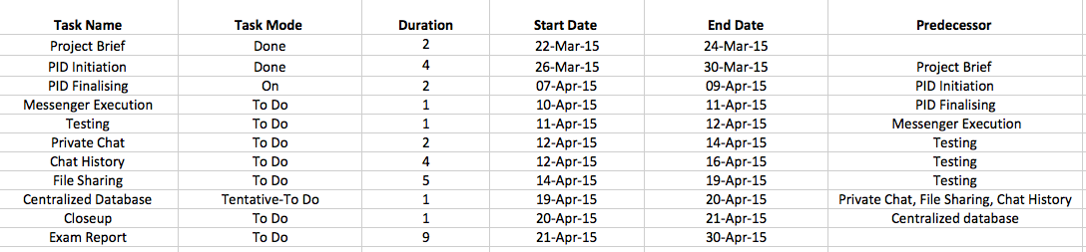

**Network Diagram**

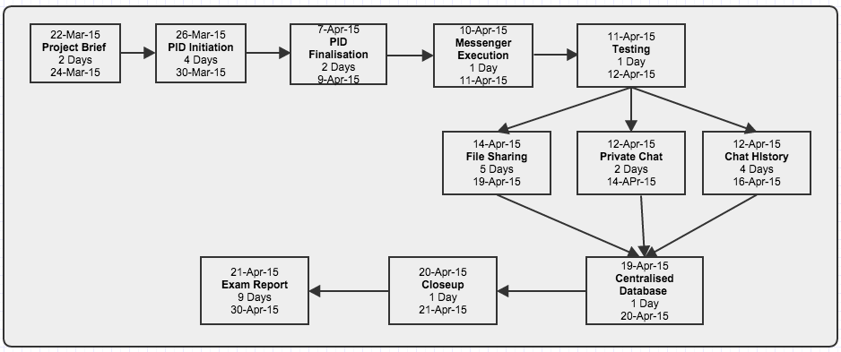

## 13 Project Controls

The project work has been divided into smaller modules to see the timely outputs and be in line with the demands of customers. Project has been delivered into following phases:

* Project Startup
* Project Initiation
* Coding Phase
* Testing
* Project Report

Each phase is concluded with some documentation or deliverables. The coding phase i.e. the actual product development and delivery has been organized using **Scrum techniques** to keep the quality control and meet the deadlines.

Following measures have been taken to make sure the progress is in line with demands:

* Work Break Down Structure
* Creating Project TimeLine
* Gantt chart & Network Diagram
* Referring Product Log
* Creating Sprint Log
* Daily sprint meeting
* Weekly Progress Meeting with Steering Committee