# 

KEA_STUD CHAT MESSENGER

Solution description and baseline cost

Document information

Document version

Approval List

Confidentiality Rating

General

Solution summary

Deliverables summary

Cost summary

Recommendation and next steps

Detailed solution description

Technical dictionary

Architecture overview

Server setup

Functional requirements

Non-functional requirements

Capacity recommendations

Impact on other system

Failover and scalability

Technical Implementation

Solution implementation components

Cost

Platform cost

License and support

Operational Cost

Risks

# Document information

## Document version

|  |  |  |
| --- | --- | --- |
| Version | Author e-mail | Description |
| 1.0 | Nikolaj B. Hemmeshøj, [nibh@kea.dk](mailto:nibh@kea.dk)  Head of Enterprise Architecture | Initial draft |
|  |  |  |

## Approval List

|  |  |  |
| --- | --- | --- |
| Who | Function | E-mail |
| Nikolaj B. Hemmeshøj | Head of Enterprise Architecture | [nibh@kea.dk](mailto:nibh@kea.dk) |
| Jarl Tuxen | Chief Information Security Officer | [jart@kea.dk](mailto:jart@kea.dk) |

## Confidentiality Rating

|  |  |
| --- | --- |
| Rating |  |
| Company Confidential | X |
| Non Confidential |  |

# General

KEA_STUD Chat messenger will provide with the possibility of chat within an institute. It will provide the user with the facility to communicate in-group or private, to exchange small/medium files during conversation, save the chat history. The chat system will work using Local Area Network (LAN).

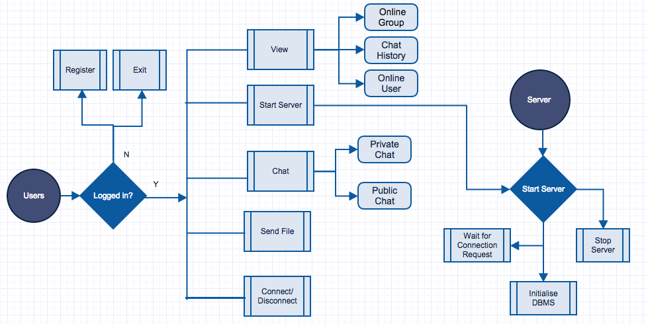

Fig-1

## Solution summary

KEA_STUD LAN chat messenger will provide ease to users in terms of connection, as it will enable users inside the organisations firewall to connect and communicate to each other using existing resources without being connected to Internet. The communication will be platform independent. Moreover it will reduce the cost of communication (by minimising mobile/text usage) and also the maintenance costs. No centralised server or active internet connection is required for communication.

## Deliverables summary

KEA_CHAT LAN messenger will deliver following results that can be measured afterwards:

* Ease of communication between KEA students and staff.
* User Login & Signup options.
* Internet less connection between users.
* Facility to send group and private messages.
* Ability to exchange files during conversation.
* Option to save message history for future referral.
* Setup manual

1. How to install server
2. How to setup Database
3. How to get the system going and maintaining

## Cost summary

High level cost elements that the project will carry once implemented or will be running:

* Software development hours in case of further extension of the software
* Maintenance costs in case of break down
* Operations costs

The initial development of KEA_STUD LAN chat messenger didn’t incur any cost because we utilised already available resources and open source software. High level cost elements that the project will not carry as it can use existing architecture.

* The Server can run on any existing machines so it saves the hosting costs.
* Similarly because of Open source software there will be no licence costs.

# Recommendation and next steps

KEA_STUD LAN chat messenger can be implemented by using one dedicated machine, which runs the Server and also stores the Database. This will help in communicating people during university hours as all the users within the campus can interact with each other without using Internet/Phone calls. The online students can help each other instantly. And administration or teachers can respond to student queries quicker.

Although the private chat option is already available but still the privacy can be improved and an administrator can be assigned for authorizing and assigning access privileges to particular users in specific chat groups. Furthermore the other features like voice/video call can be implemented for enhanced user experience.

As the load increases more servers and load balancer can be added to handle it without compromising user experience.

# Detailed solution description

Normally when a student or a staff member at KEA needs to talk to each other, within campus they call the other person but this acquires costs or if you leave an email then you need to wait for the reply and sometimes it can take up to day or two to get that which wastes lots of times and delays things. So in this way our KEA_STUD LAN chat messenger provides solution to various communication problems within the institute and save resources like time.

The strength of the system lies in enabling users to communicate without having an internet access. It allows users to save their chat histories and also allow them to exchange the files when required hence no need to hassle about composing a separate e-mail with attachment to transfer the file. KEA_STUD LAN chat messenger can support both peer-to-peer or centralized server modes. The user information and the history will be saved in MySQL database, which makes system more optimized and secure.

## Technical dictionary

**Socket:** A socket is an object that represents the low level access to the IP stack. A socket is a simulated medium that allows sending and receiving of data in an application.

## Architecture overview

KEA_STUD LAN chat messenger is based on Model View Controller (MVC) architecture. The application handling for database queries is implemented separated while the user interface presentation or the logic processing is implemented separately. The whole application is divided into further sub applications i.e. client side app and server app. The client application runs on the users computer and the server can run on any computer on network. To send/receive the message the user should be connected to the server. The user can broadcast the message to all the users online (Public Chat) or can send it to any particular user (Private Chat).

The application is developed using Object Oriented Programming in Java Language. To establish the communication link between the systems on the network we need socket connections. A socket enables the application/users to connect to the network and communicate with other applications/users connected to the same network. On a particular machine the socket is composed of an IP address and a port number.

As mentioned above there will be two applications for client and server, so two sockets are made the client application will execute the client socket while the server application will run server socket. To connect to the server socket client requires its IP and the port number. The client and server need to share the same port number in order to achieve the connection. Moreover they need to agree upon the protocol used that could be TCP, UDP or RAW.

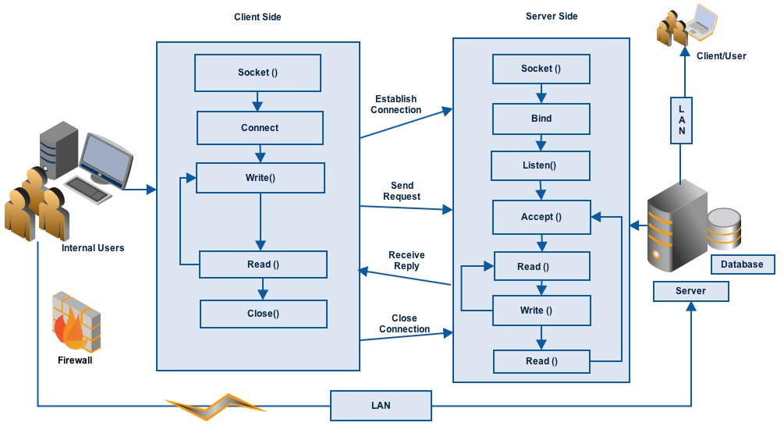

Fig-2

## Server setup

Many computers on the network have capability to run the server side of the application while they are executing or running the other services. But it can always be executed on a dedicated system to handle the load in a better way. The client knows the IP address and the port of the system on which server is running. In IP networking context server is a program that listens for the socket requests. The client sends the connection request which server accepts. And hence a communication link between client and server is established.

If the number of users will increase the additional servers can be added in the architecture, the load balancing can be implemented which can distribute the connection requests among the servers to handle the requests efficiently.

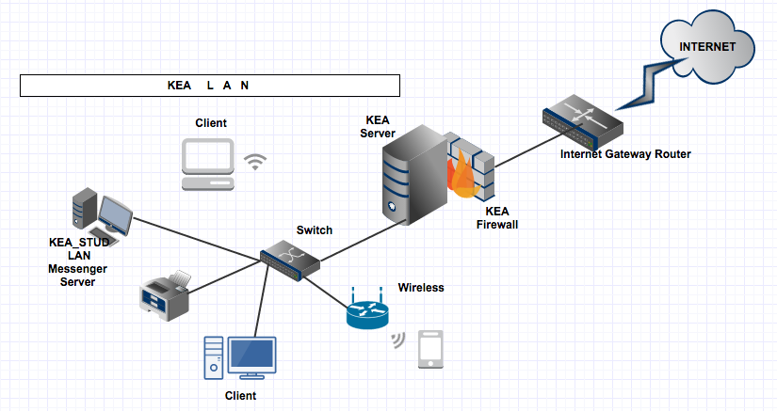

## Functional requirements

The KEA_STUD LAN chat messenger will exhibit following functional requirements:

* Register User.
* Login to the System.
* Display list of online contacts.
* Communicate without Internet access.
* View the Online users and groups.
* View chat history.
* User can chat in a group.
* Save chat history.
* Send/Receive small-medium sized files.
* Notification on receiving new message.
* The system must display the notification on receiving reply/new message.

## Non-functional requirements

Here is the list of non-functional requirements that our system should meet:

|  |  |
| --- | --- |
| **Security** | * It is a secure LAN messenger. * Doesn’t support Encryption. |
| **Reliability** | * It cannot accommodate the failure in case the server fails. But the server can be restarted to make it work. |
| **Usability** | * It has user-friendly graphical interface. * It supports English language. * It uses the single protocol, i.e. it can only communicate with other users on the same client software using the TCP/IP protocol. |
| **Supportability** |  |
| **Performance** |  |

## Capacity recommendations

How does the system scale and how do we measure it under SPT.

# Impact on other system

How does the new system impact other system or infrastructure as the company.

# Failover and scalability

How does the system scale and how does it handle failover.

# Technical implementation plan

How should the system be implemented with timeline.

## Solution implementation components (work breakdown structure)

What steps do you need to do to implement the product or project

eg.

### Preparation

1. Analysis of requirements
2. ...
3. Create installation manuals
4. Performance testing

### Development of software

1. Web service development
2. ...
3. Frontend development

### Hardware setup

1. Install Hypervisor
2. Create VM’s for project
3. Install webservers and databases
4. SPT test of basic setup
5. ...

# Cost

What does the system cost to implement.

## Platform cost

## License and support

## Operational Cost

# Risks

What risks are there in the project.

|  |  |  |  |  |  |
| --- | --- | --- | --- | --- | --- |
| Item # | Area | Description | Rank (RF=i*p) | Mitigation | Solution |
| #1 | HW | Low capacity | 15=3*1 | evaluate upgrade options | port application to other host |
|  |  |  |  |  |  |