Prepared by:
Abdul Munim (22i-1080)
Talha Azim (22i-1243)
Hadi Saleemi (22i-1043)

NUCES ,Islamabad
27 November , 2024
Software Requirments and Design Documents
Project Title : Connectify

Table of Contents
Table of Contents ii
1. Introduction 1
1.1 Purpose 1
1.2 Product Scope 1
1.3 Title 1
1.4 Objectives 1
1.5 Problem Statement 1
2. Overall Description 1
2.1 Product Perspective 1
2.2 Product Functions 2
2.3 List of Use Cases 2
2.4 Extended Use Cases 2
2.5 Use Case Diagram 2
3. Other Nonfunctional Requirements 2
3.1 Performance Requirements 2
3.2 Safety Requirements 2
3.3 Security Requirements 2
3.4 Software Quality Attributes 2
3.5 Business Rules 3
3.6 Operating Environment 3
3.7 User Interfaces 3
4. Domain Model 3
5. System Sequence Diagram 3
6. Sequence Diagram 3
7. Class Diagram 4
8. Package Diagram 4
9. Deployment Diagram 4

Introduction

Purpose
The purpose of this document is to outline the software requirements for the Connectify application, specifically version 1.0. Connectify aims to provide a platform for startups to connect, grow, and succeed in their business endeavors. It describes the core functionalities, including networking, marketing support, idea refinement, and event participation. This document focuses on the entirety of the system and its subsystems, providing a detailed understanding of how it addresses the challenges faced by startups globally.

Product Scope
Connectify is a global platform tailored for startups at the early stages of their business journeys. Its primary purpose is to simplify the process of networking, marketing, and collaboration for startups, providing them with tools and opportunities to thrive. The application offers a cohesive ecosystem where startups can:

- Discover and connect with similar startups.
- Establish meaningful connections with larger companies.
- Participate in global events to showcase products and network.

Title
Connectify: Build Tomorrow’s Company

Objectives
The primary objectives of Connectify are:

- Facilitate Networking: Enable startups to connect with each other and larger companies.
- Marketing Support: Provide affordable tools to create marketing assets and strategies.
- Event Participation: Organize events for startups to present their products to key stakeholders.
- Goal-Setting Assistance: Offer guidance to set and achieve realistic business goals.
- Encourage Innovation: Promote creativity and collaboration within a competitive market.

Problem Statement
Startups often face significant challenges during their initial stages:
- Difficulty connecting with similar startups and larger companies due to limited networks.
- Lack of resources to market their ideas effectively, and strategic planning.
- Time constraints and limited access to research about other startups in their region or industry.
- Limited platforms for showcasing their work to influential stakeholders.

Connectify was created to eliminate these obstacles. The app provides an integrated platform where startups can:

- Build meaningful connections with other startups and influential companies.
- Simplify marketing efforts using in-built tools.
- Showcase their products and network at high-profile events.
- Collaboratively set goals, and grow their business efficiently.

Overall Description

Product Perspective
Connectify is a new, self-contained platform designed to be a comprehensive tool for startup growth. It does not rely on any existing systems but aims to integrate smoothly with social media platforms, business databases, and event management systems. Its features are structured to cater to the lifecycle of startups, from ideation to scaling.
Key system components include:
- Startup Networking Module: Facilitates connections based on industry, and mutual interests.
- Event Manager: Schedules and manages participation in global events.

Product Functions
Connectify’s major functions include:

- User registration and profile creation.
- Intelligent networking recommendations.
- Event notifications and participation management.
- Collaborative workspaces for business idea improvement.
- Analytics for goal tracking and progress measurement.

List of Use Cases
• Sign Up / Registration
• Track Financial Progress
• Find Other Similar Startups
• Schedule Meeting
• Set Personal Goals
• Chat with Other Startups
• Apply for a Job
• Add a Service
• Display Biggest Achievement
• Shortlist Startups
• Set Up Events
• Announce a Job
• Store Profit / Loss

Extended Use Cases:

1 . Sign up/Registration : Talha

Use case name: Sign up/Registration
Scope the system under design: Connectify app – user account creation feature
Level: User goal level
Primary actor: New user (e.g. start-up representative )
Stakeholders and interests:
1. Start-up Owners: Want a user-friendly registration process to onboard potential partners.
2. Connectify: Ensures a smooth and secure registration process while gathering necessary information from users.
Preconditions:
1. The Connectify app or website is accessible.
2. The user is not registered on the platform yet.
3. The user has the necessary information (e.g., valid email, company details) required to complete the sign-up process.
Postcondition:
1. The user successfully creates an account.
2. The user gains access to the platform’s features, including start-up showcasing and exploration.
Main success scenario:
User System
1. The user accesses the Connectify app or website.  2. The user selects the "Sign Up" option.  4. The user provides the requested information and submits the form.  6. The user logs in to the platform to start using its features. | 3. The system prompts the user to enter required details (e.g., name, email, company, password).  5. The system confirms the registration and allows the user to log in to the platform.

Extensions:

3a. The system checks if the email address provided during sign-up is already registered. If so, it prompts the user to log in.
3b. If the system detects invalid or missing fields (e.g., weak password, missing email), it highlights the respective fields and prompts the user to correct the information.

2 . Track financial progress : Munim

Use case name: Track Financial Progress
Scope the system under design: Connectify
Level: User goal level
Primary actor: User (individual managing personal finances)
Stakeholders and interests:
1. User: Wants to monitor financial progress and make informed decisions based on their data.
2. Financial Institutions: May want users to track finances to promote products like savings plans or investments.
Preconditions:
1. User must have an account in the system.
2. The system has historical and current financial data of the user.
3. User has permission to view their financial information.
Postcondition:

1. User is able to see their financial progress visually in the form of a graph.
2. The system stores and updates user data for future tracking.
Main success scenario:
User System
1. User navigates to the "Financial Progress" section.  2. User inputs their current financial data (income, expenses, savings, etc.).  5. User views the graph and identifies trends in their financial data. | 3. System processes the input and fetches historical data.  4. System generates and displays a graph showing the user’s financial progress over time.  6. The system stores the input data for tracking the future progress.

Extensions:
2a. If the user’s financial data is missing or insufficient, the system displays a message requesting more input or shows limited progress data.
4a. If the graph generation fails due to a system error, the user is notified and the process is retried automatically.

3 . Find other similar start-ups : Hadi

Use case name: Find Other Similar Start-ups
Scope the system under design: Connectify – competitive analysis feature
Level: User goal level
Primary actor: Start-up company representative
Stakeholders and interests:
1. Start-up Company: Seeks to analyze competition and find similar businesses for partnerships or insights.
3. Connectify: Aims to facilitate valuable connections between companies and startups.
Preconditions:
1. The company representative has an account in the system.
2. The company’s profile and business data are up-to-date and accurately reflect its offerings.
3. The Connectify database contains sufficient information on other startups.
Postcondition:
1. The user finds similar start-ups for competitive analysis.
2. The system updates recommendations and provides insights for future searches.
Main success scenario:
User System
1. The user navigates to the "Competitive Analysis" section.  2. The user inputs relevant data or filters (e.g., industry, region, size, market trends, etc.).  5. The user analyzes this data, comparing key metrics like services offered, market presence, and growth. | 3. The system searches for similar start-ups that match the input criteria.  4. The system generates and displays a list of similar start-ups with key data (e.g., market position, services, revenue, etc.).  6. The system allows the user to save the results for future reference and analysis.

Extensions:

2a. If inputs are incomplete or invalid, the system prompts the user for correction.
3a. If no similar start-ups are found, the system suggests broader search criteria or alternatives.
4a. If the system experiences errors during the search, a retry is attempted or an error message is displayed with an option to notify support.

4. Schedule Meetings : Munim

Use case name: Schedule Meetings
Scope the system under design: Connectify app – scheduling and meeting coordination feature
Level: User goal level
Primary actor: Company representative
Stakeholders and interests:
1. Start-up Company: Wants to schedule meetings with potential partners or clients to discuss business opportunities.
2. Potential Partners: Need an efficient way to coordinate meetings with start-ups to explore partnerships.
Preconditions:

1. The company representative has an account in the Connectify app.
2. The company’s profile is active, and the system includes available times and contact information.
Postcondition:
1. A meeting is successfully scheduled, and both parties are notified.
2. The system updates the meeting details in the calendar for future reference.
Main success scenario:
User System
1. The user navigates to the "Schedule Meetings" section.  2. The user selects a company or contact with whom they wish to schedule a meeting.  4. The user selects a preferred time slot and sends a meeting request. | 3. The system retrieves and displays the contact’s available time slots.  5. The system sends the request and waits for confirmation from the other party.  6. Once confirmed, the system schedules the meeting and notifies both parties of the meeting details.

Extensions:
2a. If no companies or contacts are selected, the system prompts the user to choose one.
3a. If no time slots are available, the system offers the user an option to suggest a custom time.
5a. If the meeting request is declined or times do not match, the system allows the user to choose another slot or suggest a new time.

5. Post a Job : Munim

Use case name: Post a Job
Scope the system under design: Connectify app – job posting and discovery feature for start-ups
Level: User goal level
Primary actor: Bigger Company
Stakeholders and interests:
1.Bigger Company: Wants to post job opportunities to attract start-ups with relevant skills or services.
2.Start-Ups: Interested in finding relevant job postings where they can offer their expertise and services.
3.Connectify: Aims to facilitate job posting and application processes to foster partnerships between companies and start-ups.
Preconditions:

1. The company has an active account on the Connectify app. 2. The company has details ready for the job post, including job title, description, requirements, deadline, and contact details.
Postcondition:
1. The job post is successfully created and displayed on the platform. 2. Start-ups can view the job posting and apply by submitting a proposal or cover letter..
Main success scenario:
User System
1. The company navigates to the job posting section on Connectify.  2. The company selects the option to create a new job post.  3. The company enters job details such as title, description, skills required, application deadline, and contact information. | 4. The system saves the job post and verifies that all necessary details are included.  5. The job post is displayed on the platform, allowing start-ups to search and view it.

Extensions:
3a. If the company omits essential information (e.g., title or application deadline), the system prompts them to complete all required fields.
5a. If the company wants to update the job post after publishing, they can edit it through their profile.
5b. If the application deadline passes, the system automatically removes or archives the job post.

6. Set personal Goals : Munim

Use case name: Set Personal Goals
Scope the system under design: Connectify app – personal goal-setting feature
Level: User goal level
Primary actor: Start-up company representative
Stakeholders and interests:
1. Start-up Company: Wants to set business-related goals to track progress and growth.
2. Connectify: Aims to help users set and manage goals to improve their business visibility and performance.
Preconditions:
1. The user has an active account in the Connectify app.
2. The system has sufficient data on the user’s current progress and achievements.
Postcondition:
1. Personal goals are set and saved in the system.
2. The system tracks the user's progress toward these goals and provides updates over time.
Main success scenario:
User System
1. The user navigates to the "Set Personal Goals" section.  2. The user specifies their goals (e.g. improve market visibility, expand services).  4. The user confirms the goals and sets deadlines for achieving them. | 3. The system validates the input and offers goal-setting templates or suggestions based on industry standards.  5. The system saves the goals and begins tracking progress.  6. The system provides periodic updates and progress reports on goal achievement.

Extensions:
2a. If goal inputs are incomplete, the system prompts the user for clarification.
5a. If goals are unrealistic or deadlines conflict, the system alerts the user and suggests alternative timelines.

7. Chat with Start-Ups : Munim

Use case name: Chat with Start-Ups
Scope the system under design: Connectify app – Messaging feature
Level: User goal level
Primary actor: Company representative
Stakeholders and interests:
1. Company: Wants to communicate with other start-ups to explore partnerships, collaborations, or share ideas.
2. Connectify: Aims to facilitate efficient communication between start-ups to enhance business networking and opportunities.
Preconditions:
1. The user has an active account in the Connectify app.
2. The chat feature is enabled, and the user has permissions to send messages.
Postcondition:

1. A successful conversation is initiated between start-ups.
2. The chat history is saved for future reference.
Main success scenario:

User System
1. The user navigates to the "Chat with Start-Ups" section.  2. The user selects a start-up from the list of companies they want to chat with.  4. The user types a message and sends it to the selected start-up. | 3. The system establishes a chat connection and displays the messaging interface.  5. The system delivers the message, and the receiving start-up is notified.  6. Both parties can now exchange messages in real-time.

Extensions:
3a. If the chat fails to connect, the system retries or offers the user alternative communication methods (email, video call).
4a. If the message fails to send, the system notifies the user.

9. Apply for Job: Munim

Use case name: Apply for Job
Scope the system under design: Connectify app – job application feature for start-ups
Level: User goal level
Primary actor: Start-up company representative.
Stakeholders and interests:
1. Start-Ups: Want to find and apply for relevant job opportunities that match their skills and services.
2. Bigger Companies: Interested in receiving applications from qualified start-ups to fill job vacancies.
3. Connectify: Aims to streamline the job application process to connect start-ups with potential employers.
Preconditions:
- The start-up has an active account on the Connectify app.
- The start-up has searched for job postings and identified a suitable position to apply for.
Postcondition:
- The application or cover letter is successfully submitted to the relevant bigger company.
- The system confirms the application submission to the start-up.
Main success scenario:
User System
1. The start-up searches for job postings using relevant criteria (e.g., skills, location).  3. The start-up selects a job posting to view the details.  5. The start-up fills out any required application forms and uploads the necessary documents.  7. The start-up submits the application. | 2. The system displays a list of job postings that match the search criteria.  4. The system displays the full job description.  6. The system verifies that all required fields are completed and files are attached.  8. The system sends a confirmation of application submission to the start-up and forwards the application to the respective company.

Extensions:

2a. If the start-up does not find relevant job postings, they can broaden their search criteria or check back later.

10. Display Biggest achievement : Hadi

Use case name: Display Biggest Achievement
Scope the system under design: Connectify app – profile customization and achievements display feature
Level: User goal level
Primary actor: Start-up owner/company representative
Stakeholders and interests: s
1. Start-up Owner: Wants to showcase their company's biggest achievements to attract potential partners.
2. Connectify: Facilitates the display of significant achievements to enhance the visibility of start-ups on the platform.
Preconditions:
1. The user has an active account in the Connectify app.
Postcondition:
1. The biggest achievement is displayed on the user's profile page.
2. Potential partners can view and evaluate the achievement.
Main success scenario:
User System
1. The user navigates to their profile page on Connectify.  2. The user selects the option to add/edit their biggest achievement.  3. The user manually inputs the details of their biggest achievement (e.g., title, description, date ). | 4. The system saves the achievement details.  5. The biggest achievement is displayed prominently on the user's profile page for potential partners to view.

Extensions:
3a. If the user omits critical fields (e.g., title or description), the system prompts them to complete the missing fields before saving.
3b. If the achievement title exceeds a specified character limit, the system asks the user to revise the title to fit the allowed length.
5a. If the user wishes to update or change their biggest achievement after it is displayed, they can edit the achievement through the profile settings.

11. Short list Start-Ups : Talha

Use case name: Short List Start-Ups
Scope the system under design: Connectify app – start-up selection feature
Level: User goal level
Primary actor: Company representative seeking partnerships
Stakeholders and interests:

1. Company Representative: Wants to identify potential start-ups for collaboration or investment.
2. Start-ups: Aim to be shortlisted and gain opportunities for partnerships or funding.
3. Connectify: Provides a platform for showcasing start-ups and facilitates connections between them and potential partners.
Preconditions:

1. The user has an active account on the Connectify app.
2. Start-ups have profiles that include relevant information such as capabilities, achievements, and needs.
Postcondition:

1. The user successfully creates a shortlist of start-ups.
2. The shortlisted start-ups are notified for potential follow-up.
Main success scenario:
User System
1. The user navigates to the "Short List Start-Ups" section.  2. The user applies filters to search for start-ups based on criteria (e.g., industry, funding stage, location).  4. The user reviews the profiles and selects start-ups to add to their shortlist. | 3. The system displays a list of start-ups matching the criteria.  5. The system saves the shortlist and notifies the selected start-ups of their interest.

Extensions:

2a. If no start-ups match the criteria, the system suggests adjusting the filters.

12. Set up Events : Talha

Use case name: Set up Events
Scope the system under design: Connectify app – event creation and management feature for bigger companies
Level: User goal level
Primary actor: Bigger companies (organizers)
Stakeholders and interests:
1. Bigger Companies: Want to create events to allow start-ups to pitch their services and projects.
2. Start-ups: Want to attend events where they can pitch their services to bigger companies.
3. Connectify: Aims to facilitate event creation and provide a platform for interaction between start-ups and bigger companies.
Preconditions:
1. The user has an active account on the Connectify app. 2. The user has event details ready (e.g., event name, description, date, location, participation criteria).
Postcondition:
1. The event is successfully created and scheduled.
2. Start-ups can view and register for the event.
Main success scenario:
User System
1. The user navigates to the event setup page on Connectify.  2. The user selects the option to create a new event for start-ups to pitch.  3. The user inputs event details such as event name, description, date, location, and participation criteria. | 4. The system saves the event and schedules it.  5. The event is displayed on the platform, allowing start-ups to register and submit their briefs..

Extensions:
3a. If the company omits key event details (e.g., name, date), the system prompts them to fill in the missing fields.
5a. If the company wants to edit the event after creation, they can modify the details through the event management page.
5b. If the event has insufficient start-up registrations by a certain deadline, the company can cancel or reschedule the event.

13. Add a Service: Munim

Use case name: Add a Service.
Scope the system under design: Connectify app – service creation and listing feature for start-ups
Level: User goal level
Primary actor: Start-Up User
Stakeholders and interests:
- Start-Up User: Wants to showcase specific services to potential clients, providing details that will attract larger companies.
- Bigger Companies: Interested in browsing services to find providers for specific needs.
- Connectify: Aims to enable easy listing and discovery of start-up services on the platform to facilitate collaborations and contracting.

Preconditions:
1. The start-up has an active account on the Connectify app.
2. The start-up has prepared details about the service they want to offer, including description, price, and category.
Postcondition:
1. The service is successfully created and displayed on the platform.
2. Potential clients can view the service and reach out to the start-up.
Main success scenario:
User System
  1. The start-up navigates to their profile on Connectify.
  2. The start-up selects the option to add a new service.
  3. The start-up enters service details, including title, description, pricing, category, and any relevant tags.
  4. The system saves the service details.
  5. The service is displayed on the start-up’s profile and is searchable by companies based on relevant tags and categories.

Extensions:
3a. If the start-up omits essential information (e.g., title or category), the system prompts them to complete all required fields.
5a. If the start-up wishes to edit the service after posting, they can update details through their profile settings.

14. Store Profit and Loss : Talha

Use case name: Store Profit and Loss
Scope the system under design: Connectify app – financial management feature for start-ups
Level: User goal level
Primary actor: Start-ups (users)
Stakeholders and interests:
1. Start-ups: Want to track and manage their financial performance, including profits and losses, for better decision-making.
2. Connectify: Aims to provide tools for start-ups to manage their financial data effectively.
Preconditions:
1. The user has an active account in the Connectify app. 2. The user has relevant financial data (income, expenses) ready for input.
Postcondition:
1. The profit and loss data is successfully stored in the system.
2. The user can view and analyze their profit and loss statement.
Main success scenario:
User System
1. The user navigates to the financial management section on Connectify.  2. The user selects the option to input profit and loss data.  5. The user confirms the entries, and the data is saved successfully. | 4. The system calculates the profit or loss based on the provided data.

Extensions:
3a. If the user omits required fields (e.g., income or expense amount), the system highlights the missing data and prompts for completion.

5a. If the system encounters an error while saving the data, it informs the user and suggests trying again later.

Use Case Diagram 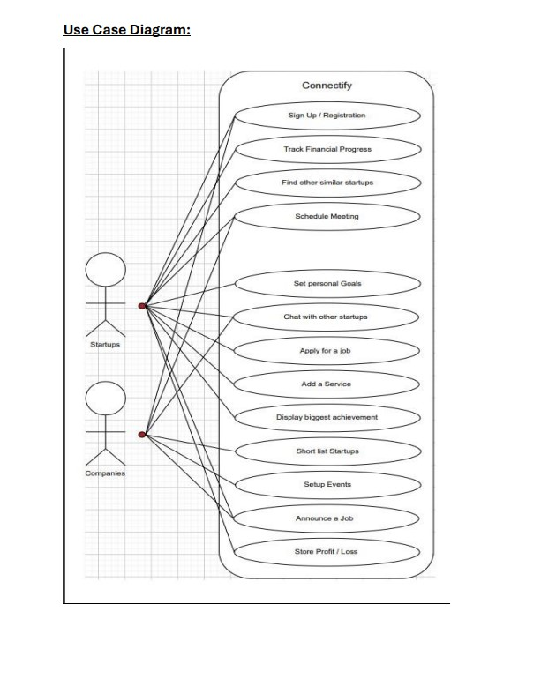

Other Nonfunctional Requirements

Performance Requirements
1.The application must launch and become fully operational within 5 seconds on a machine with the following specifications:
- Minimum Hardware: Dual-core processor, 4GB RAM, and 5 MB free storage.

2. All features, such as networking simulation should execute within 2 seconds of user interaction.

3.The application must efficiently handle up to 100 simultaneous local users on a shared machine or networked setup without significant performance degradation.

Safety Requirements
The application must comply with system resource usage restrictions to avoid overloading the hardware or causing a system freeze.

Security Requirements
1.Access to the application should be protected via local user authentication, such as a password or PIN-based system.

2.The application must include a session timeout feature that locks the interface after a defined period of inactivity (e.g., 15 minutes).

3.The software should not transmit or request any data from external servers or networks, ensuring complete offline functionality and data privacy.

Software Quality Attributes
• Usability: Intuitive user interface designed for easy navigation.
• Reliability: System uptime of 99.9% guaranteed.
• Maintainability: Modular architecture to allow seamless updates.
• Interoperability: Compatibility with existing social media and event platforms.
• Scalability: Designed to handle increased user and data loads as the platform grows.

Business Rules
• Only authenticated users with proper credentials can access saved projects or settings.
• File exports should be limited to non-sensitive formats unless explicitly authorized by the user.
• The application must prevent simultaneous overwrites by different users on the same system.

Operating Environment
Hardware: The application should function on PCs with at least:
- Processor: Dual-core CPU or higher.
- RAM: 4GB minimum.
- Storage: 500MB free space for the application and additional space for user projects.

Operating System: The application will be compatible with:
- Windows: Windows 7, 8, 10, and 11.
- Linux: Ubuntu 18.04+ and similar distributions.
- macOS: macOS 10.13 (High Sierra) and later.
Software Dependencies:
- Requires Java Runtime Environment (JRE) version 11 or higher.
- No additional third-party software is needed.

User Interfaces
The platform will feature:
- A dashboard summarizing user activities and progress.
- A networking page with recommendations and messaging features.
- Marketing tools with a drag-and-drop interface.
- Event pages for registration and updates.
- Responsive design to ensure functionality across devices.

Domain Model 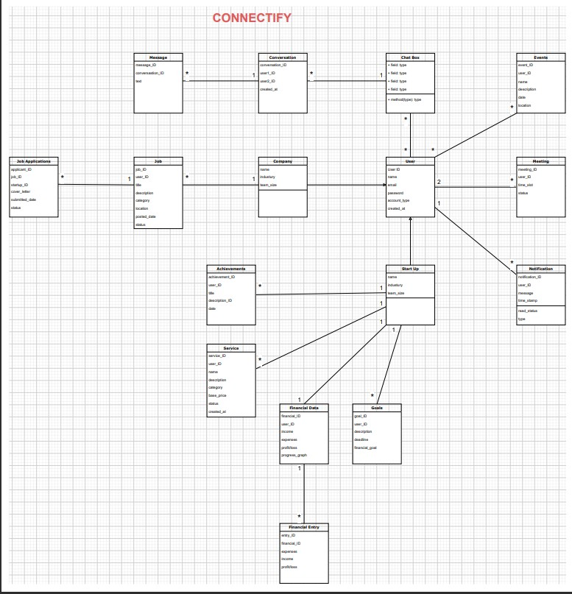

System Sequence Diagram

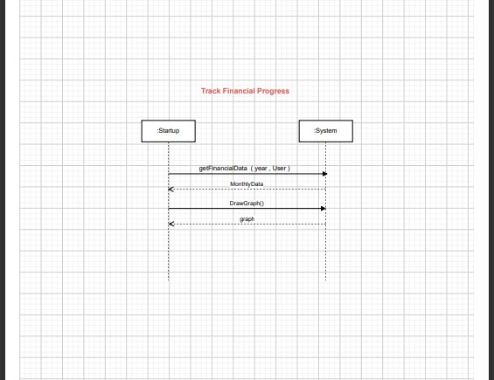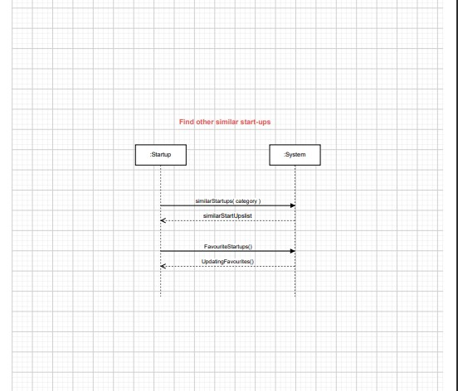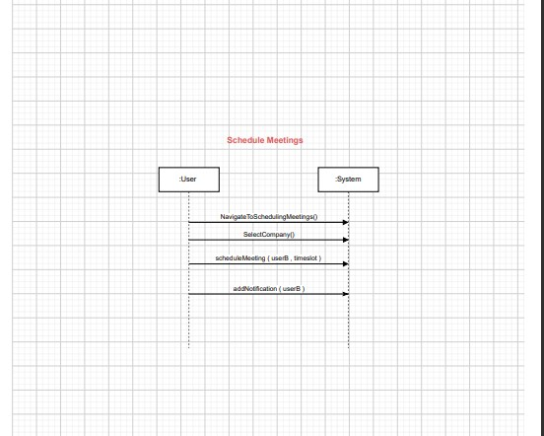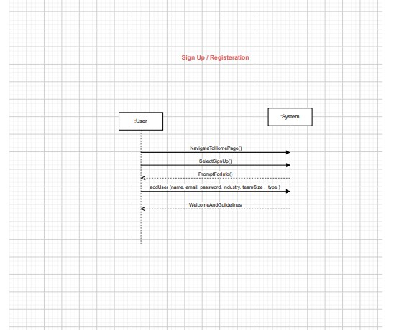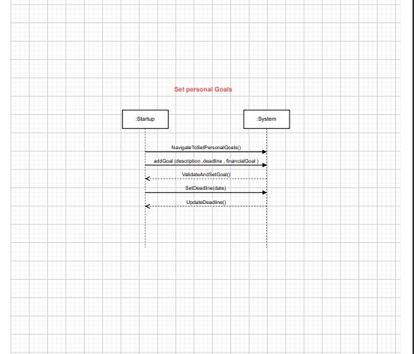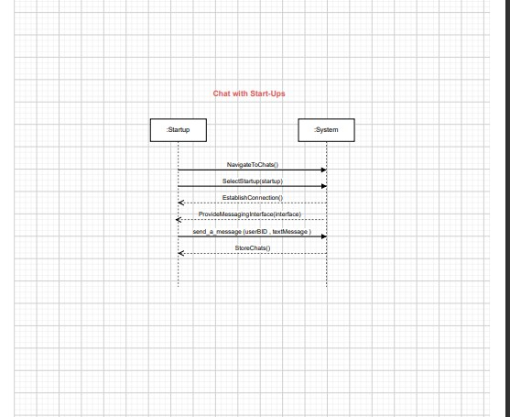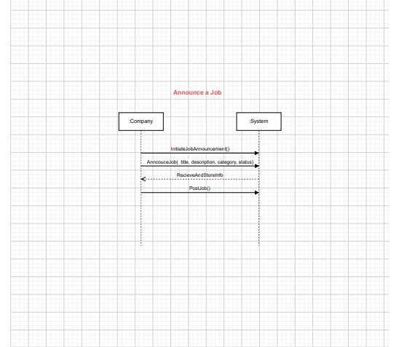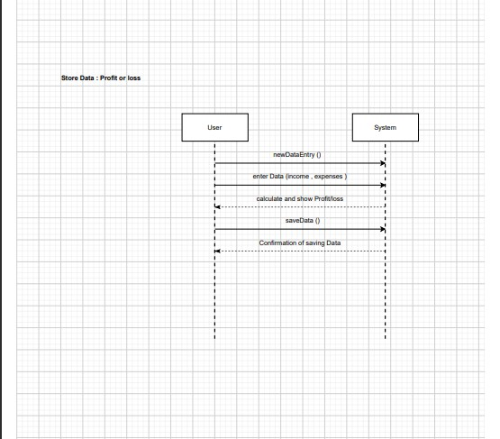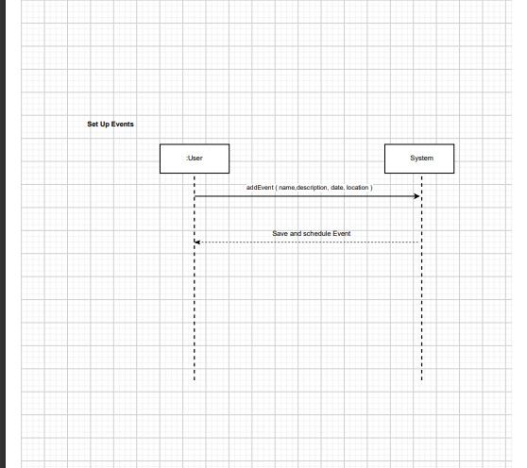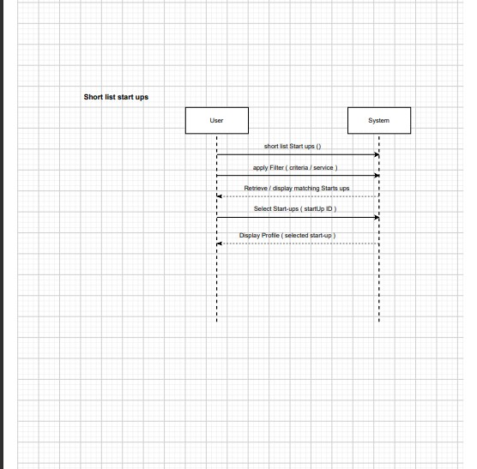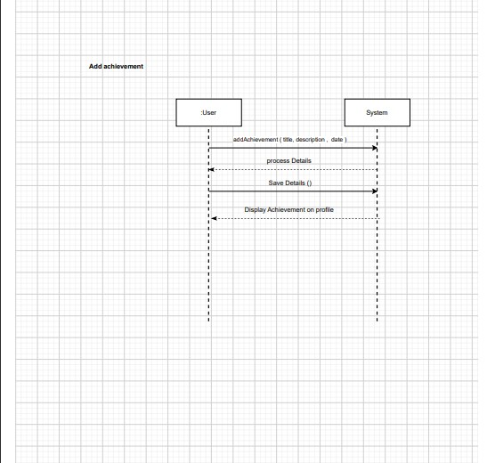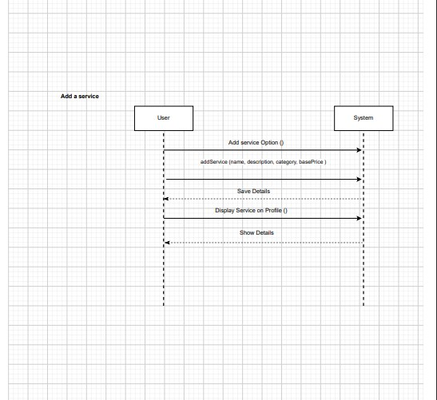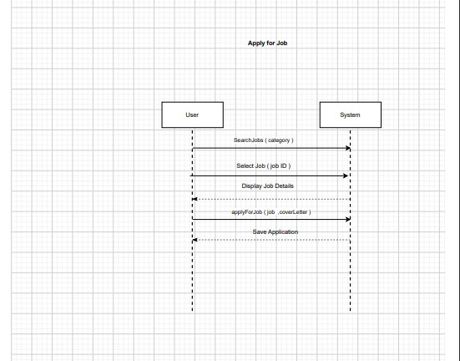

SequenceDiagram: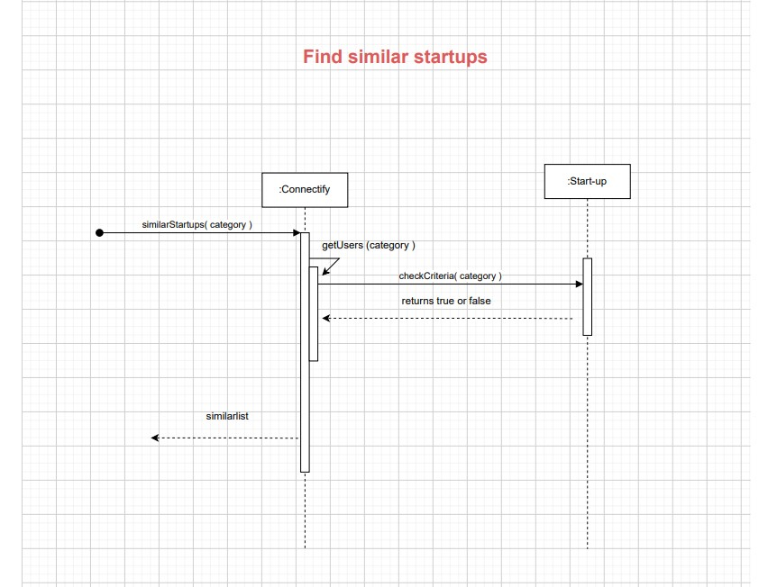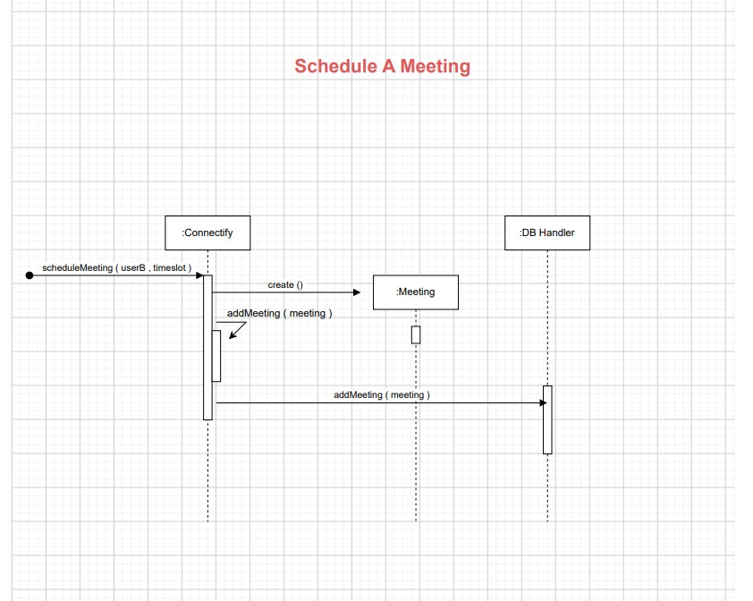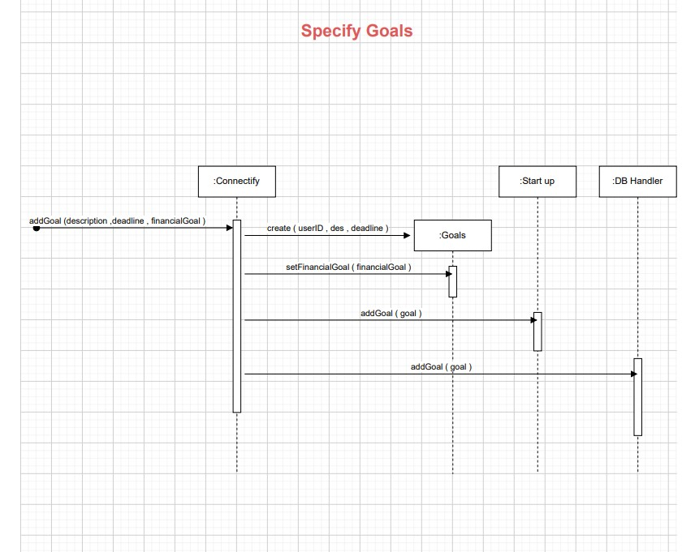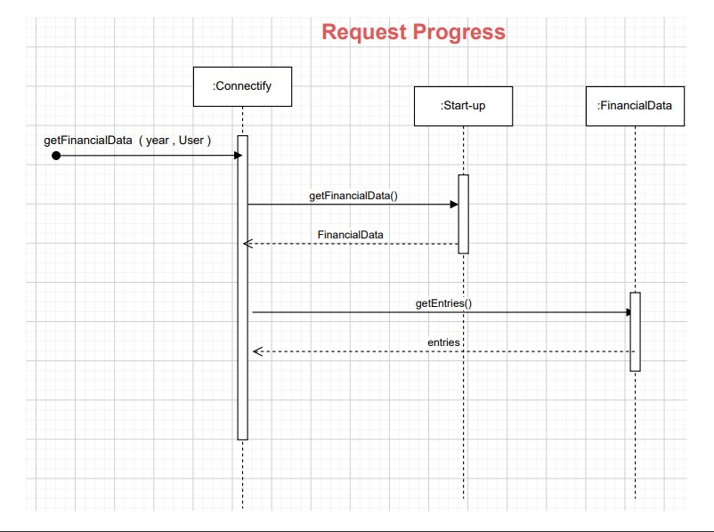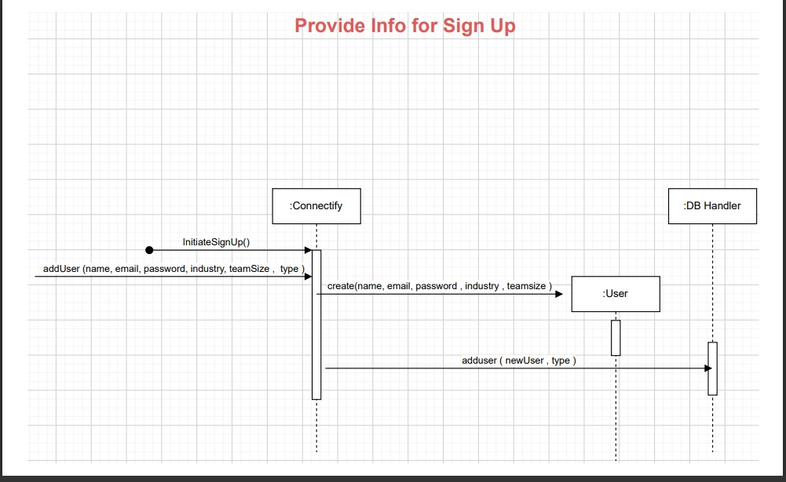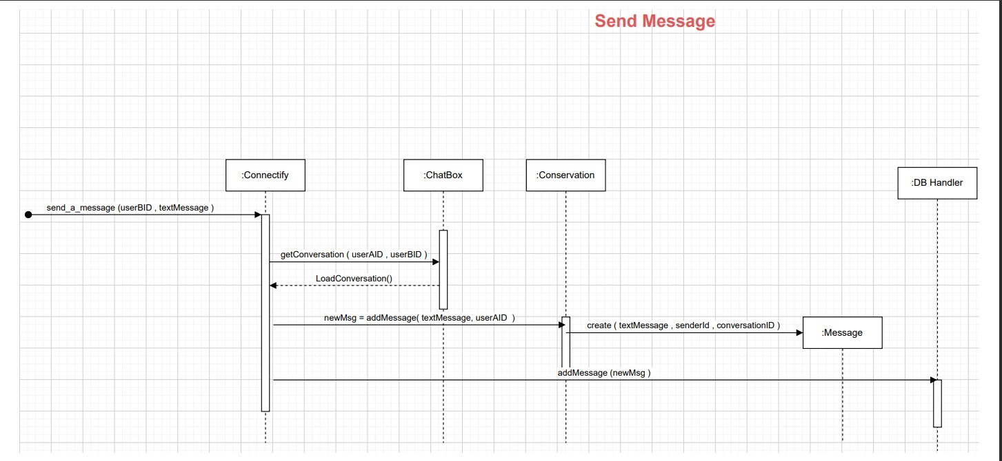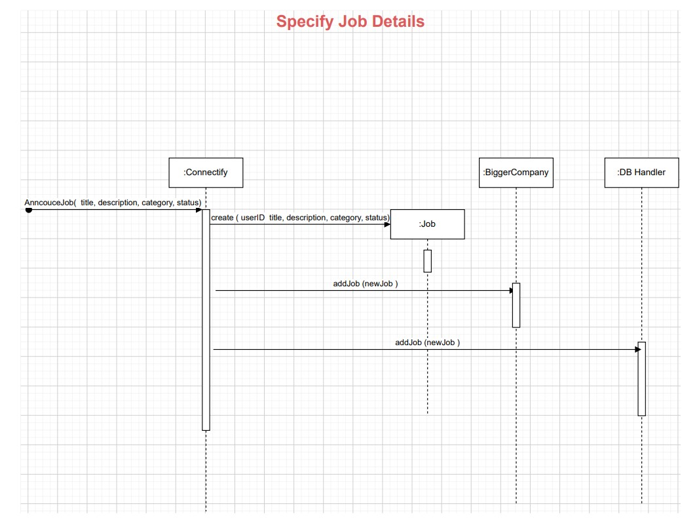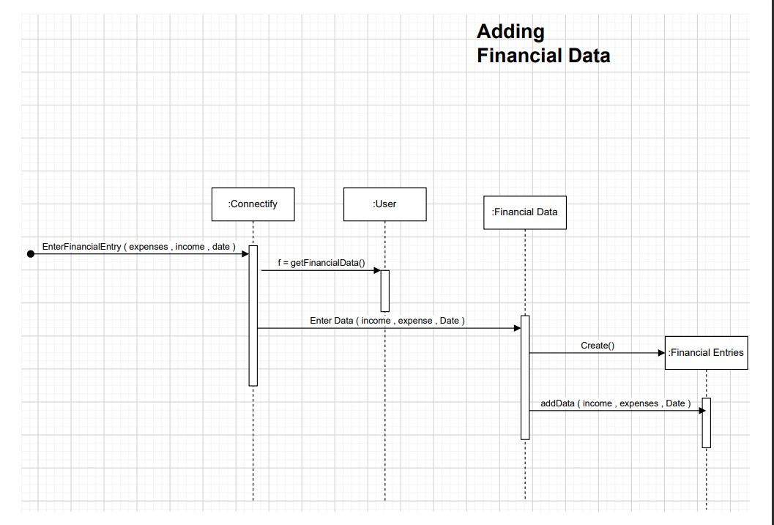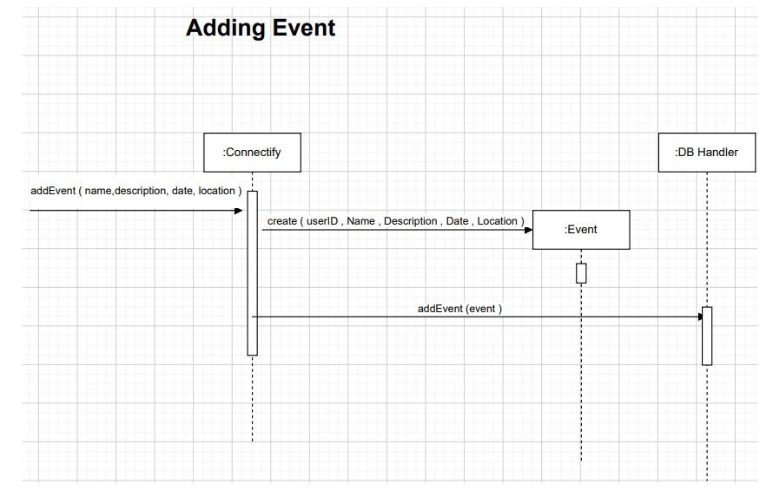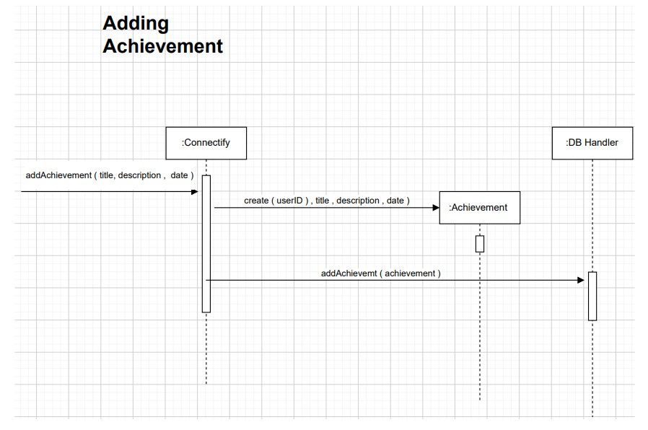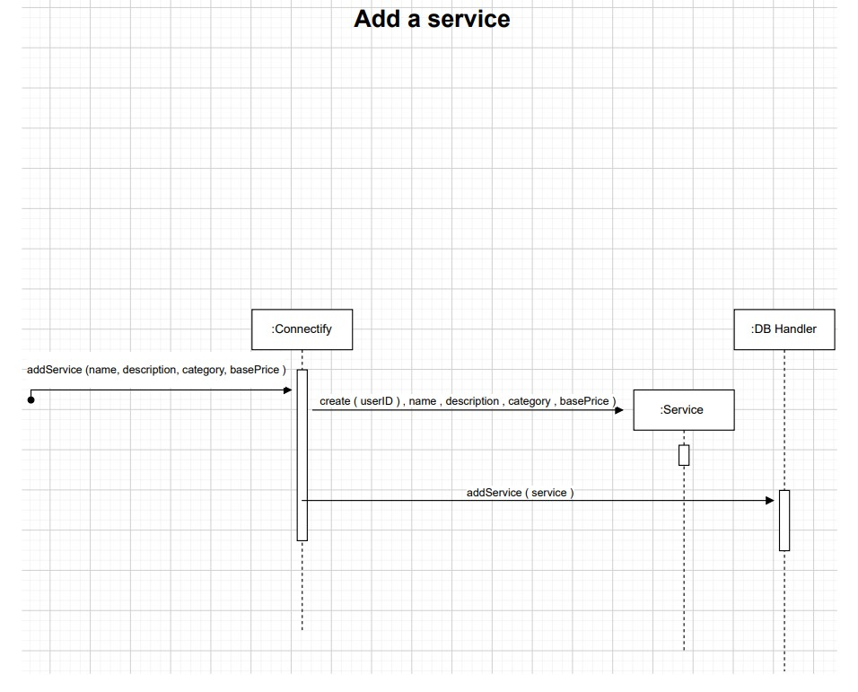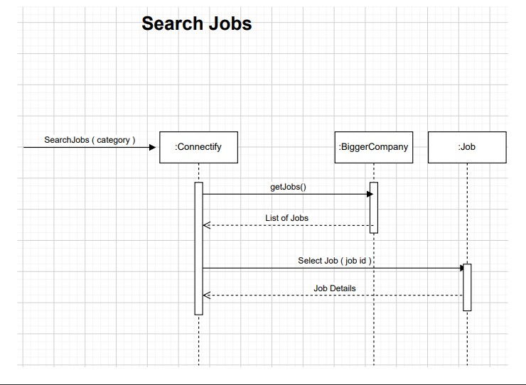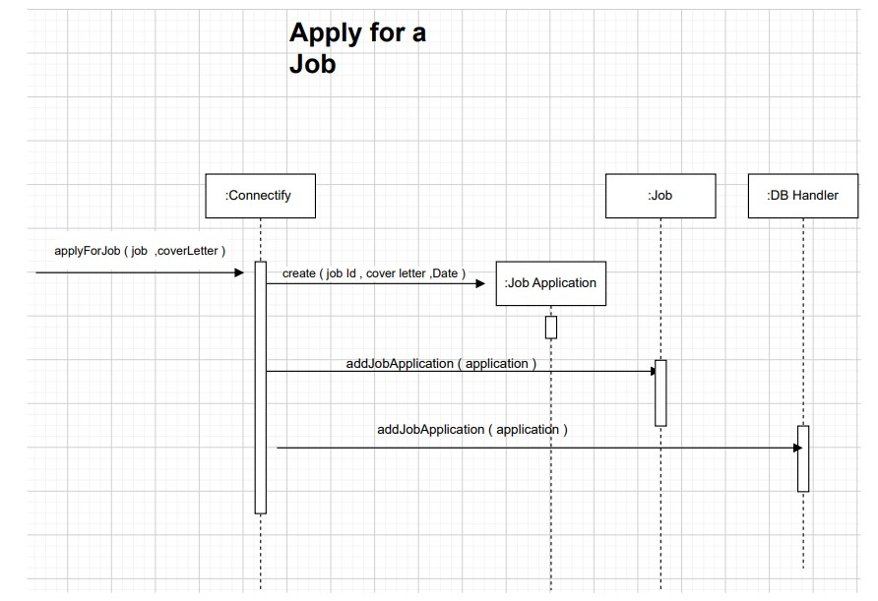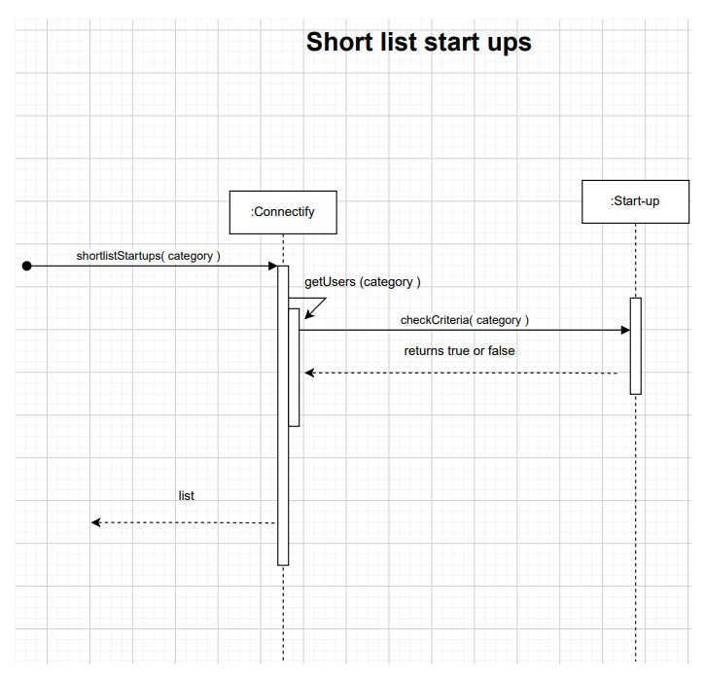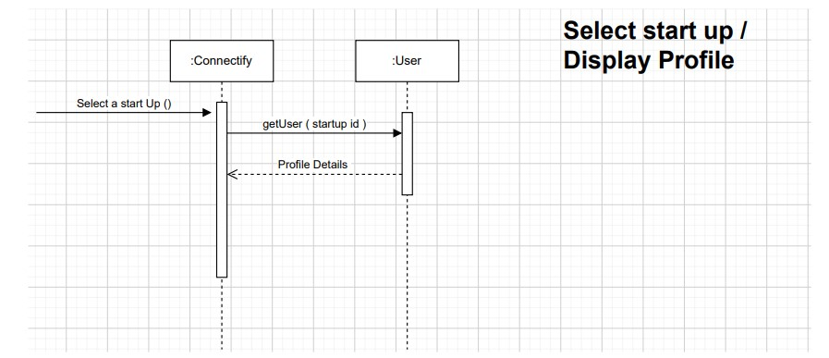

Class Diagram: 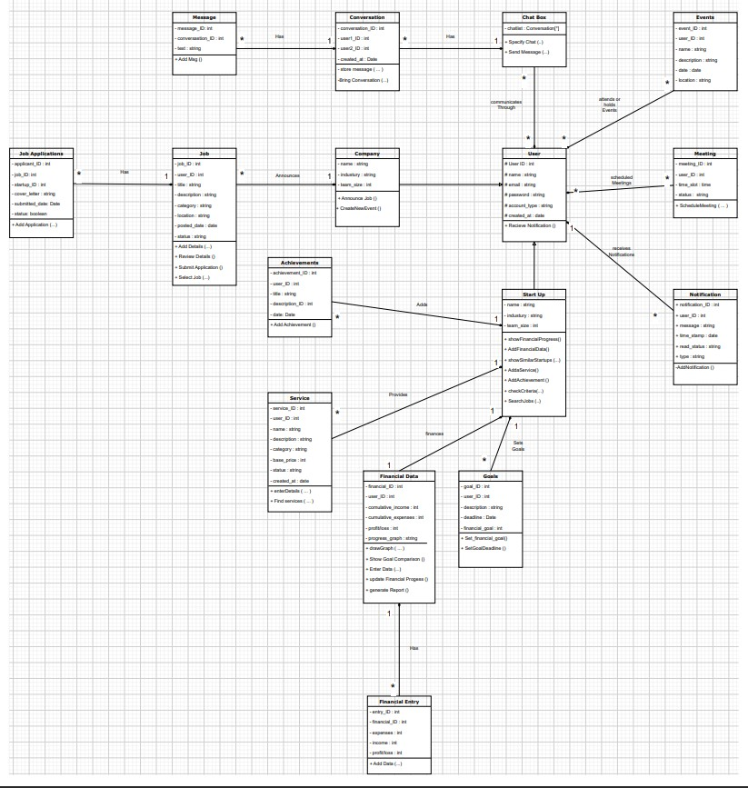

Component Diagram : 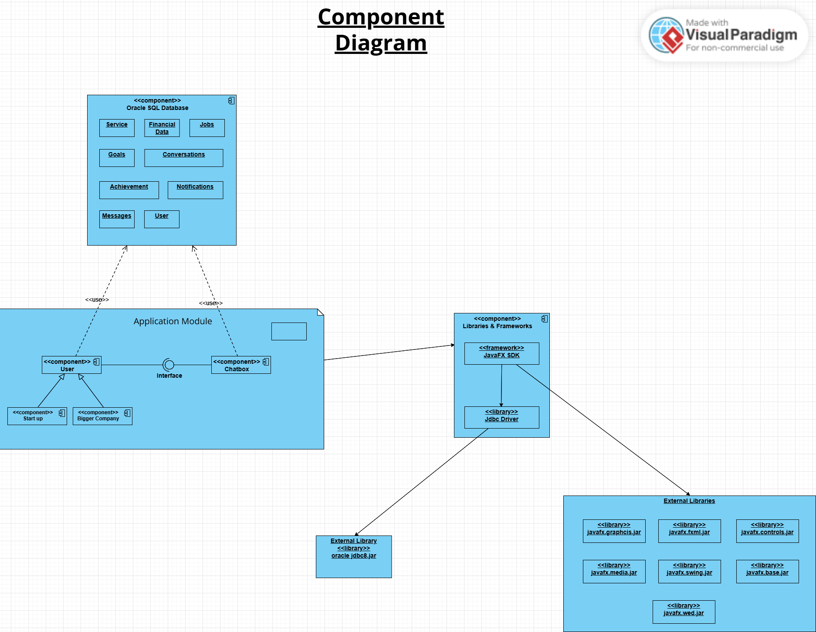

Package Diagram 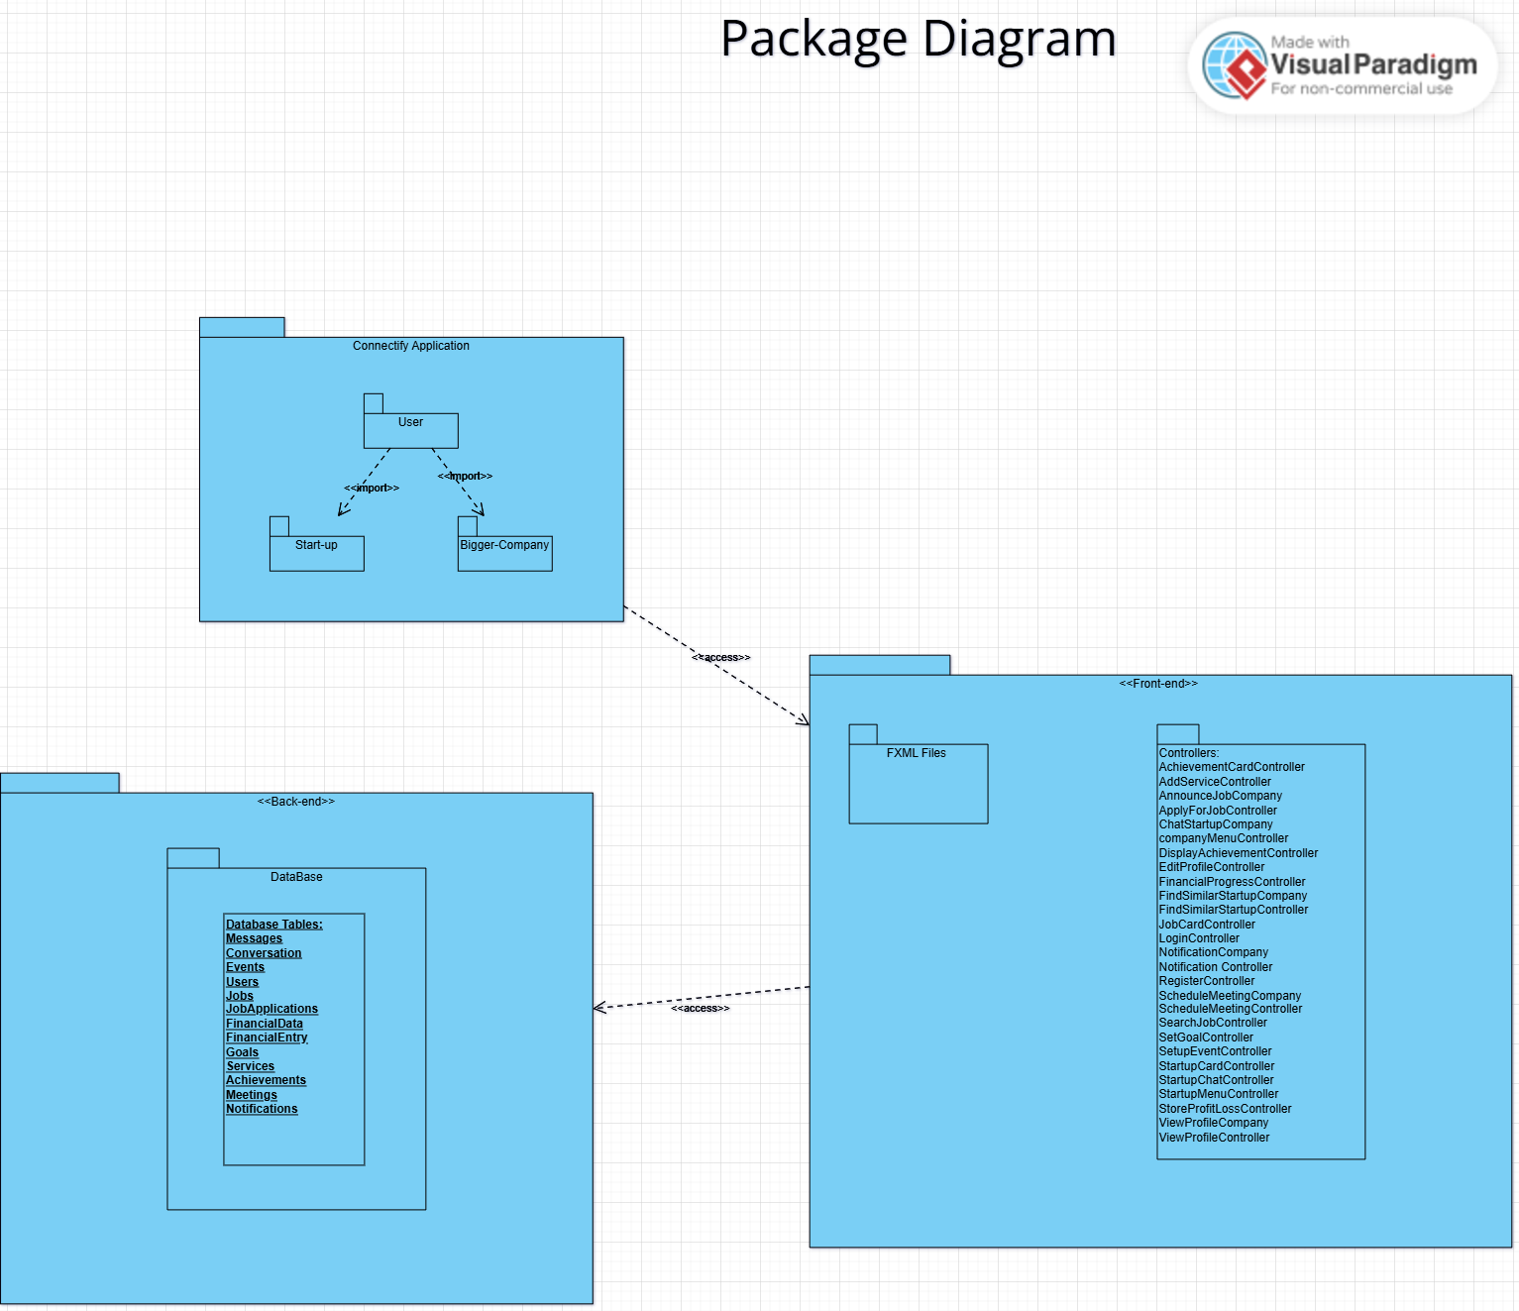

Deployment Diagram: 