Introduction to Database Systems

Project Report

Green Line



**B.S. (SE) 2000**

**Submitted by:**

**Ayesha Munir : 2020/Comp/BS(SE)/25269**

**Ravieha Haleem : 2020/Comp/BS(SE)/25304**

**10th December 2021**

**Department of Computer Science and Information Technology**

Jinnah University for Women

5-C Nazimabad, Karachi 74600

Contents

**Chapter 1:** 3

**Acknowledgment:** 3

**Project Overview:** 3

**Aims and Objectives:** 3

**Project Scope:** 3

**Chapter 2: System Design** 3

**Data Dictionary:** 3

**Entity relationship diagram:** 11

**Chapter 3: Coding** 12

**Access Tables:** 12

**Reports of tables:** 16

**Queries on Tables:** 18

**Chapter 4: Screen Shots** 22

Figure 1 Home 24

Figure 2 Registeration 25

Figure 3 Login 26

Figure 4 Staff Home 27

Figure 5 Allocation 28

Figure 6 Create Driver 29

Figure 7 Update Driver 30

# **Chapter 1:**

# **Acknowledgment:**

We would like to pay our special regards to Miss Samia Ghazala and Miss Surayya Obaid who helped us throughout the project and provided an opportunity to polish our skills according to our knowledge. And gave us the golden opportunity to do this project on the topic (Green Line), which also helped me in doing a lot of Research and we came to know about so many new things. I am really thankful to them.

# **Project Overview:**

This project is for the management of Green Bus administration, who will look after the data. Records of buses, routes and station will be at single place. Drivers will be enrolled to make secure travelling. The green bus include a card system instead of tickets, this system will be provided online and physical, it is also managed by administration.

# **Aims and Objectives:**

The Green bus management project will meet the following objectives:

1. To help easily capture the information of all employees, buses, routes, passenger and stations.
2. Provide ease to staff for maintaining these records from website.
3. To minimize data loss and provide fast access to data.
4. To reduce the time taken through manual system in order to maintain all the records.

# **Project Scope:**

The proposed software product is the Database system of Green bus Karachi. The system will be used to get the information from the passenger and then storing that data for future usage. The current system in use is a paper-based system. It is too slow and cannot provide updated lists of passengers within a reasonable timeframe. The intentions of the system are to reduce over-time pay and increase the number of passengers that can be treated accurately. Requirements statements in this document are both functional and non-functional.

# **Chapter 2: System Design**

# **Data Dictionary:**

***GREENBUS***

allocation

|  |  |  |  |  |  |  |
| --- | --- | --- | --- | --- | --- | --- |
| **Column** | **Type** | **Null** | **Default** | **Links to** | **Comments** | **Media type** |
| allocation_id (Primary) | int(11) | No |  |  |  |  |
| bus_no | varchar(6) | No |  | bus -> bus_no |  |  |
| driver_id | varchar(5) | No |  | driver -> driver_id |  |  |
| route_no | varchar(4) | No |  | route -> route_no |  |  |
| slot | varchar(40) | Yes | NULL |  |  |  |

Indexes

| **Keyname** | **Type** | **Unique** | **Packed** | **Column** | **Cardinality** | **Collation** | **Null** | **Comment** |
| --- | --- | --- | --- | --- | --- | --- | --- | --- |
| PRIMARY | BTREE | Yes | No | allocation_id | 5 | A | No |  |
| bus_no | BTREE | No | No | bus_no | 5 | A | No |  |
| driver_id | BTREE | No | No | driver_id | 5 | A | No |  |
| route_no | BTREE | No | No | route_no | 5 | A | No |  |

bus

|  |  |  |  |  |  |  |
| --- | --- | --- | --- | --- | --- | --- |
| **Column** | **Type** | **Null** | **Default** | **Links to** | **Comments** | **Media type** |
| bus_no (Primary) | varchar(6) | No |  |  |  |  |
| number_plate | varchar(7) | No |  |  |  |  |
| model_no | varchar(15) | Yes | NULL |  |  |  |
| model_year | int(4) | Yes | NULL |  |  |  |

Indexes

| **Keyname** | **Type** | **Unique** | **Packed** | **Column** | **Cardinality** | **Collation** | **Null** | **Comment** |
| --- | --- | --- | --- | --- | --- | --- | --- | --- |
| PRIMARY | BTREE | Yes | No | bus_no | 21 | A | No |  |
| number_plate | BTREE | Yes | No | number_plate | 21 | A | No |  |

card

|  |  |  |  |  |  |  |
| --- | --- | --- | --- | --- | --- | --- |
| **Column** | **Type** | **Null** | **Default** | **Links to** | **Comments** | **Media type** |
| card_id (Primary) | int(10) | No |  |  |  |  |
| type | varchar(30) | No |  |  |  |  |
| max_capacity | int(11) | No |  |  |  |  |
| balance | int(11) | Yes | NULL |  |  |  |
| valid_till | date | No |  |  |  |  |

Indexes

| **Keyname** | **Type** | **Unique** | **Packed** | **Column** | **Cardinality** | **Collation** | **Null** | **Comment** |
| --- | --- | --- | --- | --- | --- | --- | --- | --- |
| PRIMARY | BTREE | Yes | No | card_id | 5 | A | No |  |

customer_representative

|  |  |  |  |  |  |  |
| --- | --- | --- | --- | --- | --- | --- |
| **Column** | **Type** | **Null** | **Default** | **Links to** | **Comments** | **Media type** |
| login_id | varchar(5) | No |  | staff -> login_id |  |  |
| transaction_id | int(11) | No |  | transaction -> transaction_id |  |  |
| counter_no | varchar(10) | No |  |  |  |  |

Indexes

| **Keyname** | **Type** | **Unique** | **Packed** | **Column** | **Cardinality** | **Collation** | **Null** | **Comment** |
| --- | --- | --- | --- | --- | --- | --- | --- | --- |
| transaction_id | BTREE | No | No | transaction_id | 5 | A | No |  |
| login_id | BTREE | No | No | login_id | 5 | A | No |  |

departure

|  |  |  |  |  |  |  |
| --- | --- | --- | --- | --- | --- | --- |
| **Column** | **Type** | **Null** | **Default** | **Links to** | **Comments** | **Media type** |
| departure_id (Primary) | int(11) | No |  |  |  |  |
| bus_no | varchar(6) | No |  | bus -> bus_no |  |  |
| station_no | varchar(4) | No |  | station -> station_no |  |  |
| route_no | varchar(4) | No |  | route -> route_no |  |  |
| departure_time | time | Yes | NULL |  |  |  |
| arrival_time | time | Yes | NULL |  |  |  |

Indexes

| **Keyname** | **Type** | **Unique** | **Packed** | **Column** | **Cardinality** | **Collation** | **Null** | **Comment** |
| --- | --- | --- | --- | --- | --- | --- | --- | --- |
| PRIMARY | BTREE | Yes | No | departure_id | 5 | A | No |  |
| bus_no | BTREE | No | No | bus_no | 5 | A | No |  |
| station_no | BTREE | No | No | station_no | 5 | A | No |  |
| route_no | BTREE | No | No | route_no | 5 | A | No |  |

driver

|  |  |  |  |  |  |  |
| --- | --- | --- | --- | --- | --- | --- |
| **Column** | **Type** | **Null** | **Default** | **Links to** | **Comments** | **Media type** |
| driver_id (Primary) | varchar(5) | No |  |  |  |  |
| first_name | varchar(20) | No |  |  |  |  |
| last_name | varchar(20) | Yes | NULL |  |  |  |
| licence_no | varchar(25) | No |  |  |  |  |
| address | varchar(50) | Yes | NULL |  |  |  |
| date_of_birth | date | Yes | NULL |  |  |  |
| cnic | varchar(15) | No |  |  |  |  |

Indexes

| **Keyname** | **Type** | **Unique** | **Packed** | **Column** | **Cardinality** | **Collation** | **Null** | **Comment** |
| --- | --- | --- | --- | --- | --- | --- | --- | --- |
| PRIMARY | BTREE | Yes | No | driver_id | 6 | A | No |  |
| licence_no | BTREE | Yes | No | licence_no | 6 | A | No |  |

passenger

|  |  |  |  |  |  |  |
| --- | --- | --- | --- | --- | --- | --- |
| **Column** | **Type** | **Null** | **Default** | **Links to** | **Comments** | **Media type** |
| passenger_id (Primary) | varchar(5) | No |  |  |  |  |
| first_name | varchar(20) | No |  |  |  |  |
| last_name | varchar(20) | Yes | NULL |  |  |  |
| cnic | varchar(15) | No |  |  |  |  |
| address | varchar(50) | Yes | NULL |  |  |  |
| phone | varchar(12) | Yes | NULL |  |  |  |

Indexes

| **Keyname** | **Type** | **Unique** | **Packed** | **Column** | **Cardinality** | **Collation** | **Null** | **Comment** |
| --- | --- | --- | --- | --- | --- | --- | --- | --- |
| PRIMARY | BTREE | Yes | No | passenger_id | 5 | A | No |  |
| cnic | BTREE | Yes | No | cnic | 5 | A | No |  |

payment_method

|  |  |  |  |  |  |  |
| --- | --- | --- | --- | --- | --- | --- |
| **Column** | **Type** | **Null** | **Default** | **Links to** | **Comments** | **Media type** |
| payment_id (Primary) | int(5) | No |  |  |  |  |
| type | varchar(20) | No |  |  |  |  |
| amount | int(11) | No |  |  |  |  |
| account_name | varchar(30) | Yes | NULL |  |  |  |
| account_no | varchar(50) | Yes | NULL |  |  |  |

Indexes

| **Keyname** | **Type** | **Unique** | **Packed** | **Column** | **Cardinality** | **Collation** | **Null** | **Comment** |
| --- | --- | --- | --- | --- | --- | --- | --- | --- |
| PRIMARY | BTREE | Yes | No | payment_id | 5 | A | No |  |

resource_manager

|  |  |  |  |  |  |  |
| --- | --- | --- | --- | --- | --- | --- |
| **Column** | **Type** | **Null** | **Default** | **Links to** | **Comments** | **Media type** |
| login_id | varchar(5) | No |  | staff -> login_id |  |  |
| allocation_id | int(11) | No |  | allocation -> allocation_id |  |  |
| date | date | No |  |  |  |  |
| time | time | No |  |  |  |  |

Indexes

| **Keyname** | **Type** | **Unique** | **Packed** | **Column** | **Cardinality** | **Collation** | **Null** | **Comment** |
| --- | --- | --- | --- | --- | --- | --- | --- | --- |
| login_id | BTREE | No | No | login_id | 8 | A | No |  |
| allocation_id | BTREE | No | No | allocation_id | 8 | A | No |  |

route

|  |  |  |  |  |  |  |
| --- | --- | --- | --- | --- | --- | --- |
| **Column** | **Type** | **Null** | **Default** | **Links to** | **Comments** | **Media type** |
| route_no (Primary) | varchar(4) | No |  |  |  |  |
| route_name | varchar(30) | No |  |  |  |  |
| origin | varchar(30) | Yes | NULL |  |  |  |
| destination | varchar(30) | Yes | NULL |  |  |  |

Indexes

| **Keyname** | **Type** | **Unique** | **Packed** | **Column** | **Cardinality** | **Collation** | **Null** | **Comment** |
| --- | --- | --- | --- | --- | --- | --- | --- | --- |
| PRIMARY | BTREE | Yes | No | route_no | 5 | A | No |  |

staff

|  |  |  |  |  |  |  |
| --- | --- | --- | --- | --- | --- | --- |
| **Column** | **Type** | **Null** | **Default** | **Links to** | **Comments** | **Media type** |
| login_id (Primary) | varchar(5) | No |  |  |  |  |
| first_name | varchar(20) | No |  |  |  |  |
| last_name | varchar(20) | Yes | NULL |  |  |  |
| cnic | varchar(15) | No |  |  |  |  |
| date_of_birth | date | No |  |  |  |  |
| address | varchar(40) | Yes | NULL |  |  |  |
| email | varchar(30) | Yes | NULL |  |  |  |
| phone | varchar(12) | No |  |  |  |  |
| staff_type | varchar(50) | No |  |  |  |  |
| password | varchar(30) | No |  |  |  |  |

Indexes

| **Keyname** | **Type** | **Unique** | **Packed** | **Column** | **Cardinality** | **Collation** | **Null** | **Comment** |
| --- | --- | --- | --- | --- | --- | --- | --- | --- |
| PRIMARY | BTREE | Yes | No | login_id | 17 | A | No |  |
| password | BTREE | Yes | No | password | 17 | A | No |  |
| cnic | BTREE | Yes | No | cnic | 17 | A | No |  |

station

|  |  |  |  |  |  |  |
| --- | --- | --- | --- | --- | --- | --- |
| **Column** | **Type** | **Null** | **Default** | **Links to** | **Comments** | **Media type** |
| station_no (Primary) | varchar(4) | No |  |  |  |  |
| station_name | varchar(30) | No |  |  |  |  |
| area | varchar(30) | No |  |  |  |  |
| price | int(11) | No |  |  |  |  |

Indexes

| **Keyname** | **Type** | **Unique** | **Packed** | **Column** | **Cardinality** | **Collation** | **Null** | **Comment** |
| --- | --- | --- | --- | --- | --- | --- | --- | --- |
| PRIMARY | BTREE | Yes | No | station_no | 10 | A | No |  |
| station_name | BTREE | Yes | No | station_name | 10 | A | No |  |

transaction

|  |  |  |  |  |  |  |
| --- | --- | --- | --- | --- | --- | --- |
| **Column** | **Type** | **Null** | **Default** | **Links to** | **Comments** | **Media type** |
| transaction_id (Primary) | int(10) | No |  |  |  |  |
| card_id | int(10) | No |  | card -> card_id |  |  |
| payment_id | int(5) | No |  | payment_method -> payment_id |  |  |
| purchase_time | datetime | No |  |  |  |  |
| passenger_id | varchar(5) | No |  | passenger -> passenger_id |  |  |

Indexes

| **Keyname** | **Type** | **Unique** | **Packed** | **Column** | **Cardinality** | **Collation** | **Null** | **Comment** |
| --- | --- | --- | --- | --- | --- | --- | --- | --- |
| PRIMARY | BTREE | Yes | No | transaction_id | 6 | A | No |  |
| card_id | BTREE | No | No | card_id | 6 | A | No |  |
| passenger_id | BTREE | No | No | passenger_id | 6 | A | No |  |
| payment_id | BTREE | No | No | payment_id | 6 | A | No |  |

**transport_controller**

|  |  |  |  |  |  |  |
| --- | --- | --- | --- | --- | --- | --- |
| **Column** | **Type** | **Null** | **Default** | **Links to** | **Comments** | **Media type** |
| login_id | varchar(5) | No |  | staff -> login_id |  |  |
| departure_id | int(11) | No |  | departure -> departure_id |  |  |
| shift | varchar(20) | No |  |  |  |  |

Indexes

| **Keyname** | **Type** | **Unique** | **Packed** | **Column** | **Cardinality** | **Collation** | **Null** | **Comment** |
| --- | --- | --- | --- | --- | --- | --- | --- | --- |
| departure_id | BTREE | Yes | No | departure_id | 5 | A | No |  |
| login_id | BTREE | No | No | login_id | 5 | A | No |  |

# **Entity relationship diagram:**

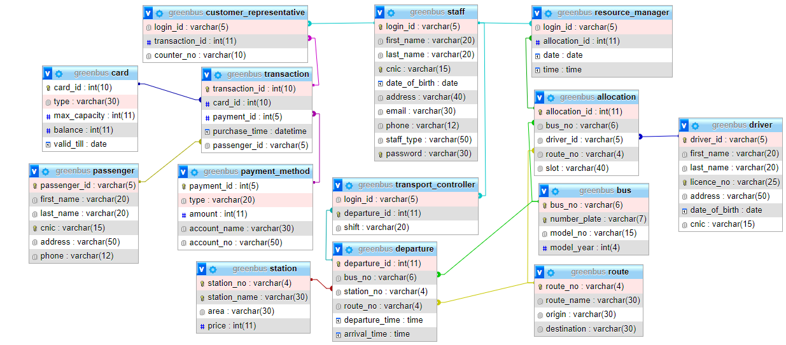

# **Chapter 3: Coding**

## **Access Tables:**

Staff**:**

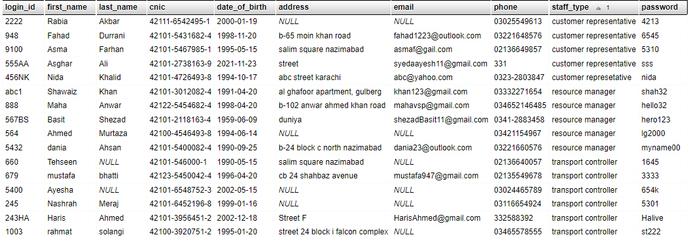

Customer Representative:

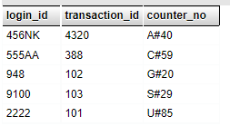

Transport Controller:

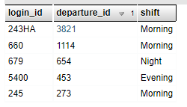

Resource Manager:

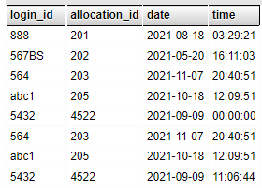

Transaction:

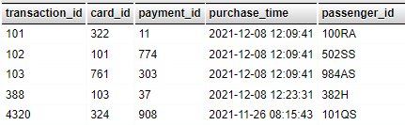

Departure:

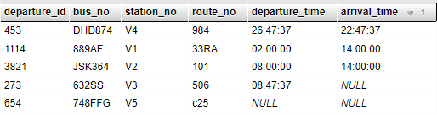

Allocation:

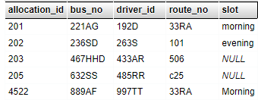

Card:

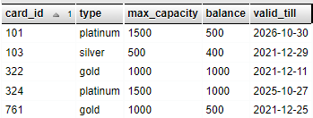

Passenger:

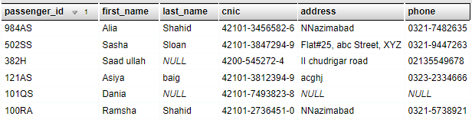

Payment Method:

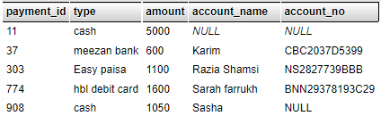

Bus:

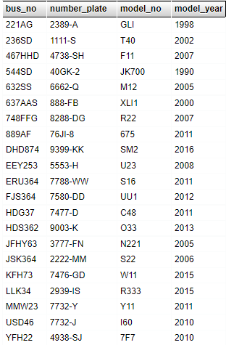

Route:

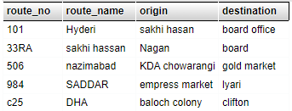

Station:

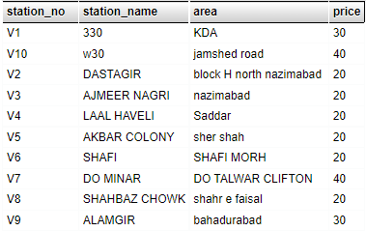

Driver:

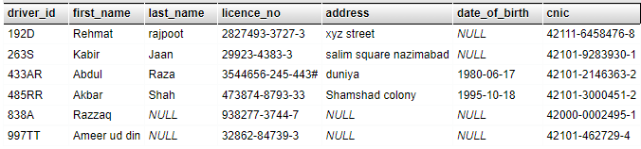

## **Reports of tables:**

Station report:

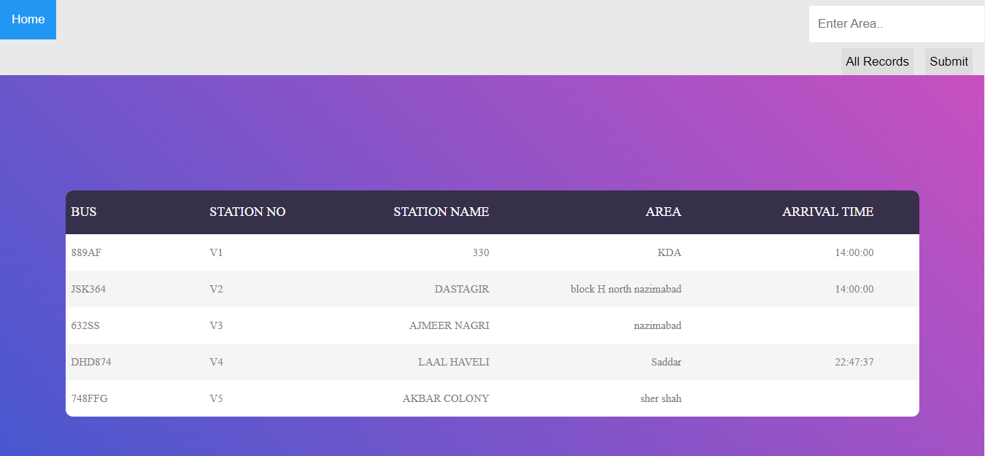

Purchase report:

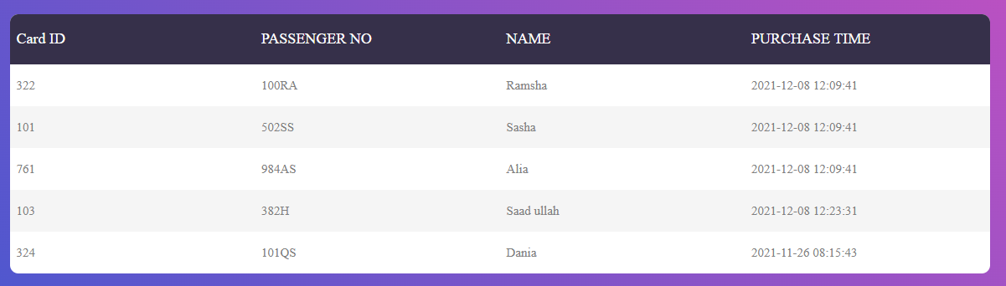

Transaction report:

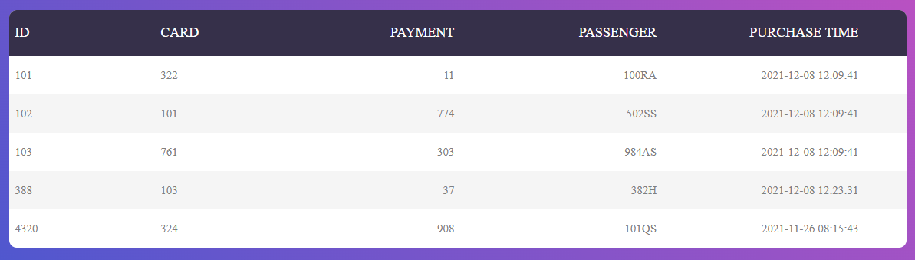

Allocation report:

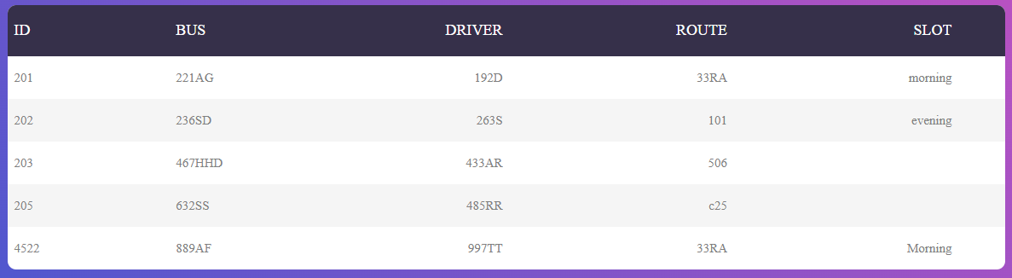

Departure report:

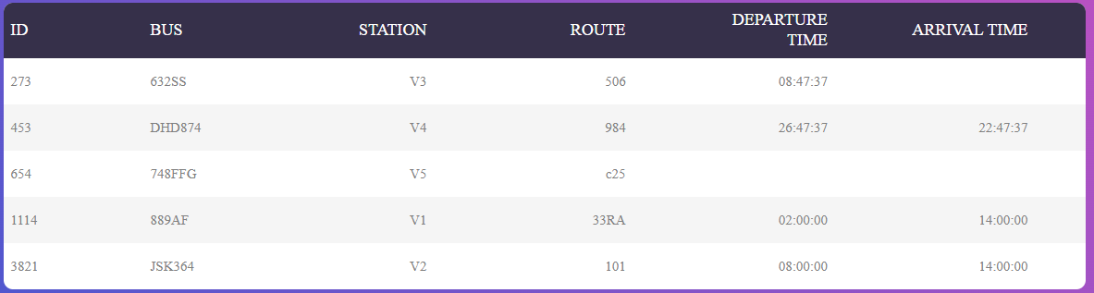

## **Queries on Tables:**

Sign Up:

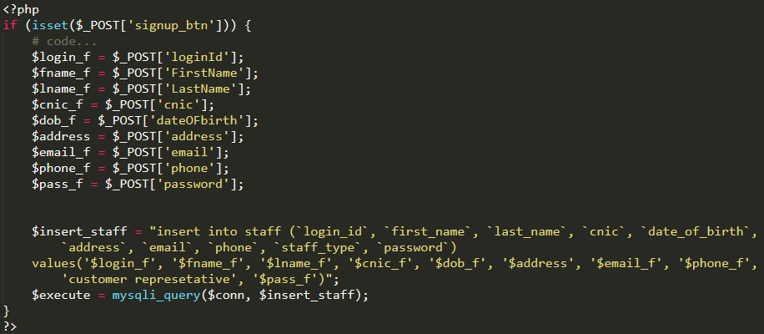

Login:

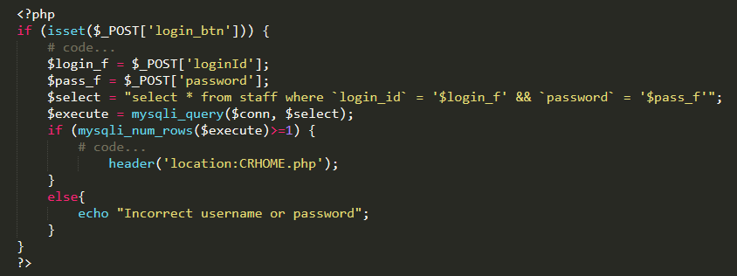

Update Driver:

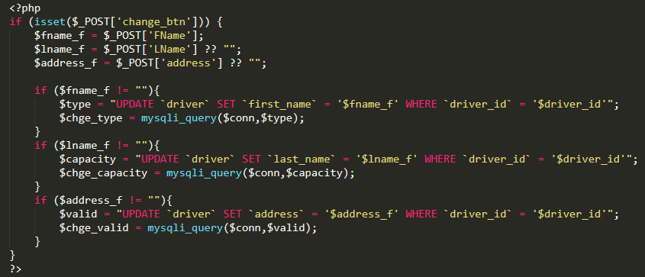

Create Transaction:

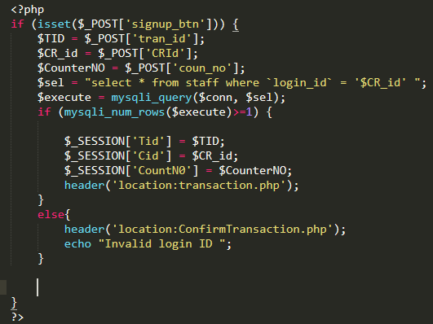

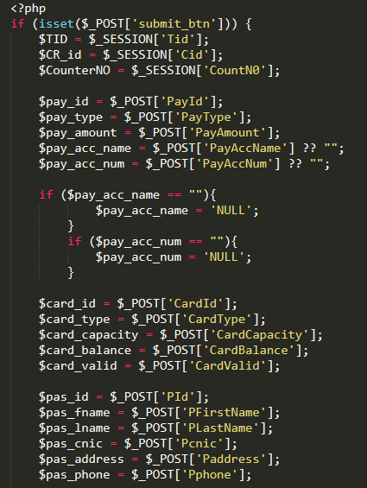

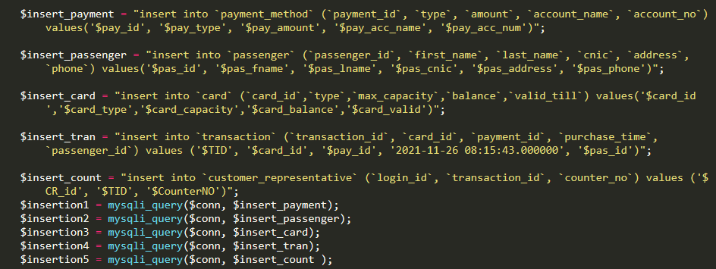

Search Transaction:

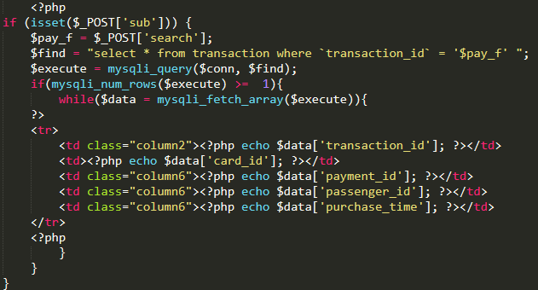

Delete Transaction:

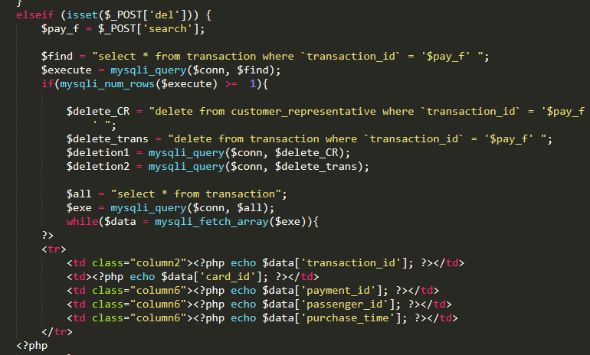

# **Chapter 4: Screen Shots**

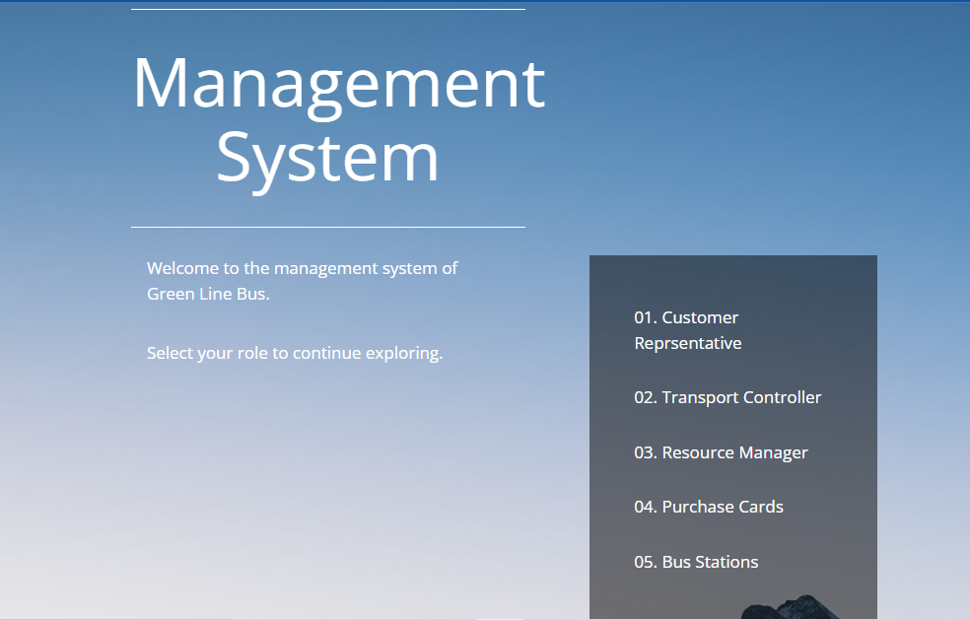

Figure 1 Home

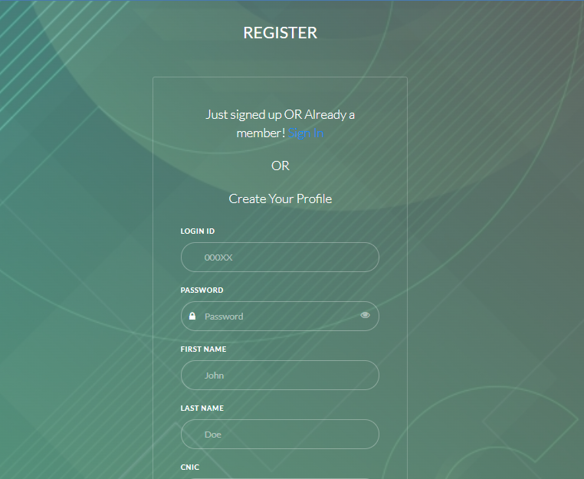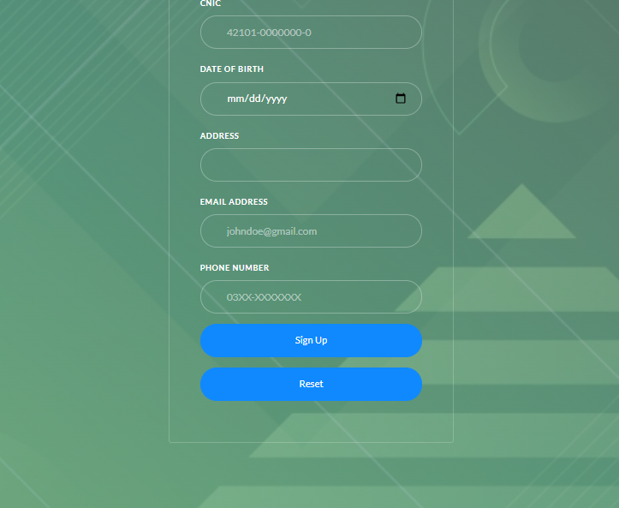

Figure 2 Registeration

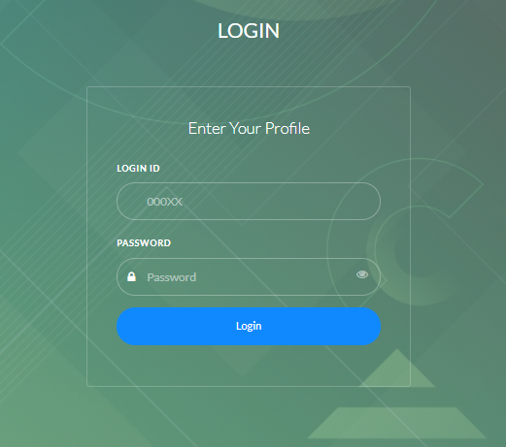

Figure 3 Login

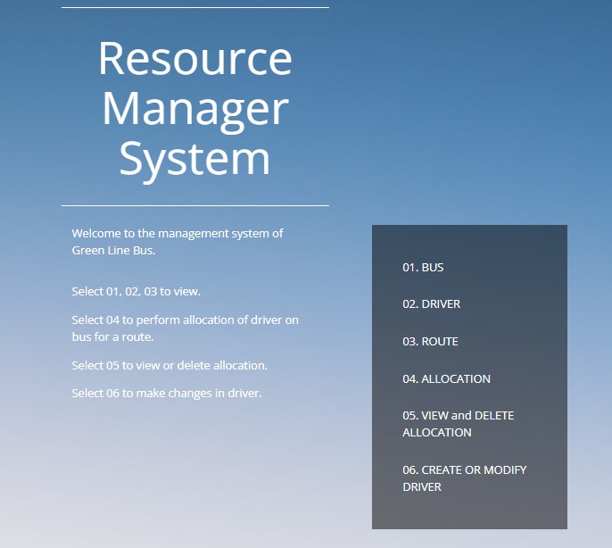

Figure 4 Staff Home

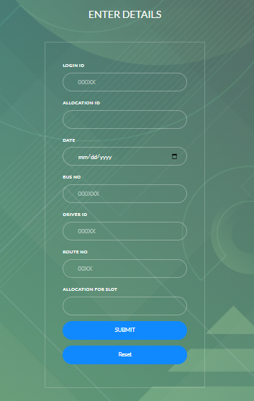

Figure 5 Allocation

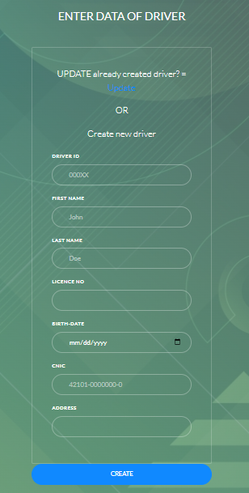

Figure 6 Create Driver

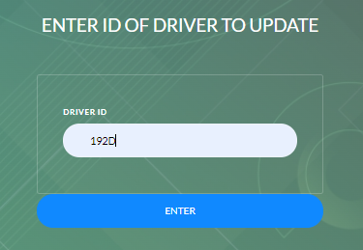

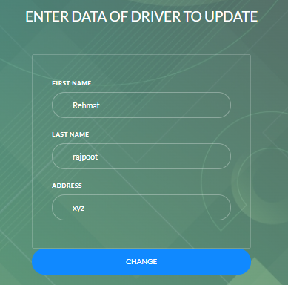

Figure 7 Update Driver