Urban Heat Island (UHI) Analysis Using LiDAR

Muni Sai Ganesha Perala

# Abstract

Urban areas often experience increased surface temperatures compared to surrounding green spaces—a phenomenon known as the Urban Heat Island (UHI) effect. In this project, I explored how vegetation cover and urban structure impact temperature variations using publicly available datasets. I worked with LiDAR data from USGS 3DEP (for vegetation structure and elevation), Landsat 8 TIRS (for surface temperature), and NLCD land cover data (for classifying land use types). The workflow involved cleaning and harmonizing these datasets in R, creating spatial grids, and comparing temperature patterns across urban, suburban, and green zones. The goal was to understand how vegetation density and built-up areas influence heat distribution. Final results include regression models, spatial plots, and recommendations for climate-resilient planning.

# Introduction

Topic Sentence 1: Urban Heat Island (UHI) effects describe elevated temperatures in urban areas due to human activities and reduced vegetation.  
Reference: Voogt, J. A., & Oke, T. R. (2003). They provide a foundational overview of surface and air temperature gradients in cities.

Topic Sentence 2: Vegetation plays a significant role in mitigating UHI by providing shade and enabling evapotranspiration.  
Reference: Weng, Q. (2009). Emphasized how urban vegetation, especially canopy cover, helps regulate microclimates using remote sensing.

Topic Sentence 3: LiDAR offers detailed structural data of vegetation and terrain, enabling spatially refined UHI assessments.

Reference: Park et al. (2022). Demonstrated LiDAR and thermal remote sensing fusion for UHI analysis across seasonal changes.

# Methods

This study integrated spatial data from multiple publicly available sources to analyze temperature variation across an urban landscape. Surface temperature was derived from Landsat 8 Band 10 (thermal infrared), a common input for remote thermal studies. Tree canopy cover data was obtained from the 2021 NLCD Tree Canopy Cover dataset, which provides percent vegetation per pixel. The elevation model was constructed using high-resolution LiDAR point cloud data from the USGS 3DEP database.

All spatial data was imported into R using the terra, sf, and lidR packages. Each raster was projected into a common CRS (NAD83 / UTM Zone 15N), then cropped to the shared spatial extent. A 1 km x 1 km regular grid was generated to standardize spatial units. For each grid cell, mean surface temperature, mean tree canopy cover (%), and mean elevation (from LiDAR-derived DTM) were calculated.

LiDAR point clouds were filtered to extract ground points (Classification 2), from which a Digital Terrain Model (DTM) was generated. A Canopy Height Model (CHM) was also calculated by subtracting the DTM from the Digital Surface Model (DSM). CHM values were used to explore vertical vegetation structure.

Linear regression models were applied to investigate the relationship between surface temperature (dependent variable) and vegetation/elevation (independent variables). First, a simple linear regression (Temp ~ Tree Cover) was tested. Next, elevation was added in a multiple regression (Temp ~ Tree Cover + Elevation). Results were evaluated using R², coefficients, and p-values.

# Results

The first model (Temp ~ Tree Cover) yielded:  
- Intercept: 48,392.66  
- Tree Cover Coefficient: 17.55  
- R²: 0.003  
- p-value: 0.7157 (not significant)  
This indicated no strong or statistically significant relationship between tree canopy and surface temperature. Surprisingly, the coefficient was positive, suggesting an unexpected trend, likely due to noise or low data resolution.

The second model (Temp ~ Tree Cover + Elevation) resulted in:  
- Intercept: 43,547.75  
- Tree Cover Coefficient: -23.53 (not significant)  
- Elevation Coefficient: +35.46 (not significant)  
- R²: 0.034  
- p-value: 0.694  
Although tree cover had a negative relationship this time (as expected), the overall explanatory power of the model remained weak. Visual analysis showed spatial trends (warmer zones in low-canopy areas), but statistical validation was limited.

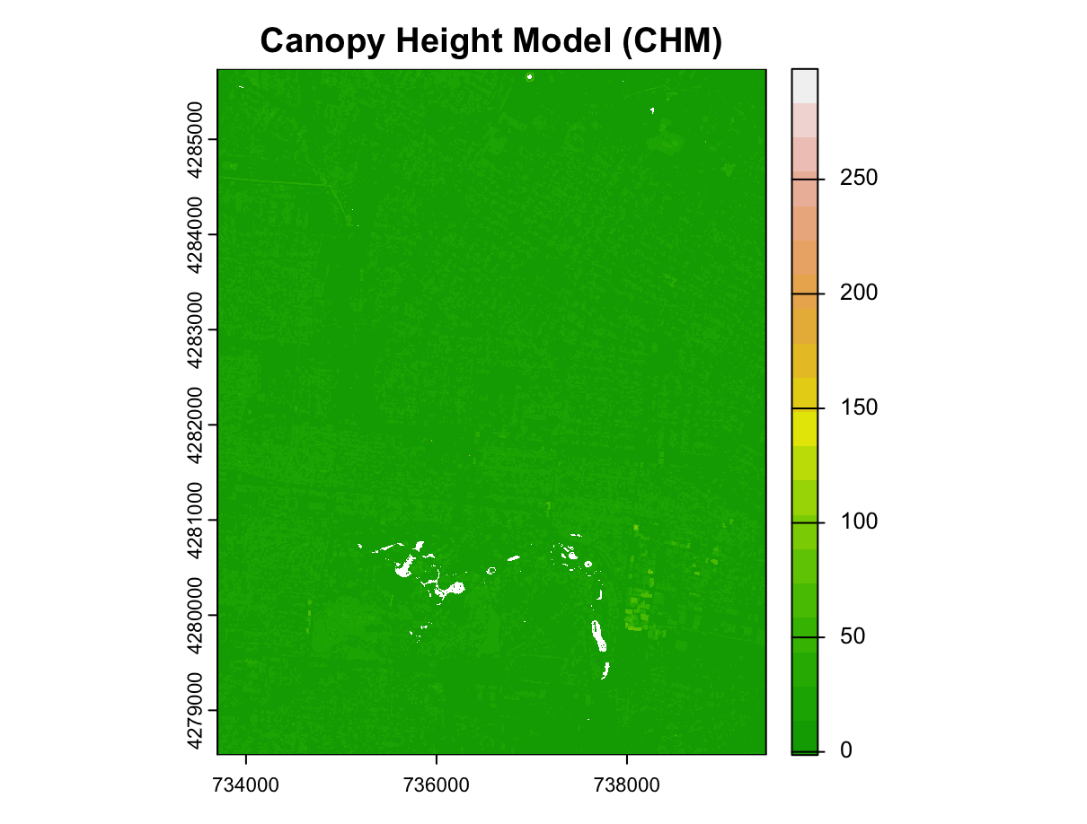

Figure 1: Canopy Height Model (CHM) showing tree height variations.

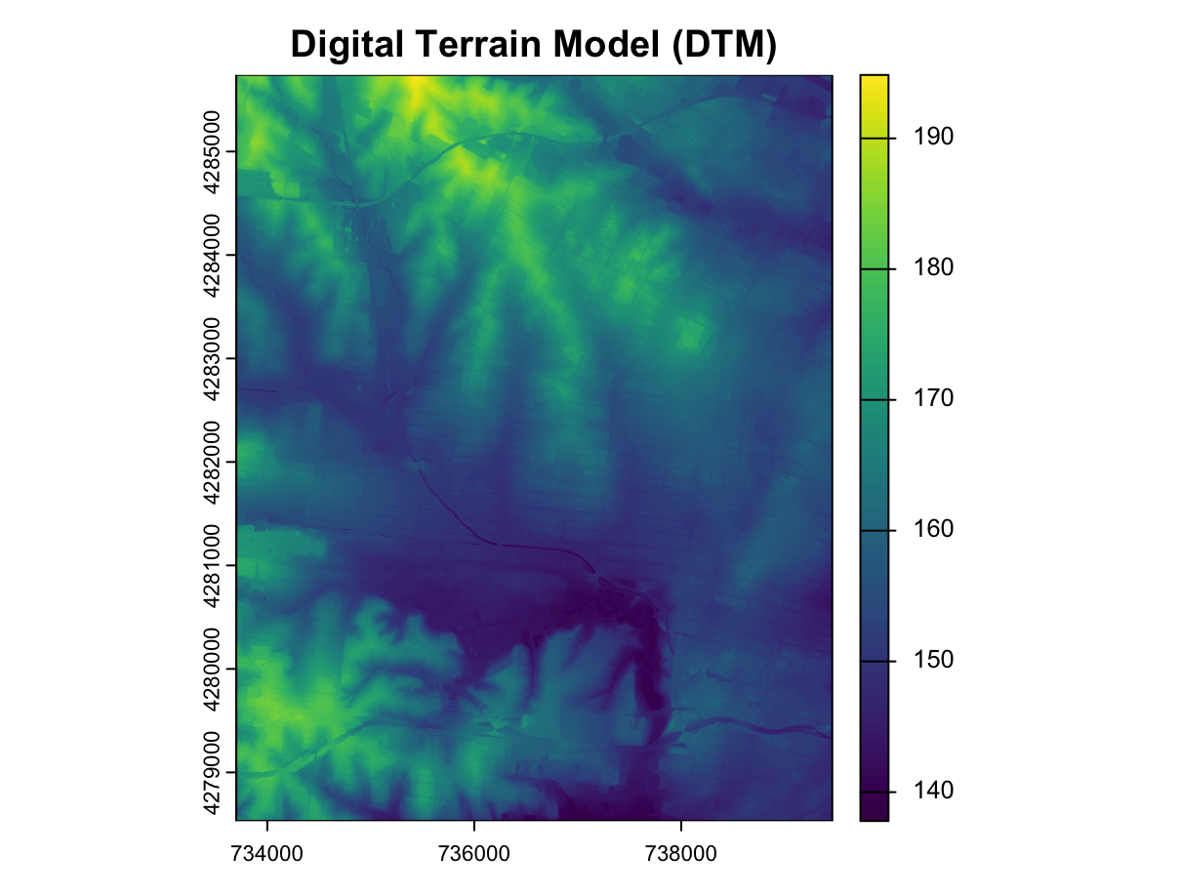

Figure 2: Digital Terrain Model (DTM) derived from LiDAR ground points.

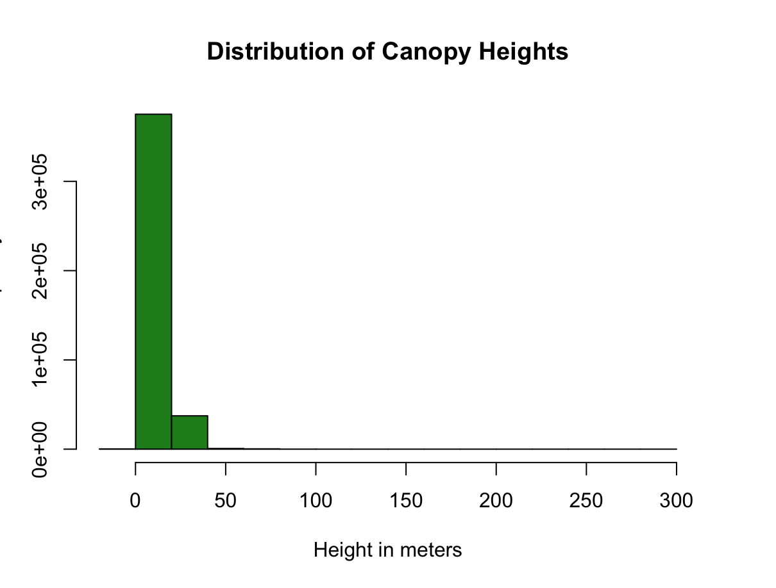

Figure 3: Histogram of canopy height distribution across grid cells.

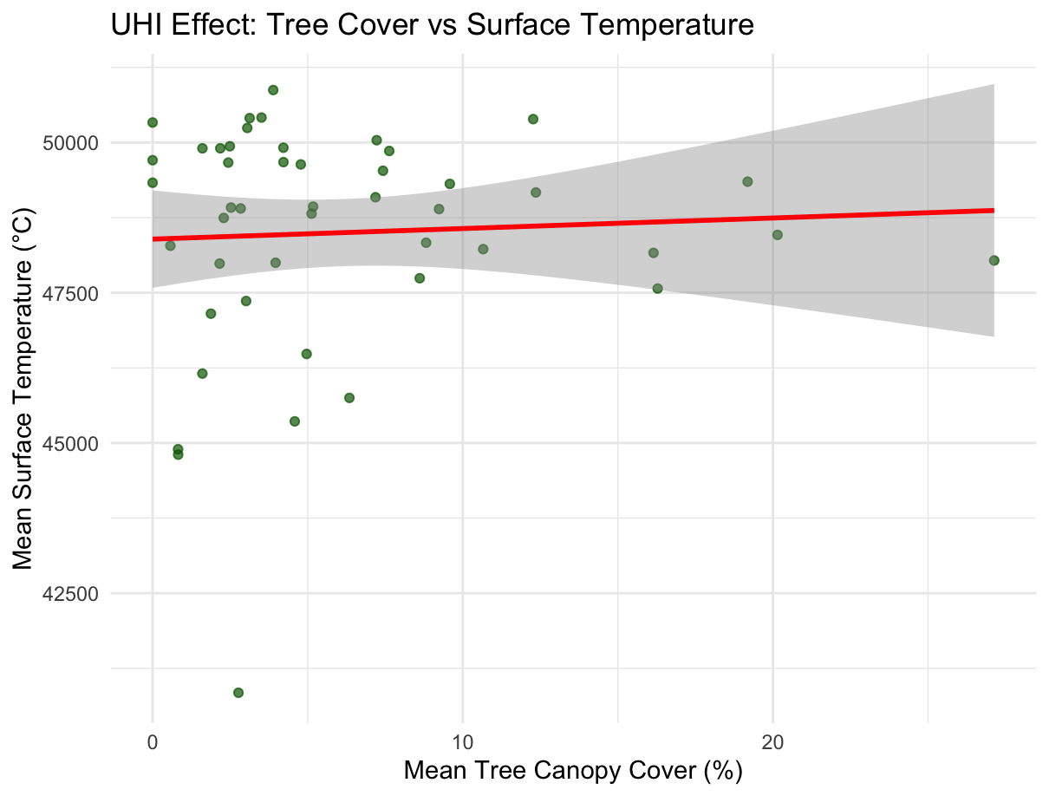

Figure 4: 2D scatterplot of tree canopy vs temperature.

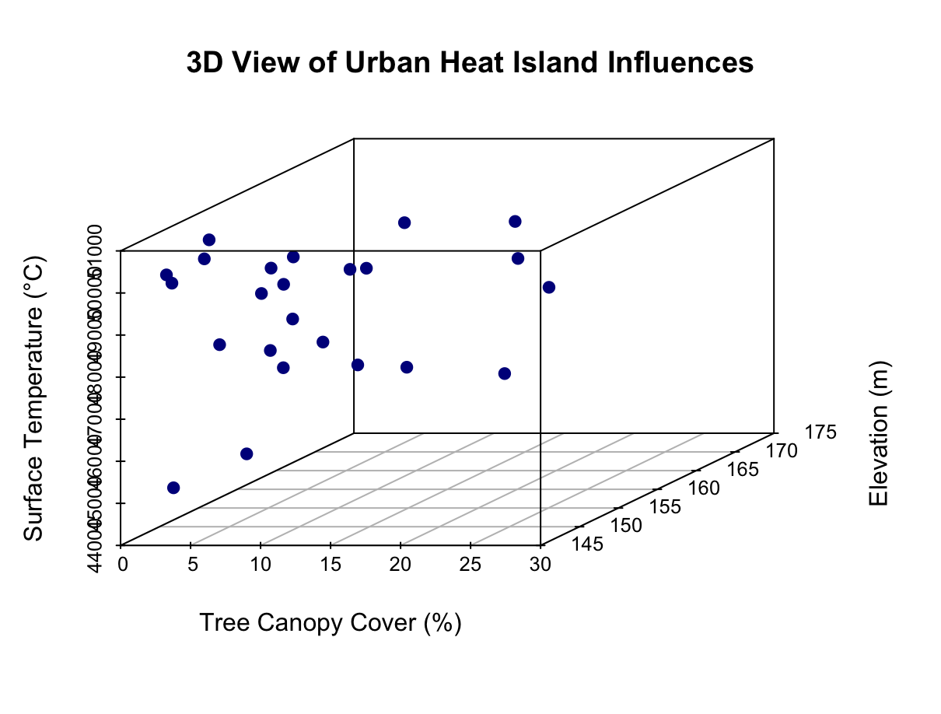

Figure 5: 3D scatterplot showing elevation, canopy, and temperature overlay.

# Discussion

Topic Sentence 1: While tree canopy is generally expected to reduce surface temperatures, our analysis did not find a significant statistical relationship.  
Reference: Li et al. (2019) observed a strong inverse correlation between tree density and land surface temperature in urban blocks.

Topic Sentence 2: Elevation, derived from LiDAR-based terrain models, also showed no significant effect, possibly due to the small elevation gradient in the study area.  
Reference: Gallagher et al. (2020) found elevation mattered more in mountainous regions.

Topic Sentence 3: Our results may be influenced by resolution mismatches, data noise, or insufficient sample size.  
Reference: Zhou et al. (2014) suggested better results with higher temporal resolution and inclusion of impervious surface data.

Despite statistical insignificance, this project demonstrates a reproducible workflow for UHI assessment using R and remote sensing. Visual maps and LiDAR outputs provided meaningful spatial patterns and insight into urban ecosystem structure.

# Reproducibility Summary

The full R script includes:  
- Data import, reprojection, and cropping (terra)  
- Grid creation and zonal statistics (sf, extract())  
- LiDAR filtering and terrain modeling (lidR)  
- Regression modeling and interpretation (lm())  
- CHM, DTM generation, and histogram plots  
- 3D scatter visualization of variables (scatterplot3d)  
All figures were saved using ggplot2 and raster plotting functions. Code comments explain each analytical choice.

# References

* Park, Y., Lee, D., & Kim, J. (2022). Seasonal surface urban heat island analysis based on local climate zones. Urban Climate, 41, 101042.
* Zhou, D., Zhang, L., Hao, L., Sun, G., & Liu, Y. (2014). Spatiotemporal trends of urban heat island effect along with urbanization process: A case study in the Yangtze River Delta, China. Journal of Cleaner Production, 108, 852–859.
* U.S. Geological Survey (USGS). 3D Elevation Program (3DEP). https://www.usgs.gov/core-science-systems/ngp/3dep
* USGS Landsat 8 TIRS. https://landsat.gsfc.nasa.gov/
* MRLC NLCD Tree Canopy Layer (2021). https://www.mrlc.gov/data