

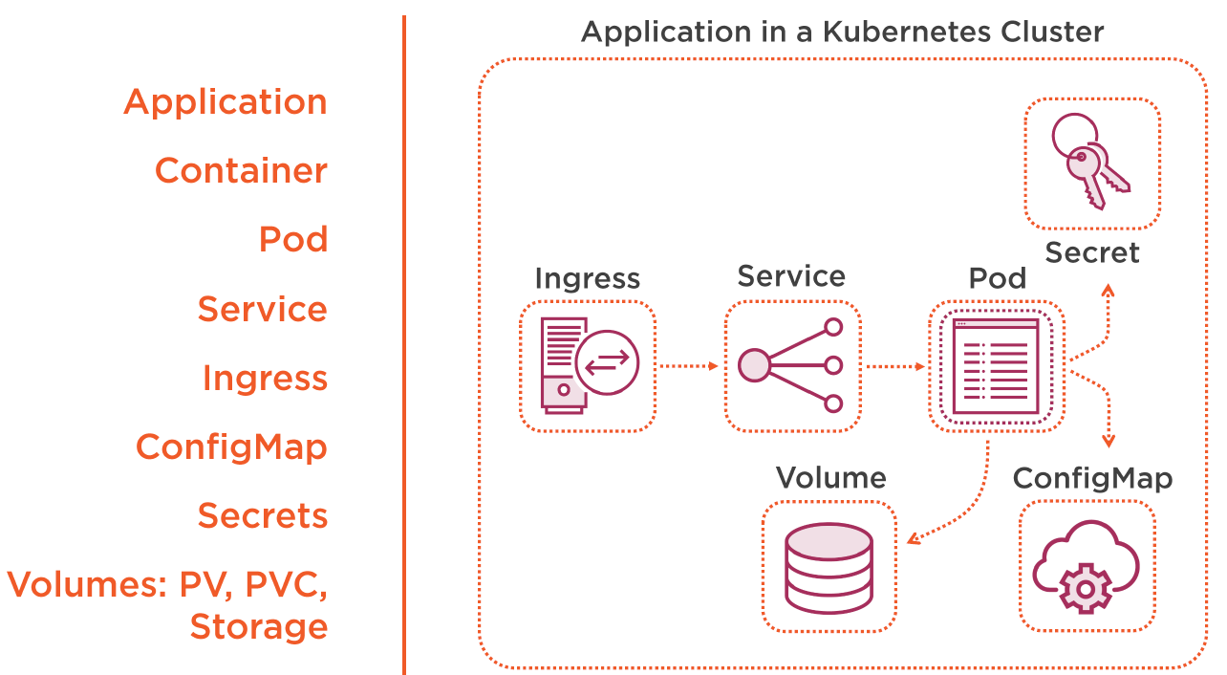

As you see in picture there will be many yml files, Helm will help manage and package those dependencies.