

Kubernetes is an open-source container-orchestration system for automating application deployment, scaling, and management of containerized applications. which used to automate container deployment.

Pods are thing but nodes. In pod we can have single or multiple containers. Every pod will have IP, memory, volumes, etc. shared across containers.

**Horizontal Scaling:**

**Self-Healing:** restarts the containers whenever it fails.

**Fault tolerance:** replace and re schedules whenever node dies.

**Clustering:**

**Zero downtime deployment:**

**Scheduling:**

**Load balancing:**

**Automated roll outs and roll backs:** roll out changes to application or config changes to all the instances (for all the container in cluster) with zero down time, it make sure it doesn’t kill all the instances same time. If any failure it’s roll backs.

**Configuration Management:** no need to redeploy.

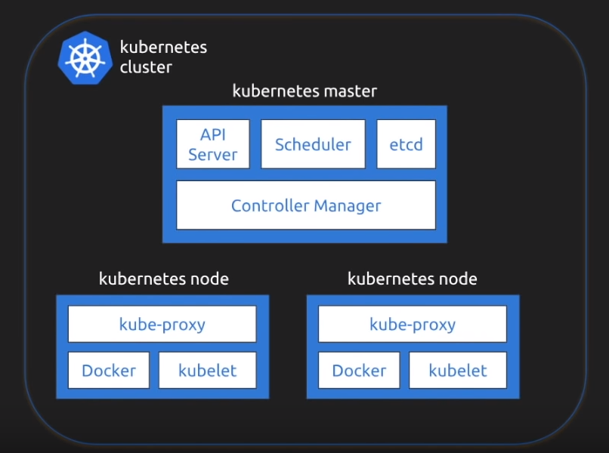

Kubernetes follows master slave architecture.

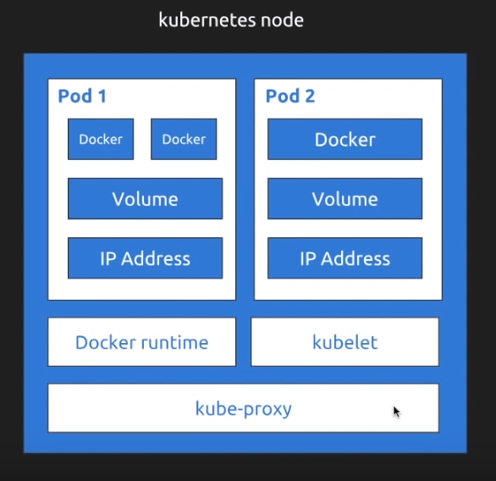

Kubernetes node will have one or multiple pods.

Container processes need to bind to different ports within a pod.

Kubernetes relies on Probes to determine the health of pod container. A probe is a diagnostic performed periodically by kubelet on a container. Two type of probes.

1. Liveness probe: used to determine if pod is healthy and running as expected.
2. Readiness probe: used to determine if pod should receive requests.

apiVersion: v1

kind: Pod

...

spec:

containers:

* name: my nginx

image: nginx:alpine

livenessProbe

httpGet

path: / index.html

port: 80

initialDelaySeconds : 15

timeoutSeconds : 2

periodSeconds : 5

failureThreshold : 1