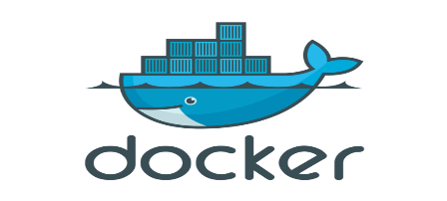

* Docker is a platform for developing, shipping and running applications using a container based Virtualization technique.
* The car needs an engine to run, similarly Docker needs an engine to run.
* Docker Engine sits on top of the host operating system
* In short **Docker** engine, ***is a lightweight container run time***. Let us go through what it means.

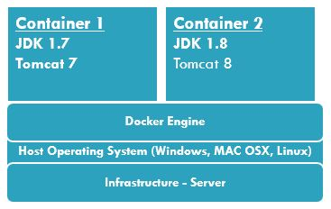

**Docker**

* Runs the same operating system as the Host OS.
* This allows it to share a lot of host operating system resources.
* In order to achieve this they originally used **LXC** (LinuX Containers) but later moved to **runC** (aka libcontainer).
* **AuFS is a layered file system**, so you can have a read only part and a write part which are merged together. One could have the common parts of the operating system as read only (and shared amongst all of your containers) and then give each container its own mount for writing.

**Virtual Machines**

* A full virtualized system **gets its own set of resources** allocated to it, and does minimal sharing.
* You get more isolation, but it **is much heavier** (requires more resources). With docker you get less isolation, but the containers are lightweight (require fewer resources).

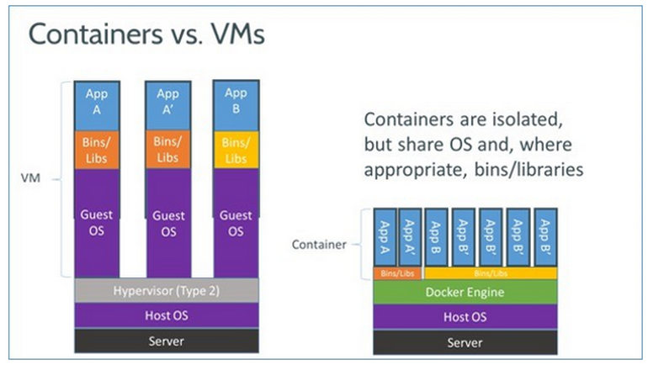

**What is the Docker platform?**

Docker provides the ability to **package** and **run** an application in a **loosely isolated environment called a container.** The isolation and security allow you to run **many containers simultaneously on a given host**.

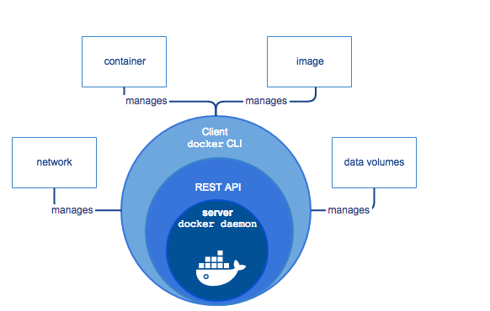

**What is the Docker Engine?**

***Docker Engine*** is a client-server application with these major components:

A **server** which is a type of long-running program called a daemon process.

A **REST API** which specifies interfaces that programs can use to talk to the daemon and instruct it what to do.

A command line **interface (CLI) client**.

From docker image you can create multiple containers.

**Docker Commands:**

$ docker version

$ docker –v



**MYSQL DB:**

$ docker pull mysql:5.7

Pulls the Docker image from docker hub <https://hub.docker.com/_/mysql/>

$ docker run --name mysql-standalone -e MYSQL_ROOT_PASSWORD=password -e MYSQL_DATABASE=test -e MYSQL_USER=sa -e MYSQL_PASSWORD=password

-d mysql:5.7

Command to run the mysql container.

$ docker build . -t users-mysql

Creating a docker image from the Spring Boot Application using the Dockerfile.

$ docker run -p 8086:8086 --name users-mysql --link mysql-standalone:mysql -d users-mysql

$ docker container ls

$ docker logs <container_name>

$ docker container rm <container_name>

<http://www.java67.com/2018/02/5-free-docker-courses-for-java-and-DevOps-engineers.html>