

1. **VOLUME**

Volume refers to the **amount of data** (peta bytes of data) generated through websites, portals and online applications.

1. **VELOCITY**

Velocity refer to the **speed with which data are being generated**. Staying with our social media example, every day 900 million photos are uploaded on Facebook, 500 million tweets are posted on Twitter, 0.4 million hours of video are uploaded on YouTube and 3.5 billion searches are performed in Google.

1. **VARIETY**

Variety in Big Data refers to all the structured and unstructured data that has the possibility of getting generated either by humans or by machines. The most commonly added data are structured -texts, tweets, pictures & videos. However, unstructured data like emails, voicemails, hand-written text, ECG reading, audio recordings etc, are also important elements under Variety.

Hadoop supports dynamic schema.

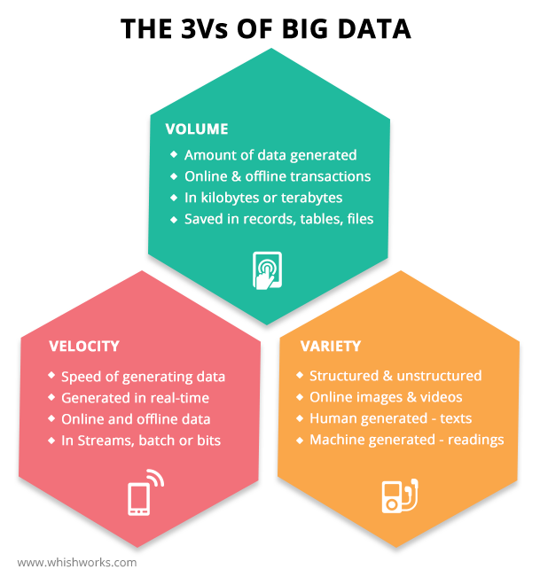

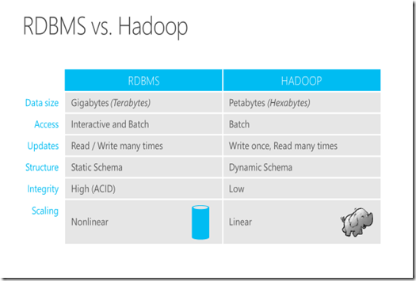

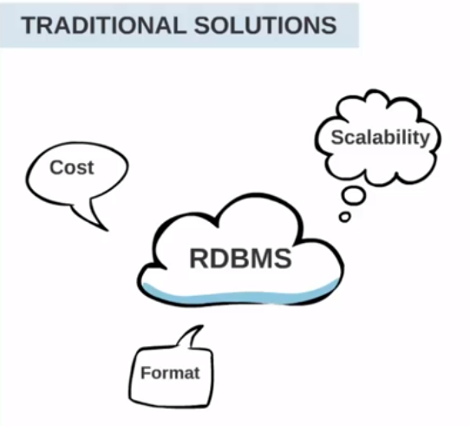

SQL data bases will not support unstructured data.