

1. generate setter and getter

alt + insert

1. remove unused imports

ctrl + alt + o

1. imports / override methods

alt + enter

<https://www.jetbrains.com/help/idea/creating-and-optimizing-imports.html>

1. switching project and work file

alt + 1

1. format selected text

ctrl + alt + L

1. format entire file

ctrl + shift + alt + L

1. if/else try/catch

ctrl + alt + t

1. searching file

ctrl + n (class file)

ctrl + shift + n (files)

1. ctrl + b for methods (will show all calling places)
2. ctrl + b for class (will go into class)
3. back

ctrl + alt + <-

1. recently opened files

ctrl + e

1. extract selected code into method

ctrl + alt + m

ctrl + alt + v for variable

1. code complete

ctrl + shift + space

1. check method signature parameters m1(ctrl + p)

ctrl + p

1. list methods in class

ctrl + f12

1. help or search all settings

ctrl + shift + a

1. You can quickly find all places where a particular class, method or variable is used in the whole project by positioning the caret at the symbol's name or at its usage in code and pressing Alt+F7 (Edit | Find | Find Usages in the popup menu).
2. To quickly see the documentation for a class or method at caret, press Ctrl+Q (View | Quick Documentation).

**Plugins:**

1. **Maven helper**
2. **Sonar lint**
3. **Java stream debugger**
4. **Spring assistant**
5. **Lombok**

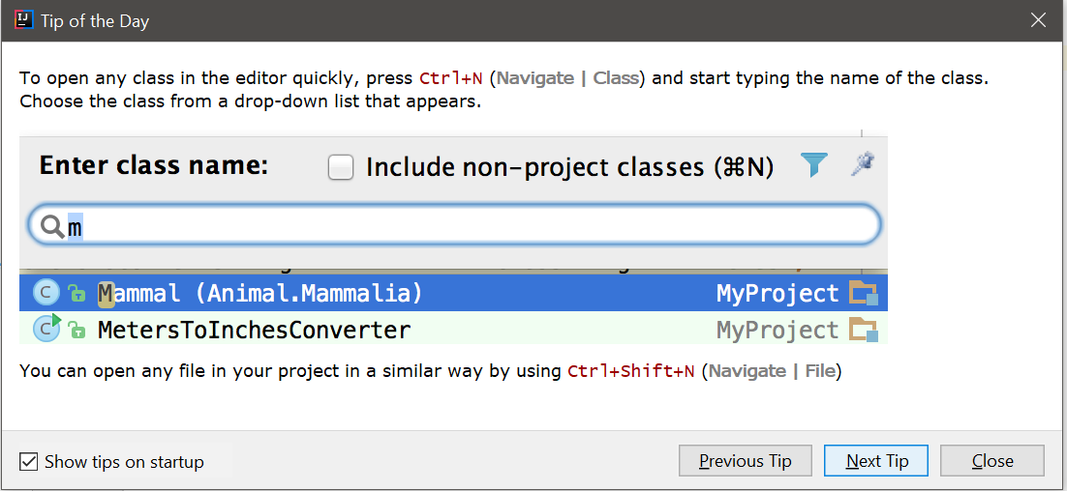

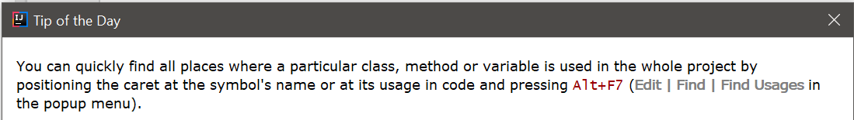

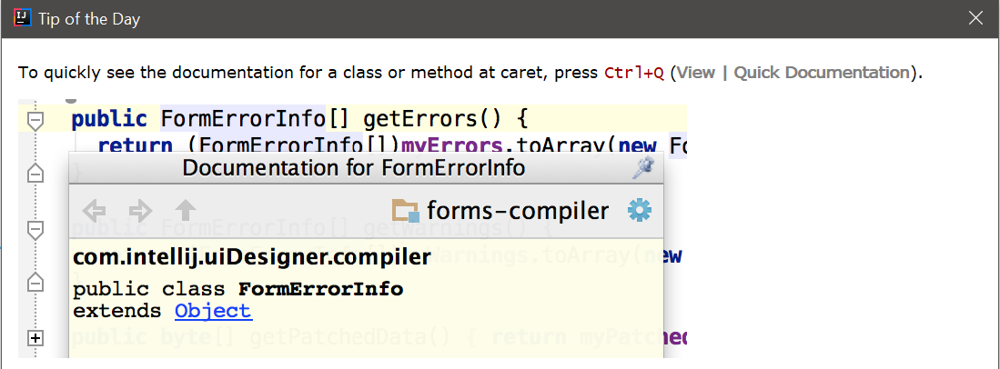

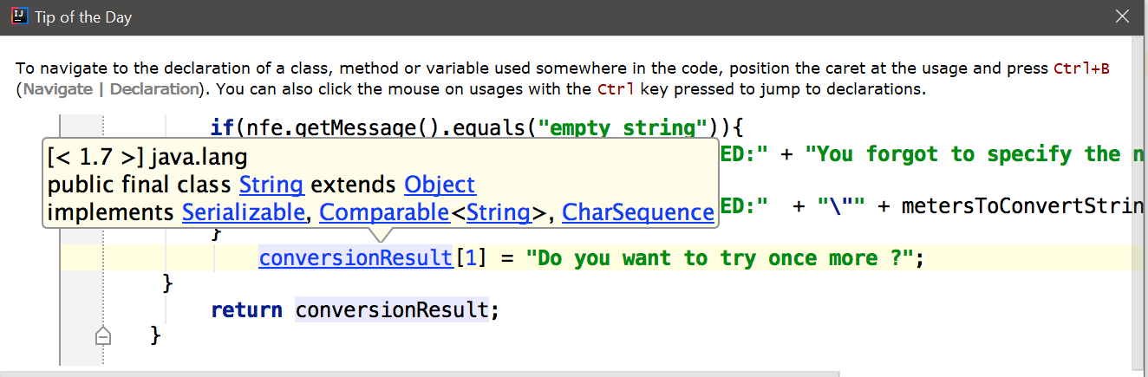

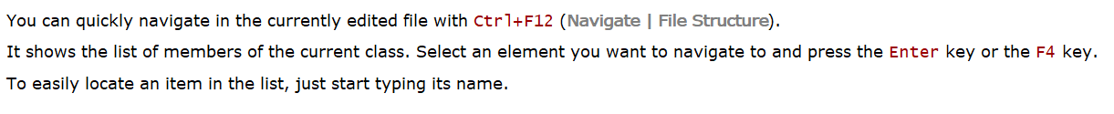

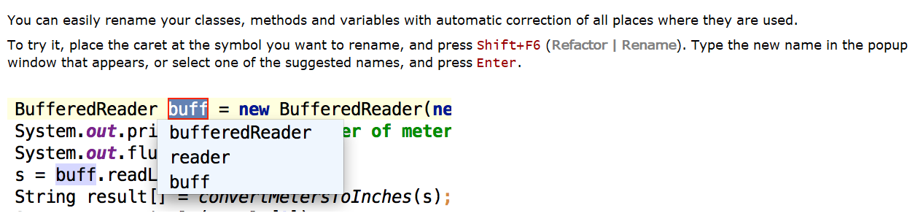



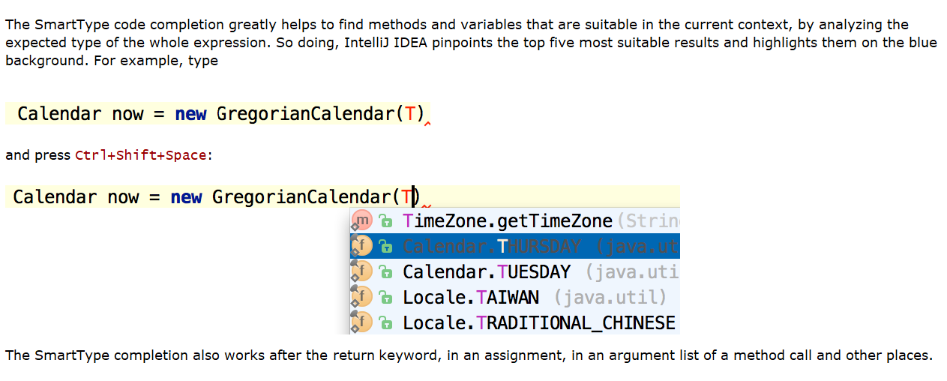



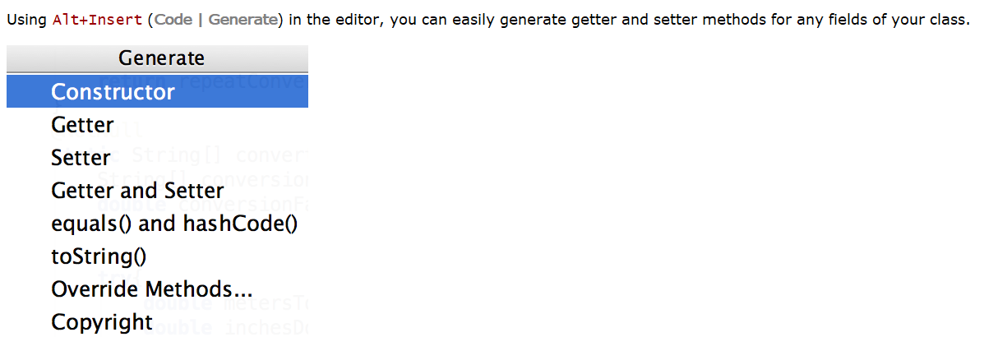

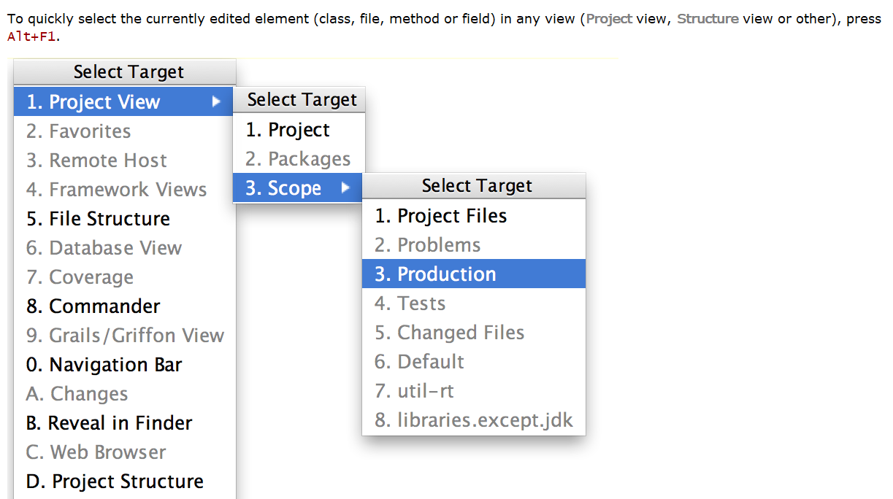

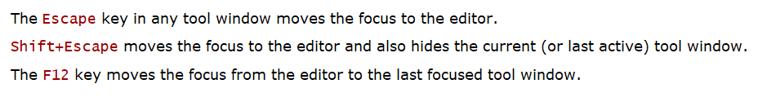

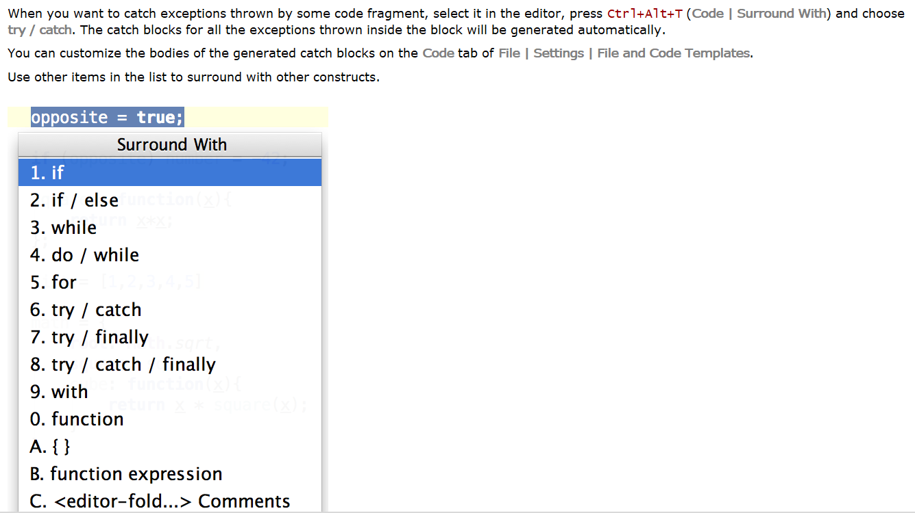

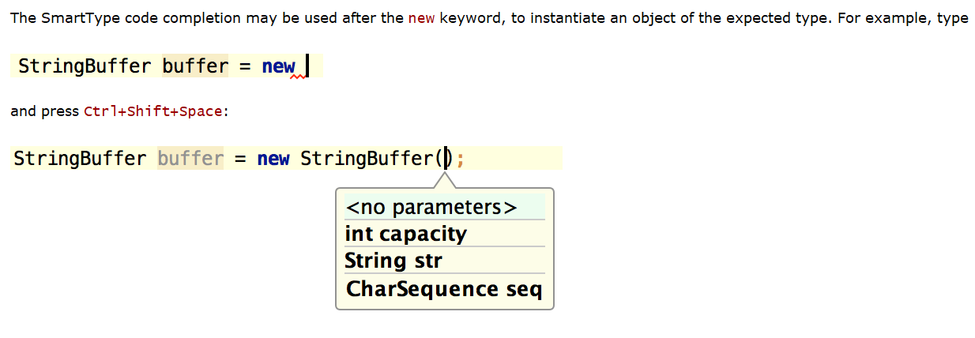





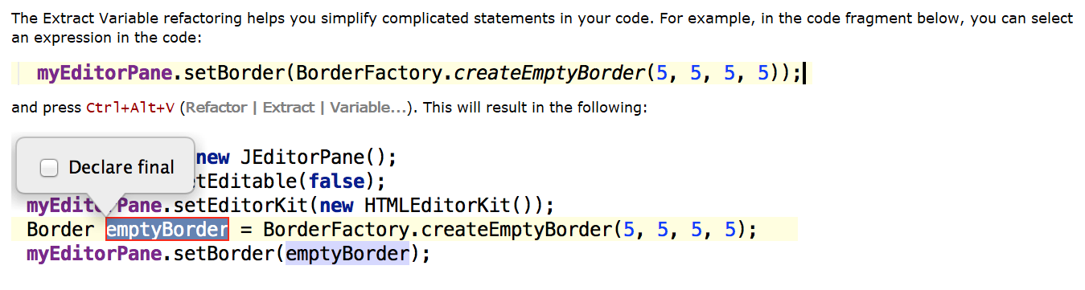

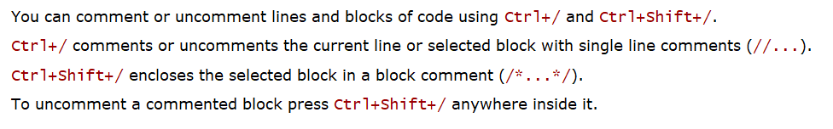



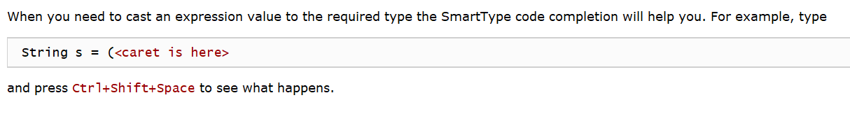

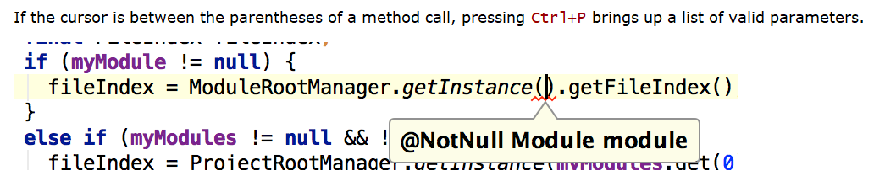



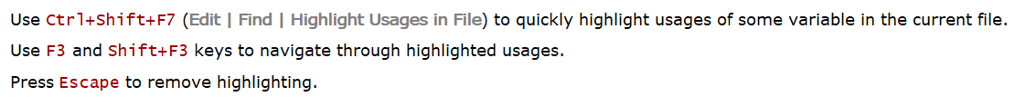

Press Alt+Q (View | Context Info) to see the declaration of the current method without the need to scroll to it.

