

The container orchestration plat form. Container management tool, which used automate container deployment.

Pods are thing but nodes. In pod we can have single or multiple containers. Every pod will have ip address.

**Horizontal Scaling:**

**Self-Healing:** restarts the containers whenever it fails.

**Fault tolerance:** replace and re schedules whenever node dies.

**Clustering:**

**Scheduling:**

**Load balancing:**

**Automated roll outs and roll backs:** roll out changes to application or config changes to all the instances (for all the container in cluster) with zero down time, it make sure it doesn’t kill all the instances same time. If any failure it’s roll backs.

**Configuration Management:** no need to redeploy.

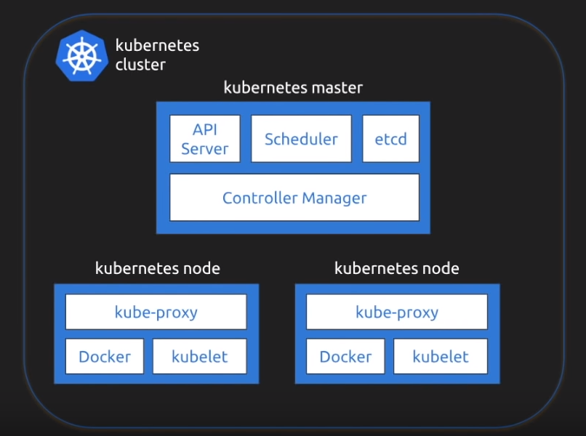

Kubernetes follows master slave architecture.

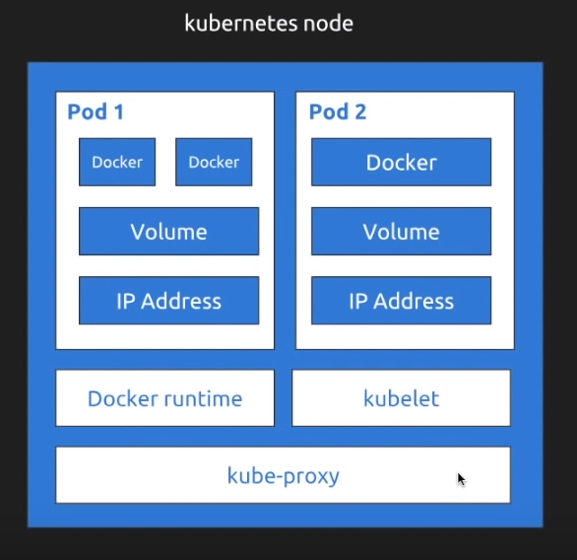

Kubernetes node will have one or multiple pods.