Step 1: Set Up the AWS Environment
1. Set Up AWS CLI and Boto3:
- Install AWS CLI and configure it with AWS credentials.
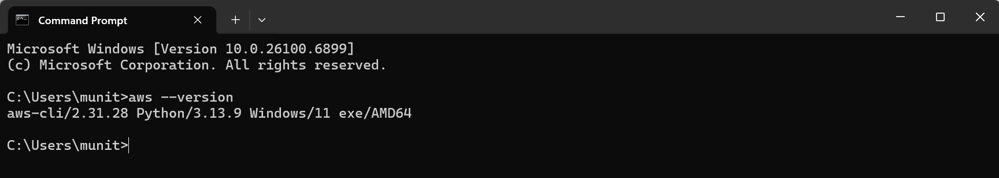
- Install Boto3 for Python and configure it.
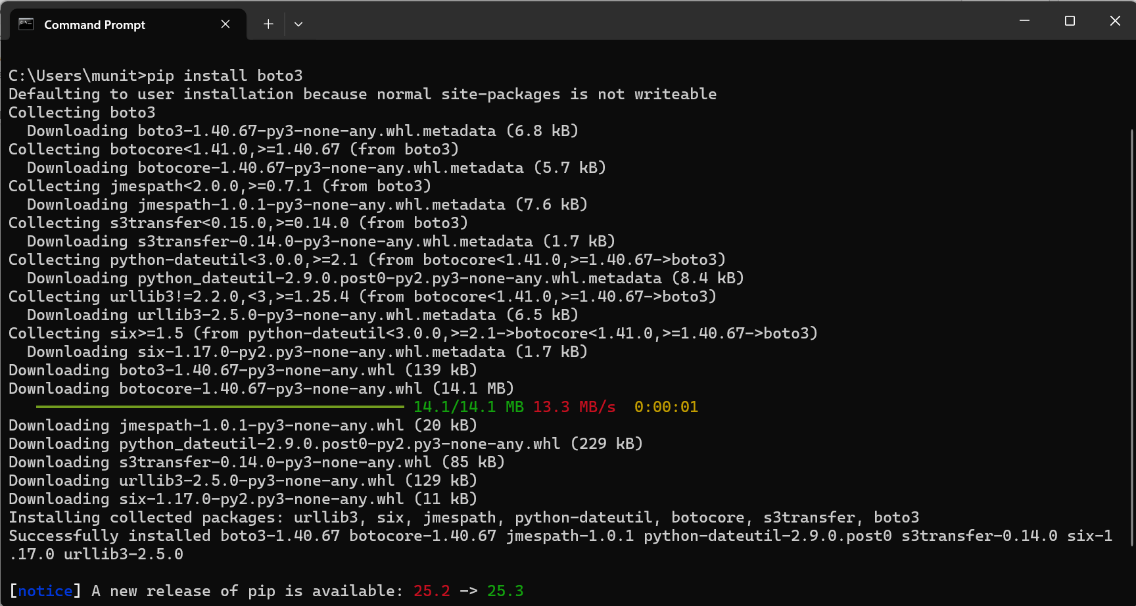
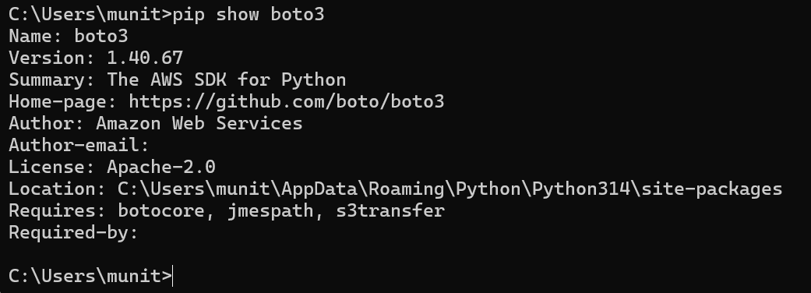
Configure AWS credentials by using the command “aws configure”
After successful configuration, run “aws sts get-caller-identity”
It will show something like below
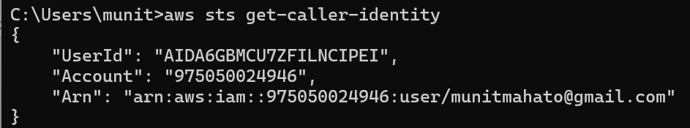
Now, we configured AWS credentials and boto 3
To check if Boto 3 is configured properly, create a python program and name it as you want, here I have named it as “myboto.py”
Python Code
import boto3
s3 = boto3.client('s3')
for bucket in s3.list_buckets()['Buckets']:
print(bucket['Name'])

and run using “python myboto.py”, this should all the s3 buckets in your aws.
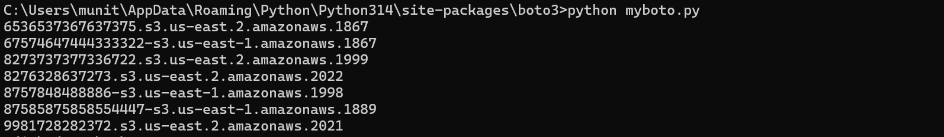

Step 2: Prepare the MERN Application
1. Containerize the MERN Application:
- Ensure the MERN application is containerized using Docker. Create a Dockerfile for each component (frontend and backend).
Create .env file for backend services
- For “Hello Service”, use PORT=3001
- For “Profile Service”, use PORT=3002
- Install npm
- Run Index.js
- “Hello Service” is running on “localhost:3001”
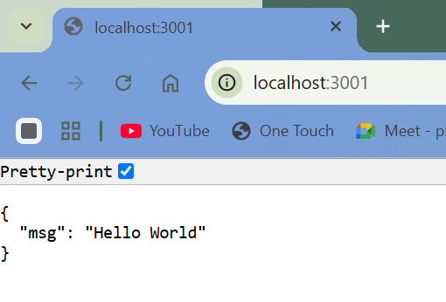
- “Profile Service” is running on “localhost:3002”
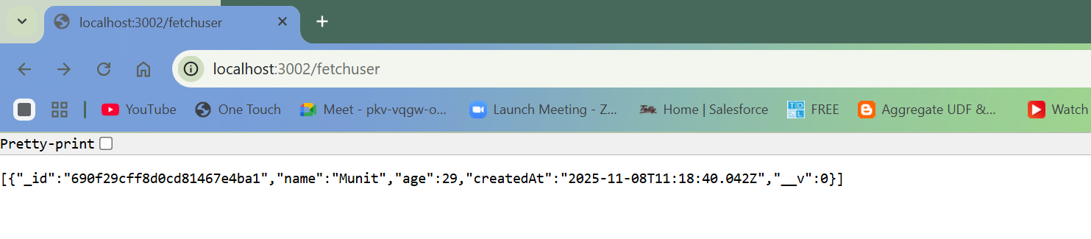
Note : We need to add user in mongo db
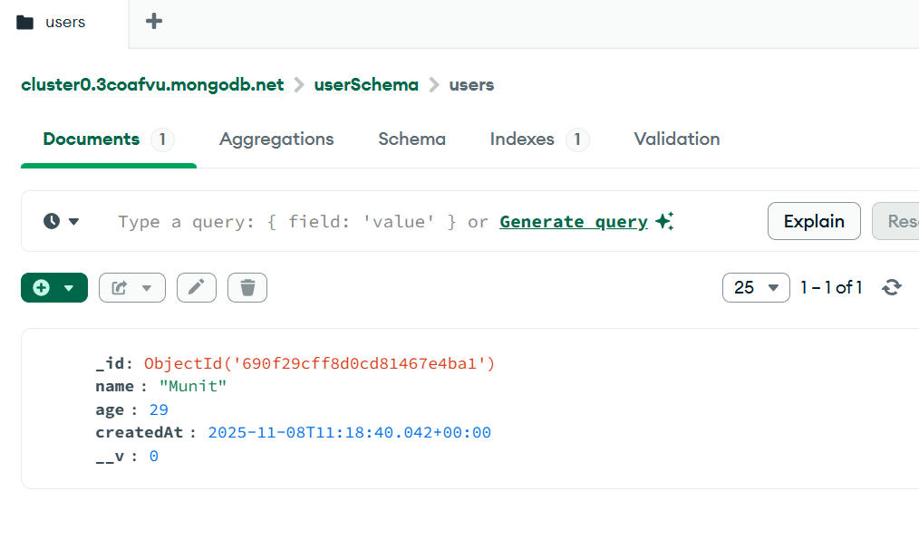
- Run Frontend
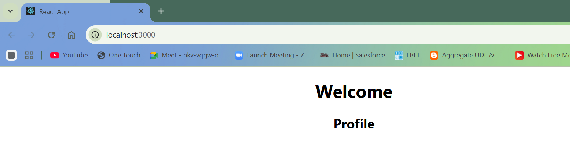

2. Push Docker Images to Amazon ECR:
- Build Docker images for the frontend and backend.
Created dockerfile for each service, backend (helloService and Profileservice) and frontend
- Create an Amazon ECR repository for each image.
Created Amazon ECR for each service
- Push the Docker images to their respective ECR repositories.

- Pushed docker image to ECR for backend HelloService
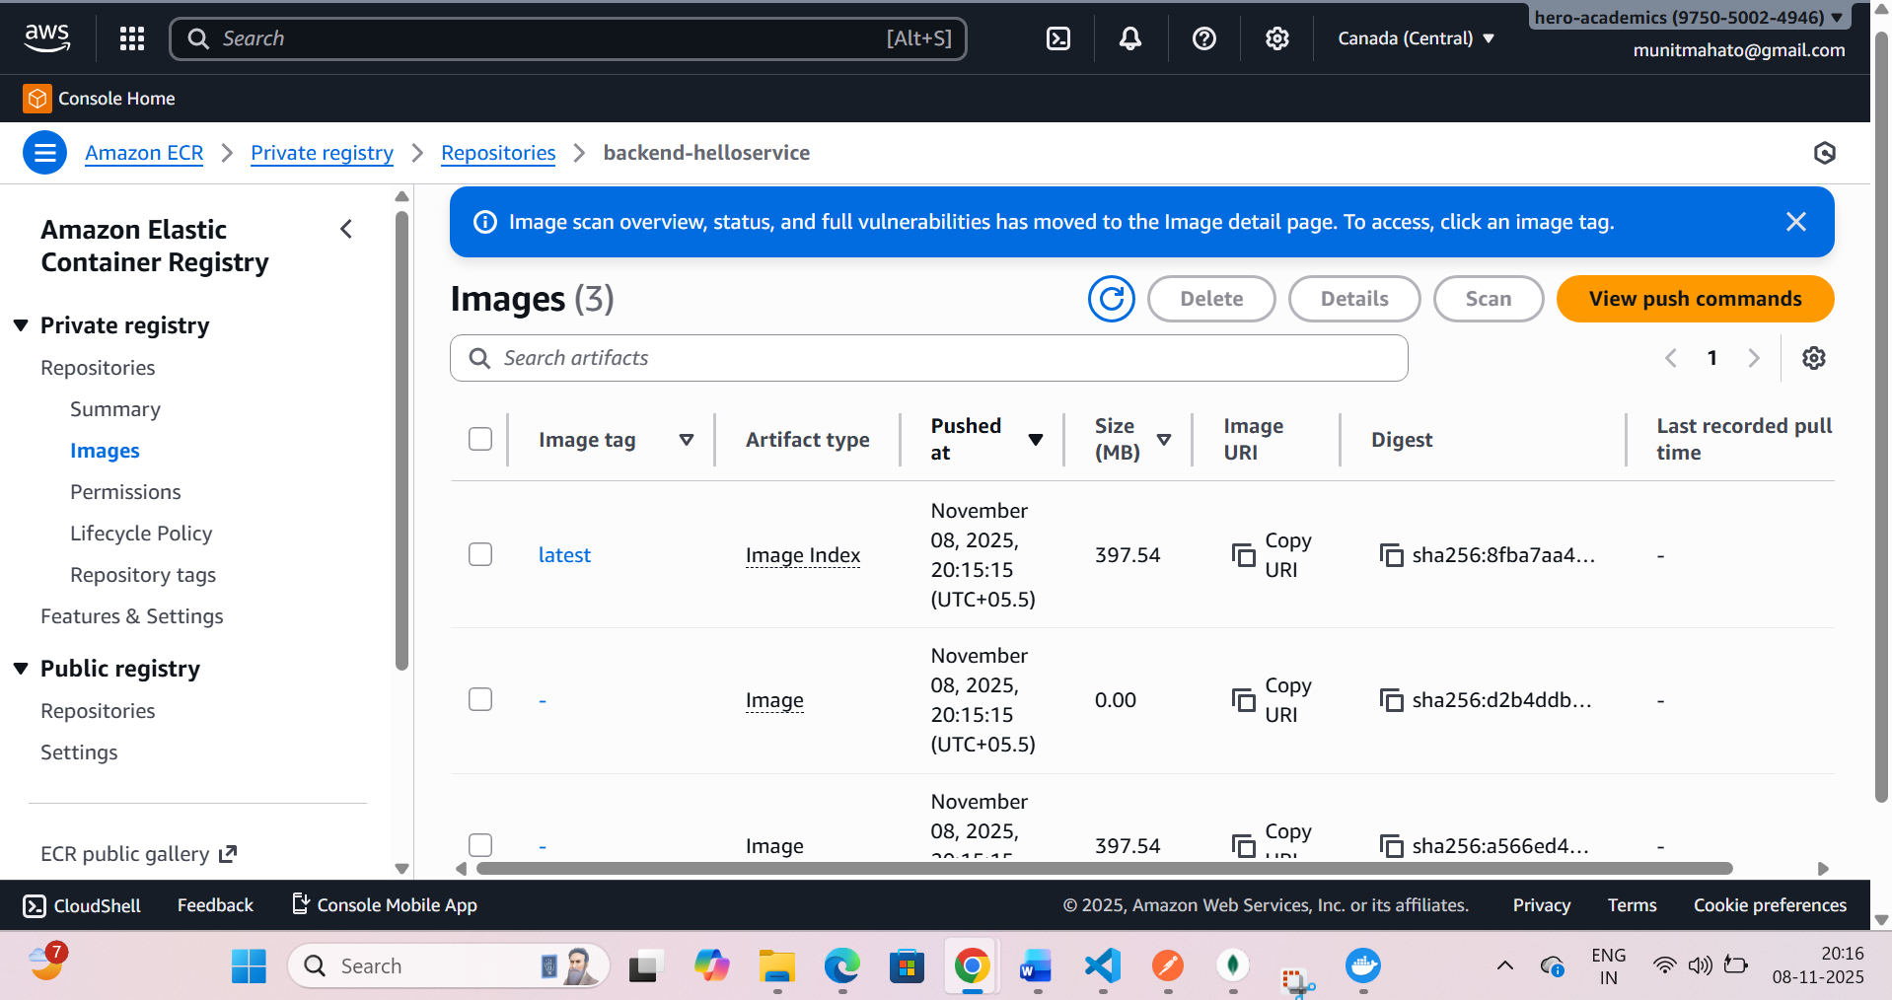

- Pushed docker image to ECR for backend ProfileService
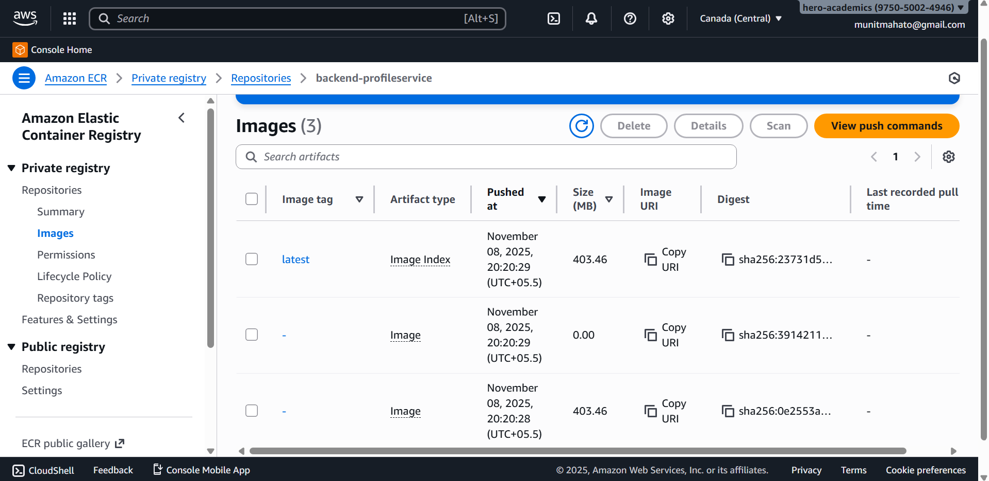

- Pushed docker image to ECR for Frontend
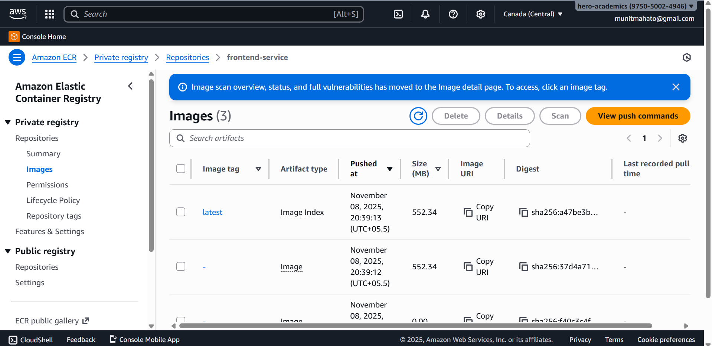

Step 3: Version Control
1. Use AWS CodeCommit:
- Create a CodeCommit repository.
- Push the MERN application source code to the CodeCommit repository.
Using GitHub for this task
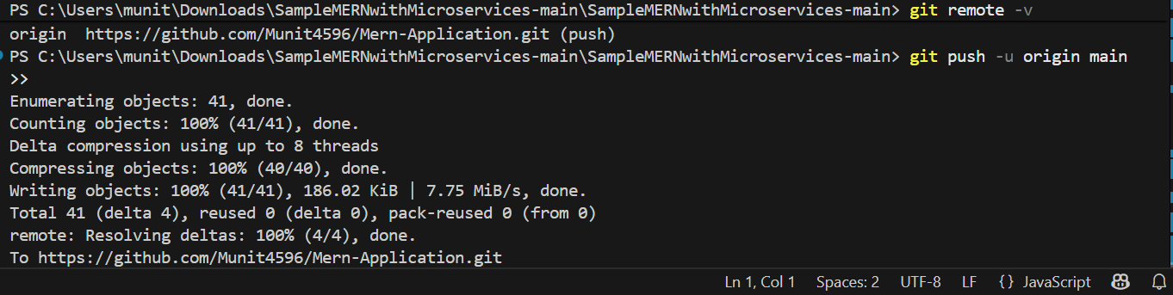
Step 4: Continuous Integration with Jenkins
1. Set Up Jenkins:
- Install Jenkins on an EC2 instance.
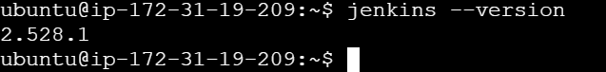
- Configure Jenkins with necessary plugins.

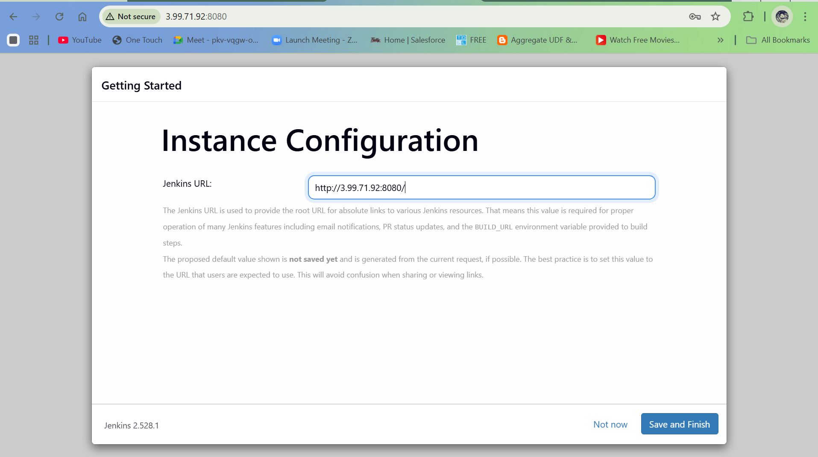

2. Create Jenkins Jobs:
- Create Jenkins jobs for building and pushing Docker images to ECR.

- Trigger the Jenkins jobs whenever there's a new commit in the CodeCommit repository.
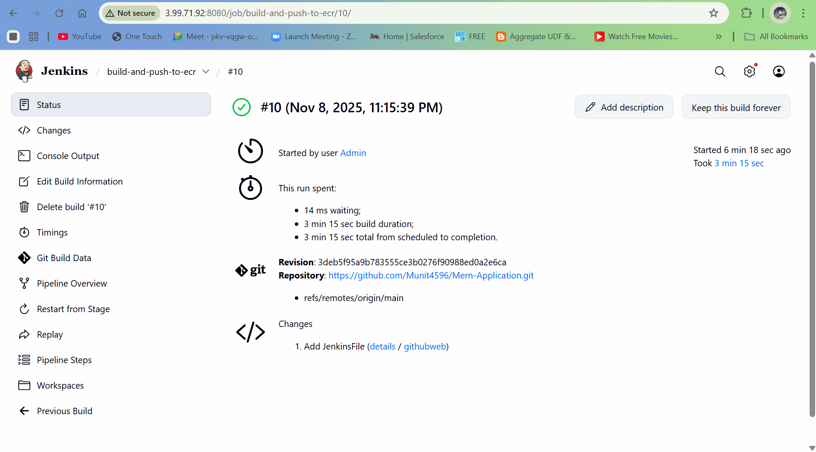
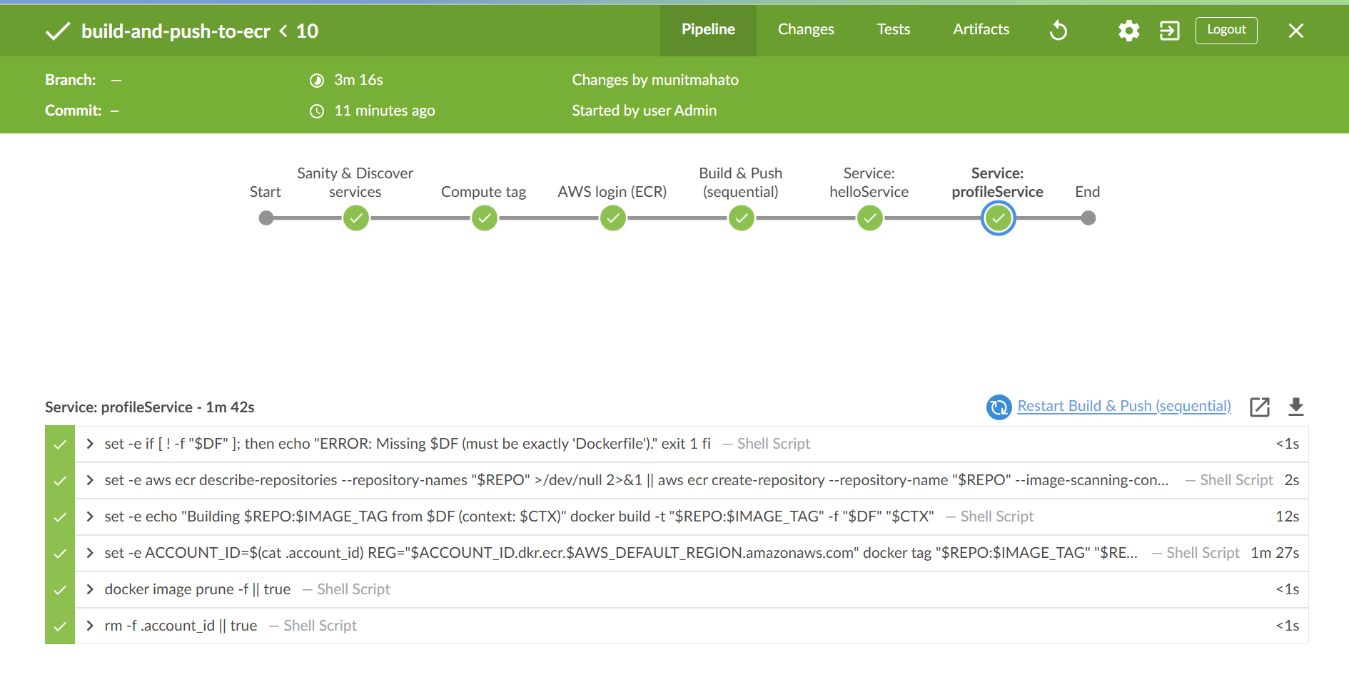
Step 5: Infrastructure as Code (IaC) with Boto3
1. Define Infrastructure with Boto3 (Python Script):
- Use Boto3 to define the infrastructure (VPC, subnets, security groups).

