**IOT Car Parking System**

**Things used in this project**

**Hardware components 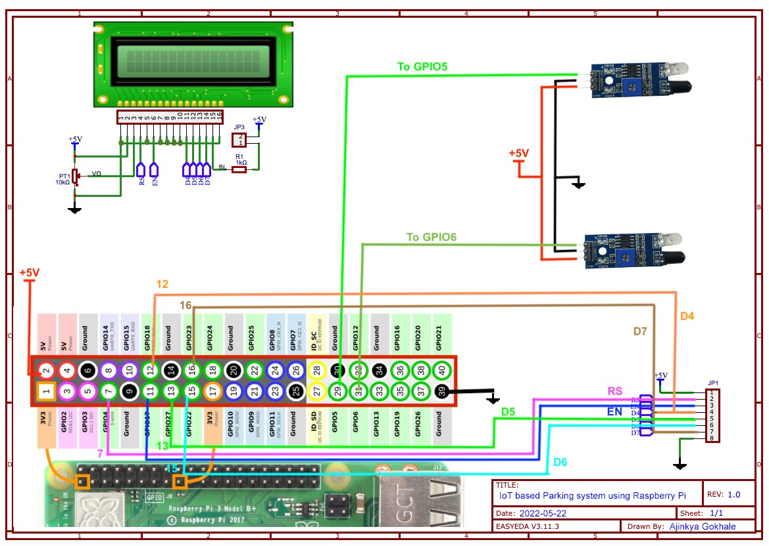:-**

1. [Raspberry Pi 3 Model B](https://www.hackster.io/raspberry-pi/products/raspberry-pi-3-model-b?ref=project-c7b2dc)
2. [Modulo IR Transceiver](https://www.hackster.io/modulo/products/modulo-ir-transceiver?ref=project-c7b2dc)
3. [Adafruit Standard LCD - 16x2 White on Blue](https://www.hackster.io/adafruit/products/standard-lcd-16x2-white-on-blue?ref=project-c7b2dc)
4. Wires
5. Soldering kit

**Software apps and online services:-**

1. MQTT
2. RasGpberry Pi Raspbian