POD 1 – DAY 1 REPORT SKELETON & REUSABLE TEMPLATES
Hospital Smart Service Operations Optimizer
This document closes the missing Day 1 documentation items identified in the Pod 1 Completion Check: a 12-heading report skeleton and reusable templates for tests, examples, and proofs. The Completion Check confirms that the system description, information categories, five system tasks, three student-ID-based numbers, ERD, menu sketch, and locked schema are already present.

A. Day 1 Report Skeleton – 12 Headings

1. Introduction
This report documents Pod 1's Day 1 deliverables for the Hospital Smart Service Operations Optimizer: the locked data schema, the entity relationship diagram, the five core system tasks, the student-ID-based logic parameters, and the on-screen menu sketch. Sections 3, 5, and 11 of this skeleton (Problem/Operational Context, Data Requirements, Testing/Examples/Proof Plan) will be expanded as the corresponding work is completed in later days.

2. System Description
The Hospital Smart Service Operations Optimizer is a software system designed to improve the management of internal hospital services by organizing hospital locations, service requests, resources, and delivery routes. The system models departments, wards, pharmacies, laboratories, and connecting routes within the hospital to help staff efficiently coordinate daily operations.
The system stores information about hospital locations, roads, service requests, and available resources such as ambulances, nurses, and porters. It supports efficient scheduling, resource allocation, route planning, and activity logging while providing a reliable database that other pods will use to implement searching, sorting, routing, scheduling, and optimization algorithms.

3. Problem / Operational Context
[Content to be completed/expanded.]

4. Information Categories
Locations: Emergency, ICU, OPD, Pharmacy, Laboratory, Maternity, Radiology, Theatre, Blood Bank, Administration.
Roads / Routes: Start location, end location, distance.
Service Requests: Patient transfer, pharmacy run, equipment delivery, laboratory sample collection, blood delivery.
Resources: Ambulances, nurses, porters.
Activity Log: User login, request created, request updated, resource assigned.
Test Results: Test name, runtime, result, date.

5. Data Requirements
[Content to be completed/expanded.]

6. Locked Data Schema
Request { id: integer, type: string, urgency_level: integer (1-5), submitted_time: string, origin_location_id: integer, destination_location_id: integer, status: string }
Location { id: integer, name: string, type: string }
Road { id: integer, from_location_id: integer, to_location_id: integer, distance: number }
Resource { id: integer, type: string, availability_status: string, current_location_id: integer }
This is the exact schema published in docs/interfaces.md. All other pods build against these field names; the Pod 1 database schema in the accompanying Pod1_Day1.docx has been fully aligned with it (no Patients table, no extra columns beyond what's listed above).

7. Entity–Relationship Diagram (ERD)
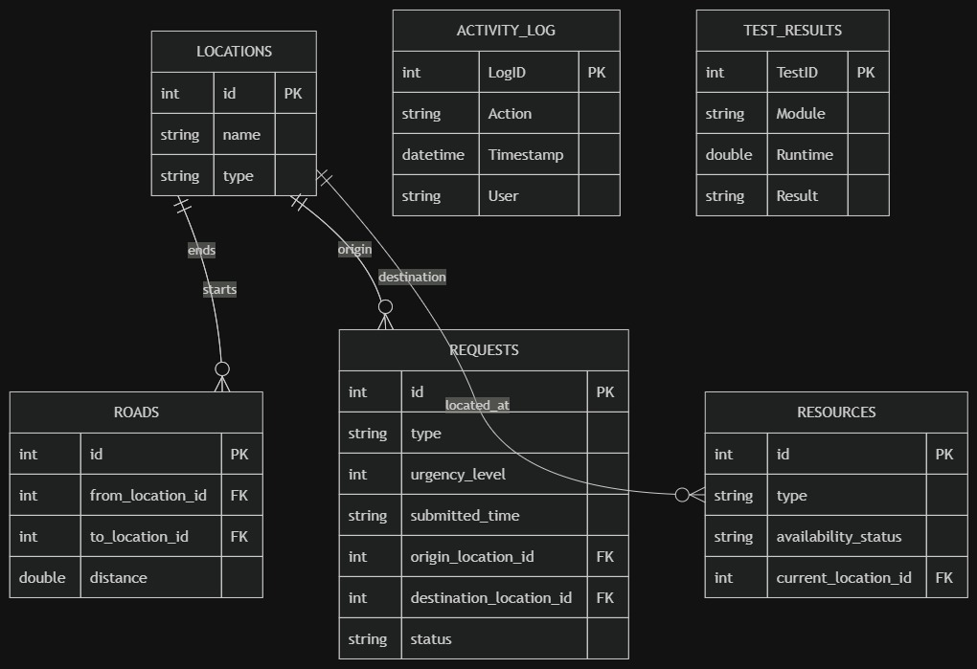

8. System Tasks / Core Operations
Register a Service Request — Input: request type, urgency level, origin and destination location. Output: request stored. Possible error: missing required field or invalid location ID.
Assign a Resource — Input: service request. Output: resource assigned. Possible error: no resource available.
Find the Shortest Route — Input: start location and destination. Output: best route. Possible error: no route exists.
Search Requests — Input: request ID. Output: matching request record. Possible error: record not found.
Save Activity Log — Input: user action. Output: activity stored. Possible error: database unavailable.

9. Student-ID-Based Parameters
Priority = 4
Distance Penalty = 44
Lookup Size = 64

10. Menu / User Interaction Sketch
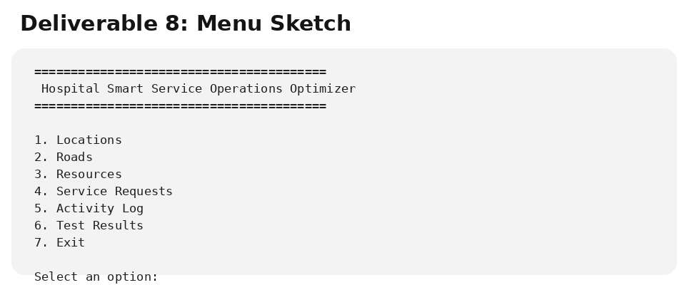

11. Testing, Examples and Proof Plan
Every tool built by any pod will use the three reusable templates in Sections B, C, and D of this document: a Test Template for each unit test (normal case, edge case, bad input), an Example Template for each required step-by-step example, and a Proof Template for each required correctness proof. The project requires at least 40 tests, six step-by-step examples, three written proofs, and two "when it fails" examples across all five pods — Pod 1 will track completion of this checklist during Day 5's testing pass.

12. Conclusion and Next Steps
[Content to be completed/expanded.]

B. Reusable Test Template
Test ID: [T01]
Module / Component: [component]
Objective: [what is being tested]
Input / Preconditions: [starting state/data]
Procedure: [steps]
Expected Result: [expected outcome]
Actual Result: [observed outcome]
Status: PASS / FAIL
Evidence: [screenshot, console output, DB result, or file]
Date: [date]
Owner: [team member]

C. Reusable Example Template
Example ID: [E01]
Feature / Task: [feature]
Scenario: [realistic scenario]
Input Data: [values used]
Expected Behaviour: [expected behaviour]
Observed Behaviour: [actual behaviour]
Result: [PASS / FAIL]
Notes: [additional explanation]

D. Reusable Proof / Evidence Template
Proof ID: [P01]
Claim Being Proven: [claim]
Evidence Type: Screenshot / Console Output / Database Query / File
Evidence Location: [file, screenshot number, table/query, etc.]
Observed Evidence: [brief description]
Conclusion: [why the evidence proves the claim]
Owner: [team member]

E. Day 1 Completion Checklist
☐ System description – completed
☐ Information categories – completed
☐ Five system tasks – completed
☐ Three student-ID-based numbers – completed: Priority 4, Distance Penalty 44, Lookup Size 64
☐ ERD – completed
☐ Menu sketch – completed
☐ Locked schema in docs/interfaces.md – completed
☐ 12-heading report skeleton – added
☐ Reusable test template – added
☐ Reusable example template – added
☐ Reusable proof template – added
Source note: The Pod 1 Completion Check confirmed that a 12-heading report skeleton and reusable tests/examples/proofs templates were missing, and separately flagged that the database schema did not match docs/interfaces.md (an unauthorized Patients table, plus patient_id/resource_id on Requests, location.floor, road.estimated_time, and resource.resource_name). Both issues have now been fixed: the schema in Pod1_Day1.docx Section 4 has been fully aligned with the locked schema, and the menu sketch has been corrected to remove the Patients option. This 12-heading structure is a practical structure aligned with the documented Pod 1 Day 1 deliverables, since the Completion Check did not specify exact heading names. Sections 1 (Problem/Operational Context), 3 (Data Requirements), and 12 (Conclusion and Next Steps) remain placeholders pending later-day content.

