Pod 1 – Day 1 Deliverables
Project: Hospital Smart Service Operations Optimizer
Pod: Pod 1 – Data, Database & Delivery
Members: Ninson Abigail, Akuffo Samuel, Dogbe Nicole Eyram

1. System Description
The Hospital Smart Service Operations Optimizer is a software system designed to improve the management of internal hospital services by organizing hospital locations, service requests, resources, and delivery routes. The system models departments, wards, pharmacies, laboratories, and connecting routes within the hospital to help staff efficiently coordinate daily operations.
The system stores information about hospital locations, roads, service requests, and available resources such as ambulances, nurses, and porters. It supports efficient scheduling, resource allocation, route planning, and activity logging while providing a reliable database that other pods will use to implement searching, sorting, routing, scheduling, and optimization algorithms.

2. Categories of Information to Store

Locations
Emergency, ICU, OPD, Pharmacy, Laboratory, Maternity, Radiology, Theatre, Blood Bank, Administration.

Roads / Routes
Start location, End location, Distance, Estimated travel time.

Service Requests
Patient transfer, Pharmacy run, Equipment delivery, Laboratory sample collection, Blood delivery.

Resources
Ambulances, Nurses, Porters, Wheelchairs, Medical carts.

Activity Log
User login, Request created, Request updated, Resource assigned.

Test Results
Test name, Runtime, Result, Date.

3. Locked Data Schema
Request
- id: integer
- type: string
- urgency_level: integer (1–5)
- submitted_time: string
- origin_location_id: integer
- destination_location_id: integer
- status: string
Location
- id: integer
- name: string
- type: string
Road
- id: integer
- from_location_id: integer
- to_location_id: integer
- distance: number
Resource
- id: integer
- type: string
- availability_status: string
- current_location_id: integer

4. Database Schema

Patients: Stores information about patients receiving hospital services.
- PatientID (PK)
- FirstName
- LastName
- Age
- Gender
- LocationID (FK)
- Condition

Requests: Stores all service requests created within the hospital.
- id (PK)
- PatientID (FK)
- ResourceID (FK)
- origin_location_id (FK)
- destination_location_id (FK)
- type
- urgency_level
- status
- submitted_time

Resources: Stores the available staff and equipment used to complete requests.
- id (PK)
- type
- ResourceName
- availability_status
- current_location_id (FK)

Locations: Stores all departments, wards, and service points in the hospital.
- id (PK)
- name
- type (e.g. ward, pharmacy, entrance)
- Floor

Roads: Stores the connections between hospital locations for route planning.
- RoadID (PK)
- StartLocationID (FK)
- EndLocationID (FK)
- Distance
- EstimatedTime

Activity_Log: Stores user activities performed within the system.
- LogID (PK)
- Action
- Timestamp
- User

Test_Results: Stores the results of performance and functionality tests.
- TestID (PK)
- Module
- Runtime
- Result

5. ERD
The Entity Relationship Diagram (ERD) illustrates the structure of the Hospital Smart Service Operations Optimizer database. It shows the entities, their attributes, and the relationships between them. Field names in the Requests, Locations, and Resources tables have been aligned with the locked schema in Section 3 (e.g. RequestID -> id, RequestType -> type, Priority -> urgency_level, RequestTime -> submitted_time, DestinationLocationID -> destination_location_id), and a new origin_location_id field has been added to Requests so each request records both a starting point and a destination. The diagram serves as the blueprint for the SQLite database and ensures that data is organized efficiently while maintaining referential integrity.
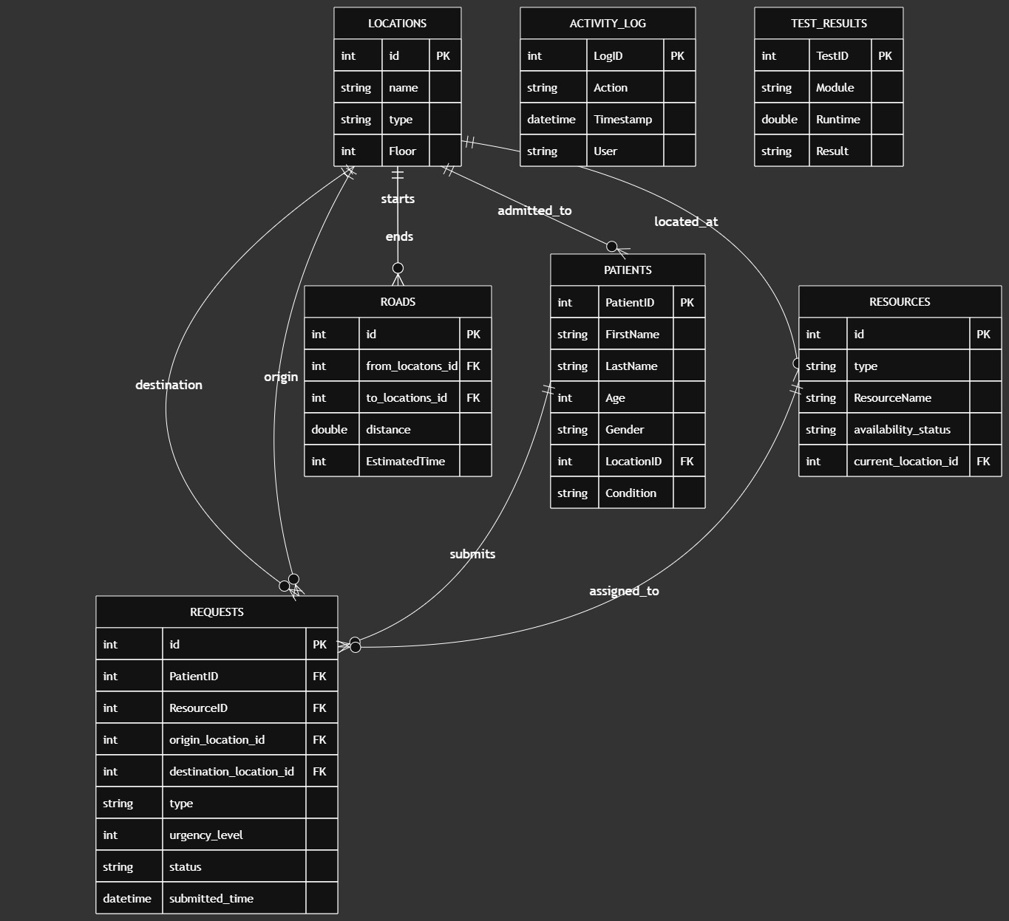

6. Five System Tasks

Register a Service Request
Input: Patient details, request type, priority
Output: Request stored
Possible Error: Missing patient ID

Assign a Resource
Input: Service request
Output: Resource assigned
Possible Error: No resource available

Find the Shortest Route
Input: Start location and destination
Output: Best route
Possible Error: No route exists

Search Hospital Records
Input: Patient ID or Request ID
Output: Matching record
Possible Error: Record not found

Save Activity Log
Input: User action
Output: Activity stored
Possible Error: Database unavailable

7. Menu Sketch
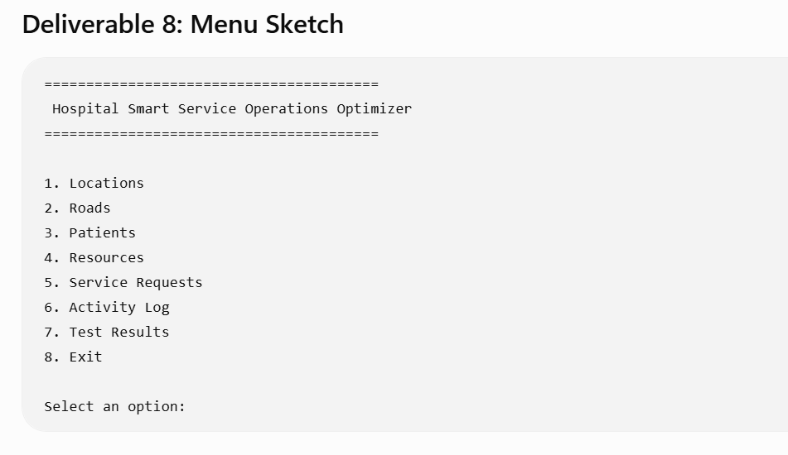

8. Student-ID-Based Numbers
Team Members
Member | Student ID
Ninson Abigail | 22067133
Akuffo Samuel | 22324067
Dogbe Nicole Eyram | 22272233

1. Priority Score
Purpose
The Priority Score determines the urgency level assigned to a service request. Higher scores represent more urgent requests.
Calculation
Take the last digit of each student ID.
- Abigail → 3
- Samuel → 7
- Nicole → 3
Sum them:
3 + 7 + 3 = 13
Convert the result to the required 1–5 range:
Priority Score = (13 mod 5) + 1
= 3 + 1
= 4
Final Value
Priority Score = 4
Explanation: The system will use 4 as the default priority value when creating sample service requests. This represents a high-priority request while remaining within the required urgency scale.
2. Distance Penalty
Purpose
The Distance Penalty is added when selecting routes between hospital locations. Longer routes incur a slightly higher cost during optimization.
Calculation
Take the last two digits of each student ID.
- Abigail → 33
- Samuel → 67
- Nicole → 33
Average them:
(33 + 67 + 33) ÷ 3
= 133 ÷ 3
= 44.33
Round down:
Distance Penalty = 44
Final Value
Distance Penalty = 44
Explanation
During route calculations, a penalty value of 44 can be incorporated into the routing logic to simulate travel costs or delays, encouraging the algorithm to prefer shorter or less congested routes.

3. Lookup Table Size
Purpose
This number determines the initial size of the program's lookup table or hash table used for storing frequently accessed records.
Calculation
Take the first two digits of each student ID.
- Abigail → 22
- Samuel → 22
- Nicole → 22
Sum them:
22 + 22 + 22 = 66
Round up to a practical implementation size:
Lookup Table Size = 64
Final Value
Lookup Table Size = 64
Explanation
Although the calculated value is 66, a lookup table size of 64 is selected because it is a practical implementation size commonly used in computing. It provides efficient indexing and is sufficient for the initial project dataset.

Final Summary Table
Program Number | Value | Purpose
Priority Score | 4 | Default urgency level for sample service requests
Distance Penalty | 44 | Additional routing cost used during route optimization
Lookup Table Size | 64 | Initial lookup/hash table size for storing records

