**EBIZ and Siteminder Component Scanner:**

The Ebiz and Siteminder component scanner will check the running Ebiz (WAS, JBOSS, IHS, Apache) and Siteminder process in all the servers mentioned in the server list. This script will be executed from the jump/Pyro server and, it will scan all the running components and generate a CSV file as Report.csv. This file will be mailed to the Email ID provided by the requestor.

This automation is intended to reduce the effort to login to each and every server and also the time required to check the running Ebiz and Siteminder process. For example if the server list has more than 100 servers it will take an Ebiz member approximately 16 hours to login to each and every server and check the running process he/she takes 10 mins per server. After this automation the task will be completed in less than 5 mins (for 100 servers).

**How to Use the Script:**

**Prerequisites:**

1. Should have access to login and execute the script from Pyro server mgtpp0000.
2. All the server names should be copied to serverlist file.

**Script:**

1. Login to mgtpp0000.
2. cd /home/wsuser/webapp/scripts.
3. Make sure all the server names are copied to serverlist and serverlist is present in /home/wsuser/webapp/scripts.



1. Run report.sh
2. Enter your Optum Email ID

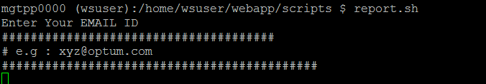

1. Once you have entered your Email ID , you will receive a mail from [wsuser@mgtpp0000.uhc.com](mailto:wsuser@mgtpp0000.uhc.com) as

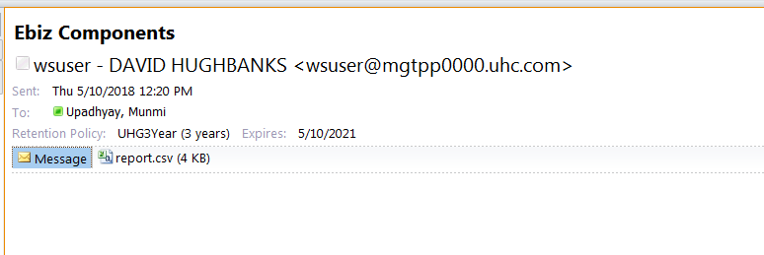

1. The report.csv file is the desired output file.

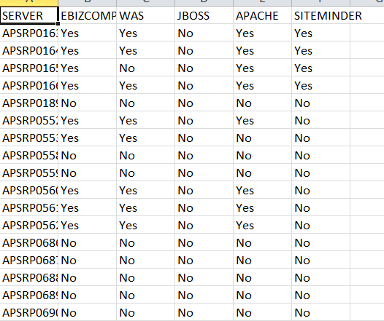

**Written By:**

**Munmi Upadhyay**