Face verification using Deepface

Deepface is a lightweight face recognition and face verification framework for python. It is a hybrid face recognition framework wrapping state-of-the-art models: VGG-Face, Google FaceNet, OpenFace, Facebook DeepFace, DeepID, ArcFace and Dlib. Those models already reached and passed the human level accuracy. The library is mainly based on TensorFlow and Keras.

In modern face recognition, the process completes in 4 raw steps:

* Detect & Align

HaarCasCade

MTCNN: MTCNN or Multi-Task Cascaded Convolutional Neural Networks is a neural network which detects faces and facial landmarks on images. It was published in 2016 by Zhang et al.

Dilb: dlib is a toolkit for making real world machine learning and data analysis applications in C++. It is mainly used dlib for face detection and facial landmark detection

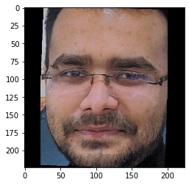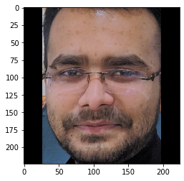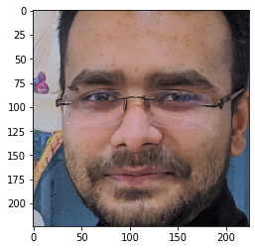SSD: SSD is a single-stage object detection method that discretizes the output space of bounding boxes into a set of default boxes over different aspect ratios and scales per feature map location. At prediction time, the network generates scores for the presence of each object category in each default box and produces adjustments to the box to better match the object shape.

Opencv , ssd, mtcnn

* Align

HaarCasCade

* Represent

VGG FaceNet

Google FaceNet

OpenFace

Facebook Deepface

* Classify

Cosine Similarity

Euclidean Distance



1. After mid,  
   presentation slide, system model(block diagram),
2. problem statement

* Problem Statement  
  Objectives  
  Methodology  
  Partial Work
* Name: Real time face verification during competitive exam