--1

create table BusInfo

( BusId Int Primary Key Identity ,

BoardingPoint nvarchar(50),

TravelDate Date,

Amount decimal,

Rating int

)

--Retrieve all boardingpoint and traveldate for the amount which is greater than 450

Select BoardingPoint,TravelDate

From BusInfo where amount>450;

--a

Alter Procedure BusInfoProc

@BoardingPoint varchar(10),

@TravelDate Date,

@Amount decimal(5,2),

@Rating int

As

Insert into BusInfo(BoardingPoint,TravelDate,Amount,Rating)

values(@BoardingPoint,@TravelDate,@Amount,@Rating)

execute BusInfoProc 'Mum','2022-11-24',450.89,4

--b

Alter view Bus_View

As

Select BusId,BoardingPoint from BusInfo

where rating>3

select * From Bus_View

ouput retrieving all boarding point and travel date

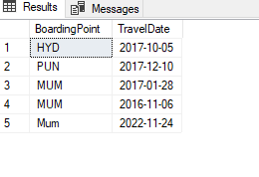

A output

