(Youtube Live Subscriber Count)

Submitted in partial fulfillment for the mini project submitted

by

Riddhi Agrawal 01

Mohd Tanveer Shaikh 49

Mahenoor Suriya 60

For the subject

Cloud Computing Laboratory



Computer Engineering Department

Rizvi College of Engineering

2017-2018

**Certificate**

This is to certify that the project entitled **“Youtube live Subscriber Count”** is a bonafide work of “**Riddhi Agrawal” (Roll No.:1)** submitted in partial fulfillment of the requirement for the mini project in the subject of Cloud Computing Laboratory.

Prof. Shiburaj P.

Guide

Prof. Shiburaj P. Dr. Varsha Shah

Head of Department Principal

**Index**

|  |  |  |  |  |  |
| --- | --- | --- | --- | --- | --- |
| Sr. No | Title | | | Page No | |
| 1. | Introduction | | | 1 | |
| 2. | Theory and Methodology | | | 2 | |
|  | 2.1 | What is API  2.1.1 Google API | | 3 | |
|  | 2.2. | Implementation | |  | |
| 3. | Conclusion | | | 5 | |
|  | | |  | |
|  |  | | |  | |
| 4. | References | | |  | |
|  |  | | | 9 | |

**Abstract**

As we know JASON is JavaScript Object Notation and is a way to store the information in a organized ,easy to acess manner which and most of the information stored on the internet is stored in JASON format which is a human readable collection of data that we can acess in logical manner.In this project of Youtube live Subscriber” we simply converts the information in JASON form by using php/jquery and application programming fetches it.This project aims to get the various details regarding the youtube channel like total number of videos that are being launched and total number of subscribers following the channel.

**Chapter 1**

**Introduction**

The project YouTube live subscriber count is based upon application programming interface in which a user will enter the id or url of the YouTube channel of their interest which are available (example:.vidyabox,nexus,croatcode,1 etc) and various details regarding the subscription channel will get displayed like total videos that the channel has launched up till date ,total number of subscribers to the channel and the current display picture for that particular YouTube channel. Along with displaying details about the channel its is dynamic too i.e if a user is viewing details of a particular YouTube channel and if a subscriber gets added to channel or deletes its account then total count of subscribers will also affect the current number that is being displayed, same will happen if a video is added or deleted from that particular youtube channel

**Chapter 2**

**Theory and methodology**

**2.1 What is API?**

An application programming interface (API) is a set of [subroutine](https://en.wikipedia.org/wiki/Subroutine) definitions, [protocols](https://en.wiktionary.org/wiki/Protocol), and tools for building [application software](https://en.wikipedia.org/wiki/Application_software). In general terms, it is a set of clearly defined methods of communication between various software components. A good API makes it easier to develop a [computer program](https://en.wikipedia.org/wiki/Computer_program) by providing all the building blocks, which are then put together by the [programmer](https://en.wikipedia.org/wiki/Programmer). An API may be for a web-based system, [operating system](https://en.wikipedia.org/wiki/Operating_system), [database system](https://en.wikipedia.org/wiki/Database_system), [computer hardware](https://en.wikipedia.org/wiki/Computer_hardware) or [software library](https://en.wikipedia.org/wiki/Library_(computing)). An API specification can take many forms, but often includes specifications for [routines](https://en.wikipedia.org/wiki/Subroutine), [data structures](https://en.wikipedia.org/wiki/Data_structure), [object classes](https://en.wikipedia.org/wiki/Class_(computer_programming)), [variables](https://en.wikipedia.org/wiki/Variable_(computer_science)) or [remote calls](https://en.wikipedia.org/wiki/Remote_procedure_call). [POSIX](https://en.wikipedia.org/wiki/POSIX), [Windows API](https://en.wikipedia.org/wiki/Windows_API) and [ASPI](https://en.wikipedia.org/wiki/Advanced_SCSI_programming_interface) are examples of different forms of APIs. Documentation for the API is usually provided to facilitate usage.

Just as a [graphical user interface](https://en.wikipedia.org/wiki/Graphical_user_interface) makes it easier for people to use programs, application programming interfaces make it easier for [developers](https://en.wikipedia.org/wiki/Software_developer) to use certain technologies in building applications. By [abstracting](https://en.wikipedia.org/wiki/Abstraction_(software_engineering)) the underlying implementation and only exposing objects or actions the developer needs, an API simplifies programming. While a graphical interface for an [email client](https://en.wikipedia.org/wiki/Email_client) might provide a user with a button that performs all the steps for fetching and highlighting new emails, an API for file [input/output](https://en.wikipedia.org/wiki/Input/output) might give the developer a [function](https://en.wikipedia.org/wiki/Subroutine) that copies a file from one location to another without requiring that the developer understand the [file system](https://en.wikipedia.org/wiki/Journaling_file_system) operations occurring behind the scenes.

The web, software designed exchange information via the internet and [cloud computing](https://searchcloudcomputing.techtarget.com/definition/cloud-computing) have all combined to increase the interest in APIs in general and services in particular. Software that was once custom-developed for a specific purpose is now often written referencing APIs that provide broadly useful features, reducing development time and cost and mitigating the risk of errors.APIs have steadily improved software quality over the last decade, and the growing number of [web services](https://searchmicroservices.techtarget.com/definition/Web-services-application-services) exposed through APIs by [cloud providers](https://searchcloudprovider.techtarget.com/definition/cloud-provider-API) is also encouraging the creation of cloud-specific applications, [internet of things (IoT)](https://internetofthingsagenda.techtarget.com/definition/Internet-of-Things-IoT) efforts and apps to support mobile devices and users. APIs take three basic forms: local, web-like and program-like.

* Local API :

Local APIs are the original form, from which the name came. They offer OS or [middleware](https://searchmicroservices.techtarget.com/definition/middleware) services to application programs. Microsoft's [.NET](https://searchwindevelopment.techtarget.com/definition/NET) APIs, the [TAPI (Telephony API)](https://searchexchange.techtarget.com/definition/TAPI) for voice applications, and database access APIs are examples of the local API form.

* Web API :

Web APIs are designed to represent widely used resources like [HTML](https://searchmicroservices.techtarget.com/definition/HTML-Hypertext-Markup-Language) pages and are accessed using a simple [HTTP](https://searchwindevelopment.techtarget.com/definition/HTTP) protocol.  Any web [URL](https://searchnetworking.techtarget.com/definition/URL) activates a web API.  Web APIs are often called [REST (representational state transfer)](https://searchmicroservices.techtarget.com/definition/REST-representational-state-transfer) or [RESTful](https://searchmicroservices.techtarget.com/definition/RESTful-API) because the publisher of REST interfaces doesn't save any data internally between requests. As such, requests from many users can be intermingled as they would be on the internet.

* Program API :

Program APIs are based on [remote procedure call (RPC)](https://searchmicroservices.techtarget.com/definition/Remote-Procedure-Call-RPC) technology that makes a remote program component appear to be local to the rest of the software. [Service oriented architecture (SOA)](https://searchmicroservices.techtarget.com/definition/service-oriented-architecture-SOA) APIs, such as Microsoft's WS-series of APIs, are program APIs.

**2.1.1 Google API**

Google APIs is a set of application programming interfaces ([APIs](https://en.wikipedia.org/wiki/API)) developed by [Google](https://en.wikipedia.org/wiki/Google) which allow communication with [Google Services](https://en.wikipedia.org/wiki/Google_Services) and their integration to other services. Examples of these include Search, Gmail, Translate or Google Maps. Third-party apps can use these APIs to take advantage of or extend the functionality of the existing services.

The APIs provide functionality like analytics, [machine learning](https://en.wikipedia.org/wiki/Machine_learning) as a service (the Prediction API) or access to user data (when permission to read the data is given). Another important example is an embedded Google map on a website, which can be achieved using the Static maps API,[[1]](https://en.wikipedia.org/wiki/Google_APIs#cite_note-1) Places API[[2]](https://en.wikipedia.org/wiki/Google_APIs#cite_note-2) or Google Earth API.

There are client libraries in various languages which allow developers to use Google APIs from within their code, including [Java](https://en.wikipedia.org/wiki/Java_(programming_language)), [JavaScript](https://en.wikipedia.org/wiki/JavaScript), [.NET](https://en.wikipedia.org/wiki/.NET), [Objective-C](https://en.wikipedia.org/wiki/Objective-C), [PHP](https://en.wikipedia.org/wiki/PHP) and [Python](https://en.wikipedia.org/wiki/Python_(programming_language)). [[5]](https://en.wikipedia.org/wiki/Google_APIs#cite_note-5)

The Google Loader is a [JavaScript](https://en.wikipedia.org/wiki/JavaScript) library which allows web developers to easily load other [JavaScript](https://en.wikipedia.org/wiki/JavaScript) [APIs](https://en.wikipedia.org/wiki/API) provided by [Google](https://en.wikipedia.org/wiki/Google) and other developers of popular libraries. Google Loader provides a JavaScript method for loading a specific API (also called module), in which additional settings can be specified such as API version, language, location, selected packages, load [callback](https://en.wikipedia.org/wiki/Callback_(computer_programming)) and other parameters specific to a particular API. Dynamic loading or auto-loading is also supported to enhance the performance of the application using the loaded APIs.

**2.1.2 JASON**

[JSON](http://en.wikipedia.org/wiki/JSON) is short for **JavaScript Object Notation,** and is a way to store information in an organized, easy-to-access manner. In a nutshell, it gives us a human-readable collection of data that we can access in a really logical manner. With the rise of [AJAX](http://en.wikipedia.org/wiki/Ajax_(programming))-powered sites, it's becoming more and more important for sites to be able to load data **quickly and**asynchronously or in the background without delaying page rendering. Switching up the contents of a certain element within our layouts without requiring a page refresh adds a "wow" factor to our applications, not to mention the added convenience for our users. These sites provide RSS feeds, which are easy to import and use on the server-side, but if we try to load them with AJAX, we run into a wall: we can only load an RSS feed if we're requesting it from the same domain it's hosted on.

JSON allows us to overcome the cross-domain issue because **we can use a method called**[JSONP](http://remysharp.com/2007/10/08/what-is-jsonp/)**that uses a callback function to send the JSON data back to our domain.** It's this capability that makes JSON so incredibly useful, as it opens up a lot of doors that were previously difficult to work around. One of the easiest ways to load JSON data into our web applications is to **use the $.ajax() method available in the jQuery library.``**

**3.2 IMPLEMENTATION:**

**Step1: Start XAMPP server.**

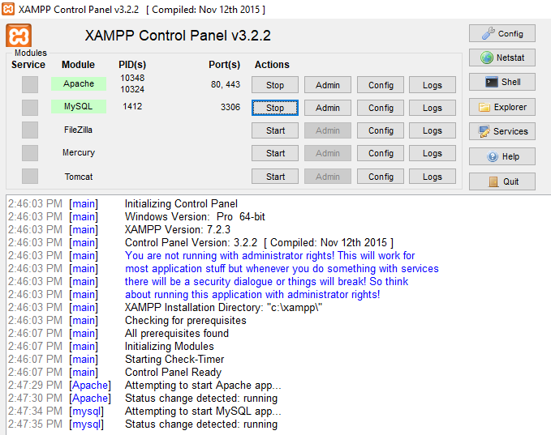

**Step 2:** Right click on index page and run the API for You Tube Live subscription Channel.

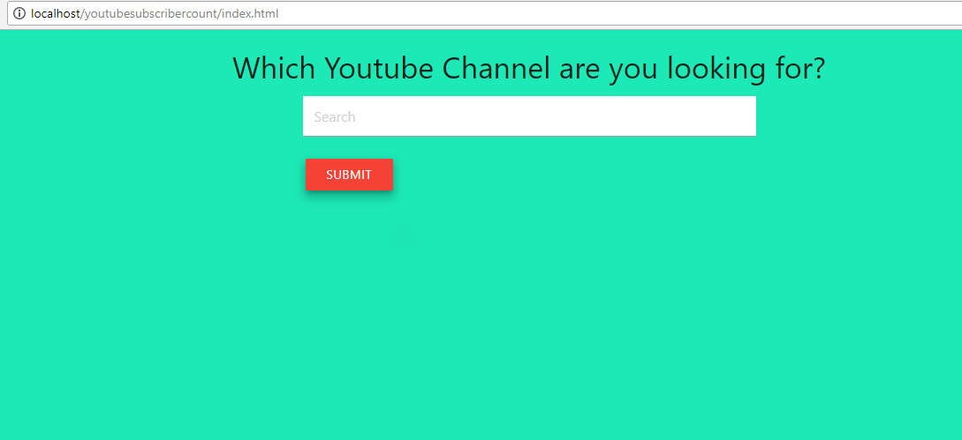

**Step 3:**  Enter the channel ID of your interest and Click on Submit.

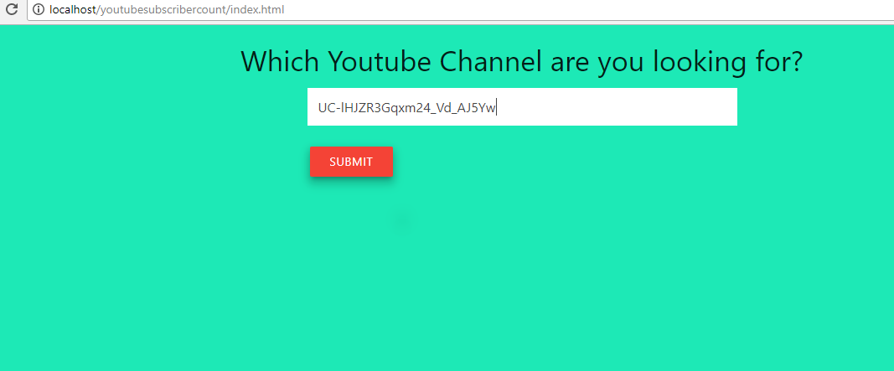

**Step 4:** After Submitting the Details of the channel gets displayed.

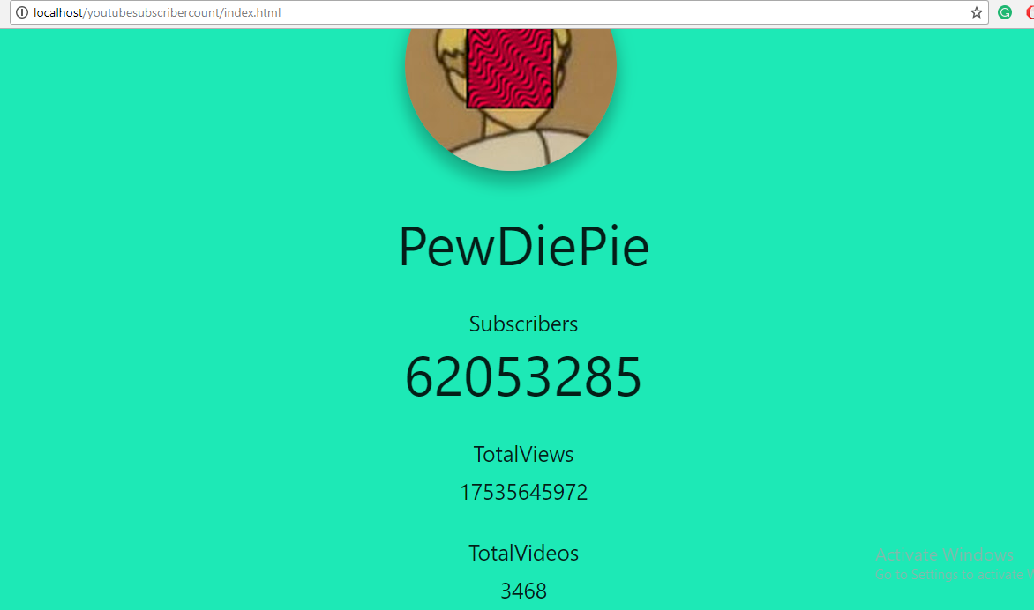

**Step 5:**  If someone unsubscribes to the channel then it counting will also affect trhe count in the display.



**Chapter 3**

**Conclusion**

Hence we have studied and made use of a Web API in a website to search for youtube live subscriber count.

**References**

<https://en.wikipedia.org/wiki/Google_APIs>

<https://searchmicroservices.techtarget.com/definition/application-program-interface-API>

<https://en.wikipedia.org/wiki/Application_programming_interface>

https://www.copterlabs.com/json-what-it-is-how-it-works-how-to-use-it/

**Chapter _**

**References**

**ASME standard**

**Book,**

[1] Merritt, H. E., 1971, *Gear Engineering*, Pitman, New York, pp. 82–83.

**Journal Paper,**

[2] Arakere, N. K., and Nataraj, C., 1998, “Vibration of High-Speed Spur Gear Webs,” ASME Journal of Vibration Acoustics, 120(3), pp. 791–800.

**Proceeding Paper,**

[3] Stewart, R. M., 1977, “Some Useful Data Analysis Techniques for Gearbox Diagnostics,” Proceedings of the Meeting on the Application of Time Series Analysis, ISVR, University of Southampton, Southampton, UK.

**Thesis,**

[4] Kong, D. W., 2008, “Research on the Dynamics and Fault Diagnosis of the Large Gear Transmission Systems,” Ph.D., thesis, JiLin University, Changchun, China.

**IEEE standard**

**Book,**

[1] J. F. Curtis, (Ed.), *Processes and Disorders of Human Comm-unication.* New York: Harper and Row, 1978.

**Journal Paper,**

[2] J. Schroeterand M. M. Sondhi, “Techniques for estimating vocal-tract shapes from the speech signal,”*IEEE Trans. Speech Audio Process.*, vol. 2, no. 1, pp. 133–150, 1994.

**Proceeding paper,**

**[3]** J. M. Pardo, “Vocal tract shape analysis for children,” in *Proc. IEEE Int. Conf. Acoust., Speech, Signal Process.*, 1982, pp. 763–766