

Student Name: Munogonaishe S Chakwizira
Student Number: H261491X
Programme: Software Engineering
Course : Object Oriented Programming
Level :2.1
Lab Report
1-10

Introduction
This report covers ten practical labs on object-oriented programming in Java. The tasks begin with simple classes and objects, then move into ways of organising and protecting data, reusing code, handling errors and working with collections and files. For each lab, I have described what the exercises involved, what the program demonstrated and what I learned from the results.

Development Environment
I used Visual Studio Code to work with the Java programs. I compiled the files from their individual lab folders using javac Main.java and ran them using java Main. During testing, I found that the terminal was using Java 8, which could not compile some features such as records and newer switch expressions. After selecting OpenJDK 25 in the terminal, those programs ran successfully. The Java version needs to be checked again when opening a new terminal.

Lab 1: Classes and Objects
The aim of this lab was to practise creating classes and objects and to understand how fields, methods and object references work in Java. It also introduced what happens when a reference is null.
I started with a Car class containing the brand, year and mileage. Three car objects were created and displayed, and an isAntique() method checked whether each car was more than 25 years old. I then used a Rectangle class to calculate the area and perimeter of five rectangles and find the one with the largest area. Another exercise showed that assigning r2 = r1 does not create a new rectangle: both variables refer to the same object. The last exercise used Person and Address to show how one object can contain another and why a null check matters.
The car details appeared with their antique status. Among the rectangles tested, the 6 by 6 rectangle had the largest area, which was 36. After changing the width through r2, the width read through r1 was also 10. This happened because both references pointed to the same rectangle. The address example also illustrated what happens when an address is missing.
This lab helped me understand the difference between an object and a reference to that object. It also showed why checking for null is important before trying to access a field.
Lab 1 – Program execution screenshot
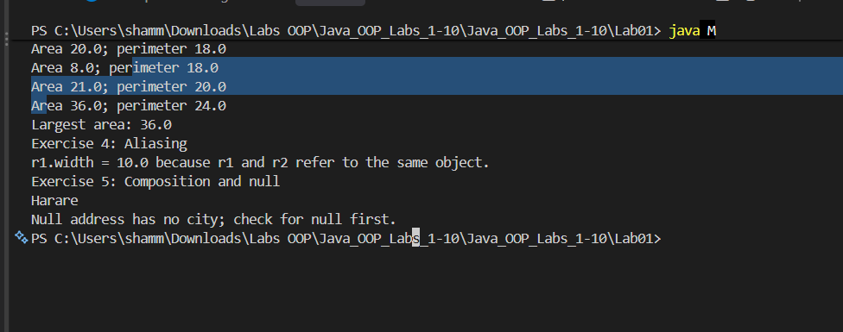

Lab 2: Constructors, this and Static Members
This lab focused on the different ways objects can be initialised, including overloaded constructors, copy constructors, the this keyword and static members.
The Circle class had a constructor that accepted a radius and another that used a default radius. A static counter kept track of the circles created. I also worked with an Employee class that had different constructors and a copy constructor. To understand the order of execution, the program used static blocks, instance blocks and constructors. Finally, a Temperature class used named factory methods to create temperatures from Celsius and Fahrenheit values.
The output showed the circle values and the total number created. The Employee examples demonstrated how constructor choices affect initial values. The static blocks ran only once, while the instance blocks and constructors ran again for each object. The temperature examples also showed the conversion between Fahrenheit and Celsius.
I learned that constructors can provide different ways to create a valid object. Static fields and blocks belong to the class as a whole, while each object has its own instance data.
Lab 2 – Program execution screenshot
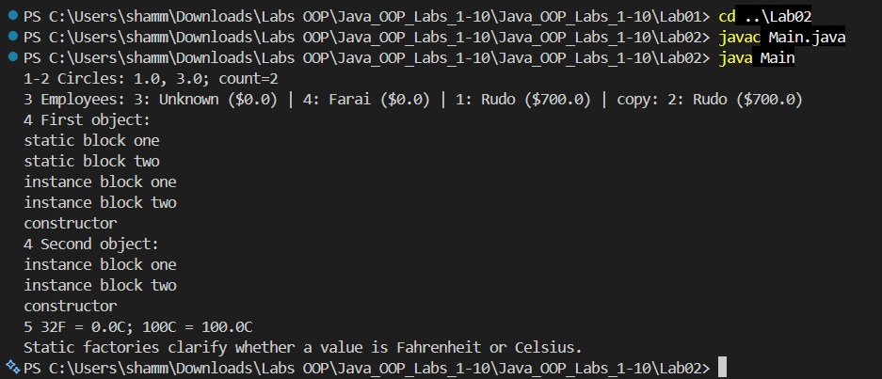

Lab 3: Encapsulation and Access Modifiers
The purpose of this lab was to keep object data private and allow changes only through methods that check whether the values are valid.
The Student class stored a student's name and marks and calculated a grade without saving the grade as a separate field. The setter rejected marks outside the accepted range. I then used a BankAccount that recorded deposits and withdrawals and returned transaction history without letting other code change the list directly. An ImmutablePerson class demonstrated how final fields and the absence of setters keep values fixed. The Temperature example stored its values in kelvin and offered Celsius and Fahrenheit methods.
The student example produced grade A for the valid marks and rejected an invalid mark of 120. The bank account printed its transaction history, and an attempt to change that history was blocked. The person details could be read but not changed through setters. The temperature program converted 25°C to 77°F and rejected a value below absolute zero.
The main lesson was that private fields alone are not enough: methods also need validation, and mutable data should not be exposed carelessly.
Lab 3 – Program execution screenshot
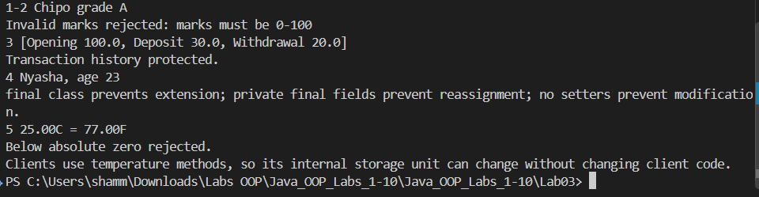

Lab 4: Inheritance
In this lab I practised extending classes, calling superclass constructors and deciding when to use inheritance rather than composition.
A Person superclass was used by Student and Teacher so both could reuse common behaviour. Next, Vehicle, Car and ElectricCar showed multilevel inheritance and the order in which constructors run. The Animal and Dog example showed why a subclass must call a matching superclass constructor when there is no default one. Finally, I compared a Stack that extends ArrayList with a Stack that contains an ArrayList.
The constructor messages appeared in the order Vehicle, Car and ElectricCar, which confirmed that the parent constructor runs before the child constructor. The Dog example worked when a name was passed to super(). The stack using composition allowed stack operations without exposing every ArrayList method.
Inheritance is useful when one type really is a more specific version of another. For a class that simply uses another object, composition is often a clearer and safer choice.
Lab 4 – Program execution screenshot
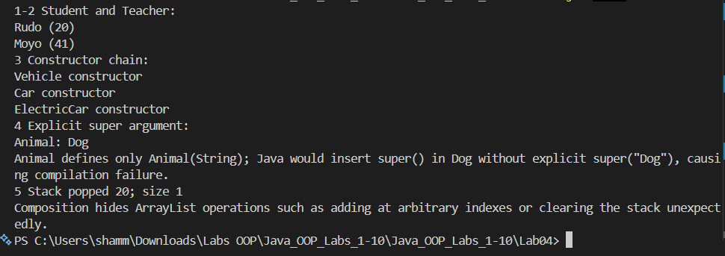

Lab 5: Polymorphism
This lab compared overloading and overriding and showed how Java can call different methods through a common reference type.
The first task overloaded a print method for integers, decimal values, text and integer arrays. I then created Cat, Cow and Duck subclasses and called their sound() methods through an Animal array. Another task added an Intern to an employee hierarchy and calculated payroll without changing the loop. The field-and-method example compared what happens when a superclass reference points to a subclass. The final exercise processed card and mobile-money payments and compared explicit type checks with a polymorphic process() method.
The printer handled the different input types, and the animal loop used the sound for each actual animal. The mixed employee payroll added up to 4,200. The superclass reference accessed the Base field but ran the Child method, showing the difference between fields and overridden methods. Both card and mobile-money payments were processed in the final example.
I now understand that overloading is selected using the arguments at compile time, while overriding depends on the object being used when the program runs. Polymorphism also makes it easier to introduce new classes later.
Lab 5 – Program execution screenshot
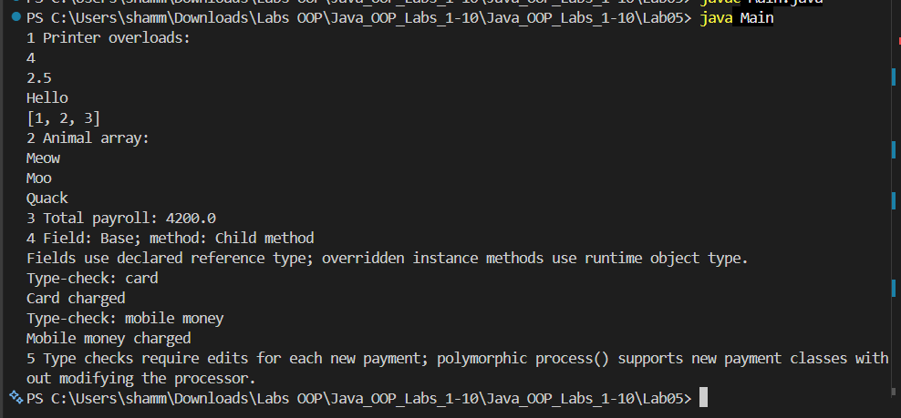

Lab 6: Abstraction, Abstract Classes and Interfaces
This lab looked at abstract classes and interfaces and when each one is useful in a program.
An abstract Shape class required its subclasses to calculate area and perimeter, which I implemented for Circle, Rectangle and Square. A Flyable interface was used by both Bird and Aeroplane. The Account example shared deposit behaviour but required SavingsAccount and CurrentAccount to provide their own monthly fees. I also sorted students by name using Comparable and by marks using Comparator. The final exercise resolved two interfaces that supplied a default method with the same name.
The shape calculations were displayed, including a square with area 25 and perimeter 20. Both Bird and Aeroplane produced flying messages. The accounts showed monthly fees of 2 and 10. The student list could be sorted in two different ways. The conflicting hello() methods were resolved by overriding the method and calling the interface implementations explicitly.
Abstract classes are helpful when related classes share some data or code. Interfaces are better for describing an ability that different kinds of classes can have.
Lab 6 – Program execution screenshot
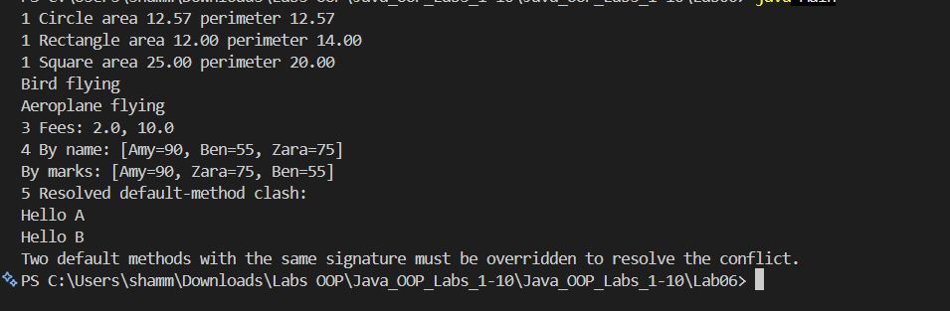

Lab 7: Exception Handling
The main aim was to deal with errors without unexpectedly stopping the program and to practise Java's exception-handling keywords.
The first exercise read numbers for division and handled invalid input and division by zero. The next exercise caught an array index error. I created an InvalidAgeException for ages outside 0 to 120 and used an InsufficientFundsException when withdrawing too much money from an account. The last exercise placed a return statement inside try and printed a message inside finally to test the order of execution.
Using the default values, division returned 5. The program reported an invalid array index and rejected age 150. It also handled insufficient funds instead of allowing an incorrect withdrawal. In the final example, the finally message printed before the returned value of 42 appeared.
This practical showed me why it helps to catch specific exceptions and give clear messages. I also saw that finally still runs when the try block returns a value.
Lab 7 – Program execution screenshot
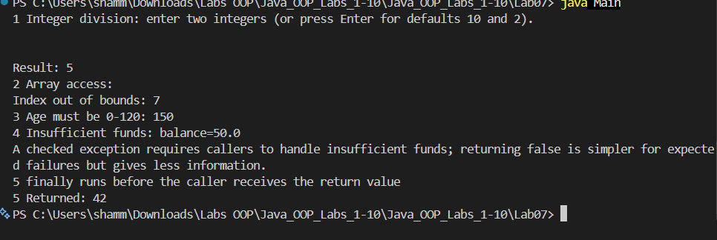

Lab 8: Generics and Collections
This lab introduced generic classes and methods and explored how collections can be used for different kinds of data.
I used lists of numbers to calculate values and test ordering, then a LinkedHashSet to remove duplicate names while keeping their original order. A generic Stack<T> demonstrated how one class can work with different data types. I also counted word frequencies using a map and wrote a generic bubble-sort method for arrays of integers and strings. The exercises compared primitive types with wrapper types in generics.
The collection exercises displayed their results, including a frequency count in which 'java' appeared three times. Sorting produced [1, 2, 3, 4] for the integers and [apple, orange, pear] for the words. The final output explained why a wrapper array such as Integer[] is suitable for a generic method, while int[] does not work in the same way.
Generics reduce the need for repeated code and catch many type problems during compilation. This lab also made the differences between lists, sets and maps easier to understand.
Lab 8 – Program execution screenshot
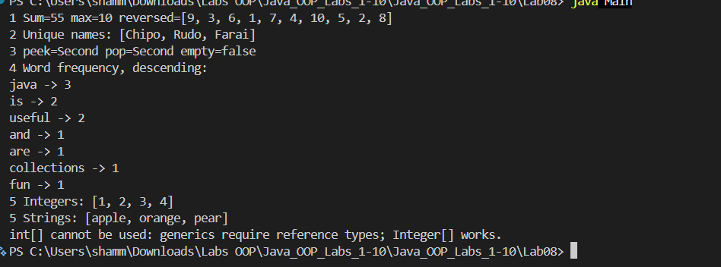

Lab 9: Nested Types, Enums and Records
This lab explored enums, records, equality, linked structures and how related values can be handled in Java.
I used an enum with LOW, MEDIUM and HIGH values, then a switch expression to give advice for each level. A Student record demonstrated the shorter syntax for storing simple data. In another task, Book objects were compared by ISBN using equals() and hashCode(), which affected how a HashSet treated duplicates. I also used a linked list and completed a coin-change task with different coin denominations.
The three levels printed their advice: keep monitoring, take precautions and act immediately. Two Student records with the same values compared equal. The HashSet contained just one book when the ISBNs matched. The linked list printed 1, 2, 3. The coin example gave three quarters, one dime and two pennies for 87 cents.
Records make simple data classes shorter to write, while correctly matched equals() and hashCode() methods matter when objects are stored in sets. Enums are also more useful than plain text values when the possible options are fixed.
Lab 9 – Program execution screenshot
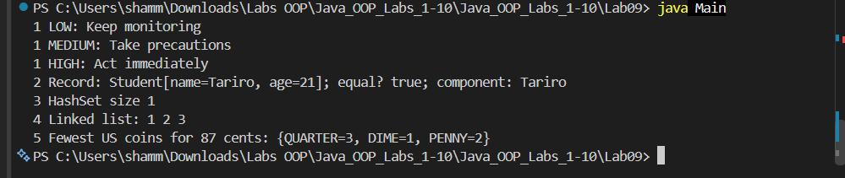

Lab 10: File I/O, Lambdas and Streams
The final lab focused on reading and writing files and using lambdas and streams to work with collections of data.
The program wrote sample text to a file and read the lines back. It used a Predicate<Integer> and a stream to keep odd numbers from a list. Another exercise counted the lines, words and characters in a text file. Student data was used to calculate the class average and identify learners above that average. The final task grouped learners by grade and wrote separate CSV files for each group.
The text file contained five lines, which were read back successfully. The filtered numbers were [1, 3, 5, 7]. The text-counting exercise reported five lines, 16 words and 120 characters. The class average was 73.75, with Amy and Nyasha above it. The program also generated grade-A.csv, grade-B.csv and grade-C.csv for the grouped learners.
I learned how Java can save information outside the program and read it again later. Streams and lambdas also made filtering, counting and grouping data more straightforward.
Lab 10 – Program execution screenshot
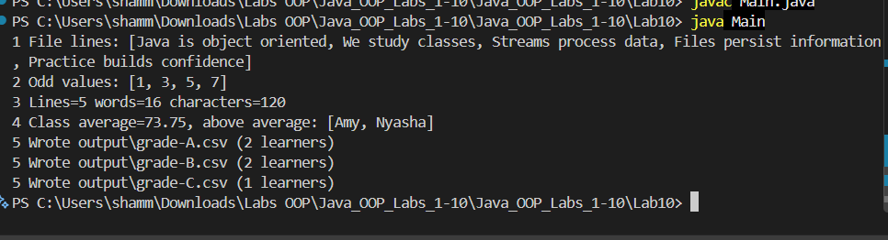

Overall Conclusion
Across these ten labs, I moved from creating basic objects to working with larger sets of related classes and data. The exercises showed how encapsulation protects values, inheritance and polymorphism support reuse, and abstract classes and interfaces help organise different behaviours. Exception handling makes programs more reliable, while collections, generics, streams and file operations help manage information. Running the programs also highlighted the importance of checking the JDK version when using newer Java features. Overall, the practical work helped connect the theory of OOP to actual Java programs.

