# open.py

def main():

    open("/path/to/mars.jpg")

if __name__ == '__main__':

    main()

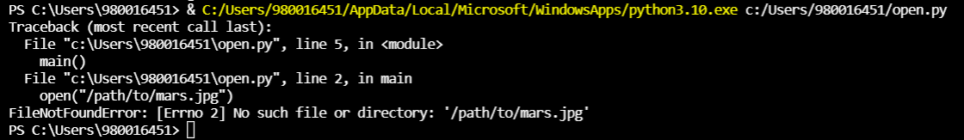

# config.py

def main():

    try:

        configuration = open('config.txt')

    except FileNotFoundError:

        print("Couldn't find the config.txt file!")

if __name__ == '__main__':

    main()

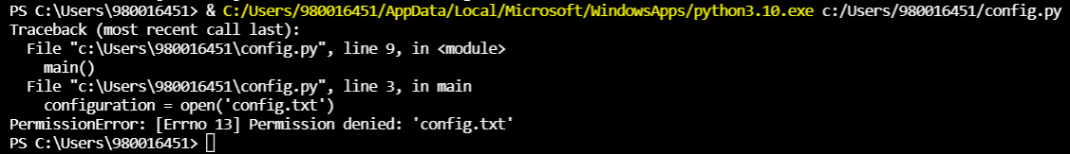

def main():

    try:

        configuration = open('config.txt')

    except Exception:

        print("Couldn't find the config.txt file!")

if __name__ == '__main__':

    main()



def main():

    try:

        configuration = open('config.txt')

    except FileNotFoundError:

        print("Couldn't find the config.txt file!")

    except IsADirectoryError:

        print("Found config.txt but it is a directory, couldn't read it")

if __name__ == '__main__':

    main()

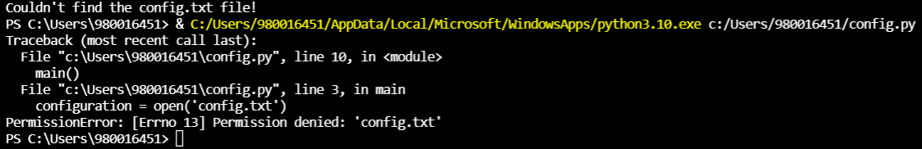

Eliminar archivo.txt



def main():

    try:

        configuration = open('config.txt')

    except FileNotFoundError:

        print("Couldn't find the config.txt file!")

    except IsADirectoryError:

        print("Found config.txt but it is a directory, couldn't read it")

    except (BlockingIOError, TimeoutError):

        print("Filesystem under heavy load, can't complete reading configuration file")

if __name__ == '__main__':

    main()

