Programming Exercise
Introduction
In this assignment statistical models were developed and analysed to assist with a bank’s telemarketing campaigns. The models would be able to classify if a phone call would result in the sale of a long-term bank deposit based on a selection of variables.
The first section covers Exploratory Data Analysis, and the second part involves model training and evaluation. All analysis and training were done using R.
Part 1: Exploratory Analysis
Overview
The Dataset used for this exercise is a sample based on the marketing campaign of a Portuguese banking institution. It provides 20 input features for each observation and a target column, named “y”, with a binary category of “yes” or “no” on the result of selling a term deposit. The dataset used for this problem was provided by the UoE online and various samples including the original dataset can be found on the UCI Machine learning repository (UCI, 2012).
Investigating the structure of the raw dataset indicated 4100 observations. There were 11 variables of the type character and 10 of numerical format, the variables of type character indicating the categorical variables, the categorical variables were converted to type factor.
While there are no missing values in the dataset, 6 of the categorical variables had a category of “unknown”, these were:
- job = 39
- marital = 11
- k = 167
- default = 799
- housing = 104
- loan = 104
These ended up spanning 1224 rows.
Numerical Features
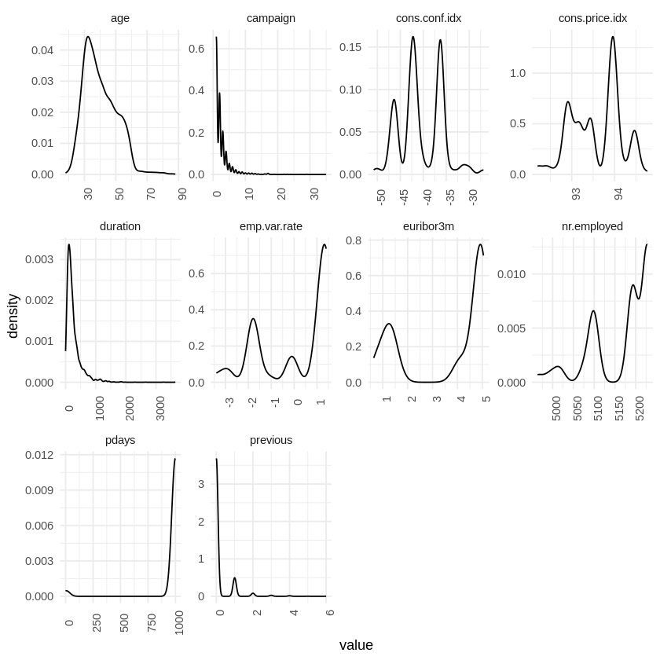
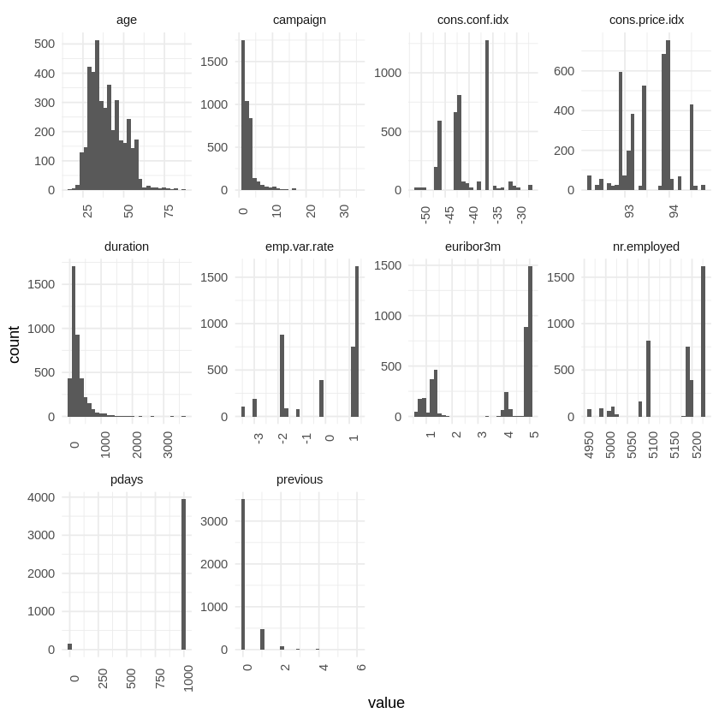
The distribution and relationships between the numerical variables were investigated. Figure 1 compares density plots and histograms of the numerical variables in the dataset, features like cons.conf.idx and cons.price.idx are bimodal while the other features seem to be skewed. The feature “age” while being skewed to the right, seems to be the closest to as normal distribution, with the mode age just above 30.

Figure : To the left are density plots of numerical variables and to the right is corresponding histograms.

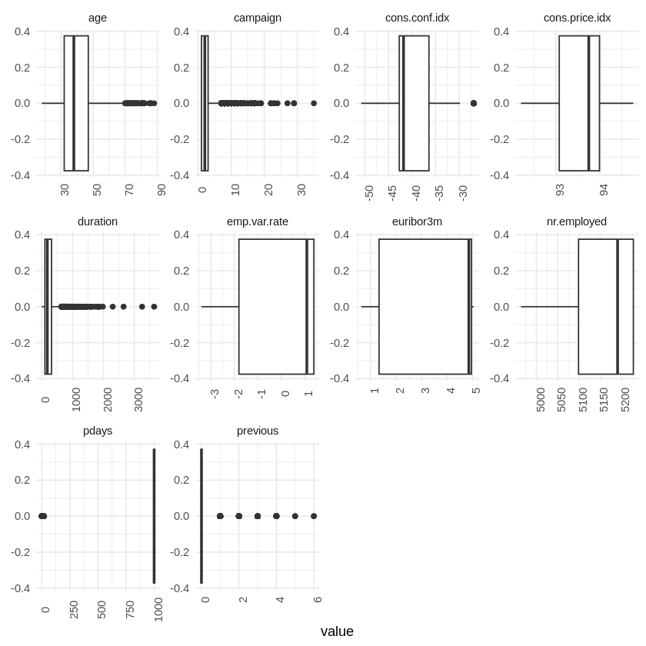
Based on the distributions in Figure 1, it is logical to assume there are outliers in the data. Figure 2 shows boxplots for each numerical variable and clearly outlines which ones have outliers that can affect statistical modelling.

Figure : Boxplots of numerical variables in the dataset.
Campaign, duration, pdays and previous have a lot of outliers in their distribution, and all the distribution plots show that observations of a client above the age of 70 are rare. Outliers will be dealt with later.
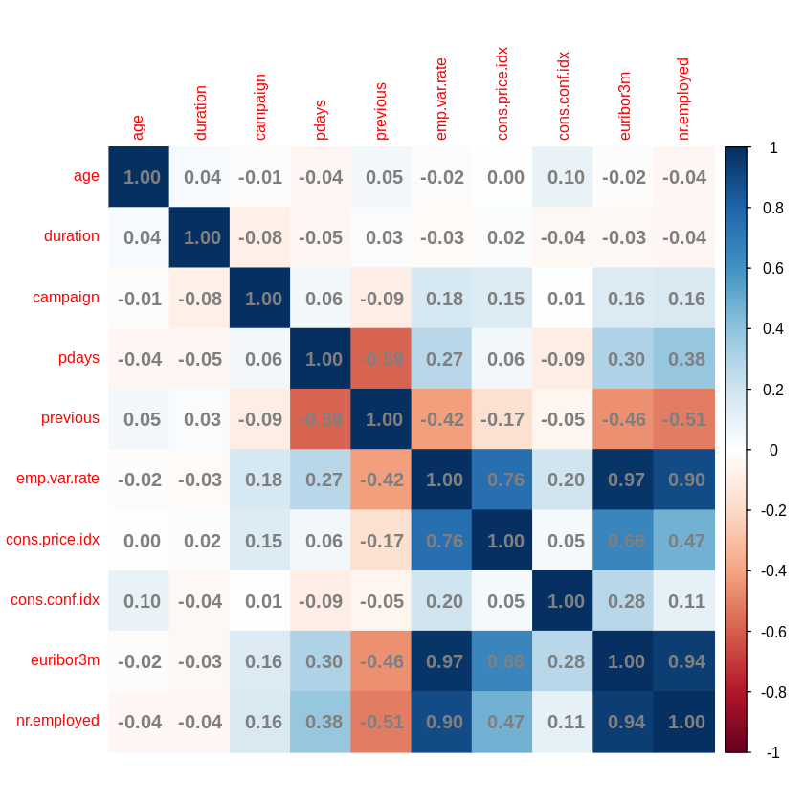
Correlation was also investigated for numerical features using a correlation heatmap in Figure 3. The aim of this was to identify highly correlated features for feature selection, this could then be used to reduce dimensionality and complexity of the model as well as improving the statistical model’s ability to generalise once trained (Mudadla, 2023).

Figure : Correlation Heatmap of numerical features.

The following Features can be seen to show correlation:
- pdays and previous
- emp.var.rate, nr.employed, cons.price.idx and euribor3m

Categorical Features
The distribution of the data between categories in the categorical features can be explored using a bar plot as in Figure 4. The target feature “y” is very imbalanced, there are only 451 observations that resulted in “yes”, accounting for approximately 11% of the data.
Another interesting feature is “default”, which indicates whether the contact has credit in default. There is only one observation for yes, majority responded no and then there is the unknown category. It is possible that the instances in the unknown category are where the contact has not wanted to disclose that they have defaulted on credit payments considering the lack of observations for yes.
The information given by “default” can mean that while there are unknown categories in 6 of the features, they are still valuable categories and can feed patterns into the model.

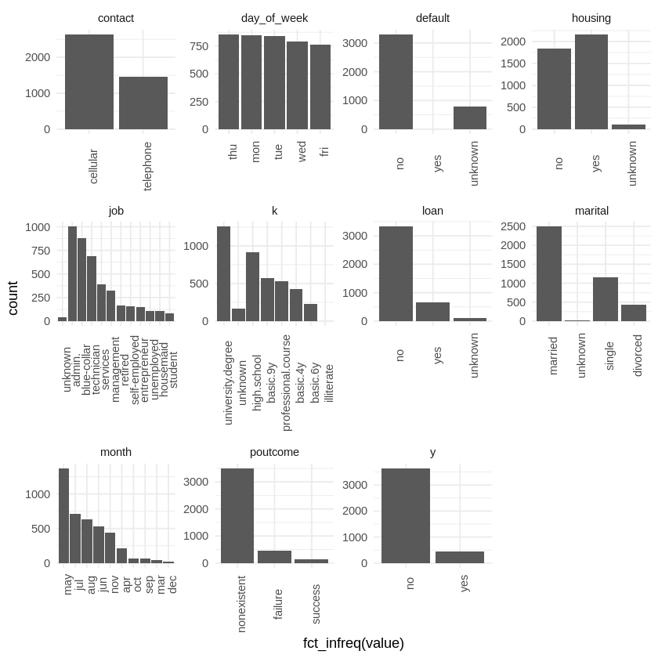

Figure SEQ Figure \* ARABIC 4: Bar plot of categorical features.
Chi-Square Test
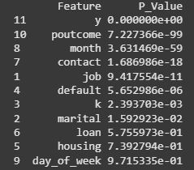
The relationship between the target feature and categorical variables was investigated using a Chi-Square test of independence to find which categorical features were more important (GeeksforGeeks, 2025).

Figure : p-values of features ordered by feature importance.

Figure 5 shows that poutcome, month, contact, job, default and k have a p-value < 0.05 showing the is a statistically significant association between these features and the target feature (Mindrila and Balentyne, 2013).
Cleaning and Preparing the Data
To prepare the data for modelling it normally needs cleaning, data transformation, feature selection and feature engineering (Brownlee, 2020). As it was established there was no missing values and “unknown” can be informative for the model, the first step was to select the features the model would be trained on.
Feature selection
The initial models would be trained on all variables to compare different algorithms performance and to compare performance before and after feature selection. The “pdays” column was removed however due low of variance and correlation with “previous” as this would not provide much useful information to the models trained (Das and Mert Cakmak, 2018).
Dealing with outliers
Next the numerical features with outliers were transformed, the features age, campaign, duration and previous show outliers and are right skewed. To reduce the reduce the impact of outliers and retain information in the modelling, these variables were log transformed (Sreekanth, 2025).
Encoding Categorical Variables
The categorical variables we one-hot encoded so that input variables were numeric. One downside to this was that the number of columns increased to 62, however the categorical variables did not have an intrinsic ordering and therefore one-hot encoding was more suitable (Ali, 2023).
Scaling the data
The data was then scaled using standardization (z-score) scaling.
Part 2: Statistical Modelling
Splitting the data
Once the data was in a format that all models could train on consistently, it then needed to be split into training and testing sets. A validation set was not created for this project and the test set was used to evaluate model performance. 80% was used for the training set and 20% was used for the test set.

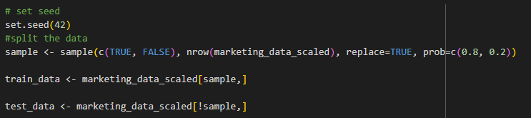
Figure : Code sample to split the data into training and test sets.
All models were trained with a seed of 42.
Logistic Regression
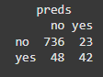
A logistic regression model was trained on all the training data with the glm() function. Once predictions had been made a confusion matrix was created and accuracy calculated as 0.92.

Figure : Confusion Matrix of logistic regression model.
It is seen in figure 7 that the model is good at predicting outcomes of the category “no” however has slightly more False negatives than True positives. This may be due to the imbalance of the target variable categories.
KNN
A KNN model was then trained with the knn3() function from the caret package on the same data. A k value of 65 was used. Accuracy was calculated as 0.90.
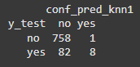

Figure : Confusion Matrix for KNN model.

It can clearly be seen from figure 8 that this model performs worse on predicting positive or “yes” instances.
Random Forest
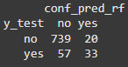
A Random Forest model was then trained using the randomForest package and the number of trees set to 500. The accuracy of the model is 0.91.

Figure :Confusion Matrix for Random Forest model.

Comparison of Models
An ROC plot was created to compare all the models trained and AUC was calculated, this information can be seen in figure 10.
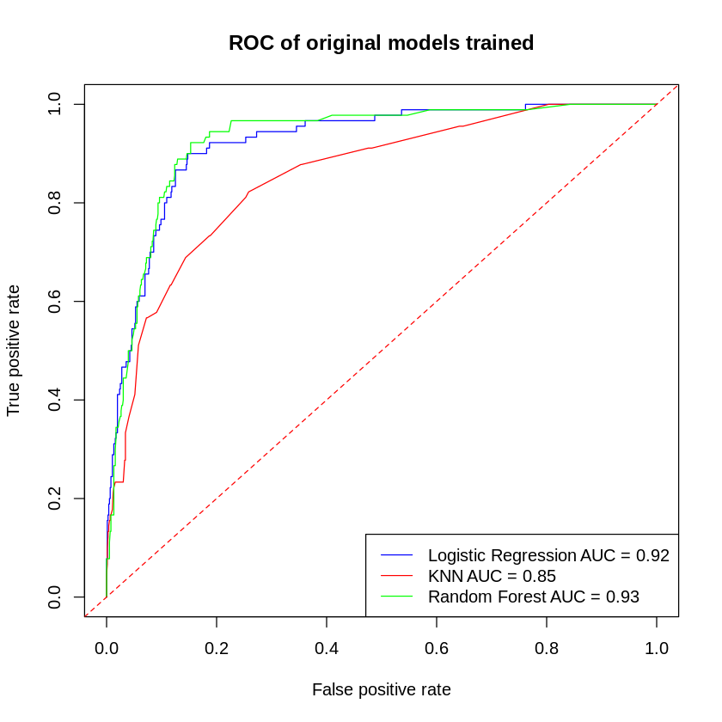
Figure : ROC plot of models trained before feature selection.
From the ROC curve it seems that the Logistic regression and Random Forest models perform similarly while the KNN model performs a little worse. Aligning with accuracy and confusion matrix for each.
Comparison of Models after Feature Selection
As a result of training the Random Forest model, some further insight could be gained by creating a Variable Importance plot. This can be seen in Figure 11. Based on the original EDA done and the Feature importance plot these variables were kept:
- duration
- euribor3m
- age
- nr.employed
- poutcome
- campaign
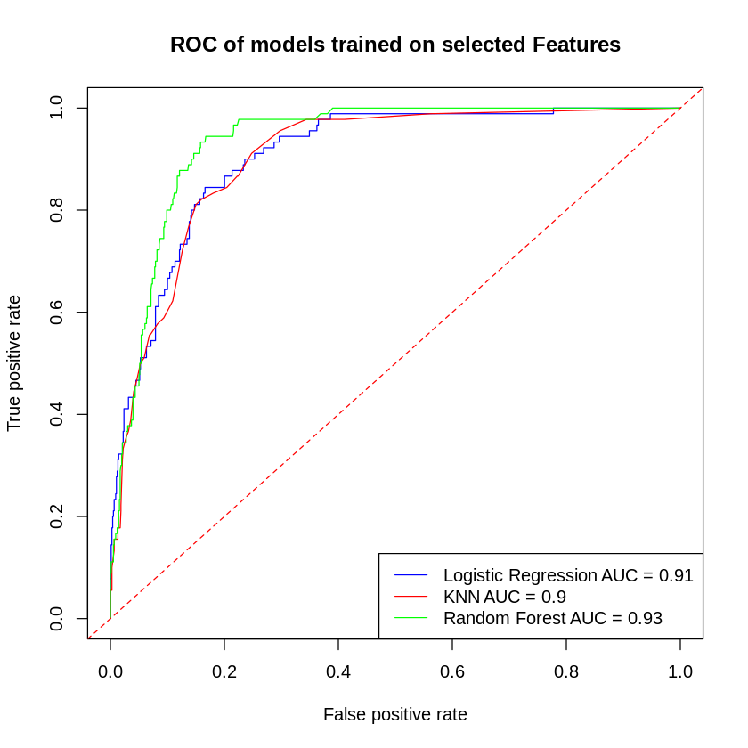
The models were retrained, and the ROC plot can be seen in Figure 12.

Figure : ROC plot of models trained with feature selected variables.
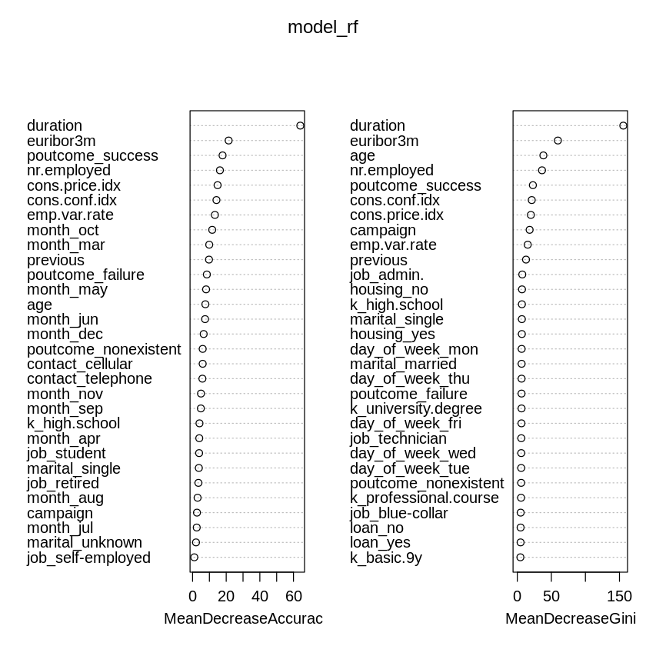
As a result of the minimising the number of features, the KNN model slightly improved while the Logistic Regression performance worsened. The Random Forest still has better performance than the other modelling methods used with regards to accuracy and the ROC plot.

Figure : Variable Importance plot derived from initial Random Forest model.
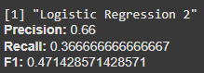
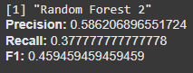
Comparing the f1 score of the models, all had a score below 0.5 indicating poor performance with regards to predicting “yes” accurately for the target variable. The second logistic regression score being 0.47 and the second random forest being 0.46.

Figure : Precision, Recall and F1-Score metrics, Logistic regression model 2 on the left with Random Forest model 2 on the right.

Summary
While accuracy metrics and ROC curves indicate good model training and performance, it is not indicative of how well the models predict different outcomes. In this case while comparing models and reducing features, it has been seen that the models are performing worse with regards to predicting the positive “yes” class. This can be attributed to the imbalanced dataset with only 11% of the data resulting in positive value.
To improve the model’s performance with regards to precision, recall and f1-scores, methods such as undersampling or oversampling could be used to balance the dataset (Buhl, 2022). Techniques such as hyper-parameter tuning and cross-validation could also be used, either on Logistic regression or Random Forest as they seem to be the better models for this problem.

References
UCI. (2012). UCI Machine Learning Repository: Bank Marketing. Available at: https://archive.ics.uci.edu/dataset/222/bank+marketing [Accessed 23 March 2025].
Mudadla, S. (2023). Why we have to remove highly correlated features in Machine Learning? Medium. Available at: https://medium.com/@sujathamudadla1213/why-we-have-to-remove-highly-correlated-features-in-machine-learning-9a8416286f18 [Accessed 24 March 2025].
GeeksforGeeks. (2025). ML | Chi-square Test for feature selection. [online] Available at: https://www.geeksforgeeks.org/ml-chi-square-test-for-feature-selection/ [Accessed 24 March 2025].
Mindrila, D. and Balentyne, P. (2013). The Chi Square Test. University of West Georgia. Available at: https://www.westga.edu/academics/research/vrc/assets/docs/ChiSquareTest_LectureNotes.pdf [Accessed 24 March 2025].
Brownlee, J. (2020). What Is Data Preparation in a Machine Learning Project. [online] Machine Learning Mastery. Available at: https://machinelearningmastery.com/what-is-data-preparation-in-machine-learning/ [Accessed on 24/03/2025].
Das, S. and Mert Cakmak, U. (2018). Hands-On Automated Machine Learning : a beginner’s guide to building automated machine learning systems using AutoML and Python. Birmingham: Packt Publishing.
Sreekanth, V. (2025). How to Handle Outliers in Your Data Preparation? Medium. Available at: https://medium.com/@vigneshvars2001/how-to-handle-outliers-in-your-data-preparation-192d0ded9b81 [Accessed 24 March 2025].
Ali, M. (2023). Handling Categorical Data in Python Tutorial. Available at: https://www.datacamp.com/tutorial/categorical-data [Accessed 24 March 2025].
Buhl, N. (2022). Introduction to Balanced and Imbalanced Datasets in Machine Learning. Available at: https://encord.com/blog/an-introduction-to-balanced-and-imbalanced-datasets-in-machine-learning/ [Accessed 24 March 2025].

