Software Requirements Specification

for

Car trip simulation

Version 1.0 approved

Prepared by Rafat Munshi, Aysha Khan

Department of Computer Engineering, ZHCET

Aug 26, 2016

Table of Contents

Table of Contents ii

Revision History ii

1. Introduction 1

1.1 Purpose 1

1.2 Intended Audience and Reading Suggestions 1

1.3 Product Scope 1

1.4 References 2

2. Overall Description 2

2.1 Product Perspective 2

2.2 Product Functions 3

2.4 Operating Environment 3

2.5 Design and Implementation Constraints 4

3. External Interface Requirements 4

3.1 User Interfaces 4

3.2 Hardware Interfaces 13

3.3 Software Interfaces 13

4. System Features 13

4.1 Functional Requirement Specification 14

4.2 User characteristics 15

Revision History

|  |  |  |  |
| --- | --- | --- | --- |
| **Name** | **Date** | **Reason For Changes** | **Version** |
|  |  |  |  |
|  |  |  |  |

# Introduction

## Purpose

The purpose of this document is to present a detailed description of the Car trip simulation System. It will explain the purpose and features of the system, the interfaces of the system, what the system will do, the constraints under which it must operate and how the system will react to external stimuli. This document is intended for both the stakeholders and the developers of the system

## Intended Audience and Reading Suggestions

This document is intended for the developers, users, testers, and documentation writers.

## Product Scope

This web based application system will be a car trip simulation system for a user to find directions and simulate his/her car’s movement on the screen. Zoom in and zoom out options are available to have a view of the proximity areas of the car with various zooming levels. For a particular speed of the car, the zoom in will animate the car movement slowly and the zoom out will cause the car to move faster given a steady speed. An option to increase or decrease the speed of the car is also given for better functionality of the application.

## References

IEEE. *IEEE Std 830-1998 IEEE Recommended Practice for Software Requirements Specifications.* IEEE Computer Society, 1998.

# Overall Description

## 2.1 Product perspective

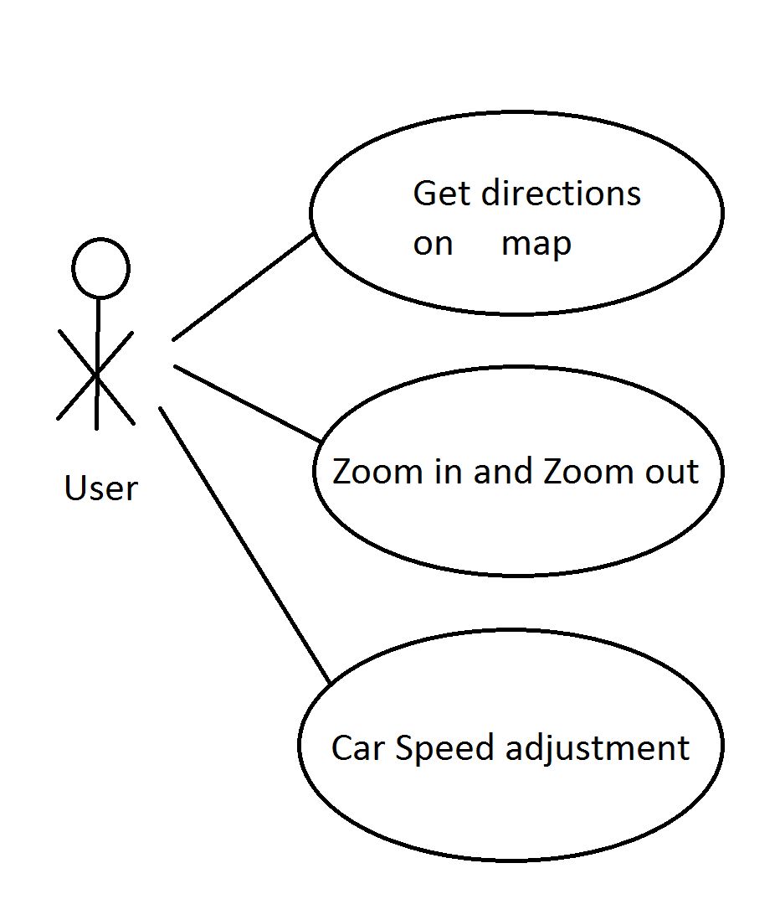

Figure - System Environment use case

The Student Registration System has one active actors and one cooperating system.

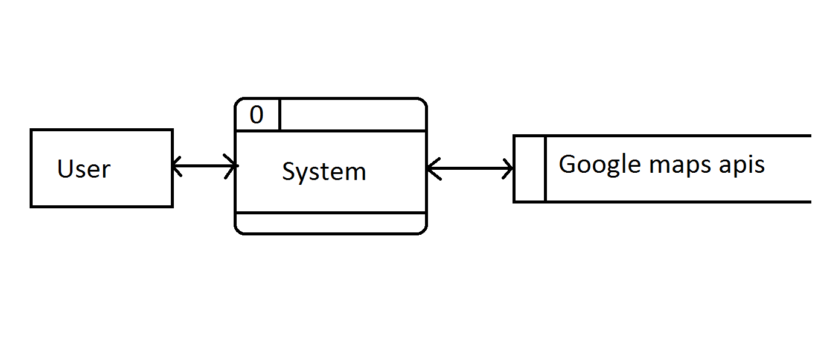

## Product Functions

Architecture diagram –

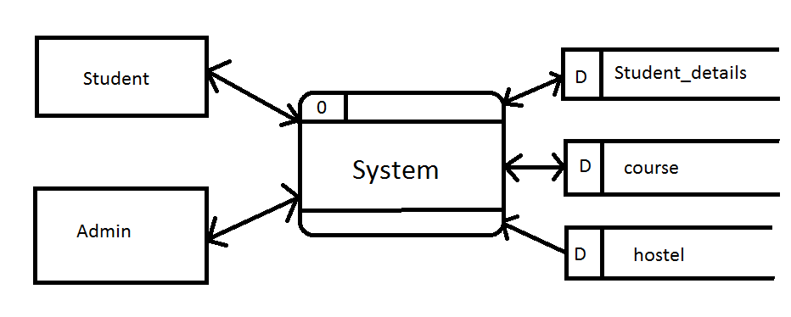

## Operating Environment

The application should run on any machine with a javascript compatible browser.

## Design and Implementation Constraints

It is required to implement this web application using google maps javascript apis along with an appealing user interface and should be cross browser compatible

# External Interface Requirements

## User Interfaces

The GUI interface below will each give an idea of the requirements on each interface of the user and messages to display

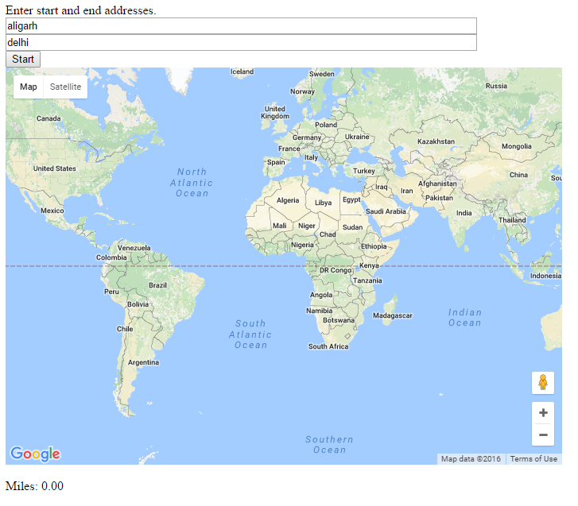

The home page should display the map along with input boxes for user to input source and destination as shown.

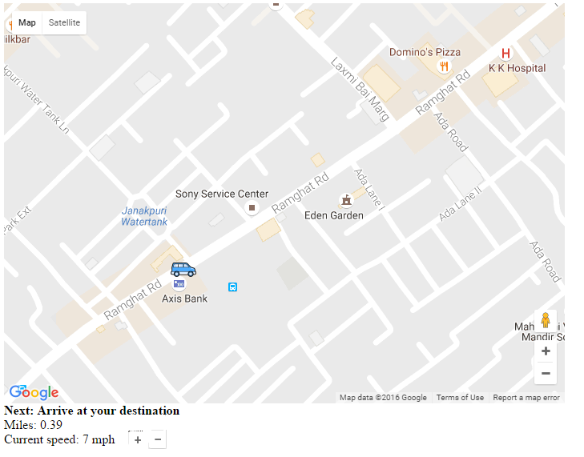

After user inputs the source and destination, a car icon should start moving the path between the source and destination as shown. The selected speed and driving instruction should be shown as displayed in mock up. The zoom icons should also be displayed this way. A plus and minus icon for speed adjustment should also be provided.

## 3.2 Hardware Interfaces

No hardware interfaces required.

## Software Interfaces

The only software interface is the google maps api server for which the browser would be client.

# System Features

The application should be accessible to any user in the network from any machine.

## Functional Requirements Specification

This section outlines the use cases for the active user separately.

### Use Case

#### Use case: Find direction

**Diagram:**

User

Find directions

**Initial Step-By-Step Description**

1. The user enters the address of the two locations between which he/she wants to find directions.
2. The system displays a map with the best direction from the source to the destination address with proper markers.
3. A car icon is showed to travel from the source to the destination at a predefined speed.
4. As the car moves, the instructions for travelling ahead are displayed.
5. Once the car reaches its destination, the animation stops and a message is displayed –“Trip completed”.

#### Use case: Zoom level change

**Diagram:**

User

Zoom level change

**Initial Step-By-Step Description**

1. The user is provided with a plus and minus symbol on the map to change zoom levels.
2. On click of plus symbol, the map zooms in and consequently the path and its surrounding details increase and the speed of the animation of the car increases as the car has a steady speed.
3. On click of minus symbol, the map zooms out and consequently the path and its surrounding details decrease and the speed of the animation of the car decreases as the car has a steady speed.
4. On reaching the end of the screen of the car icon, the next part of the map should be loaded with the car icon at the center of the screen. Thus the whole path map should be loaded part by part based on the completion of the traversal of the car icon on the screen.
5. Total 8 levels of zoom required

#### Use case: Speed adjustment

**Diagram:**

User

Speed adjustment

**Initial Step-By-Step Description**

1. The user should be able to increase or decrease the speed of the car and based upon that speed, the animation of the car fastens or slows down. The car icon should be covering the distance in that exact time which is calculated based on the current speed.

## User Characteristics

The user is expected to be having knowledge of using google maps. He/She should be using the application real time based upon the speed of his/her vehicle to be able to benefit from the application.