Software Requirements Specification
for
Student Registration System
Version 1.0 approved
Prepared by Rafat Munshi, Aysha Khan
Department of Computer Engineering, ZHCET
Aug 20, 2016

Table of Contents
Table of Contents ii
Revision History ii
1. Introduction 1
1.1 Purpose 1
1.2 Document Conventions 1
1.3 Intended Audience and Reading Suggestions 1
1.4 Product Scope 1
1.5 References 1
2. Overall Description 2
2.1 Product Perspective 2
2.2 Product Functions 2
2.3 User Classes and Characteristics 2
2.4 Operating Environment 2
2.5 Design and Implementation Constraints 2
2.6 User Documentation 2
2.7 Assumptions and Dependencies 3
3. External Interface Requirements 3
3.1 User Interfaces 3
3.2 Hardware Interfaces 3
3.3 Software Interfaces 3
3.4 Communications Interfaces 3
4. System Features 4
4.1 System Feature 1 4
4.2 System Feature 2 (and so on) 4
5. Other Nonfunctional Requirements 4
5.1 Performance Requirements 4
5.2 Safety Requirements 5
5.3 Security Requirements 5
5.4 Software Quality Attributes 5
5.5 Business Rules 5
6. Other Requirements 5
Appendix A: Glossary 5
Appendix B: Analysis Models 5
Appendix C: To Be Determined List 6

Revision History
Name | Date | Reason For Changes | Version

Introduction

Purpose
The purpose of this document is to present a detailed description of the Student Registration System. It will explain the purpose and features of the system, the interfaces of the system, what the system will do, the constraints under which it must operate and how the system will react to external stimuli. This document is intended for both the stakeholders and the developers of the system

Intended Audience and Reading Suggestions
This document is intended for the developers, users, testers, and documentation writers.

Product Scope
This web based application system will be a Student Registration System for a a student of the university as well as the administrator of the application. This system will be designed to register students for the particular semesters in the various courses offered by the University. It shall provide a one stop place for students to register, view and edit their details as well as the admin for viewing all students in the course and edit student and course information, which would have been much difficult with paper work and files. By maximizing the student’s and admin’s work efficiency, the system will meet the university’s needs and requirements while remaining easy to understand and use.
The system also contains a relational database containing a list of courses with their maximum limit, All student details, and hostel details.

References
IEEE. IEEE Std 830-1998 IEEE Recommended Practice for Software Requirements Specifications. IEEE Computer Society, 1998.

Overall Description

2.1 System Environment use case
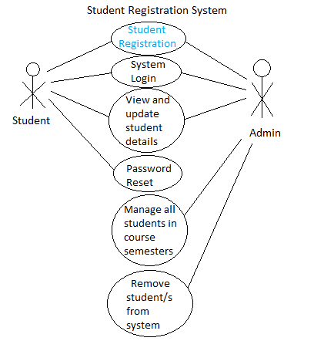
Figure 1 - System Environment use case

The Student Registration System has two active actors and one cooperating system.
The student can register to a course for a particular semester, view and update his/her information through this system. The admin can view all students enrolled in a particular course of the University for the particular semester, add or remove and student/s, search any student and view and update his/her details. There is a link to the (existing) Courses table in the database.

Product Functions
Context diagram (DFD level 0)-

Operating Environment
The application should run on any machine with Windows OS.

Design and Implementation Constraints
It is required to implement this web application on Php and mysql database along with an appealing user interface and should be cross browser compatible

External Interface Requirements

User Interfaces
The GUI interface below will each give an idea of the requirements on each interface of the user and messages to display

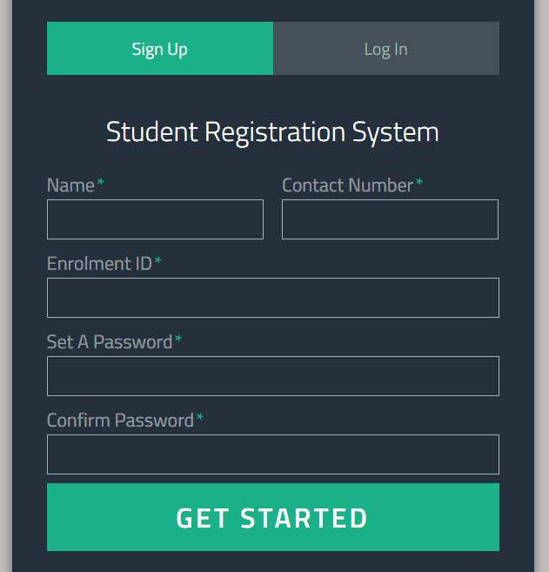
An interface for signing up into the system for a student. This should be the home page. It should take inputs as shown in the figure

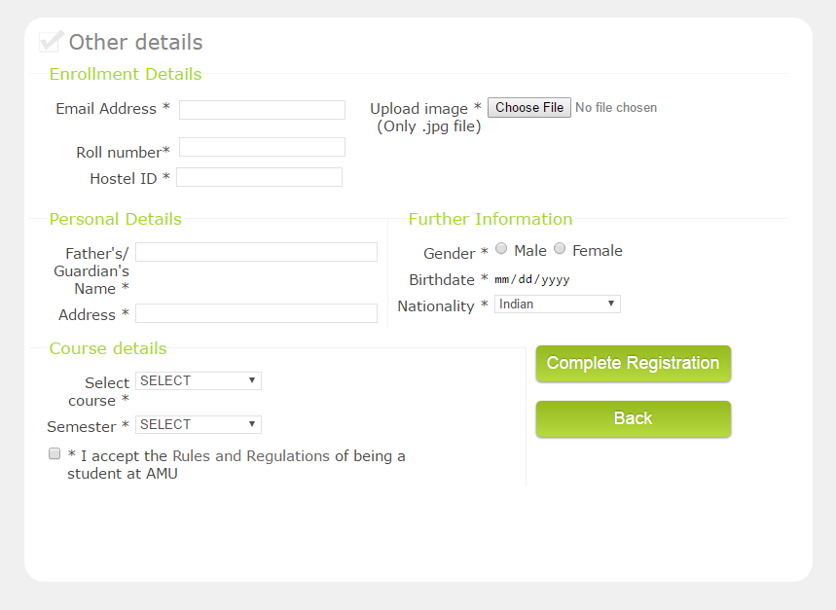
A next interface to complete registering other details and registering in a sem of a course.

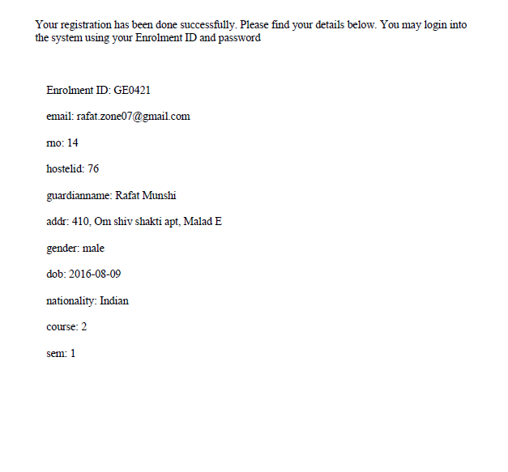
After successfully completing registration, the system should open up a pdf with confirmation message and other details like shown in the figure.

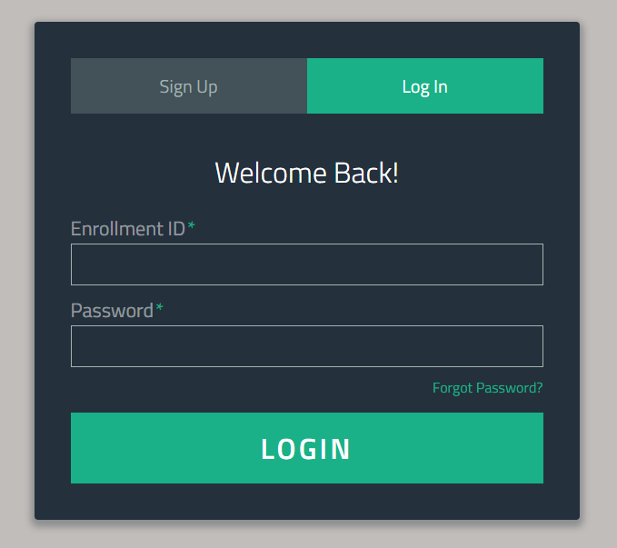

An interface for logging into the system for registered students using enrolment id and password

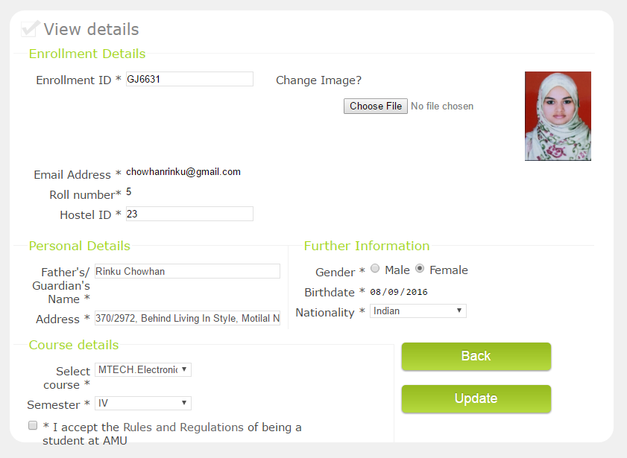
After logging into the system, the student should be able to view his/her details and be able to edit the information.

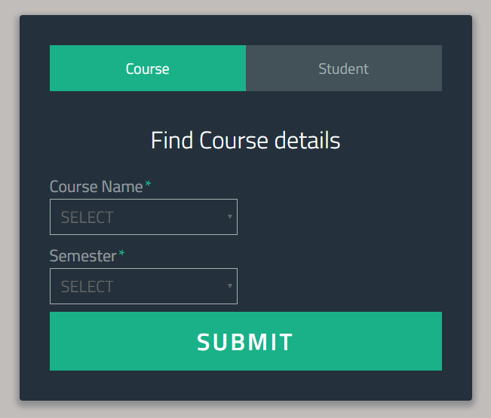
This is the page for the admin. The admin should be able to view all the enrolled students in a particular course for the particular semester.
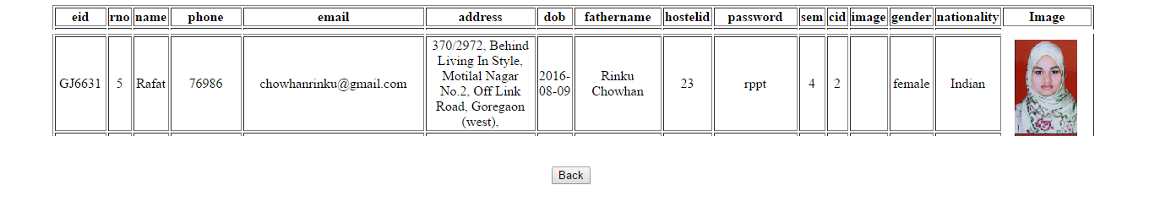
The result can be shown in this way.
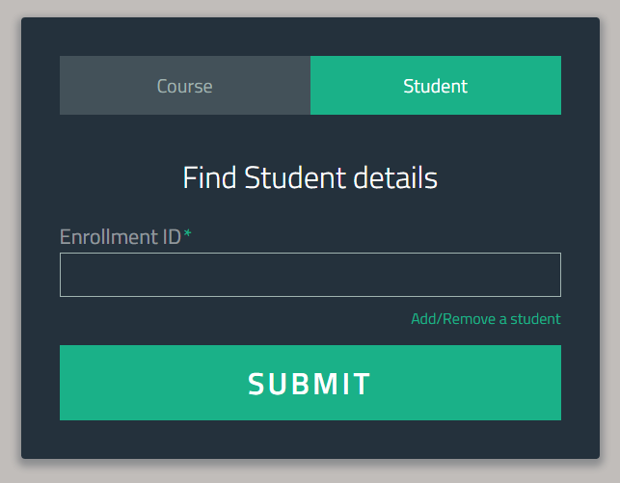
The interface for the admin to search and view details of a particular student. After this the admin should be able to similarly be able to edit the student’s details.

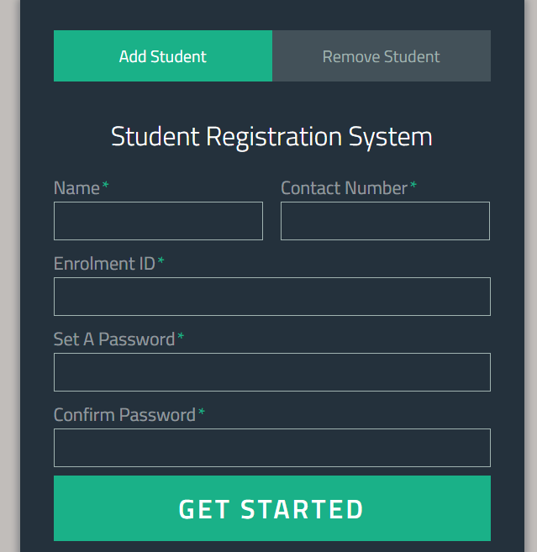
An interface is to be provided to the admin to register a student similarly.
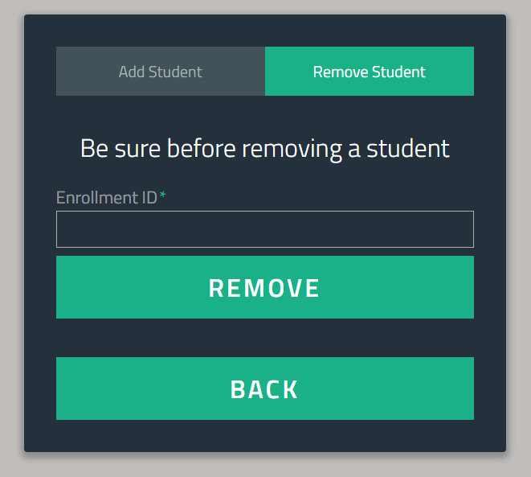
Admin should also be able to delete a student from the system in case of fraudulent or mistaken registrations/sign ups.

3.2 Hardware Interfaces

No hardware interfaces required.

Software Interfaces
Only external interface should be the student database with all student’s, courses’ and hostel details.

System Features
The application should be accessible to any user in the network from any machine.

Functional Requirements Specification
This section outlines the use cases for each of the active user separately.

Student Use Case

Use case: Student Registration
Diagram:
Student
Student Registration

Initial Step-By-Step Description

- Student able to register all the details as shown in the GUIs.
- Check for enrolment id if not already registered, only then register this student else alert the user to login with the enrolment id and registered password or check the enrolment id.
- Check for availability in the course and semester. If already reached the maximum limit then alert user that registrations in the semester is over, and to kindly check the course and semester while registering.
- A student should not be able to register in more than one course and is needed to be registered in atleast one course of the university.
- If the check is pass, successfully register the student and generate and display a pdf for the user as shown in the GUI above.

Use case: System Login
Diagram:
Student
System Login

Initial Step-By-Step Description

- Student should be able to login using enrolment id and password.
- System should check the enrolment id and password with the database and direct to viewing details page on successful login
- An error alert should be presented in case the id and password are incorrect

Use case: System login
Diagram:
Admin
System Login

Initial Step-By-Step Description

- The admin should be able to login with common username and password i.e id= 0000 and password should be “amu_reg”
- With this username and password, the admin can get to the admin page as shown in the GUI.

User Characteristics
The student is expected to already have knowledge of his/her details of enrolment in the university course and be ready with the soft copy of his/her image in jpg format.
The admin is expected to have knowledge of database administration as well as the rules and regulations of enrolment in the university.

Forgot password feature

4.1.1 Description
The student should be able to reset his/her password by verifying his/her details of email and date of birth followed by a success message of password reset.

Other Nonfunctional Requirements

Logical Structure of the Data

The logical structure of the data of the actors of Student Registration database is given below.
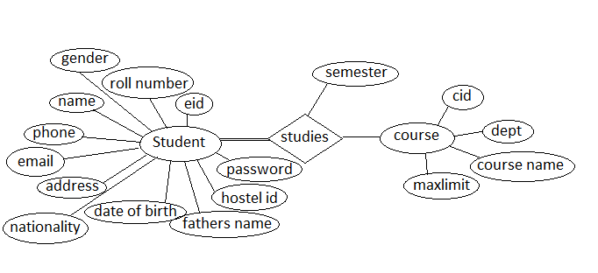
Figure 2 - Logical Structure of the Student Registration System

Student details
Data Item | Type | Description | Comment
Name | Text | Name of the student | Atleast 7 characters long
EID | Text | Enrolment ID | 6-7 characters long
Roll number | Number
Gender | Option | Male or female
Phone | Number |  | 10-15 length.
email | Email |  | @ present
address | Text
nationality | Option | Indian or NRI
Date of birth | Date
Fathers name | Text
Hostel id | Text
password | Text |  | Atleast 8 characters long
semester | Number
cid | Text |  | Course id
dept | Text
Course name | Text
Max limit | Number

Safety Requirements
<Specify those requirements that are concerned with possible loss, damage, or harm that could result from the use of the product. Define any safeguards or actions that must be taken, as well as actions that must be prevented. Refer to any external policies or regulations that state safety issues that affect the product’s design or use. Define any safety certifications that must be satisfied.>

Security Requirements
<Specify any requirements regarding security or privacy issues surrounding use of the product or protection of the data used or created by the product. Define any user identity authentication requirements. Refer to any external policies or regulations containing security issues that affect the product. Define any security or privacy certifications that must be satisfied.>

Software Quality Attributes
<Specify any additional quality characteristics for the product that will be important to either the customers or the developers. Some to consider are: adaptability, availability, correctness, flexibility, interoperability, maintainability, portability, reliability, reusability, robustness, testability, and usability. Write these to be specific, quantitative, and verifiable when possible. At the least, clarify the relative preferences for various attributes, such as ease of use over ease of learning.>
Appendix A: Glossary
<Define all the terms necessary to properly interpret the SRS, including acronyms and abbreviations. You may wish to build a separate glossary that spans multiple projects or the entire organization, and just include terms specific to a single project in each SRS.>
Appendix B: Analysis Models
<Optionally, include any pertinent analysis models, such as data flow diagrams, class diagrams, state-transition diagrams, or entity-relationship diagrams.>
Appendix C: To Be Determined List
<Collect a numbered list of the TBD (to be determined) references that remain in the SRS so they can be tracked to closure.>

