Introduction:
The company is considering opening a car dealership in the US. They want me to analyze the market trend there. Some attributes of a car are valued by the Americans and those also affect the price of the car.
I am given a data set that includes the vehicle features, price, and location. Using that data I can analyze where they can open the dealership, which manufacturer’s cars they can deal with, which models are trending of those manufacturers, which type, size, color, drive, fuel, number of cylinders, air condition, and transmission is liked by the Americans.
Feature | Explanation
Manufacturer | Who is the manufacturer of the car?
Model | What is the model of the car?
State | In which state this car exists?
Type | What is the type of car? i.e. SUV, Truck, Sedan etc.
Size | What is the size of car? i.e. full-size, mid-size, compact etc.
Drive | How many wheels are used for drive? i.e. 4wd, fwd, rwd.
Transmission | i.e. Automatic, or manual
Cylinders | The number of cylinders.
Fuel | What fuel is used? i.e. Gas, diesel, hybrid, electric etc.
Color | What is the color of car?
AC | Does the car has air conditioning or not?

Data Cleaning:
In data cleaning I did three important things:
1. Handling null values
The data set was having 4593 null values in 5 different columns. One column was having numerical values that’s why I replace null values with 0. and the other four columns were having categorical values so I replaced null values with modes of those columns.
2. Handling negative values in the price column
price column was having 4 negative values in it that are logically incorrect. The price can’t be negative. So, I used absolute mathematical functions to change those negatives into positives.
3. Handling low values in the price column
The price column was having some very low prices i.e. 9, 15, 20, etc. That can’t be true values for the price of a car so I dropped all those records whose price was lower than 500. Because this can be a minimum price for a car.

Exploratory Data Analysis:
After doing exploratory data analysis I found following interesting observations:

- If we look at the data of manufacturers we shall get to know that ford, chevrolet, toyota, and honda are the top 4 manufactures of cars in America.

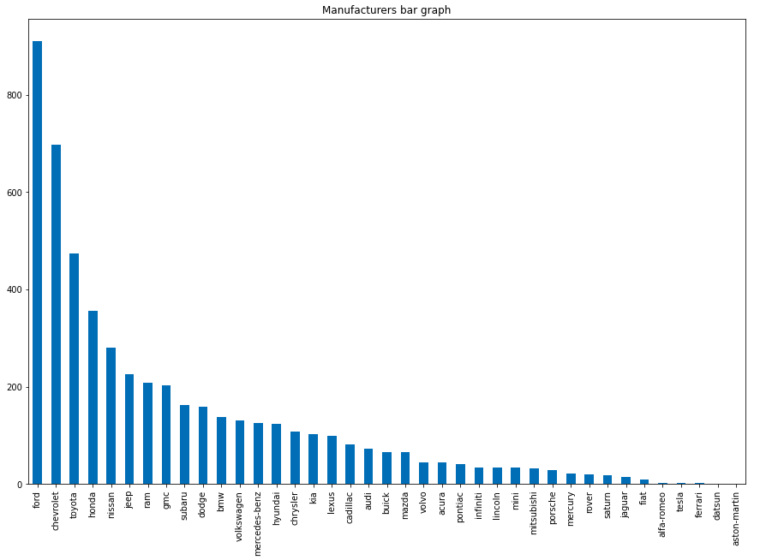
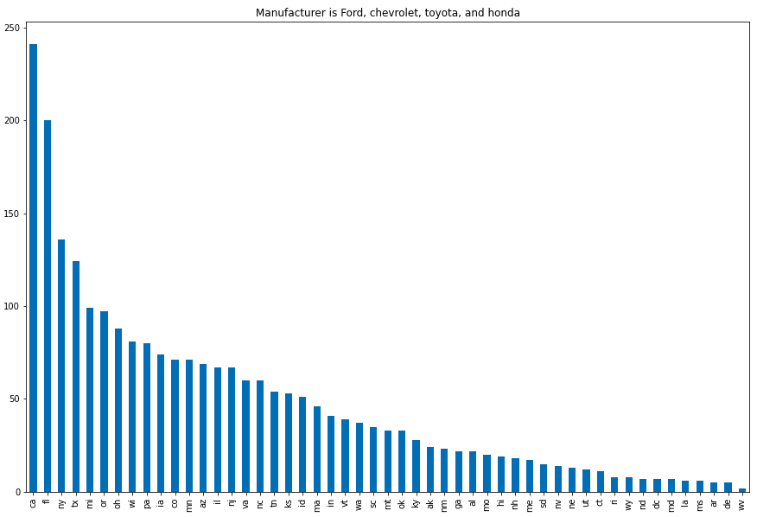

- If we see the states of cars. I saw there are some certain states in which there are maximum number of vehicles with having manufacturers as ford, chevrolet, toyota, and honda . Which includes CA, FL, NY, and TX.

3. If we look at the trending features of the vehicles that are liked by the customers, We shall get to know that:
- White, Black and Silver are the most liked colors.
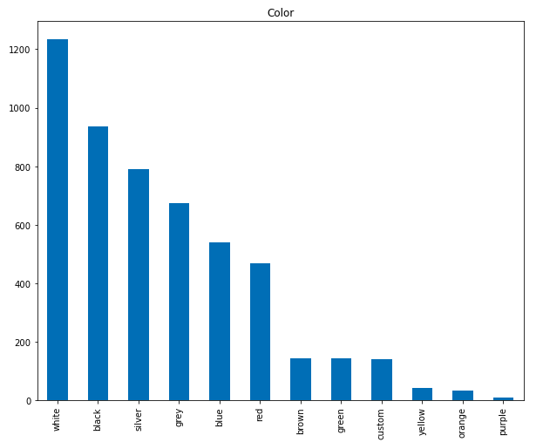
- Gas and Diesel are the most used fuel types.
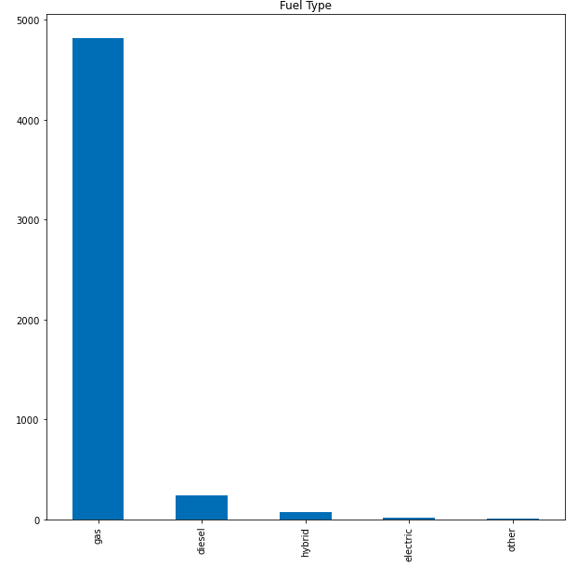
- Non Air Conditioned vehicles are more used.
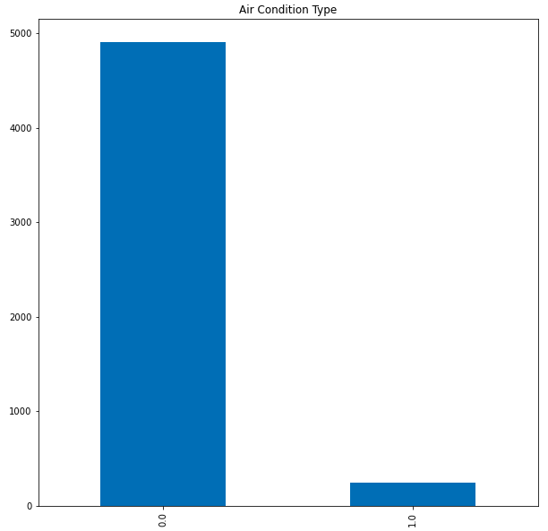
- 4WD is most liked drive type.
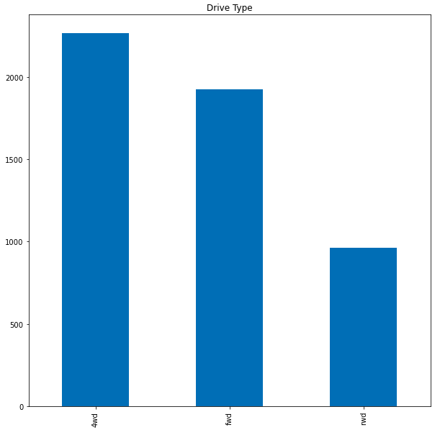

Descriptive Analytic:
Questions that my client can ask:

1. Which state will be the best to open dealerships of cars?
2. Which manufacturer’s cars will sell out the most?
3. What are the most liked attributes/features of the vehicles by the customer.?

Why these questions are important to my client:

1. State is important for my client because if he will know about the best state where there are maximum cars, then He can open his dealership in that state to get the maximum targeted customers.
2. After knowing the state next question will be obvious if I’m opening a dealership which manufacturer’s vehicles should I sell? After knowing the answer to this question my client will take the decision that whose cars he should sell considering the facts and trends of the market.
3. After knowing the state to open the dealership and famous manufacturers my client will want to know the famous and trending features of the vehicles that are liked by the customers. So that he can have those features in the vehicles to get maximum sales.

The answers:
1. After analysis I got to know that CA, FL, and NY are the most favorite states having 24% of overall vehicles.
2. If we look for famous manufacturers we shall get to know that Ford, Chevrolet, Toyota, and Honda are the most famous manufacturers. With 47% holding of overall data.
3. If we look for different features following are the most liked features:
- Color: White, Black and Silver
- Drive type: 4WD
- Fuel type: Gas and Diesel
- Air Conditioner: Non Air Conditioner.

Machine Learning:
Machine learning is making the machine to learn from the data and patterns in the data. It is a sub field of artificial Intelligence which makes machine intelligent to take decisions with minimal human intervention. Considering this problem and data that is given we can make an intelligent model that can predict the price of a car after giving information about the car.
This is a supervised machine learning problem. Supervised machine learning is a form of machine learning when we use labeled data to train our models for classification or regression problems accurately.
This can be solved using regression algorithm, Linear Regression is a machine learning algorithm which works on the concept of correlation between the variables. It predicts the dependent variable from the independent variable.
So, this regression technique finds out a linear relationship between a dependent variable and the other given independent variables.
This algorithm will be used because the price column has continuous data points which can be predicted using regression algorithm.

