outputs_0hr_NoInhibitors: No Inhibitors, 0 hr LPS (no LPS). **Row 1 is IL1b expression** (spots/cell). **Row 2 is TNFa expression** (spots/cell). Each column is a single-cell (ie Cell Number).

outputs_0hr_NoInhibitors: Concatenated data from all biological replicates at single condition

outputs_0hr_NoInhibitors_0: 1st biological replicate

outputs_0hr_NoInhibitors_1: 2st biological replicate

outputs_0hr_NoInhibitors_2: 3st biological replicate

outputs_0hr_NoInhibitors_3: 4st biological replicate

File naming for concatenated data:

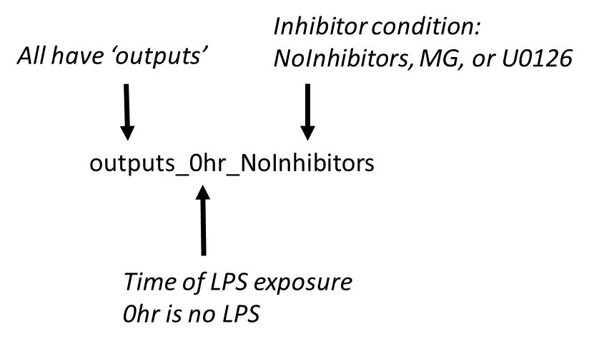

File naming for individual biological replicates

