A SEARCH ON HIGH PROFILE CYBERATTACK
- THE STUXNET VIRUS:- Stuxnet is a worm a type of computer virus—that was first discovered in June 2010. Stuxnet quickly became one of the most publicized computer viruses in history because it was used to monitor and control computers that were involved in Iran’s nuclear program.
Stuxnet is a powerful computer worm designed by U.S. and Israeli intelligence that to disable a key part of the Iranian nuclear program. Targeted at an air-gapped facility. It When Stuxnet infects a computer, it checks to see if that computer is connected to specific models of programmable logic controllers (PLCs) manufactured by Siemens. PLCs are how computers interact with and control industrial machinery like uranium centrifuges. If no PLCs are detected, the worm does nothing; if they are, Stuxnet then alters the PLCs’ programming, resulting in the centrifuges being spun irregularly, damaging or destroying them in the process. While this is happening, the PLCs tell the controller computer (incorrectly) that everything is working fine, making it difficult to detect or diagnose what’s going wrong until it’s too late.was designed to destroy the centrifuges Iran was using to enrich uranium as part of its nuclear program.
MARRIOTT DATA BREACH:- This Marriott data breach exposed the personal information of hundreds of millions of customers from various countries who had made bookings with the company’s Starwood properties over the past several years. As a result of the incident, Marriott faced significant recovery expenses, legal ramifications and reputational damages.
In 2014—two years before Marriott even acquired Starwood—the latter company’s guest reservation system was infiltrated by cybercriminals via remote access trojan (RAT). Put simply, a RAT is a harmful computer program that grants the perpetrator unauthorized administrative control of their victim’s technology. A multitude of digital vulnerabilities at Starwood’s properties could have contributed to the success of the cyber-criminals’ RAT. Namely, these properties were using outdated versions of Windows Server across their computer systems and had left their remote desk protocol (RDP) ports open to the internet. Despite this intrusion within the guest reservation system, Starwood was unable to detect the cybercriminals’ activity—allowing them to remain unnoticed.
- UNITED NATIONS DATA BREACH:- this attack was conducted by the ethical hacking group Sakura Samurai and they were able to take over a number of databases internal systems and also gain access to private password-protected git repositories. They did this because the UN has a vulnerability disclosure program and also a hall of fame.
Now I find this attack interesting for a number of reasons. One, it didn't use complicated and expensive infrastructure to launch the attack and also didn't come with a high level of sophistication in terms of how the exploits were conducted.
But had this been a malevolent actor or a bad actor using this, well, the results could have been really quite severe.
- Microsoft customer support database breach:-these cyber attack result to the exposure of 250 million users data.In June 2023, there were reports of a potential security breach at Microsoft, where a master key was said to have been leaked. This key could have potentially compromised customer data stored in the cloud. According to Microsoft, it is believed that attackers from China may have successfully used this leaked key to monitor emails, particularly those of European government agencies that primarily use Microsoft 365's Exchange Online service to host and manage email in the cloud.According to current knowledge, almost all users of Microsoft's cloud services could be affected if they use the ‘Sign in with Microsoft’ feature.Microsoft has blocked stolen keys in the meantime, but it remains to be seen whether attackers have already been able to install backdoors. At the moment, there is a lot of uncertainty and little information from Microsoft.
- Lifelabs data breach:- LifeLabs provides laboratory testing across Canada. In 2019, LifeLabs experienced a data breach. The data breach resulted because a software patch had not been installed. Cyber-attackers gained access to LifeLabs systems and during that year gained the personal health data of millions of Canadians. The cyber-attackers then demanded payment for the return of the data. LifeLabs paid and in exchange the cyber-attackers agreed not to release the data on the internet.The LifeLabs data breach primarily affected Ontario and British Columbia residents, prompting investigations by both provinces’ Information and Privacy Commissioners (IPC). LifeLabs claimed privilege over requested documents, but the Court upheld the IPCs decision to reject these claims, ruling that statutory obligations override privilege for facts related to privacy breaches, and that health information custodians cannot evade their responsibilities by placing breach-related facts in privileged documents.

ANALYSIS OF STUXNET CYBERATTACK
The analysis of stuxnet cyberattack will be written based on the following:-
- Who were the victims of the attacks:- the victims of the attack are the Iran’s nuclear facilities, specifically the Natanz uranium enrichment plant.
- What technologies and tools were used in the attack:-the technologies and tools that were used include
- Zero-day vulnerabilities in Windows systems
- Stolen digital certificates to appear legitimate
- Rootkits to hide its presence
- Programmable Logic Controller (PLC) code to sabotage industrial systems
- USB-based propagation, allowing infection of air-gapped systems.

- When did the attack happen within the network:-the attack was discovered within the network in june 2010.
- What system were targeted:-the system that were targeted include
- Industrial Control Systems (ICS) and Supervisory Control and Data Acquisition (SCADA) systems
- Siemens PLCs used in uranium enrichment
- Windows-based engineering workstations used to program PLCs
E.what was the motivation of the attackers in this case? What did they hope to achieve?
The motivation of the attackers was to sabotage the Iranian nuclear program. And what they hope to achieve was to cause a delay/disable the iran nuclear enrichment capabilities without direct military intervention.
F.what was the outcome of the attack?(stolen data,ransom,system damage,etc)
The outcome of the attack include:-
- Over 1,000 centrifuges were damaged or destroyed.
- iran’s nuclear program suffered a significant setback
- • The cyberattack set a new precedent for digital weapons causing physical destruction
- • It sparked a global awareness of the potential dangers of cyberwarfare
- • The worm eventually spread beyond Iran and infected systems worldwide, though without damaging them

A LAB ON TCP(TRANSMISSION COMMUNICATION PROTOCOL) AND UDP(USER DATAGRAM PROTOCOL) COMMUNICATION.

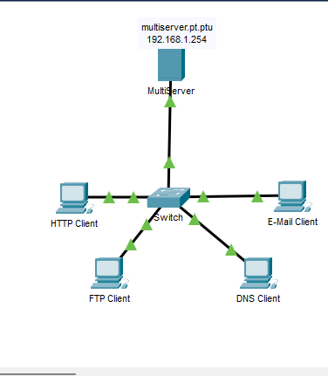
Part 1 :- generate network traffic in simulation mode and view multiplexing

Step 1:-
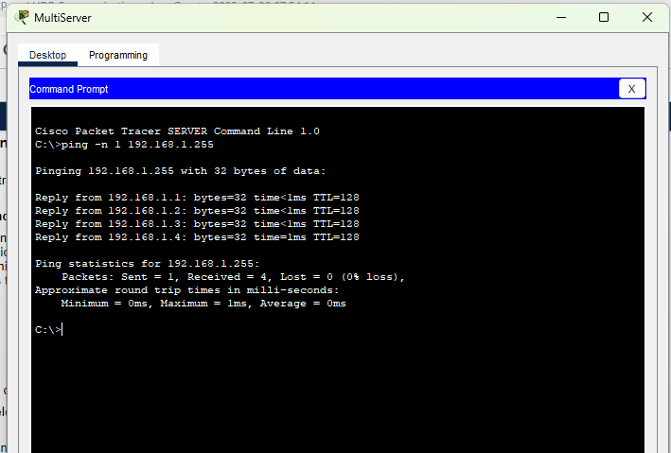

Step 2 :-
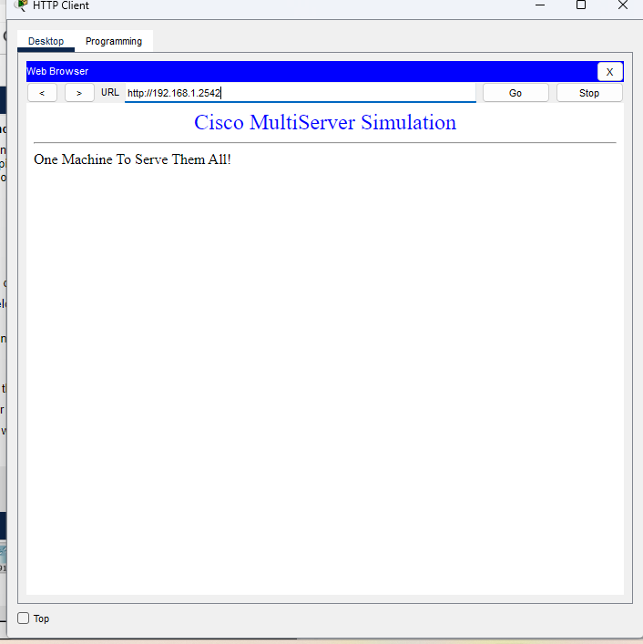
Step 3:-
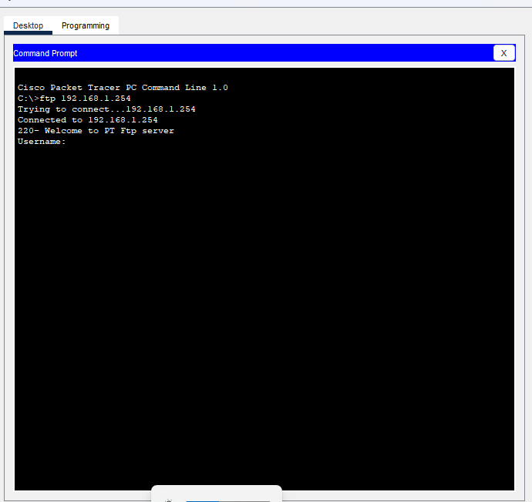

Step 4:-
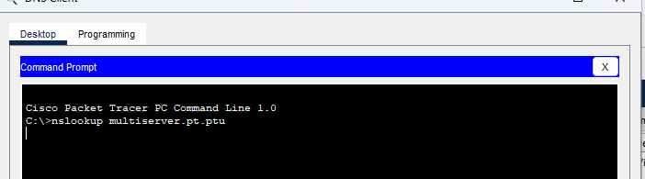

Step 5:-
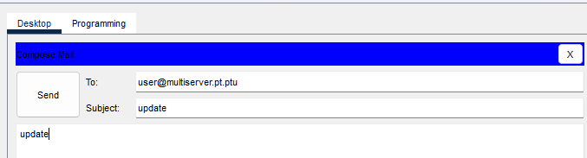

Step 6 :-
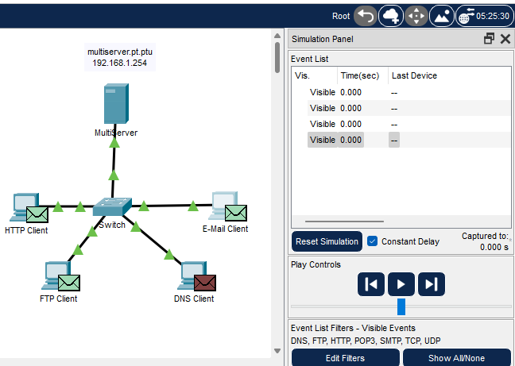

Step 7:-
Part 2:-examine functionality of the TCP and UDP protocols

Step 1:-
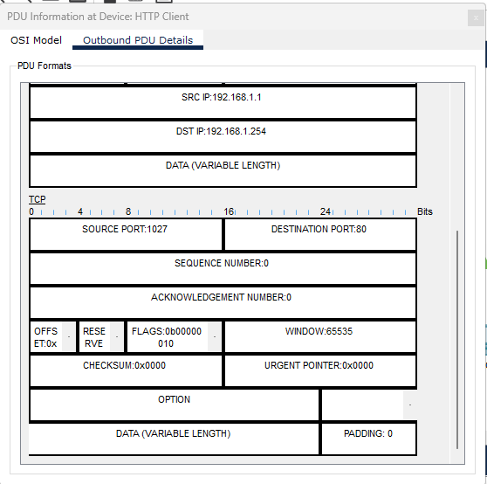

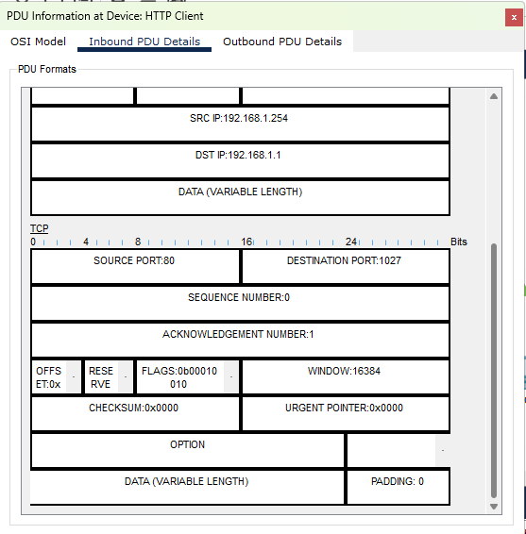

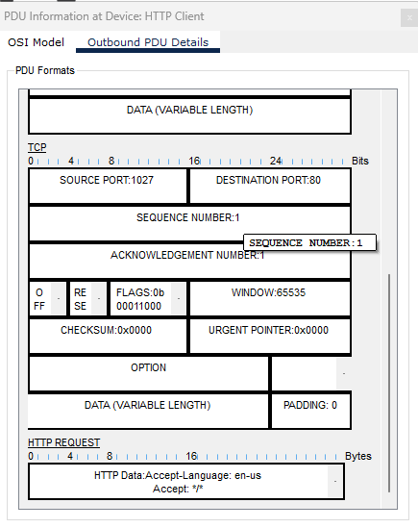

Step 2:-
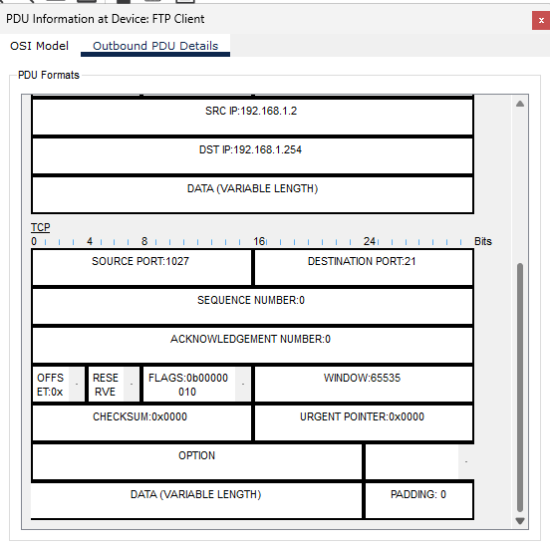

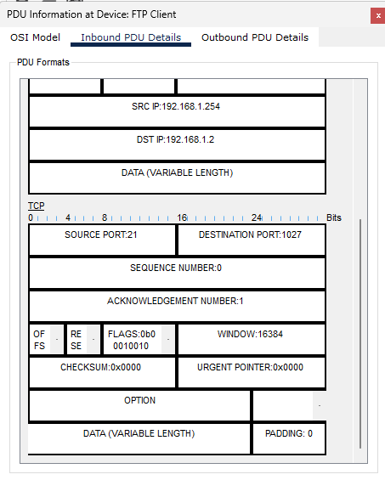

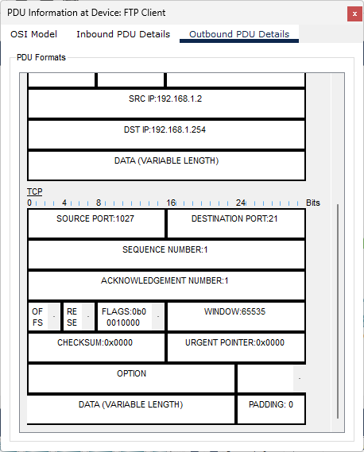

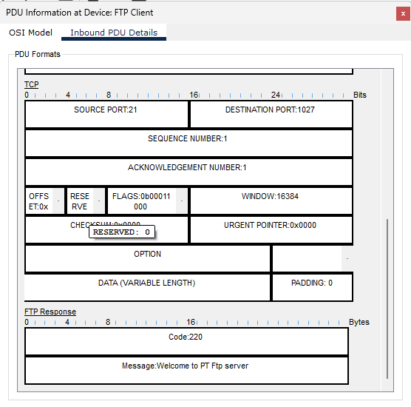

Step 3 :-
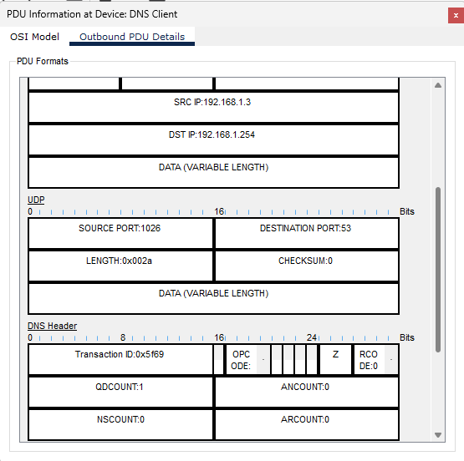

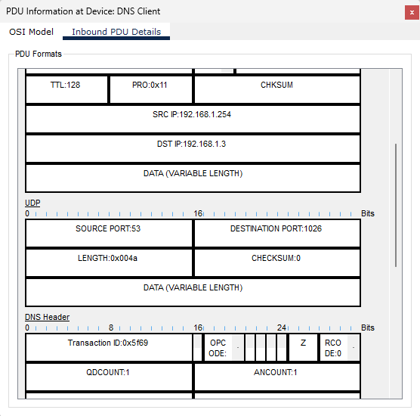

Step 4:-
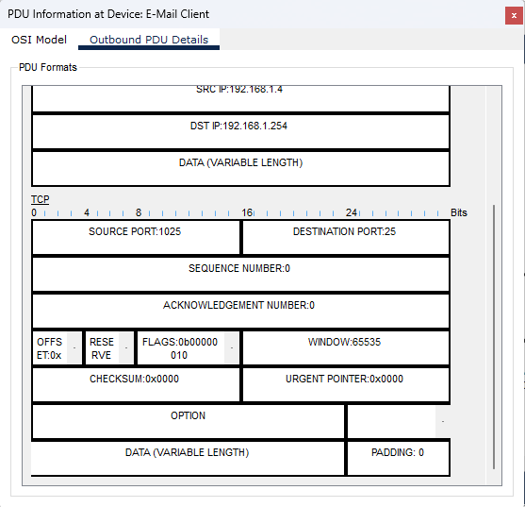

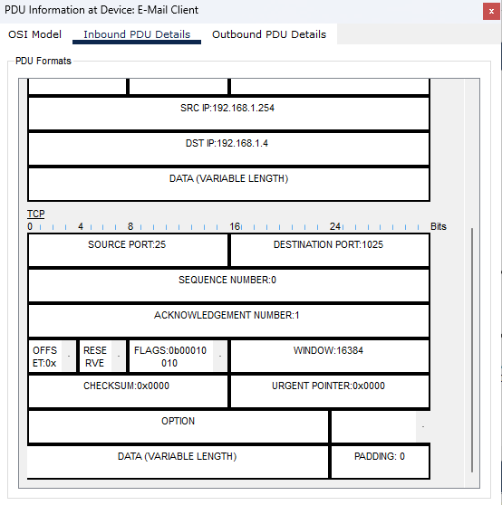

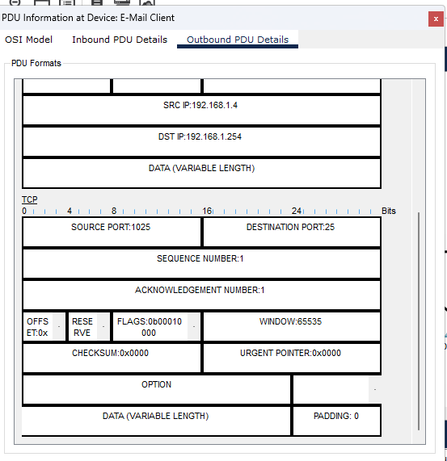

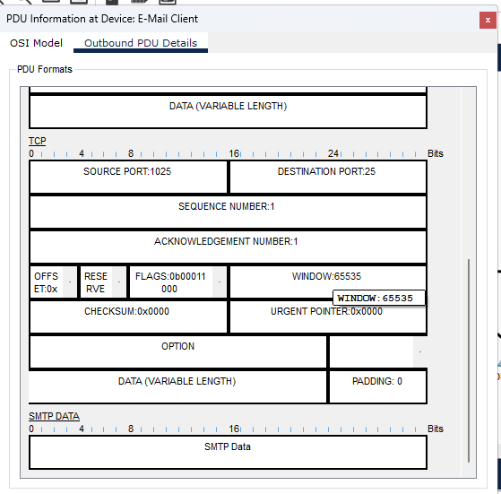

A LAB ON USING CISCOS IOS SHOW COMMAND

PART 1:- connect to the ISR cisco 4321 Router
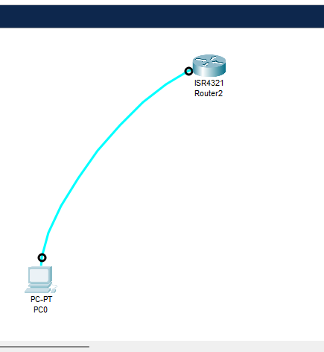

PART 2:-EXPLORE THE SHOW COMMAND
STEP 1:-
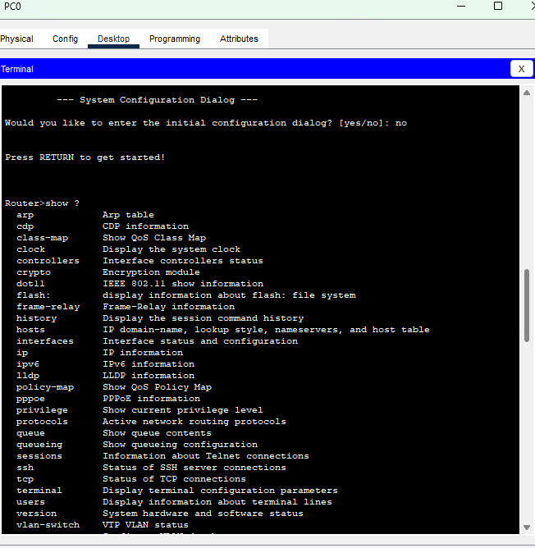

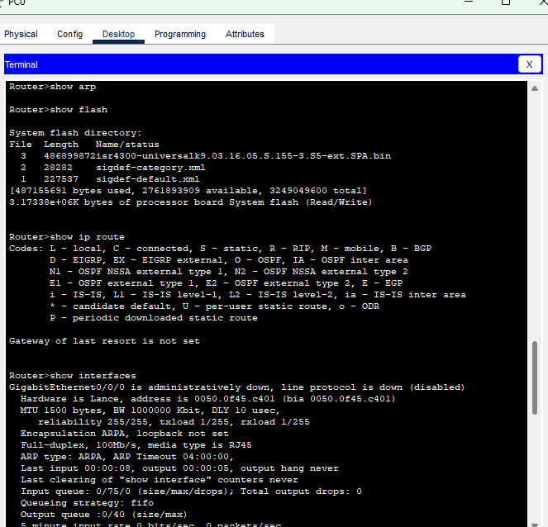

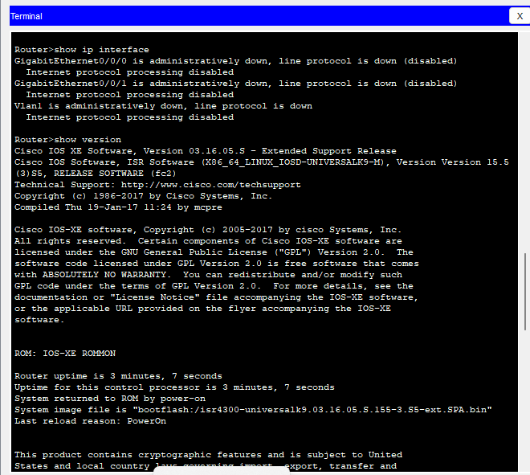

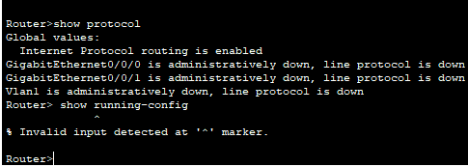

STEP 2:- 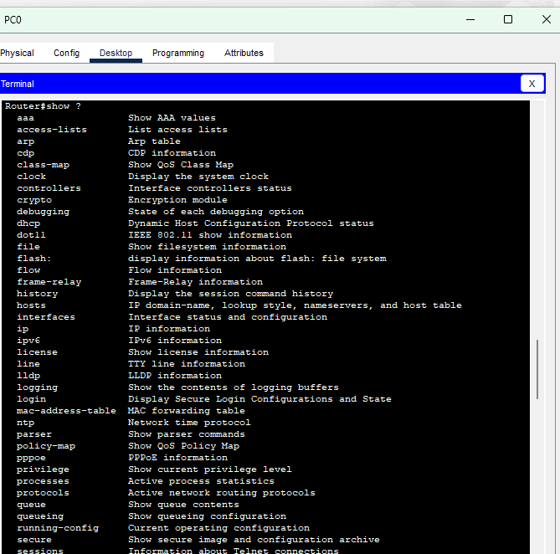
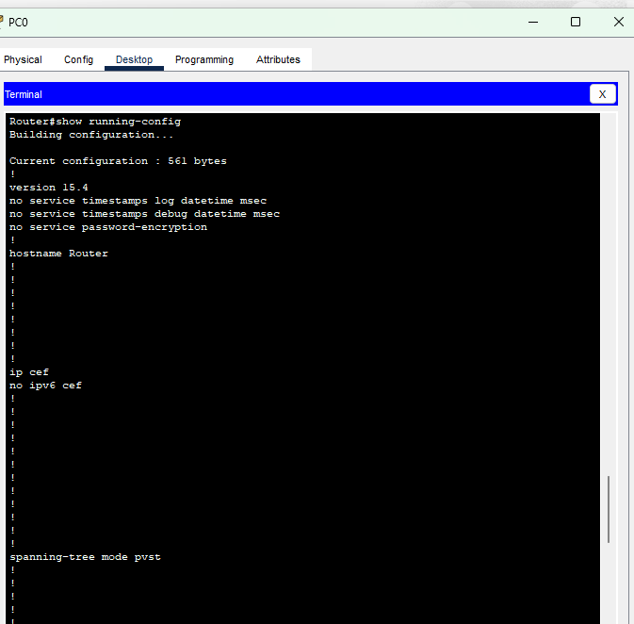

ASSIGNMENT ON BECOMING A DEFENDER

- List of cybersecurity certification and the organization that provide them
- CompTIA Security+ – CompTIA
- Certified Ethical Hacker (CEH) – EC-Council
- Certified Information Systems Security Professional (CISSP) – (ISC)²
- GIAC Security Essentials (GSEC) – Global Information Assurance Certification
- Cisco Certified CyberOps Associate – Cisco
- Certified Information Security Manager (CISM) – ISACA
- Offensive Security Certified Professional (OSCP) – Offensive Security
- Cetified cybersecurity technician(CCT)-EC-Council
- The 3 certification I picked include:-
- CompTIA Security+ (Vendor Neutral)
- Entry-level certification covering network security, threats, vulnerabilities, identity management, cryptography, and risk management.
- Requires passing one exam (SY0-701).
- Widely recognized as a baseline for cybersecurity careers.
- Certified Ethical Hacker (CEH) (Vendor Neutral)
- Focused on penetration testing and ethical hacking techniques.
- Requires passing one exam; candidates can prepare through official training or self-study.
- Topics: footprinting, scanning networks, system hacking, malware threats, web app security, and cryptography.
- CISSP (Vendor Neutral, Advanced)
- High-level certification for experienced professionals (minimum 5 years paid work experience in at least two security domains).
- Covers 8 domains: security & risk management, asset security, security architecture & engineering, communications & network security, identity & access management, security assessment & testing, security operations, and software development security.
- Requires passing one comprehensive exam.
- STEP 2: INVESTIGATE POSITIONS AVAILABLE WITHIN CYBERSECURITY
- How many new job listings were posted within the last two weeks?
- Around 450–600 new postings (varies by region).
- Salary range for the top 10 listings:
- Between $70,000 – $135,000 per year depending on role and experience.
- Most common qualifications required by employers:
- Bachelor’s degree in Computer Science, Cybersecurity, or related field.
- Knowledge of network security, firewalls, and intrusion detection/prevention systems.
- Hands-on experience with Linux/Windows security, cloud security, and penetration testing.
- Industry certifications required by employers:
- CompTIA Security+
- CEH (Certified Ethical Hacker)
- CISSP (Certified Information Systems Security Professional)
- Cisco CyberOps or CCNA Security
- OSCP (Offensive Security Certified Professional)
- Do any certifications match Step 1a?
- NO.
- Online resources to legally test hacking skills (example: Google Gruyere):
- Google Gruyere: Focuses on web application security challenges like cross-site scripting (XSS), cross-site request forgery (CSRF), and injection flaws.
- Other platforms:
  - Hack The Box – penetration testing labs.
  - TryHackMe – guided cybersecurity challenges.
  - OverTheWire – war games for Linux and network exploitation.
  - PortSwigger Web Security Academy – web application vulnerabilities.

A LAB ON IMPLEMENTING BASIC CONNECTIVITY
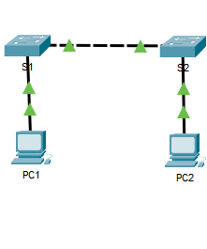
PART 1:- PERFORM SVI CONFIGURATION ON S1 AND S2
STEP 1:-
STEP 2:-
- 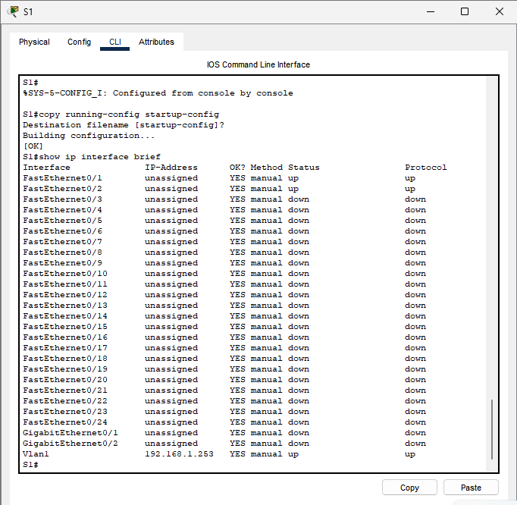

STEP 3:-
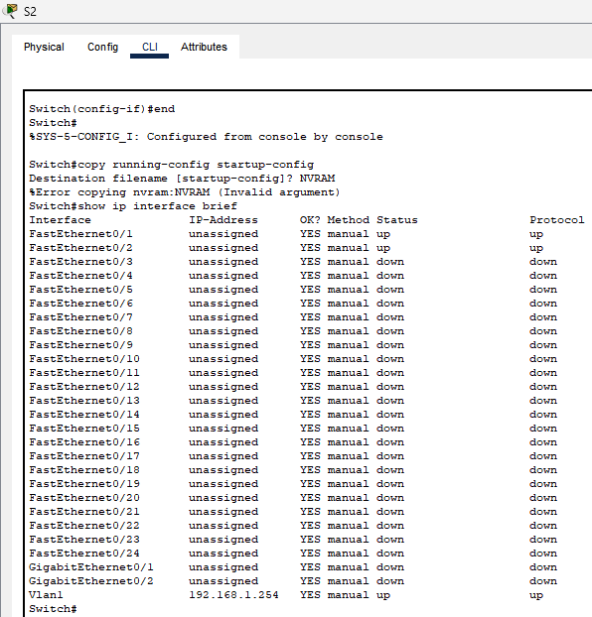

PART 2:- CONFIGUR THE PC’S
STEP 1:-
STEP 2:-
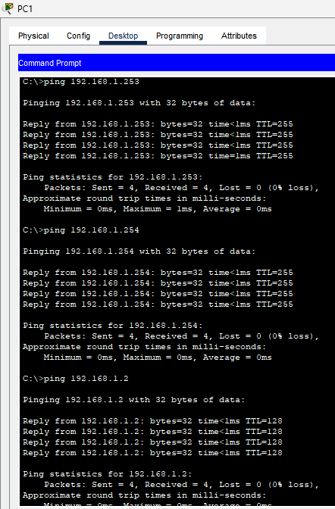
STEP 3 :-
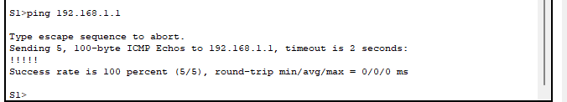
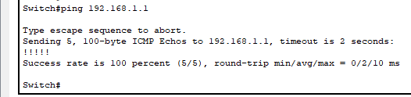

A LAB ON CONFIGURE INITIAL ROUTER SETTINGS
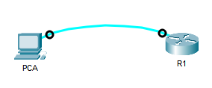
PART 1:- verify the default router configuration
STEP 1:-
STEP 2:-

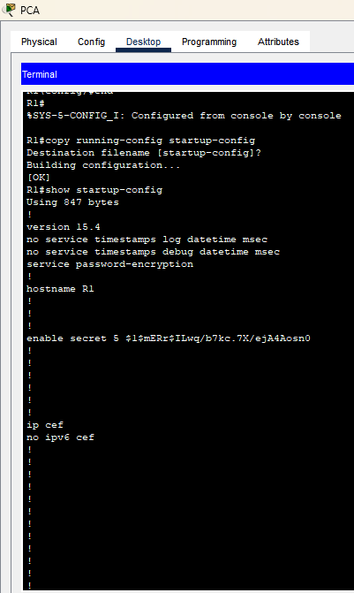
PART 2:- CONFIGURE AND VERIFY THE INITIAL ROUTER CONFIGURATION
STEP 1:-

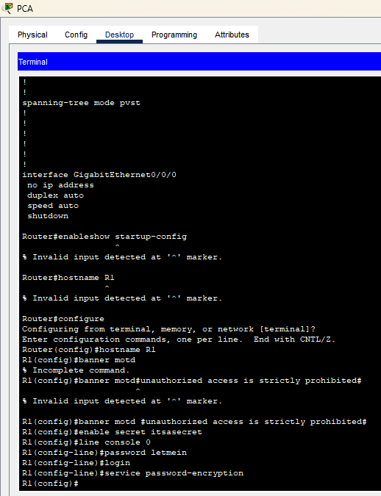
STEP 2 :-
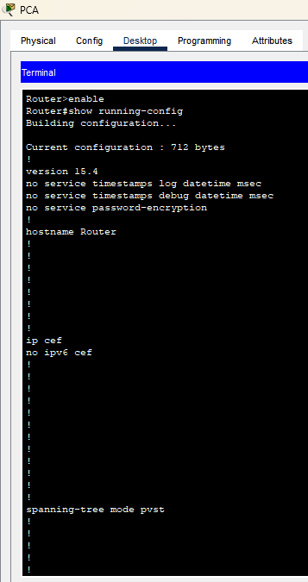

PART 3:- SAVE THE RUNNING CONFIGURATION FILE
STEP 1:-
STEP2:-
