Use cases

**Use Cases Diagram**

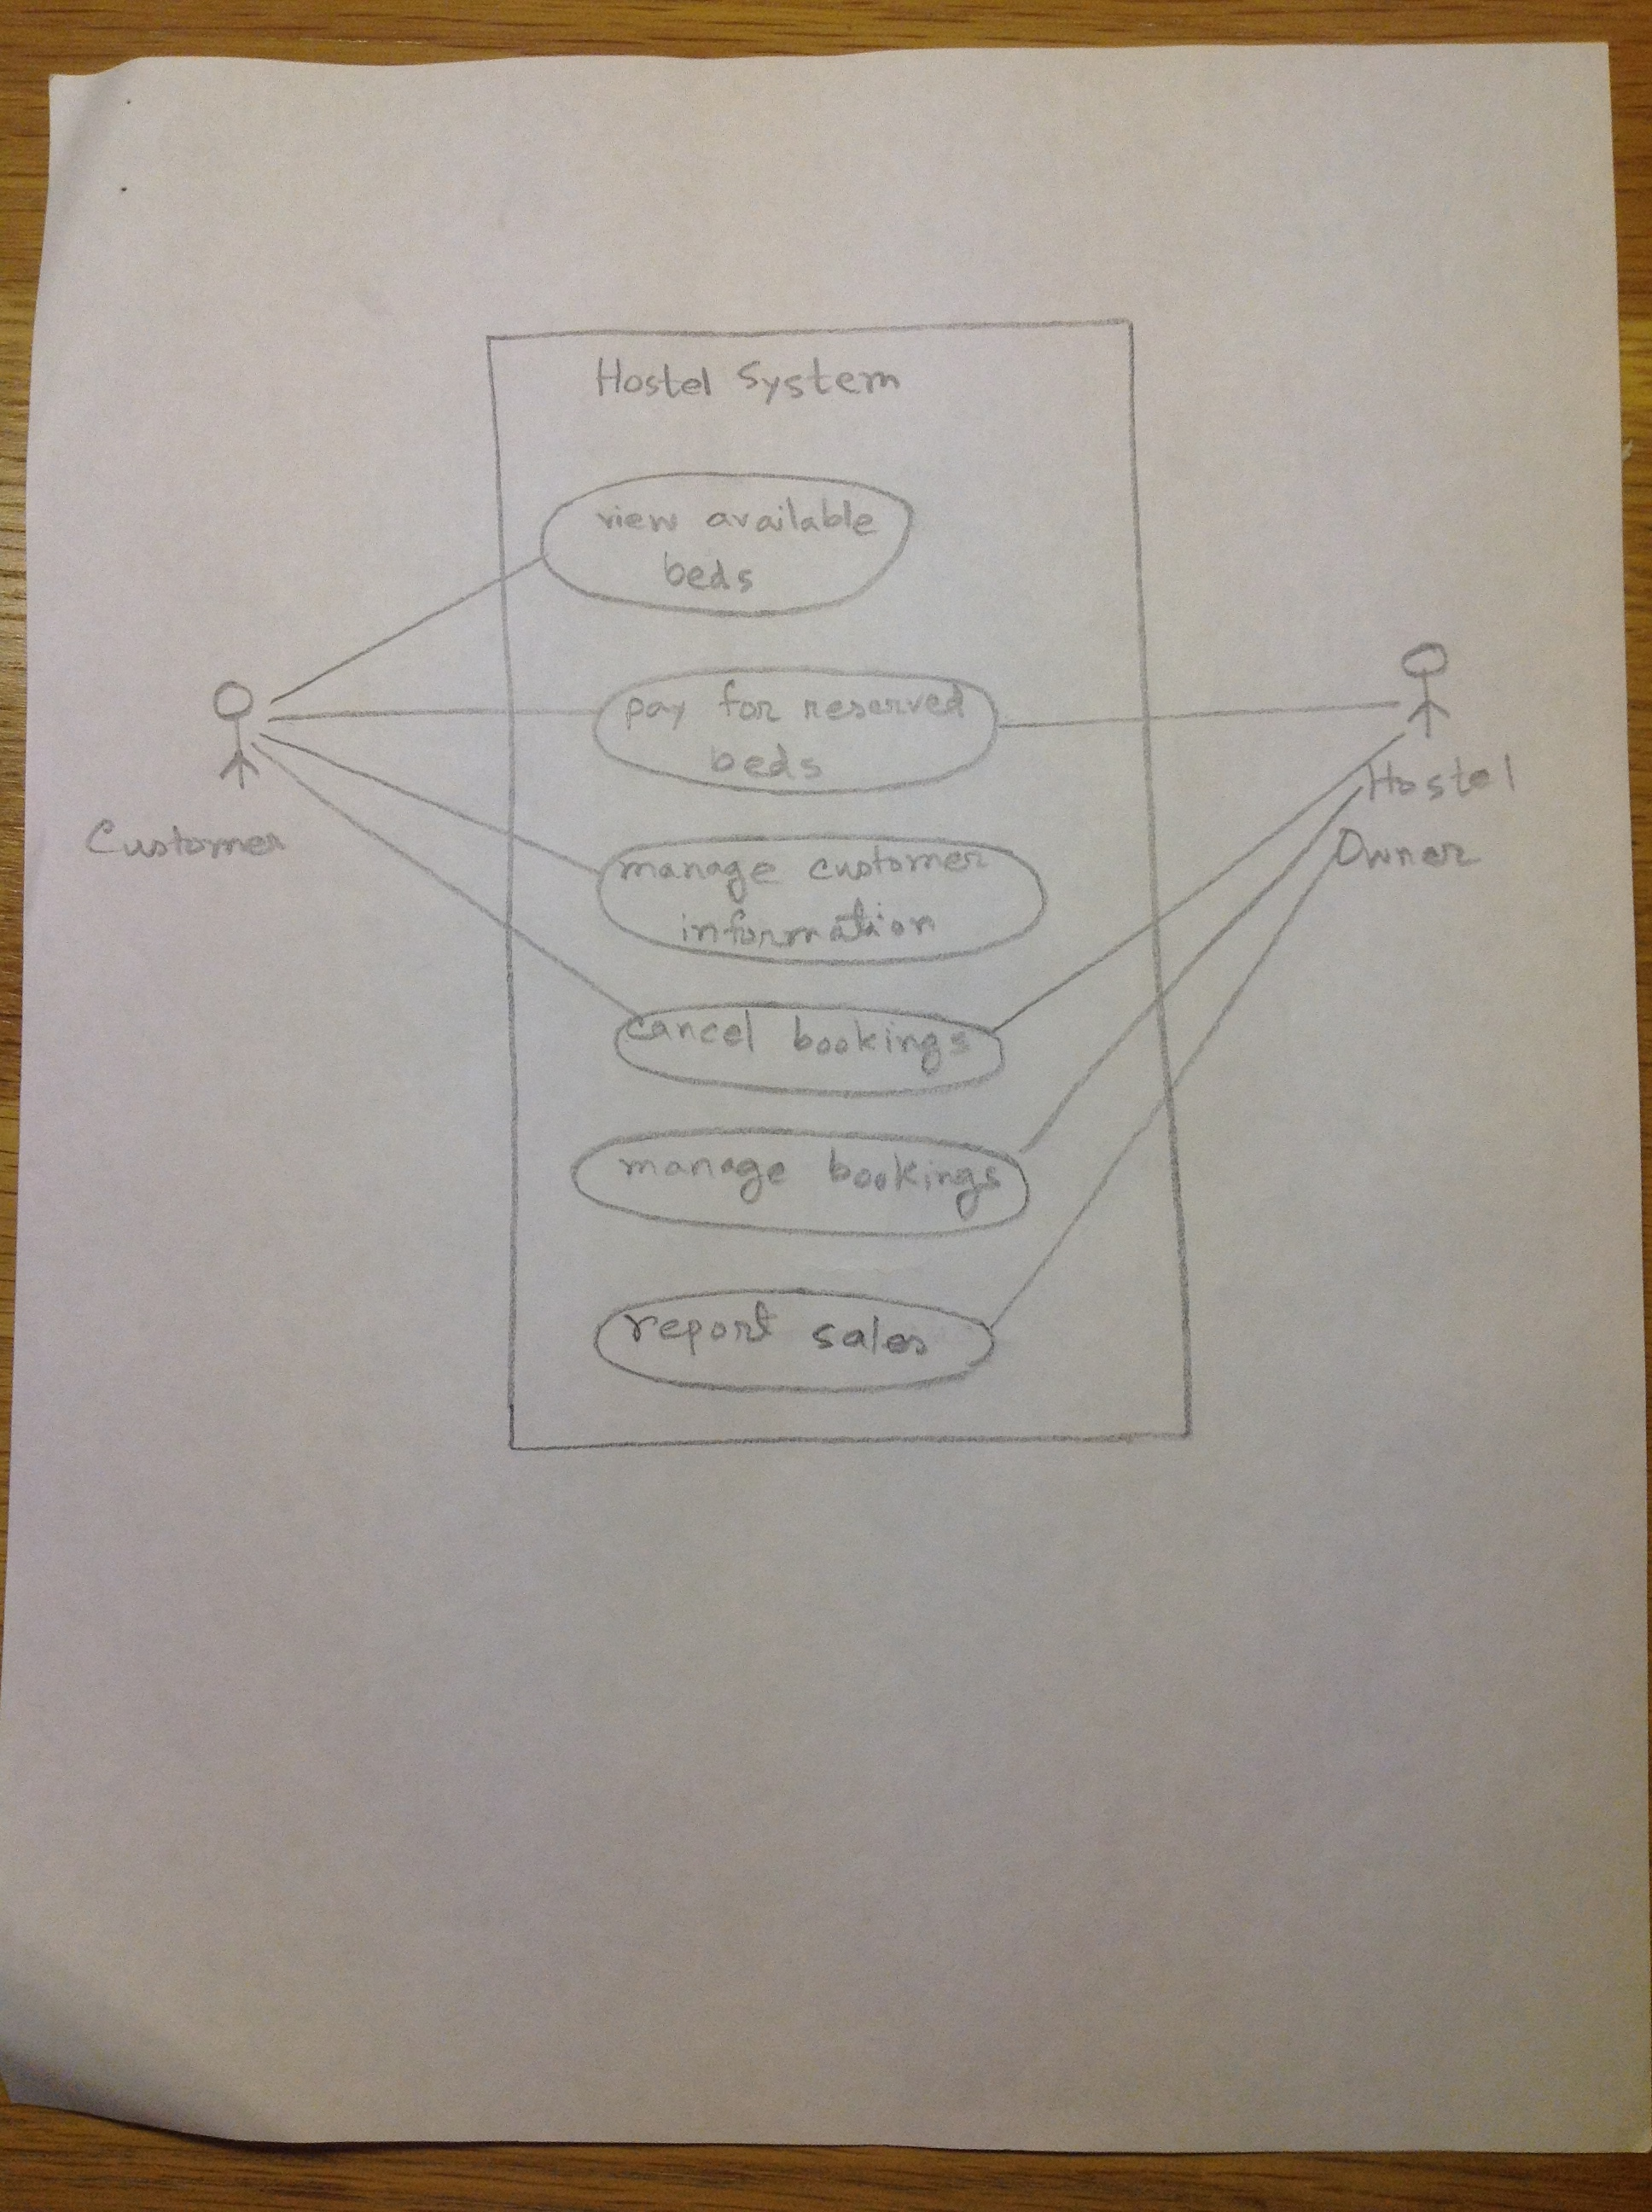

**Pay for reserved beds: (not implemented, can’t do booking)**

1. Use Case Name: pay for reserved beds

2. Version: 1.0

3. Goal: The Customer books one or multiple beds in a hostel room and he is charged for it.

4. Summary: The customer goes to the Hostel Booking system, his bookings are scanned and then the system calculates the amount that the Customer needs to be charged

5. Actors: there are two actors, the Customer who reserves bed in hostel room and the Owner who operates the system.

6. Preconditions: the System must be turned on.

7. Triggers: the Customer arrives at the System.

8. Basic course of events:

a) Customer arrives at the system checkout with hostel bed reservations to purchase

b) The system determines the reservation price and adds the bed in the specific hostel room to the running sales transaction

c) The hostel id, name, address, contact, restrictions and the price of the current booking are displayed

d) When done the system calculates the total amount to be paid and displays the amount

e) The Owner processes the payment, which can only be credit card.

9. Alternative paths: Beds are not enough.

10. Postconditions: the system has updated the available beds in the hostel room for beds that have been paid for

11. Business rules: only credit card is accepted.

12. Notes: The software works with MS-Windows and Mac OSX

13. Author and date: Muntaser Khan, 11/25/2013

**View available beds:**

1. Use Case Name: view available beds

2. Version: 1.0

3. Goal: The Customer view available beds in a specific city and its hostel details.

4. Summary: The customer arrives at the hostel system; he views beds and details in the system.

5. Actors: there is only one actor, the Customer who view beds.

6. Preconditions: the System must be turned on.

7. Triggers: the Customer arrives at the System.

8. Basic course of events:

a) Customer arrives at the system and views beds with different date and city .

b) The system shows the price in order, dates, and number of beds.

c) Customer query the beds based on exact date search.

9. Postconditions: The system shows the beds in the hostel in the specific city based on query from customer.

10. Business rules: Customers has no right to view owner’s webpage.

11. Notes: The software works with MS-Windows and Mac OSX

12. Author and date: Muntaser Khan, 11/25/2013

**Manage customer information:**

1. Use Case Name: Manage customer information

2. Version: 1.0

3. Goal: The Customer manages his own information and updates it.

4. Summary: The customer arrives at the shop tour system, he manages his private information and the system updates his information.

5. Actors: there is only one actor, the Customer who manages his information.

6. Preconditions: the System must be turned on.

7. Triggers: the Customer arrives at the System and login to his account.

8. Basic course of events:

a) Customer arrives at the system and changes his personal information.

b) The system updates the personal information for the customer.

c) The new information will display.

d) When done the system store the information to database.

9. Alternative paths: customer who is new must register first to management information.

10. Postconditions: the system has updated personal information and displayed them.

11. Business rules: new customer cannot manage information.

12. Notes: The software works with MS-Windows and Mac OSX

13. Author and date: Muntaser Khan, 11/25/2013

**Cancel order:**

1. Use Case Name: cancel order

2. Version: 1.0

3. Goal: The Customer cancels order and gets refunds.

4. Summary: The customer arrives at the shop tour system, his bookings are scanned and then the system calculates the amount that the Customer needs to be refunded.

5. Actors: there are two actors, the Customer who reserves beds and the Owner who operates the system.

6. Preconditions: the System must be turned on, and the owner must arrive at the system.

7. Triggers: the Customer arrives at the System.

8. Basic course of events:

a) Customer arrives at the system to cancel the reservation that he purchased before.

b) The system determines the bed price and adds the bed id to the running transaction.

c) The description and the price of the current reservation are displayed

d) When done the system calculates the total amount to pay back and displays the amount.

e) The Owner processes the refund, which can be credit card.

9. Alternative paths: only two days before the tour start.

10. Postconditions: the system has updated the available beds for hostels that have been released.

11. Business rules: only credit card is accepted.

12. Notes: The software works with MS-Windows and Mac OSX

13. Author and date: Muntaser Khan, 11/25/2013

**Manage bookings:**

1. Use Case Name: manage bookings

2. Version: 1.0

3. Goal: The owner manages bookings, e.g. cancel or add bookings.

4. Summary: The owner arrives at the shop tour system and manages tours. The system updates the new information for the owner.

5. Actors: there is only one actor, the owner who operates the system.

6. Preconditions: the System must be turned on.

7. Triggers: the owner arrives at the System.

8. Basic course of events:

a) The owner arrives at the system to manage bookings.

b) The system stores the new information to database.

c) The price, reserved number of beds, dates of the current bookings are displayed

9. Alternative paths: password and username do not belong to owner.

10. Postconditions: the system has store the information to database,

11. Notes: The software works with MS-Windows and Mac OSX

13. Author and date: Muntaser Khan, 11/25/2013

**Report sales:**

1. Use Case Name: Report sales

2. Version: 1.0

3. Goal: The owner sets the time range and a report on revenue and order numbers are shown.

4. Summary: The owner arrives at the shop tour system, sets exact search detail and the system operates the query and generates report.

5. Actors: there is only one actor, the owner operates the system.

6. Preconditions: the System must be turned on.

7. Triggers: the owner arrives at the System.

8. Basic course of events:

a) Owner arrives at the system and requires reports to the system.

b) The system generates the reports.

c) The system calculates the revenue, number of bookings and cancellations.

d) The revenue, number of bookings and cancellations are displayed.

9. Alternative paths: password and username do not belong to owner.

10. Postconditions: the system has generated reports.

11. Notes: The software works with MS-Windows and Mac OSX

12. Author and date: Muntaser Khan, 11/25/2013