Given the provided data, what are three conclusions that we can draw about crowdfunding campaigns?

1st conclusion is the theater category has most success rate. After theater, music has second most success rate. And after theater and music, film and video category have most success rate. In general, we can say that entertainment category has most success rate.

from the sub category analysis, we can see that plays is the most successful subcategory. Out of 344 campaigns, it was successful in 187 campaigns.

from the analysis based on time, we can see that the July month has the most success rate, and January month has most failed campaign.

What are some limitations of this dataset?

The data set is not symmetric distribution. The successful and failed backers count analysis shows that the dataset is a skewed distribution. As it is not a symmetric distribution the central tendency of the data can be inaccurate. Not only that but also there is huge number of outliers.

What are some other possible tables and/or graphs that we could create, and what additional value would they provide?

As the dataset has outliers, we could create table and graph to exclude the outliers which would help us analyze the data more accurately.

We could also create tables and graph based on each country. Number of successful, failed, live or canceled campaign based on each country would give us better geographic understanding of the dataset.

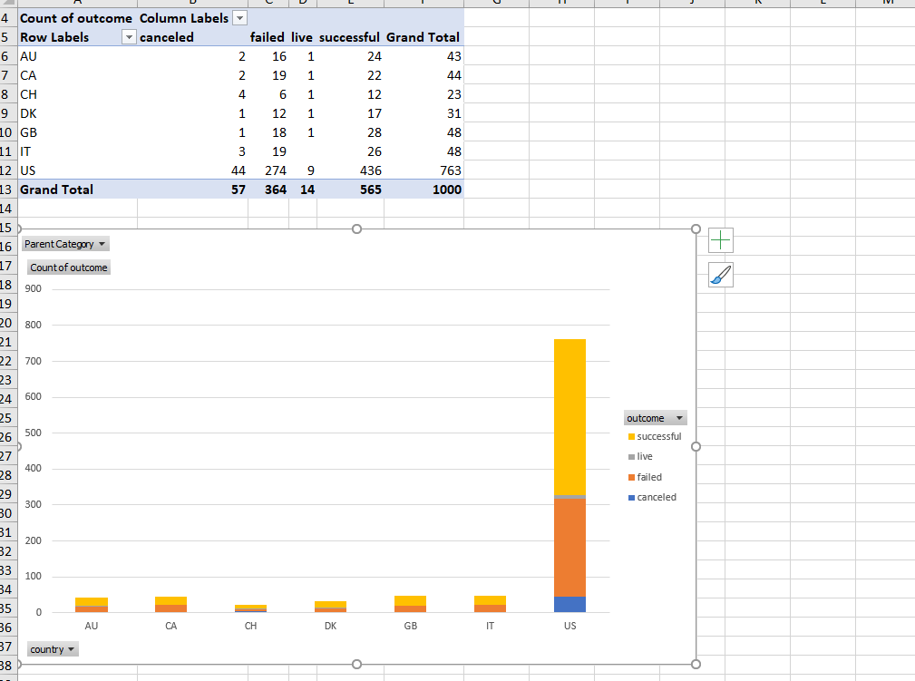

For example, this graph shows us the US has most success rate.

Success rate of US = (436 / 763) x 100 = 57.14%

And Switzerland has the lowest success rate of 52.17%