As a whole, schools with higher budgets, did not yield better test results. As we can see per Bailey High School budget was $628.0 but overall passing rate is 54.64. On the other hand per Holden High School budget was $581.0, but the overall passing rate is 89.22 which is more than Bailey High School overall passing rate.

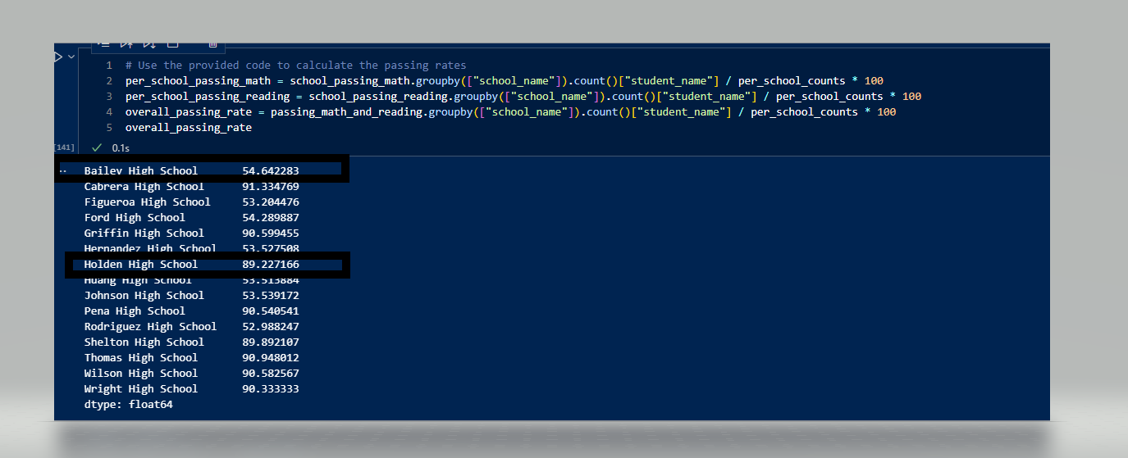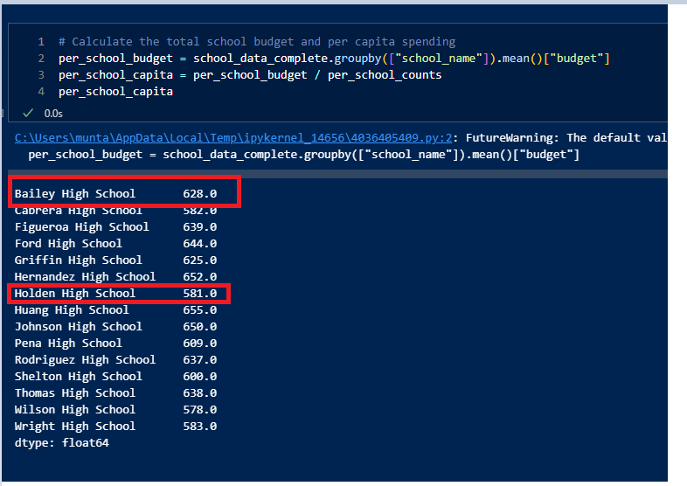

The district schools have more student than the charter schools. Charter Schools are on the top 5 list (Highest Performing Schools), and district schools are in the bottom performing schools.

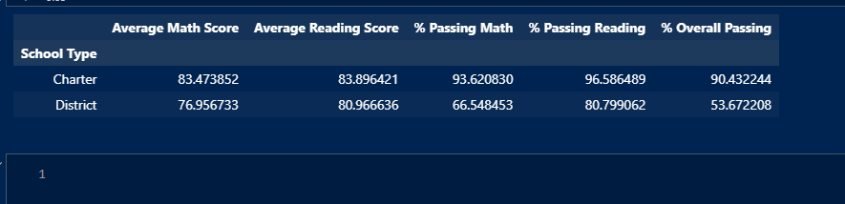

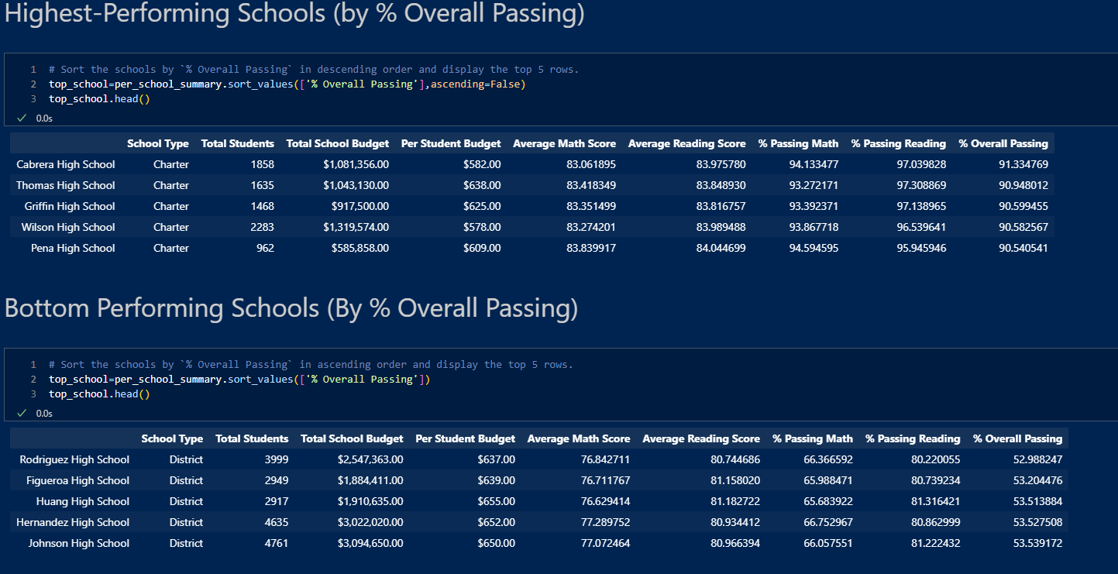

We can also see from the above analysis that, per student budget is higher in top performing school.

By analyzing average reading score and average math score, we can see that students did better in reading than in math.

