CityMind
An Urban Intelligence System

PHASE 1: Problem Analysis and Design
Deadline: 26th April
Course | Artificial Intelligence
Programme | BS Computer Science
Phase | 1 of 3 — Design Document
Deadline | 26th April

24I-0828 Muhammad Ali Naqvi
24I-0847 Muntazir Mehdi
24-0548 Ammar Iqbal

1. Problem Understanding
This section describes how our group understands each of the five challenges presented in the CityMind project statement. All descriptions are written in our own words following group discussion.

Challenge 1: City Layout Planning
Our Understanding
This challenge asks us to place different types of city locations — hospitals, schools, industrial zones, residential areas, power plants, and ambulance depots — onto an empty grid while satisfying a set of urban planning rules. The three core constraints are: (1) industrial zones cannot be adjacent to schools or hospitals; (2) every residential area must be within three road hops of at least one hospital; and (3) power plants must be placed within two road hops of an industrial zone.
What makes this problem interesting is the fallback requirement: if no fully valid layout is possible given the grid size, the system must still find a configuration that violates the fewest constraints and must identify exactly which rule caused the conflict.

Challenge 2: Road Network Optimization
Our Understanding
Once the city layout exists, we must decide which roads to build. The primary goal is to connect all city locations at the lowest possible total construction cost. There is, however, a non-negotiable safety requirement: there must always be at least two completely independent paths between the Primary Hospital and the Ambulance Depot. If any single road is lost — due to flooding or an accident — an alternative route must still exist.
In our initial group discussion we briefly considered a Genetic Algorithm, since we had recently covered it in class, but we quickly recognized that this is fundamentally a graph optimization problem rather than a search-over-configurations problem. Our final approach is described in Section 2.

Challenge 3: Ambulance Placement
Our Understanding
The city has three ambulances that must be placed at depot locations in the grid. The objective is to minimize the worst-case response time — meaning we want the citizen who is furthest from any ambulance to be as close as possible. This is a minimax placement problem, not a simple shortest-path problem.
The search space grows extremely fast: if the grid has N eligible positions and we place 3 ambulances, the number of unique combinations is C(N,3), which becomes enormous for realistic city sizes. Exhaustive search is not feasible.

Challenge 4: Emergency Routing Under Changing Conditions
Our Understanding
A medical team must travel across the city to reach a sequence of trapped civilians. The environment is dynamic: roads can flood or become blocked while the team is already in transit. The moment a road becomes impassable, the route must be recalculated immediately — and the recalculated route must still be the shortest available path, not just any valid path. The team must also visit all civilian locations, not just the nearest one.

Challenge 5: Crime Risk Prediction and Integration
Our Understanding
This challenge has three connected parts. First, we must group neighborhoods into clusters based on population density and industrial proximity — without any pre-labeled training data. Second, we must generate a synthetic crime dataset using logic we design and justify ourselves, then train a classification model that assigns each neighborhood a risk level of High, Medium, or Low. Third, the predicted risk levels must feed back into the shared city graph as a cost multiplier, making high-risk areas more costly to route through.
Our group debated how to assign crime risk. One suggestion was that lower-population-density areas would be higher risk since they are less monitored. However, Muntazir made the observation — supported by examples from Pakistani cities — that areas close to industrial zones tend to have higher crime rates due to economic pressure, transient populations, and lower policing levels. We adopted this logic for our synthetic dataset generation.

2. Algorithm Choices and Justifications

2.1 Challenge 1 — Constraint Satisfaction Problem (CSP) with Backtracking
Chosen Technique | CSP with Backtracking + Minimum Remaining Values (MRV) heuristic
Why this fits | City layout planning is a textbook CSP: we have variables (locations to place), domains (valid grid cells), and hard constraints (proximity rules). Backtracking systematically assigns values and undoes assignments the moment a constraint is violated, exploring only consistent partial solutions. This is far more efficient than generating random layouts and checking them afterward.
Fallback handling | If no complete valid assignment exists, we switch to a min-conflict strategy: we place all location types while tracking how many constraints each placement violates, then select the assignment with the least total violations and report the specific constraint that caused the conflict.
Alternative considered | We briefly considered a Genetic Algorithm. GAs can produce near-valid layouts but offer no guarantee of finding a valid solution if one exists, and offer no structured way to identify exactly which constraint is violated. CSP gives us both — validity guarantee and conflict identification — which the problem explicitly requires.

2.2 Challenge 2 — Kruskal's MST + Uniform Cost Search (UCS)
Chosen Technique | Kruskal's Minimum Spanning Tree algorithm, augmented with a UCS-based secondary path to enforce the redundancy constraint
Why this fits | Kruskal's algorithm finds the globally optimal set of edges that connects all nodes at minimum total cost — which is exactly the road-building objective. After building the MST, we check whether the Primary Hospital and Ambulance Depot are connected by two independent paths. Since the MST provides only one path between any node pair, we then remove the direct edge between these two nodes temporarily and run UCS to find the cheapest alternative route. This ensures redundancy while adding only the minimum extra cost necessary.
Step-by-step logic | Sort all possible roads by cost. Add roads in order (Kruskal) until all locations are connected. Check Hospital-to-Depot path count. If only one path exists, run UCS on the graph-minus-direct-edge to find the cheapest backup path and add those edges.
Alternative considered | A pure Genetic Algorithm could search for road configurations but would not guarantee minimum cost or the specific two-path redundancy condition. Kruskal's gives a mathematically provable minimum spanning tree, and UCS guarantees the cheapest alternative path — both properties are verifiable and explainable.

2.3 Challenge 3 — Genetic Algorithm (GA)
Chosen Technique | Genetic Algorithm with population-based search, fitness function targeting worst-case response time
Why this fits | The placement of 3 ambulances across a large grid has a combinatorial search space that grows as C(N,3) where N is the number of eligible positions. For a 20x20 grid this is already over 1,000 possible combinations; realistic city sizes push this into the tens of thousands. GA explores this space efficiently through selection, crossover, and mutation without needing to evaluate every combination. Importantly, every chromosome (set of 3 placements) is automatically a valid state since all positions are legal — this means mutation never produces invalid solutions and no repair step is needed. The fitness function computes the maximum shortest-path distance from any citizen to the nearest ambulance and minimizes it across generations.
Alternative considered | Simulated Annealing was considered. SA is also suitable for this search space but converges more slowly and is harder to tune for a minimax objective. GA's population-based approach naturally maintains diversity and avoids local optima more reliably for placement problems.

2.4 Challenge 4 — Dynamic A* (D* Lite)
Chosen Technique | D* Lite (Dynamic A*), a replanning variant of A* designed for changing environments
Why this fits | Standard A* finds the optimal path in a static graph, but Challenge 4 has a dynamic environment where roads can become blocked mid-journey. Rerunning full A* from scratch every time a road changes is correct but wasteful. D* Lite is specifically designed for this: it maintains a backward search tree from the goal and when an edge weight changes it updates only the affected portion of the search tree rather than recalculating everything. This guarantees that the path returned is always the current shortest available path — satisfying the explicit requirement of the problem — while being efficient enough to run in real time. The heuristic used is Euclidean or Manhattan distance to the current target civilian, which is admissible, ensuring optimality.
Alternative considered | Plain A* with full replan on every change would also guarantee optimality but is computationally expensive for large grids with frequent changes. BFS guarantees shortest path in unweighted graphs but our graph has variable edge weights (risk multipliers from Challenge 5), so BFS would not find the optimal weighted path.

2.5 Challenge 5 — K-Means Clustering + Decision Tree Classifier
Step 1 — Clustering | K-Means Clustering (unsupervised). Neighborhoods are grouped based on population density and industrial proximity without any labelled data. K-Means is suitable here because both features are continuous numeric values and we want naturally formed clusters rather than predefined categories. We will experiment with k=3 or k=4 clusters.
Step 2 — Dataset generation | We generate a synthetic crime dataset using the following logic: neighborhoods with high industrial proximity AND high population density are rated High risk (transient population, economic pressure); neighborhoods with high industrial proximity but low residential density are rated Medium risk; low-density, low-proximity neighborhoods are rated Low risk. This is consistent with Muntazir's real-world observation about Pakistani cities.
Step 3 — Classification | Decision Tree Classifier (supervised). The classifier is trained on our generated dataset to predict High / Medium / Low risk for each neighborhood. We chose a Decision Tree over K-Nearest Neighbors because Decision Trees produce interpretable rules that we can trace and explain during the viva. KNN is a reasonable alternative but functions as a black-box distance comparator, making it harder to justify specific predictions.
Integration | The predicted risk level for each node is converted to a cost multiplier: High = 1.5x, Medium = 1.2x, Low = 1.0x. These multipliers update the shared city graph edge weights and are immediately visible to the ambulance placement module (Challenge 3) and the emergency router (Challenge 4).
Why two different learning types | Clustering is unsupervised because we do not have pre-existing crime labels — we are discovering structure. Classification is supervised because we use our generated (labelled) dataset to learn a mapping from features to risk level. These are genuinely different learning paradigms applied to different sub-problems.

3. Shared City Graph Structure
The shared city graph is the single source of truth for the entire CityMind system. Every module reads from and writes to this one object — no module keeps its own internal copy. Any change (a road flood, an updated risk weight, a new ambulance assignment) is immediately visible to all other components.
We use a hybrid Object-Oriented design: a 2D array of CityNode objects where each node stores its own adjacency dictionary of neighbors. This gives us the spatial advantages of a grid and the routing efficiency of an adjacency list at the same time.

3.1 The CityNode Class
Each position in the grid is represented by a CityNode object. The node holds two categories of data — static properties that do not change after layout initialization, and dynamic properties that are updated during the simulation:

Coordinates | row, col — integer grid position. Used by A* / D* Lite as the spatial heuristic input (Manhattan distance to target).
Static: location_type | One of: Residential, Hospital, School, Industrial, Power Plant, Ambulance Depot. Set once by Challenge 1.
Static: population_density | Numeric value indicating how many people live or work at this location. Used as input to the K-Means clustering in Challenge 5.
Dynamic: risk_index | Float value updated by the ML classifier in Challenge 5. Converted to a cost multiplier: High = 1.5, Medium = 1.2, Low = 1.0.
Dynamic: is_accessible | Boolean flag. Set to False when a road event makes this location unreachable. All pathfinding queries check this flag first.
Dynamic: neighbors | A Python dict mapping each adjacent CityNode to its current edge weight. This is the adjacency structure — stored directly on the node, not in a separate edge list.

3.2 The CityGraph Manager
All CityNode objects are wrapped in a CityGraph class that owns the 2D array and exposes helper methods used by every module. Storing the grid as a 2D array (rather than a flat list of nodes) allows Challenge 1 and Challenge 3 to perform spatial proximity queries directly — for example, checking whether a residential node is within 3 hops of a hospital by doing a BFS starting at grid[r][c], without needing to search through the entire node list.

3.3 Edge Weight Logic
Standard road | Weight = 1.0. Default for all connections.
Residential zone road | Weight = 0.8. Set during Challenge 2 road construction.
Effective travel cost | base_weight × destination.risk_index. Risk multipliers from Challenge 5 are already stored on the node, so this multiplication happens at traversal time inside the router — no separate data structure needed.
Blocked road (flood) | node.block_road_to(neighbor) removes the key from the neighbors dict in O(1). The change is immediate — D* Lite in Challenge 4 detects the missing edge on its next traversal attempt and triggers replanning.

3.4 Module Interaction with the Graph
The table below summarises what each module does with the shared graph object:

Module | Reads from Graph | Writes to Graph | Trigger
C1: Layout | Empty grid structure | Node types, coordinates, initial accessibility | Runs once at startup
C2: Roads | Node positions from C1 | Edge weights, road connections | Runs after C1 completes
C3: Ambulance | Node positions, edge weights, risk multipliers | Ambulance depot assignments on nodes | Runs at simulation start; re-evaluates as risk weights change
C4: Router | Edge weights, accessibility flags, risk multipliers | Nothing — read-only | Triggered on each emergency event and on any road-blocked event
C5: Crime ML | Population density, location type, industrial proximity per node | Risk multiplier on each node | Runs once before simulation; can re-run if layout changes

4. User Interface Wireframe
The CityMind interface is divided into four zones: a top control bar, the main city grid canvas, a right-side panel with layer toggles and statistics, and a bottom live event log. The layout is described below and a visual sketch follows.

Top Bar | Application title, simulation control buttons (Initialize, Run Step, Run All, Reset), and a status indicator showing the current simulation step number.
City Grid Canvas (center) | The main visualization area. Displays the 20x20 city grid with color-coded nodes by location type. Supports three overlay toggles: Road Network (edges drawn between connected nodes), Ambulance Coverage (colored coverage zones around each ambulance depot), and Crime Risk Heatmap (node fill intensity based on predicted risk level).
Right Panel | Layer toggle checkboxes for the three overlays. A summary statistics box showing total road cost, worst-case ambulance response distance, and current blocked road count.
Bottom Event Log | A scrollable chronological list of system decisions: e.g. 'Step 7: Road (3,4)-(3,5) blocked. Router recalculated path for Team A via (3,6)-(4,6).' Entries are color-coded by event type (routing = blue, risk update = orange, road blocked = red).
Legend | A color key for node types and risk levels, displayed in the bottom-right corner of the canvas.

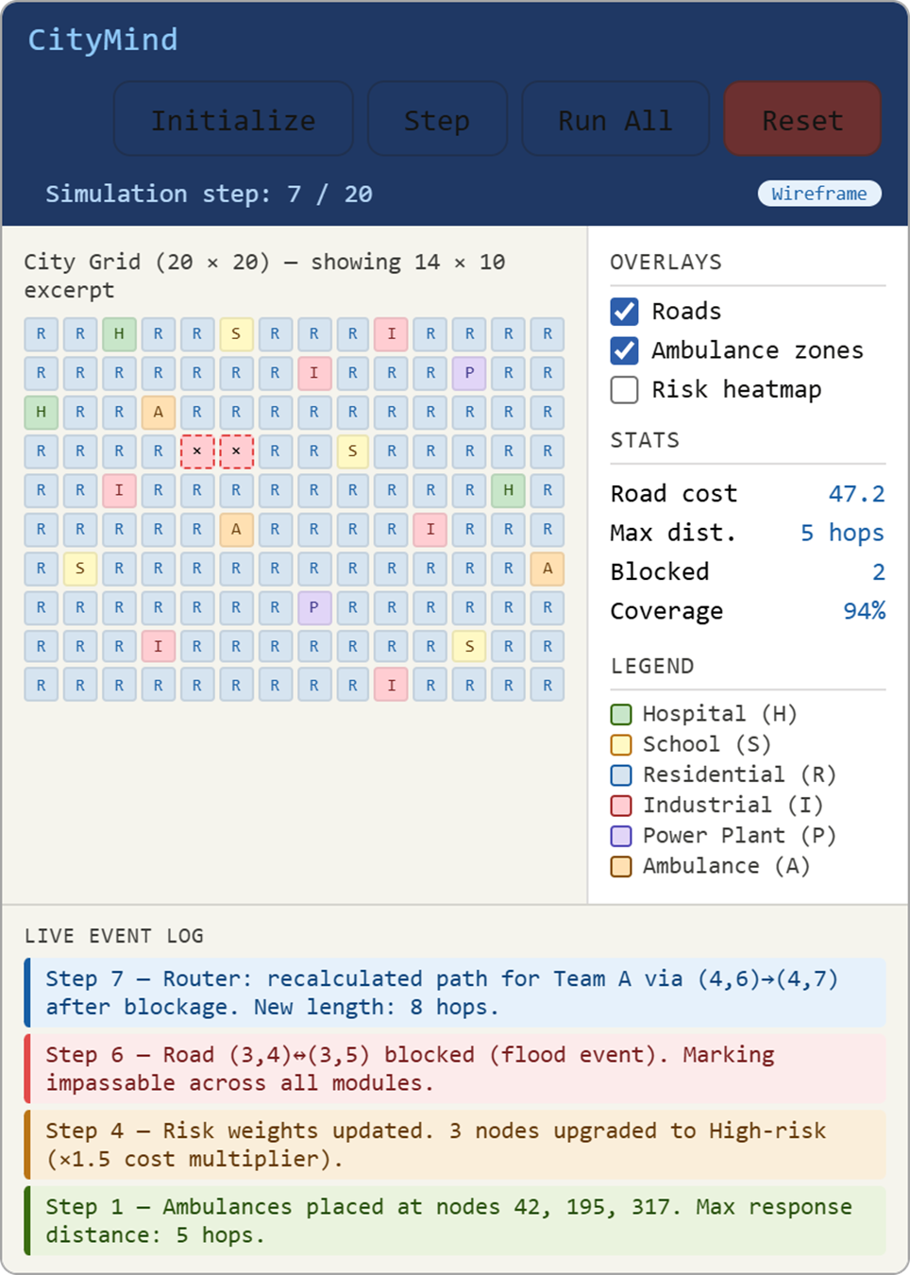

5. Work Breakdown
Work is divided evenly across three group members. Each member is responsible for two primary deliverables in Phase 2 plus their corresponding section in this Phase 1 document. Integration of the shared city graph is a joint responsibility with a designated lead.

Member | Responsibilities | Phase 1 Contribution
Member 1  (Ali Naqvi) | - Challenge 1: CSP city layout planner with backtracking and min-conflict fallback  - Challenge 2: Road network builder using Kruskal's MST + UCS redundancy path  - Phase 1: Authored Sections 1.1, 1.2, 2.1, 2.2 | - Wrote problem understanding for C1 and C2  - Researched and justified CSP vs GA for C1  - Researched and justified Kruskal + UCS vs pure GA for C2
Member 2 (Muntazir) | - Challenge 3: Genetic Algorithm ambulance placement with minimax fitness  - Challenge 5: K-Means clustering + Decision Tree classifier + graph integration  - Phase 1: Authored Sections 1.3, 1.5, 2.3, 2.5 | - Wrote problem understanding for C3 and C5  - Proposed industrial-zone crime risk logic for synthetic dataset  - Researched GA for C3 and Decision Tree vs KNN for C5
Member 3  (Ammar Iqbal) | - Challenge 4: D* Lite emergency routing with real-time replanning  - Shared city graph structure and initialization module  - Visual interface (city grid, overlay toggles, event log)  - Phase 1: Authored Sections 1.4, 2.4, 3, 4 | - Wrote problem understanding for C4  - Designed city graph structure and module interaction table  - Drafted the UI wireframe description  - Researched D* Lite vs plain A* for C4

Note on AI Tool Usage
We used AI tools during Phase 1 for brainstorming and to compare algorithmic alternatives. All decisions — especially the choice of D* Lite over plain A*, the hybrid Kruskal + UCS approach, and the crime risk logic — were debated within the group before adoption. Every algorithm in this document can be explained by the group member responsible for it from first principles.

