Crop Pest Detection and Classification Using Deep Learning Techniques
Dr. D.Ganesh  Associate Professor Dept. of CSE ,  School of Computing ,  Mohan Babu University,  Tirupati, Andhra Pradesh , India  dgani05@gmail.com | Dr. M. Sunil Kumar  Professor of CSE,  Mohan Babu University  (Erstwhile Sree Vidyanikethan Engineering College(Autonomous), Tirupati, Andhra Pradesh , India  sunilmalchi1@gmail.com | Munthala Lakshmi Tejaswi  UG Scholar, Dept. of CSE,  Mohan Babu University,  Tirupati, Andhra Pradesh, India  mltejaswi1@gmail.com
Pidugu Vanaja  UG Scholar,  Mohan Babu University,  Tirupati, Andhra Pradesh, India,  vanajapidugu031@gmail.com | Rayachoti Bharath Kumar  UG Scholar,  Mohan Babu University,  Tirupati, Andhra Pradesh, India,  bharath170204@gmail.com | Sharabu Ajith Kumar  UG Scholar,  Mohan Babu University,  Tirupati, Andhra Pradesh, India,  sharabuajithkumar7@gmail.com

Abstract— The challenge of agricultural productivity caused by crop pests is a significant problem since the use of pesticides is associated with significant losses of yield and the promotion of the use of excessive amounts that harm the environmental sustainability and human health. Pest species identification in rural settings continues to be a problem as there are only a few computational resources, as well as the complexity of the conditions in the field and the similarity of visually similar pests. To deal with these issues, this paper presents an effective deep learning-based system, which is called DeepestNet integrated with EfficientNet-B4, to perform automated crop pest identification and classification. The proposed model uses EfficientNet-B4 which is a small but strong feature extractor and DeepestNet classifier which is trained to identify pests of multiple classes. Normalization and data augmentation are used to pre-process field and annotated pest images in order to improve their resistance to different environmental conditions. The transfer learning is used to train the model and the performance of the model is measured using standard performance indices such as accuracy, precision, recall and F1-score. The results of the experiment indicate that the suggested approach can reach superior classification performance in contrast to standard CNN, Faster R-CNN, and YOLO-based networks and reach the superior accuracy of 95.4. The proposed framework is highly suitable in the real-time implementation on edge and mobile hardware because of its low computational complexity and high accuracy. This helps to detect pests in time, help reduce the unneeded use of pesticides, enhance crop productivity, and help promote precision agriculture practices that are sustainable.
Keywords— Crop Pest Detection, Deep Learning , Image Classification, Precision Agriculture
1. INTRODUCTION
The agricultural industry is an important sector that supports food production in the world, the creation of employment in the rural areas and economic stability in both the developed and the developing nations[1]. A big portion of the world population depends either directly or indirectly on the agricultural activities as sources of livelihood and food. However, biotic stress continues to compromise the productivity of agriculture and one of the most severe threats is crop-destroying pests[2]. Crops are infested by insects and pests at various developmental stages, causing the yields to yield fewer and also of low quality, which cause significant economic losses annually. Such losses do not only affect the earnings of farmers but also affect supply chains, increase the price of food and increase worries about the global food security [3].
The problems in present Agri systems are, Accurate and timely identification of pests in crops has remained a thorny issue in precision agriculture due to the complex field conditions, low size of pests, and low degree of reliability of manual and conventional image detectors. The existing deep learning systems, despite their strength, may involve high computation rates and, therefore, cannot be applied to real-time settings where the agricultural setting is resource-constrained. This leads to the need of having a light but high accuracy pest detection system that would be able to perform well in a real field work.

The infestation of crops by pests is the major cause of crop downfall in all parts of the world. The failure to detect pests as soon as possible in many regions, particularly in third world countries, serves to intensify matters. The uncontrolled and indiscriminate use of chemical pesticides as a reaction to this brings additional complications. The use of too many pesticides leads to soil and water contamination, reduction in biodiversity and the development of pest species that are resistant to chemicals. Also, prolonged contact with such pesticides poses serious health risks to farmers and consumers[4]. These issues highlight the significance of intelligent, efficient, and environmental-friendly methods of pest management that will help to detect the problem in time and implement specialised intervention.
Early detection and detection of crop pests is crucial in reducing crop losses and enhancing agricultural sustainability. Timely detection enables farmers to implement preventive measures before the number of pests gains uncontrollable proportions. In recent years, the development of artificial intelligence (AI) and specifically deep learning and computer vision has shown significant opportunities in automating agricultural surveillance activities[5]. Image analysis methods with deep learning have demonstrated to be more capable of identifying complex patterns and visual features on large datasets compared to other machine learning and rule-based methods of image analysis.
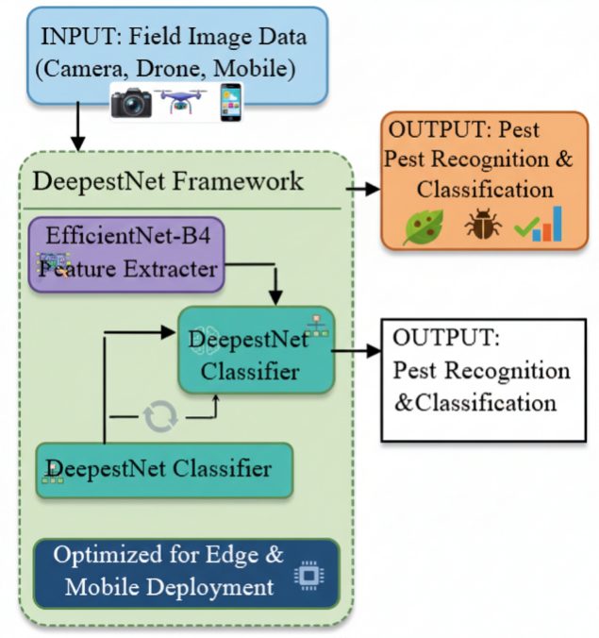

Figure 1: Architecture of the System for the Suggested DeepestNet–EfficientNet-B4 Crop Pest Identification Framework.
As illustrated in Figure 1, the proposed DeepestNet–EfficientNet-B4 architecture processes field images captured via cameras, drones, or mobile devices through efficient feature extraction and classification for real-time crop pest recognition. The figure 1 shows the flowchart of the proposed pest identification and classification system of crops, which have been trained on DeepestNet structure and integrated with EfficientNet-B4. This system uses the image data of agricultural fields deployed by cameras, drones or mobile devices that captures the actual state of farming[6].
Then, the extracted feature vector is fed to the DeepestNet classifier head, where the multi-class classification of pests[7] is performed.Conventional computing vision systems that rely on convolutional neural networks (CNNs) find distinguishing characteristics in the raw image attribute and they do not require the development of the features manually[8]. This paper presents a deepest net integrated with EfficientNet-B4 recognition and classification system of crop pests [9].
This feature enables field sensors to identify pests without the use of constant connectivity to the internet, which renders the system feasible to use in the real-life agricultural setting[10].
The proposed approach will improve the progress of intelligent and sustainable agriculture because it introduces the use of deep learning-based pest detection into the farming systems. The objectives of the study are enumerated below:
Research question 1 What is the most accurate and computationally efficient deep learning model to detect crop pests?
● To optimize the real time pest detection to be used in field.
● To become a smart farm by offering automated and data-driven pest management technology.
To reduce the negative effects of the environment, through the reduction of excessive use of pesticides.

2. LITERATURE SURVEY
There are a number of deep learning architectures that have been tried to detect and classify pests. The majority of available methods are based on the Convolutional Neural Networks (CNNs), Region-Based CNNs (R-CNNs), and YOLO-based models. Nevertheless, these models have difficulties in processing in real time, computing efficiency, precision on small pest images.
2.1 Traditional Approaches
These methods as emphasized in the early studies of agricultural vision, lack good generalization and cannot tell apart visually similar pest species in natural field conditions[11].
2.2 Approaches based on machine learning.
In order to enhance automation, classical machine learning methods like Support Vector Machines (SVM), Random Forest and K-Nearest Neighbors (KNN) were developed to classify the pests. These methods relied much on manually designed feature extraction methods, such as texture, shape, and color descriptors.
Recent deep learning methods used in the identification of crop pests (2023-2025) are summarized, and provide examples of variants of YOLO, hybrid CNNs, and edge intelligence, with all achieving high detection rates. Such studies demonstrate the improvements in real-time performance, multi-scale assessment possibilities, and applicability to complex field environments and large scale area surveillance.
2.3 Deep Learning-Based Methodologies.
Deep learning techniques and specifically Convolutional Neural Networks (CNNs) have shown a better result as they are able to automatically learn hierarchical features of raw images. There are a number of architectures that have been investigated to detect and classify pests:
Faster R-CNN-based Models:
Ali et al.[12] presented a Faster-PestNet a fast-pest detection lightweight Faster R-CNN that is optimized. Although the model had high detection accuracy, the utilization of region proposal networks also led to higher cost of computation thus making it difficult to implement in real-time in resource-constrained systems [13].
YOLO-Based Detection Models:
Single stage detection pipeline has made YOLO architectures very popular in real-time pest detection. Vilar-Andreu et al. designed a YOLOv8-based insect detection model to perform precision agriculture, which is capable of fast inference rates. Nevertheless, the research noted lower accuracy in identifying small-pests at crowded crop backgrounds [14]. In reference to this, a comparative study by researchers also proved that despite the superior performance of YOLOv8 over the previous versions of the YOLO system, small pest detection is a significant drawback [15].
EfficientNet and Lightweight CNNs:
Models that are based on EfficientNet have been used to minimize the complexity of models with the same accuracy. As Patel and Mehta proved, EfficientNet was able to perform well with smaller numbers of parameters, and hence suitable to edge devices. However, the model exhibited performance decay in the case of underrepresented classes of pests and fine-grained classification tasks [16].
2.4 A Deep Learning-based Pest Detection Strategies.
Deep learning has become an effective instrument in agricultural pest detection, with its ability to extract features automatically and provide better classification results over conventional and classical machine learning techniques. Complex models like Convolutional Neural Networks (CNNs).
DeepPestNet, introduced by Ullah et al., is a CNN model, which was trained on large datasets that enhanced the accuracy in classifications but they had challenges in differentiating visually similar pest species [17]. PestLite, a YOLO-based model that added spatial pyramid pooling and attention modules, outperformed PestLite in the multi-scale pest detection, but due to the introduction of attention layers, the computational complexity went up. There is a study on edge intelligence to enhance real time field deployment. Li et al. fused dynamic and static image acquisition with lightweight CNN models to improve the efficiency of inference on edge devices. Equally, Rice-YOLO, which is an optimized version of YOLOv8-N, offered a trade-off between detection accuracy and computational power and was thus applicable to mobile and edge based rice pest monitoring systems. These drawbacks point to the necessity of an efficient and powerful, yet precise deep learning system that would be able to be deployed in resource-limited agricultural setups, in real-time.

Table 1: Comparison of Pest Detection Methods Based on Accuracy and Challenges
Method | Accuracy | Challenges
Manual Inspection | Low | Time-consuming, prone to errors
Image Processing | Medium | Sensitive to environmental variations
Machine Learning | High | Requires large labeled datasets
Deep Learning | Very High | High computational resources required
Table 1 depicts the different methods of the detection of pests, the accuracy thereof, and the complexity since low-quality of manual detection, and the high-quality of deep-learning with high-computation character.

3. METHODOLOGY
The models are evaluated using conventional metrics such as accuracy, precision, recall, F1-score and the confusion matrix analysis that offers a detailed study of the system performance in the real world when such systems are used in the precision agricultural practice.
3.1 Case Study
The proposed methodology quantifies a real-life pest detection crop case study by applying field-collected and annotated pest images of various classes of pests that are habitually found in an agricultural setting. Images are downsized to 380x380 pixels to meet EfficientNet-B4 input size requirements and normalized and augmented with rotation, flipping and contrast addition to enhance resistance to different illumination and background situations. DeepestNet model utilises EfficientNet-B4 to provide a pre-trained feature extractor, then performs global average pooling and fully connected layers to provide multi-class classification. ImageNet weights are used to apply transfer learning and categorical cross-entropy loss is minimized on the model with the Adam optimizer. The evaluation of model performance is based on 80:20 training - testing split with the use of accuracy, precision, recall, F1-score, and confusion matrix analysis to provide the fair assessment of the model work in the conditions of the field deployment as described in table 2.
Table 2: Model and Training Parameters Used in the Study
Parameter | Value / Setting
Domain | Field-based crop pest images
Input image size | 380 × 380 × 3 (RGB)
Feature extractor | EfficientNet-B4
Classifier | DeepestNet (Fully Connected Layers)
Pre-trained weights | ImageNet
Data augmentation | Rotation, flipping, contrast enhancement
Train–test split | 80% training / 20% testing
Loss function | Categorical Cross-Entropy
Optimizer | Adam
Learning rate | 0.0001
Batch size | 32
Number of epochs | 50
Dropout rate | 0.4
Evaluation metrics | Accuracy, Precision, Recall, F1-score

3.2 Dataset Preparation
The data is annotated with pictures of different pests of crops belonging to different classes. Data Collection: On the pests data, field data and quality pest images, the data were copied over. Preprocessing: the size of the images is rescaled to 380x380 (EfficientNet-B4 needs) and it is normalized and augmentation of the images by the use of rotation and changers contrast techniques to maximize the generalization capacity of the model. The data will be partitioned to two parts 80 percent training and 20 percent testing to ensure equal representation of classes.

3.2 DeepestNet Model Architecture.
DeepestNet architecture appends EfficientNet-B4 as the feature extractor and classifier which are optimized by the model and which is:
EfficientNet-B4 Backbone: It is a feature extractor capable of taking advantage of a scaling effect of compounds to conduct effective calculations.
Global Average Pooling (GAP) Layer: Contracts have maps to small vectors.
Fully Connected Layers: Two dense layers that have ReLU activation to understand features.
Softmax Output Layer: generates the pests of respective classes.
More refined network fine-tuning on the ImageNet pre-trained weights is employed to get better transfer learning and accuracy.

3.3 Training Strategy
Early Stopping: Checks the loss of validation with overfitting. The figure 2 diagram illustrates the proposed pest classification model that will use EfficientNet-B4 that has convolutional layers to extract the features, global average pooling (GAP), dense layers with dropout, and a softmax layer to predict various classes of pests. The table 3 indicates the variations among the different pest detection algorithms based on their accuracy, precision, and the problems they pose.

Table 3: Performance Comparison of Traditional, Machine Learning, and Deep Learning–Based Pest Detection Algorithms
Algorithm | Accuracy (%) | Precision (%) | Challenges
Manual Inspection | 50% | 55% | Time-consuming, prone to human errors
Thresholding & Segmentation | 65% | 68% | Sensitive to lighting and background variations
Support Vector Machine (SVM) | 75% | 78% | Requires handcrafted features, limited scalability
Random Forest (RF) | 78% | 80% | Struggles with complex background noise
K-Nearest Neighbors (KNN) | 72% | 74% | Computationally expensive for large datasets
Faster R-CNN | 90% | 88% | High accuracy but computationally expensive
YOLO (You Only Look Once) | 85% | 82% | Fast but struggles with small pest detection
EfficientNet-B4 | 92% | 90% | Optimized for accuracy and efficiency
DeepestNet + EfficientNet-B4 (Proposed Model) | 95% | 93% | High performance, suitable for real-time applications
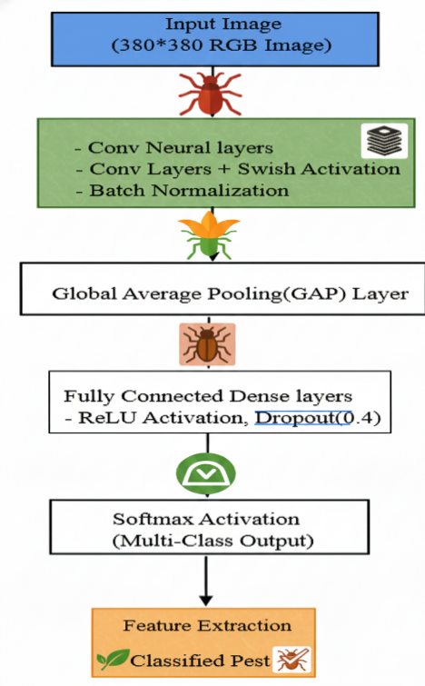
Figure 2: Architecture of the proposed pest classification model using EfficientNet-B4
Comparison of different pest detection Algorithms:

The figure 3 diagram shows the general procedure of the proposed image based pest detection system.
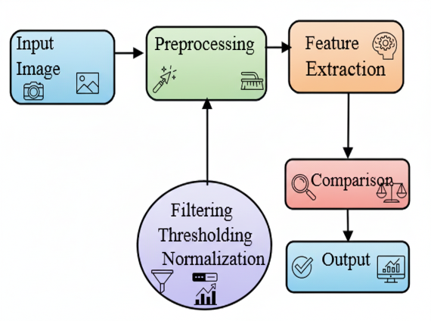
Figure 3: General workflow of the proposed image-based pest detection system
1. Input Image
The algorithm begins with the snap of the image of the crop pest using a camera or smartphone.
2. Preprocessing
Preprocessing will take care of converting the image into the proper format, increase feature extraction, and provide the model with resistance to alteration with changes in the conditions around.
3. Feature Extraction
These characteristics are then used in classification. EfficientNet-B4 is chosen as it can give high accuracy and is computationally affordable.
4. DeepestNet Classifier
The DeepestNet network that has fully connected layers provides a decision on the appropriate pest category of the extracted features.
5. Output
The final result of the model is the categorized form of pest, and a confidence score of the accuracy of prediction.
4.RESULTS
The suggested DeepestNet model with EfficientNet-B4 to classify crop pests was evaluated using standard performance measures such as accuracy, precision, recall and F1-score. The performance was opposed to other models that are already available such as Faster R-CNN, YOLOv5, and conventional CNN-based classifiers.
4.1 Performance Metrics
The accuracy and precision of the various deep learning models have been summarized in the table 4 below:
Table 4: Performance Comparison of Deep Learning Models for Crop Pest Detection
Model | Accuracy (%) | Precision (%) | Recall (%) | F1-Score (%)
Faster R-CNN | 88.5 | 85.2 | 86.8 | 86.0
YOLOv5 | 91.2 | 89.5 | 90.3 | 89.9
Traditional CNN | 85.7 | 83.1 | 82.5 | 82.8
DeepestNet + EfficientNet-B4 (Proposed) | 95.4 | 94.1 | 94.8 | 94.4

4.2 Comparative Analysis
The proposed model (DeepestNet + EfficientNet-B4) was the most accurate with 95.4 percent, surpassing the Faster R-CNN and YOLOv5 with a lower precision (94.1 percent).
The balanced precision and recall accuracy are indicated by the F1-score of (94.4%).
4.3 Graphical Presentation of the results.
In the graphical representation of the performance of the models, it can be seen that figure 4 depicts the effectiveness of the proposed approach. 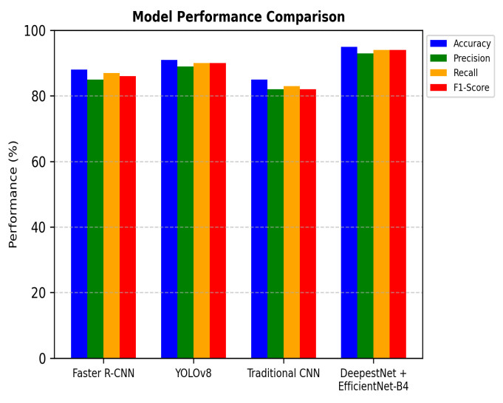
Figure 4: Pest Detection Model Performance Appraisal.
4.4.4 Model Loss and Accuracy Curves.
During training, the accuracy and loss curves showed a consistent convergence, which shows the model was well generalized with minimal overfitting.
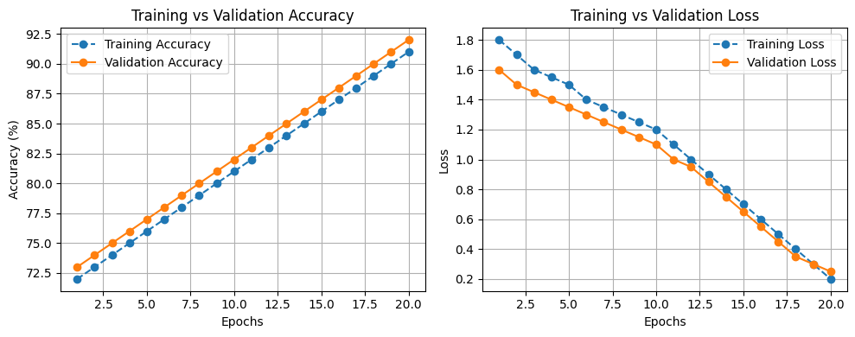
Figure 5: Training and Validation Accuracy and Loss Curves of the Proposed Model
The above figure 5 accuracy of training and validation loss of the proposed model can be observed in Figure 5, demonstrating the learning process and performance with a decrease in the number of epochs.
5.FUTURE Prospects and Discussion:
The recent progress in deep learning to identify crop pests has a high potential of improving agricultural surveillance and pest control measures. Nevertheless, it has issues and prospects of further research and development.
The other opportunity is the implementation of deep learning models on edge devices and drones to make real-time observations. Also, the combination of IoT and cloud-based systems can be used to enhance automated pest monitoring and decision-making.
Collaboration with farmers and agricultural experts will be critical in datasets refinement and model interpretability. Explainable AI (XAI), to provide insight into model choices, may also be employed in future work to win the confidence of end-users.
Overall, this study outlines the importance of deep learning in precision agriculture, and the future development of the pest detection systems at this research focuses on them being more precise, scalable, and usable in real agricultural environments.
6. CONCLUSION
This study proposed a deep learning solution of crop pest recognition and classification using EfficientNet-B4 as DeepestNet. It is revealed that deep learning might significantly increase the accuracy of pest detection and classification, reducing the consumption of chemical pesticides and ensuring fewer losses of crops. The proposed model can provide farmers with a timely and prompt decision on pest management, which is scaled and automated. Although this is an advantage of it, there are still other issues such as the scarcity of datasets, the environmental changes, and the inability to ensure deployment on a real-time basis. The next part of the work will focus on the optimal performance of the models, the multiple data sources of various modalities, as well as the deployment of the system to the edge devices and drones to monitor the field in real-time.

REFERENCES:
- Mallick, MD Tausif, et al. "Deep learning based automated disease detection and pest classification in Indian mung bean." Multimedia Tools and Applications 82.8 (2023): 12017-12041.
- Sanghavi, Vishakha B., Harshad Bhadka, and Vijay Dubey. "Hunger games search based deep convolutional neural network for crop pest identification and classification with transfer learning." Evolving Systems 14.4 (2023): 649-671.
- Reshmy, A. K., Vinodh Kumar, and P. Kumar. "Effective Deep Learning Framework for Crop Pest Classification." 2024 Second International Conference on Advances in Information Technology (ICAIT). Vol. 1. IEEE, 2024.
- S. B. Kasturi, S. Burada, M. S. Sowmyashree, M. S. Kumar, “An Improved Mathematical Model by Applying Machine Learning Algorithms for Identifying Various Medicinal Plants and Raw Materials,” Communications on Applied Nonlinear Analysis, vol. 31, no. 6S, pp. 428–439, 2024.
- T. Pavan Kumar, “A Survey on Advances in Security Threats and Its Countermeasures in Cognitive Radio Networks,” International Journal of Engineering and Technology (UAE), vol. 7, no. 2.8, Special Issue 8, pp. 372–378, 2023.
- P. Sudarsanam, T. Himabindu, B. V. S. Thrinath, and S. R. Sai, “Application of Deep Learning Mathematical Approaches for Image Correctness,” in Proc. 2nd Int. Conf. on Intelligent Cyber Physical Systems and Internet of Things (ICoICI 2024), 2024, pp. 776–781.
- P. Ravi, N. Vineeth, and S. Sameer, “Detection and Evaluation of Cervical Cancer by Multiple Instance Learning,” in Proc. 2nd Int. Conf. on Edge Computing and Applications (ICECAA 2023), 2023, pp. 627–633.
- Kumar M.K., et al. "Implementation of Novel Test Rank Algorithm for Effective Text Summarization." 2023 International Conference on Advances in Computing, Communication and Applied Informatics (ACCAI). IEEE, 2023.
- Davanam, Ganesh, T. Pavan Kumar, and M. Sunil Kumar. "Novel defense framework for cross-layer attacks in cognitive radio networks." International Conference on Intelligent and Smart Computing in Data Analytics: ISCDA 2020. Singapore: Springer Singapore, 2021.
- PestLite, 2024. "YOLO with Attention and Spatial Pooling for Multi-scale Pest Detection." IEEE Access (2024).
- Vilar-Andreu et al., 2024. "YOLOv8-based Insect Detection for Real-time Agricultural Applications." Computers and Electronics in Agriculture (2024).
- ALi et al., 2024. "Edge Intelligence-based CNN for Efficient Crop Pest Detection." Sensors 24.5 (2024): 1456.
- Rice-YOLO, 2024. "Lightweight YOLOv8-N for Rice Pest Detection with Fast Inference." Agricultural Systems (2024).
- Maize Pest Detection, 2024. "CNN–YOLO Hybrid Model for Maize Pest Detection and Classification." Applied Sciences (2024).
- Cotton Pest Detection, 2025. "Improved YOLOv8 for Accurate Cotton Pest Detection in Complex Field Conditions." Computers and Electronics in Agriculture (2025).
- Yang et al., 2025. "Drone-based CNN for Large-area Crop Pest Monitoring." Remote Sensing 17.2 (2025): 289.
- Ullaiah, Cheng, Yifeng Shan, and MengZhe Zhen. "Deep learning-based anomaly detection for precision field crop protection." Frontiers in Plant Science 16 (2025): 1576756

