**CINE VAULT**

A Report submitted under Project-Based Learning

In Partial Fulfillment of the Course Requirements for

“MOBILE APPLICATION DEVELOPMENT(22CS104002)”

Submitted By

| **M.Sravya** | **22102A040174** |
| --- | --- |
| **M.L.Tejaswi** | **22102A040176** |
| **M.Lavanya** | **22102A040178** |
| **P.Vanaja** | **22102A040207** |
| **S.Ajith Kumar** | **22102A040248** |

Under the Guidance of

**M.Surya**

Department of CSE



**Department of Computer Science and Engineering**

**School of Computing**

**MOHAN BABU UNIVERSITY**

Sree Sainath Nagar, Tirupati – 517 102

**2024-2025**

 **MOHAN BABU UNIVERSITY**

#### Vision

To be a globally respected institution with an innovative and entrepreneurial culture that offers transformative education to advance sustainability and societal good.

#### Mission

* Develop industry-focused professionals with a global perspective.
* Offer academic programs that provide transformative learning experience founded on the spirit of curiosity, innovation, and integrity.
* Create confluence of research, innovation, and ideation to bring about sustainable and socially relevant enterprises.
* Uphold high standards of professional ethics leading to harmonious relationship with environment and society.

**SCHOOL OF COMPUTING**

**Vision**

To lead the advancement of computer science research and education that has real-world impact and to push the frontiers of innovation in the field.

#### Mission

* Instil within our students fundamental computing knowledge, a broad set of skills, and an inquisitive attitude to create innovative solutions to serve industry and community.
* Provide an experience par excellence with our state-of-the-art research, innovation, and incubation ecosystem to realise our learners’ fullest potential.
* Impart continued education and research support to working professionals in the computing domain to enhance their expertise in the cutting-edge technologies.
* Inculcate among the computing engineers of tomorrow with a spirit to solve societal challenges.

#### 

#### DEPARTMENT OF COMPUTER SCIENCE AND ENGINEERING

**Vision**

To become a Centre of Excellence in Computer Science and its emerging areas by imparting high quality education through teaching, training and research.

**Mission**

⮚ Imparting quality education in Computer Science and Engineering and emerging areas of IT industry by disseminating knowledge through contemporary curriculum, competent faculty and effective teaching-learning methodologies.

⮚ Nurture research, innovation and entrepreneurial skills among faculty and students to contribute to the needs of industry and society.

⮚ Inculcate professional attitude, ethical and social responsibilities for prospective and promising engineering profession.

⮚ Encourage students to engage in life-long learning by creating awareness of the contemporary developments in Computer Science and Engineering and its emerging areas.

**B.Tech. Computer Science and Engineering**

#### PROGRAM EDUCATIONAL OBJECTIVES

After few years of graduation, the graduates of B.Tech. CSE will be:

|  |  |
| --- | --- |
| **PEO1.** | Pursuing higher studies in core, specialized or allied areas of Computer Science, or Management. |
| **PEO2.** | Employed in reputed Computer and I.T organizations or Government to have a globally competent professional career in Computer Science and Engineering domain or be successful Entrepreneurs. |
| **PEO3.** | Able to demonstrate effective communication, engage in teamwork, exhibit leadership |

skills and ethical attitude, and achieve professional advancement through continuing education.

#### PROGRAM OUTCOMES

On successful completion of the Program, the graduates of B.Tech. CSE Program will be able to:

|  |  |
| --- | --- |
| **PO1.** | **Engineering Knowledge**: Apply the knowledge of mathematics, science, engineering fundamentals, and an engineering specialization to the solution of complex engineering problems. |
| **PO2.** | **Problem Analysis**: Identify, formulate, review research literature, and analyze complex engineering problems reaching substantiated conclusions using first principles of mathematics, natural sciences, and engineering sciences. |
| **PO3.** | **Design/Development of Solutions**: Design solutions for complex engineering problems and design system components or processes that meet the specified needs with appropriate consideration for the public health and safety, and the cultural, societal, and environmental considerations. |
| **PO4.** | **Conduct Investigations of Complex Problems**: Use research-based knowledge and research methods including design of experiments, analysis and interpretation of data, and synthesis of the information to provide valid conclusions. |
| **PO5.** | **Modern Tool Usage**: Create, select, and apply appropriate techniques, resources, and modern engineering and IT tools including prediction and modeling to complex engineering activities with an understanding of the limitations. |
| **PO6.** | **The Engineer and Society**: Apply reasoning informed by the contextual knowledge to assess societal, health, safety, legal and cultural issues and the consequent responsibilities relevant to the professional engineering practice. |
| **PO7.** | **Environment and Sustainability**: Understand the impact of the professional engineering solutions in societal and environmental contexts, and demonstrate the knowledge of, and need for sustainable development. |
| **PO8.** | **Ethics**: Apply ethical principles and commit to professional ethics and responsibilities and norms of the engineering practice. |
| **PO9.** | **Individual and Team Work**: Function effectively as an individual, and as a member or leader in diverse teams, and in multidisciplinary settings. |
| **PO10.** | **Communication**: Communicate effectively on complex engineering activities with the |

engineering community and with society at large, such as, being able to comprehend and write effective reports and design documentation, make effective presentations, and give and receive clear instructions.

**PO11. Project Management and Finance**: Demonstrate knowledge and understanding of the

engineering and management principles and apply these to one’s own work, as a member and leader in a team, to manage projects and in multidisciplinary environments.

**PO12. Life-long Learning**: Recognize the need for, and have the preparation and ability to engage

in independent and life-long learning in the broadest context of technological change.

#### PROGRAM SPECIFIC OUTCOMES

|  |  |
| --- | --- |
| **PSO1.** | Apply knowledge of computer science engineering, Use modern tools, techniques and technologies for efficient design and development of computer-based systems for complex engineering problems. |
| **PSO2.** | Design and deploy networked systems using standards and principles, evaluate security measures for complex networks, apply procedures and tools to solve networking issues. |
| **PSO3.** | Develop intelligent systems by applying adaptive algorithms and methodologies for solving |

problems from inter-disciplinary domains.

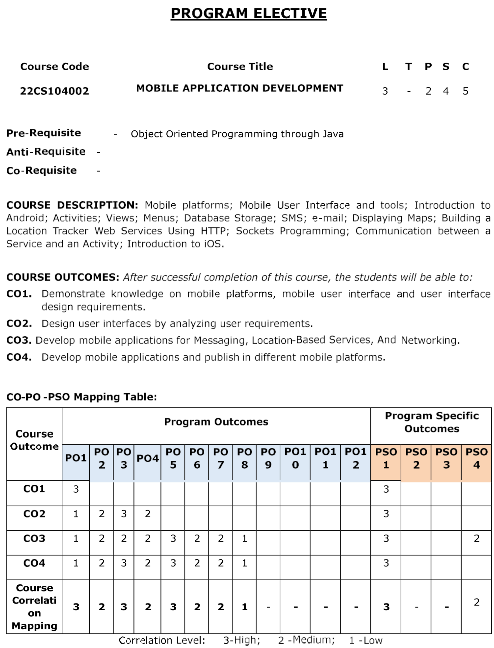

**MOHAN BABU UNIVERSITY**

Sree Sain

ath Nagar, Tirupati

–

517 102



**Department of Computer Science and Engineering**

#### CERTIFICATE

This is to certify that the Project Entitled

**CINE VAULT**

Submitted By

**M.Sravya 22102A040174**

**M.L.Tejaswi 22102A040176**

**M.Lavanya 22102A040178**

**P.Vanaja 22102A040207**

**S.Ajith Kumar 22102A040248**

is the work submitted under Project-Based Learning in Partial Fulfillment of the Course Requirements for “MOBILE APPLICATION DEVELOPMENT (22CS104002)” during 2024-2025.

**Supervisor: Head:**

M.Surya Dr. G. Sunitha

Department of CSE Professor & Head

School of computing School of computing

Mohan Babu University Mohan Babu University

Tirupati Tirupati

#### ACKNOWLEDGEMENTS

First and foremost, I extend my sincere thanks to **Dr. M. Mohan Babu**, Chancellor, for his unwavering support and vision that fosters academic excellence within the institution.

My gratitude also goes to **Mr. Manchu Vishnu, Pro-Chancellor**, for creating an environment that promotes creativity and for his encouragement and commitment to student success.

I am deeply appreciative of **Prof. Nagaraj Ramrao**, Vice Chancellor, whose leadership has created an environment conducive to learning and innovation.

I would like to thank **Dr. K. Saradhi**, Registrar, for his support in creating an environment conducive to academic success.

My sincere thanks to **Dr. B.M. Satish**, Dean of the School of Engineering and Computing, for his valuable support and guidance in all academic matters.

I am also grateful to **Dr. G. Sunitha**, Head of the Department of Computer Science and Engineering, for her valuable insights and support.

Finally, I would like to express my deepest appreciation to my project supervisor, **M.Surya,**

Department of Computer Science and Engineering for continuous guidance, encouragement, and expertise throughout this project.

Thank you all for your support and encouragement.

#### Table of Contents

**Chapter Title Page No.**

**No.**

**Abstract**

**1 Introduction**

1.1 ProblemStatement 1

1.2 Importance of the Problem 1

1.3 Objectives 2

1.4 Scope of the Project 3

1. **System Design**

2.1 Architecture Diagram 4-5

2.2 Module Descriptions6-7

2.3 Database Design 8-11

1. **Implementation**

3.1 Tools and Technologies Used 14-16

3.2 Front-End Development 17-20

3.3 Back-End Development 21-24

3.4 Integration 25-29

**4 Testing, Results and Discussion**

* 1. Test Cases 30-35
  2. Testing Methods 36-40
  3. Output Screenshots 41-46
  4. Analysis of Results 47-50

1. **Conclusion** 
   1. Summary of Findings 51-53
   2. Future Enhancements 54-57
2. **References** 58

#### 

#### ABSTRACT

This mini project titled **"Mini Netflix App"** is a simplified version of the popular video streaming platform, developed using **Android Studio**, **Java**, and **XML layouts**. The application aims to demonstrate basic Android development concepts such as user interface design, dynamic content rendering, and activity navigation.

The Mini Netflix App showcases a list of popular movies using **RecyclerView**, where each movie item displays a **poster image** and **title**. Images are efficiently loaded from URLs using the Glide library. When a user taps on a movie item, they are navigated to a **detail screen** that provides additional information such as the moviedescriptionandfull**-**sizeposter.

The UI is designed using XML layout files, incorporating CardView, ImageView, and TextView elements to create a clean and visually appealing user interface similar to the Netflix app. The app uses a hardcoded list of movies as dummy data, but can be easily extended to fetch data from Firebase or a REST API.

This project provides a strong foundation in building Android applications and demonstrates the integration of UI components, data handling, activity transitions, and image loading-key aspects of modern Android app development.

Key Words : Android Studio, Java, XML Layout, RecyclerView, CardView, Movie App, Netflix Clone ,Movie Streaming

**INTRODUCTION**

The process of developing a mobile application begins with identifying a relevant real-world concept and translating it into an interactive digital experience. In this project, the focus is on building a “**Mini Netflix App”**, a basic yet functional clone of the Netflix user interface. This application is developed using Android Studio, the official integrated development environment (IDE) for Android app development, leveraging Java as the programming language and XML for designing user interfaces.

To begin development, a new Android project is created in Android Studio with an EmptyActivity template.Project structure is organized into key components such as Activities, Adapters, Layouts, and Model classes. The app is designed to be lightweightandmodular, enabling easy updates and feature enhancements.

With the rapid growth of multimedia streaming platforms, applications like Netflix have become essential in the digital entertainment industry. The Mini Netflix App aims to provide users with a simple and interactive interface to browse a collection of movies. Each movie is represented with a posterimage, title, and description, offering a glimpse of the core features found in real-world media apps. The project uses RecyclerView to efficiently display movie items in a scrollable list, and CardView to enhance visual presentation.

Images are loaded from online URLs using the Glidelibrary, ensuring smooth and optimized image handling. The app architecture includes multipleactivities, where clicking on a movie item opens a new screen showing detailed information about the selected movie.

This project serves as an excellent starting point for students and beginners to understand the foundations of Android UI design, data binding, event handling, and component-based development. While it uses hardcoded data for simplicity, the structure is scalable and can be extended to include backend integration, such as Firebase or REST APIs, for real-time movie listings.

**1.1 Probelm Statement**

In today’s digital age, streaming platforms like Netflix, Amazon Prime, and Disney+ have transformed how people consume movies and TV shows. However, building such feature-rich applications from scratch can be complex and overwhelming for beginners learning Android development. There is a need for a simplified version of a movie browsing app that allows students and entry-level developers to understand the core concepts of mobile application development, such as user interface design, activity navigation, image handling, and data binding.

The problem addressed in this project is to design and implement a basic Android application that simulates the frontend interface of Netflix, enabling users to view a list of movies with their posters, titles, and descriptions, and navigate to a details screen for each movie.This project provides a practical solution by delivering a Mini Netflix App using Android Studio, Java, and XML, which serves as a foundation for learning and future development of more complex streaming applications.

**1.2 Importance of Probelm**

Understanding how to build interactive and user-friendly mobile applications is a crucial skill in today’s technology-driven world. The rise of streaming services like Netflix has set a high standard for user interface design, content presentation, and performance. However, for students and beginner developers, creating such applications from scratch can be challenging due to the complexity of backend systems, APIs, and UI frameworks.

This project focuses on addressing the need for a simplified learning model by breaking down the core elements of a streaming app into manageable components. The importance of this problem lies in providing a hands-on opportunity to:

* Bridge the gap between theoretical knowledge and practical Android development.
* Build confidence in using essential components like RecyclerView, CardView, and Activity navigation.
* Understand how to structure an Android app for scalability and maintainability.
* Offer a foundation for future projects that can include dynamic content, user authentication, and real-time data using Firebase or APIs.

### 1.3 Objectives

The main objective of the **Mini Netflix App** project is to develop a basic movie browsing application using **Android Studio**, with **Java** as the programming language and **XML** for designing the user interface. This project aims to simulate the core frontend features of a real streaming application in a simplified format that is suitable for beginners.

#### Specific objectives include:

1. **To design a user-friendly interface** that allows users to browse a list of movies using visual elements like posters and titles.
2. **To implement RecyclerView and CardView** for displaying movie items in a scrollable and aesthetically pleasing layout.
3. **To load and display movie posters from URLs** using the Glide library for optimized image handling.
4. **To implement activity transitions** where tapping on a movie item opens a detailed view with more information such as description and full-size image.
5. **To enhance understanding of Android development concepts**, including layouts, adapters, intents, event handling, and modular app structure.
6. **To provide a scalable structure** that can be easily extended in the future to include real-time data using Firebase or APIs.
7. **To create a mini project that acts as a learning tool** for students, helping them gain confidence in building Android applications.

By achieving these objectives, the project not only builds a strong foundation in Android development but also prepares learners to take on more complex, real-world applications by applying best practices in mobile app design and development.

### 1.4 Scope of the Project

The Mini Netflix App project is designed as a foundational mobile application that introduces and reinforces key concepts in Android development. It is primarily targeted at students, beginners, and aspiring Android developers who want to gain hands-on experience with building interactive user interfaces and handling multimedia content.

This project focuses on the frontend functionality of a streaming platform, where users can browse through a collection of movies, view their posters, titles, and descriptions, and navigate to a detailed view of each item. Although the app currently uses hardcoded data for simplicity, its modular design allows for future enhancements such as:

* Integration with real-time databases (e.g., Firebase).
* Support for RESTful APIs to fetch dynamic movie data.
* Adding features like search, filter, and categories.
* Implementation of user authentication and login systems.
* Playing trailers or short clips using video streaming APIs.

The scope of this project is limited to building a static, user-interface-focused movie browsing app, but it serves as a stepping stone toward developing a full-featured media streaming application. This project provides valuable insight into building scalable Android apps and lays the groundwork for integrating more advanced technologies in the future.

### 

**System Design**

### 2.1 Architecture Diagram

**ER – Diagram**

An **Entity-Relationship Diagram (ERD)** for your **Mini Netflix App** will illustrate the relationships between different entities (like movies and their details) in the system.

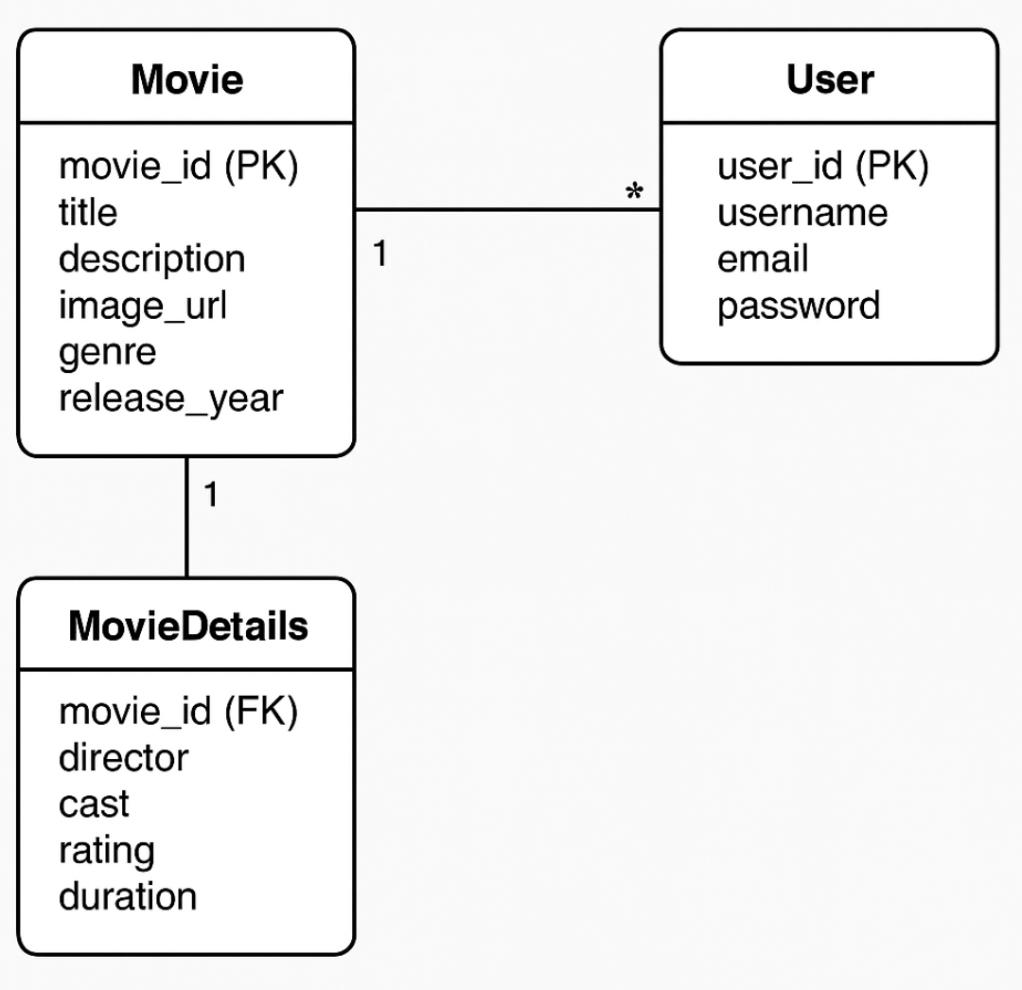

**Data Flow Diagram**

* User Browses Movies → App requests movie list from the Movie Data Store → Movie Data Display retrieves and shows posters, titles, and descriptions.
* User Selects a Movie → App sends selection to the Movie Details Display process → Movie Data Store returns director, cast, rating, etc. → Details screen is rendered.
* All data is currently hardcoded (in-memory), but the same flow applies if you replace the data store with a backend API or Firebase.

overview of how information flows, where it originates, and how it is stored or modified within the system.

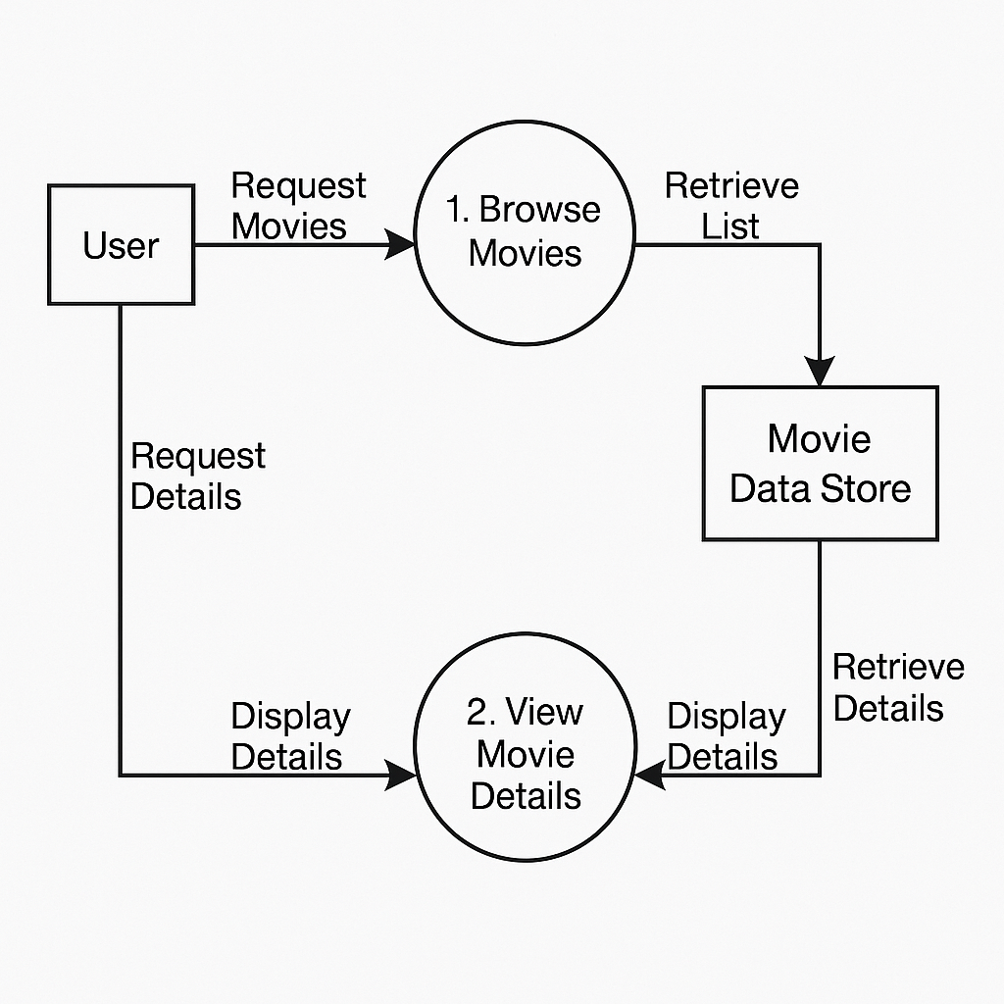

##### 2.2 Module Description

 The **modules** for your **Mini Netflix App**:

### ****UI Design Module (User Interface)****

* **Description**: This module is responsible for designing the user interface of the app using **XML** files. It includes layout files for the main screen, movie cards, and detailed movie information.
* **Components**:
  + activity_main.xml: Contains the **RecyclerView** to display the movie list.
  + item_movie.xml: Layout for displaying each movie as a **CardView**.
  + activity_detail.xml: Layout for displaying detailed information about the selected movie.
* **Objective**: To create a responsive and interactive UI for browsing movies.

### ****Movie Data Handling Module****

* **Description**: This module handles the movie data and acts as the backend. The data is either hardcoded or can be fetched from a server in future versions.
* **Components**:
  + Movie.java: A Java class that stores movie attributes (title, description, image URL, etc.).
  + **MovieAdapter.java**: RecyclerView adapter that binds movie data to the UI.
* **Objective**: To manage and display movie data.

### ****Navigation and Interaction Module****

* **Description**: This module handles user interactions and navigation between different app screens.
* **Components**:
  + **MainActivity.java**: Manages the main screen and launches **DetailActivity** on item selection.
  + **DetailActivity.java**: Displays detailed information about the selected movie.
  + **Intents**: Used for navigation between the main and details screen.
* **Objective**: To allow users to navigate and interact with the app seamlessly.

### ****Image Loading and Optimization Module****

* **Description**: This module uses the **Glide** library to load movie posters and other images efficiently.
* **Components**:
  + **Glide Library**: Handles smooth and optimized image loading from URLs.
* **Objective**: To provide efficient image handling, ensuring smooth performance and fast image loading.

### ****Data Store Module****

* **Description**: This module manages the storage and retrieval of movie data. Initially, this will be static or hardcoded, but it can be extended in the future to connect to a real-time database or API.
* **Components**:
  + **Hardcoded Data**: A static list of movies stored within the app.
  + **API (Future Scope)**: Integration with an external movie database API (e.g., TMDb or Firebase).
* **Objective**: To manage the movie data and allow for potential integration with real-time data.

### ****Backend Integration (Future Scope)****

* **Description**: Future implementation to dynamically fetch movie data from a real-time database or API (e.g., Firebase, REST APIs).
* **Objective**: To extend the app’s functionality by fetching data dynamically, allowing for real-time updates and personalized content.

##### 

These modules work together to create a functional and scalable mini Netflix app. The system is designed with a simple structure that can be expanded upon as future updates or features are introduced. This modular approach ensures that the app is both easy to maintain and flexible enough to accommodate additional functionalities like real-time data fetching, user authentication, or recommendations.

### 2.3 Database Design

The **Mini Netflix App** will rely on a simple database design to manage movie data and support future scalability (such as adding user profiles, movie ratings, and more). Below is a conceptual database design for this app. The database will store movies, their details, and other essential data, which can be extended later to include user data, preferences, and recommendations.

### ****1. Movie Table****

This table stores all the essential details of movies. Each record will represent a movie and its attributes.

|  | **Data Type** | **Description** |
| --- | --- | --- |
| movie_id | INTEGER | Primary Key, Unique ID for each movie. |
| title | VARCHAR | Title of the movie. |
| description | TEXT | Short description or plot summary of the movie. |
| release_date | DATE | The release date of the movie. |
| genre | VARCHAR | Genre(s) of the movie (e.g., Action, Comedy). |
| image_url | TEXT | URL of the movie's poster image. |
| rating | DECIMAL(3,2) | Average rating of the movie (if applicable). |

Example:

| **title** | **description** | **release_date** | **genre** | **image_url** | **rating** |
| --- | --- | --- | --- | --- | --- |
| Inception | mind-bending thriller about dreams. | 2010-07-16 | Sci-Fi, Thriller | https://image_url.com/inc.jpg | 8.8 |
| The Dark Knight | Batman battles Joker in Gotham City. | 2008-07-18 | Action, Drama | https://image_url.com/dark.jpg | 9.0 |

### ****2. User Table (Future Scope)****

This table will store user profile information, allowing users to personalize their experience in the app, such as saving favorite movies, watching history, and ratings.

| **Column Name** | **Data Type** | **Description** |
| --- | --- | --- |
| user_id | INTEGER | Primary Key, Unique ID for each user. |
| username | VARCHAR | Username for the user. |
| email | VARCHAR | Email address of the user. |
| password | VARCHAR | Password for account security. |
| join_date | DATE | The date when the user joined the platform. |

Example:

| **user_id** | **username** | **email** | **password** | **join_date** |
| --- | --- | --- | --- | --- |
| 1 | johndoe | john@example.com | password123 | 2025-04-20 |
| 2 | janedoe | jane@example.com | password456 | 2025-04-21 |

### ****3. Movie-User Interaction Table (Future Scope)****

This table will record user interactions with movies, such as ratings and watch history. This allows the app to recommend movies based on user preferences.

| **Column Name** | **Data Type** | **Description** |
| --- | --- | --- |
| interaction_id | INTEGER | Primary Key, Unique ID for each interaction. |
| user_id | INTEGER | Foreign Key, references User table. |
| movie_id | INTEGER | Foreign Key, references Movie table. |
| rating | DECIMAL(3,2) | Rating given by the user (1-10 scale). |
| watch_date | DATE | The date the movie was watched. |

#### **Example:**

| **interaction_id** | **user_id** | **movie_id** | **rating** | **watch_date** |
| --- | --- | --- | --- | --- |
| 1 | 1 | 1 | 8.5 | 2025-04-20 |
| 2 | 2 | 2 | 9.0 | 2025-04-21 |

### ****4. Movie Genre Table (Future Scope)****

If we want to manage multiple genres for a movie (e.g., Action, Drama, Comedy), this table would be helpful to store each genre as a separate record linked to the movies.

| **Column Name** | **Data Type** | **Description** |
| --- | --- | --- |
| genre_id | INTEGER | Primary Key, Unique ID for each genre. |
| genre_name | VARCHAR | Name of the genre (e.g., Action, Comedy, Drama). |

#### **Example:**

| **genre_id** | **genre_name** |
| --- | --- |
| 1 | Action |
| 2 | Drama |
| 3 | Sci-Fi |

### ****Relationships Between Tables****

1. **Movie-User Interaction:** The Movie and User tables are linked through the **Movie-User Interaction Table**, where users can rate or mark movies as watched. This table can later support features like personalized recommendations.
2. **Genres:** The Movie table can be linked to the Movie Genre Table if movies can belong to multiple genres. This allows efficient management and filtering by genre.

### ****Future Scope for Backend****

* **API Integration:** The app can be integrated with an external movie database API (e.g., TMDb or Open Movie Database) to fetch dynamic movie data.
* **Firebase or Real-Time Database:** For storing and retrieving data dynamically, Firebase can be used to save user preferences and movie data in real-time.
* **User Preferences:** Advanced features like saving favorite movies, tracking watch history, and recommending movies based on ratings can be added in the future.

This database design is simple but can scale with the addition of more features like user authentication, real-time recommendations, and movie streaming functionality. It lays the foundation for future growth and the potential to move from a static app to a dynamic, user-interactive platform.

# Implementation

### 3.1 Tools and Technologies Used

For a project involving an online platform for farmers to sell goods, a variety of tools and technologies would be used to cover different aspects, from front-end and back-end development to database management, security, and hosting. Here’s a list of commonly used tools and technologies for such a project, divided by area:

##### 1. Front-End Development

* **HTML, CSS, and JavaScript**: Basic building blocks for creating web pages and user interfaces.
* **React.js or Angular**: Popular JavaScript frameworks for building dynamic, responsive user interfaces. React provides component-based architecture, making it easier to develop and maintain the front end.
* **Bootstrap or Tailwind CSS**: CSS frameworks that help create responsive, mobilefriendly designs with pre-built components and styles.
* Axios or Fetch API: For making HTTP requests from the front end to the back-end API.

##### 2. Back-End Development

* **Node.js with Express:** Node.js is a JavaScript runtime commonly used with the Express framework to create RESTful APIs and handle server-side logic.
* **Django or Flask (Python):** Python-based frameworks for building scalable and secure back-end applications. Django is particularly good for projects needing built-in security and scalability.
* **Ruby on Rails:** Another back-end framework, popular for rapid application development and used in e-commerce and marketplace projects**.**
* **Java (Spring Boot):** If the project needs enterprise-level architecture, Spring Boot is a Java framework ideal for developing scalable, production-ready applications.

##### 3. Database Management

* **MySQL or PostgreSQL**: Relational databases often used for storing structured data like product information, user details, and orders.
* **MongoDB:** A NoSQL database, useful for projects needing flexible data storage or handling large, unstructured data sets.
* **Redis:** An in-memory data structure store used for caching, which can improve performance for frequently accessed data.
* **Firebase:** A backend-as-a-service platform that offers real-time database and user authentication. Firebase is suitable for smaller projects or prototypes.

##### 4. Authentication and Security

* **JWT (JSON Web Tokens):** For user authentication, especially in RESTful APIs, JWT is commonly used to create secure tokens that authenticate and authorize users.  **- OAuth2:** An authorization framework that allows users to log in with third-party providers (e.g., Google or Facebook).
* **SSL/TLS:** For securing the data transmission between the client and server, SSL/TLS encryption is essential for e-commerce platforms.

##### 5. Payment Processing

* **Stripe or PayPal**: Widely used payment gateways for handling secure payment processing.
* **Square:** Another popular payment solution, often used for small businesses and marketplace projects.

##### 6. Hosting and Deployment

* **AWS (Amazon Web Services):** Offers various cloud services, including EC2 for hosting servers, S3 for storage, and RDS for managed databases.
* **Google Cloud Platform (GCP):** Another cloud provider offering services like Google App Engine, Cloud Storage, and Firebase.
* **Heroku:** A platform-as-a-service that simplifies deployment for small to medium-sized applications.
* **Netlify or Vercel:** For front-end hosting, especially useful for static sites and apps created with frameworks like React.

##### 7. APIs and Integrations

* RESTful APIs: Standard architecture for creating APIs that handle CRUD operations for entities like products, users, and orders.
* GraphQL: A query language for APIs, often used when the front-end needs more flexibility in data fetching.
* Google Maps API: Useful for integrating location-based services, like showing the location of farms or delivery areas.

Using a combination of these tools and technologies, a developer or team can build a complete, secure, and scalable online platform for farmers to sell goods, from managing the product listing and order processing to payment handling and data analysis.

### 3.2 Front-End Development

Front-end development is the process of building the part of a web application that users interact with directly. It involves creating a user-friendly, responsive, and accessible interface that makes it easy for users to navigate the application and perform actions. Here’s an overview of the essential technologies and tools commonly used in front-end development, along with some specific tools for building a farmer goods-selling platform.

**1. HTML (HyperText Markup Language):**

* Defines the structure of the web page.
* HTML elements represent different types of content (e.g., headings, paragraphs, images, links) and organize the layout of a page.
* For a farmer goods platform, HTML might define the structure of pages like the home page, product listings, and the shopping cart.

**2. CSS (Cascading Style Sheets):**

* Used for styling and layout of the HTML structure.
* CSS controls the look and feel of the website, including colors, fonts, margins, padding, and responsive design.
* For a selling platform, CSS would be used to create a visually appealing and consistent design across pages, with an emphasis on making the platform easy to use on both desktops and mobile devices.

**3. JavaScript:**

* JavaScript is a programming language that enables interactivity and dynamic behavior on web pages.
* Essential for creating features like product filtering, form validation, shopping cart updates, and displaying product details dynamically.
* JavaScript, often in conjunction with front-end frameworks, handles asynchronous requests (e.g., adding products to the cart without refreshing the page).

**Popular Front-End Frameworks and Libraries**

**1. React.js:**

* A popular JavaScript library for building user interfaces, particularly single-page applications.
* React uses a component-based architecture, making it easy to reuse UI components like product cards or navigation bars across the platform.
* For a farmer selling goods platform, React can manage state effectively (like shopping cart items) and dynamically update pages as users interact with the platform.

**2. Vue.js:**

* A lightweight and versatile JavaScript framework.
* Known for its simplicity and flexibility, Vue is ideal for smaller projects or components within larger applications.
* Vue would be useful for features like product search and filtering, allowing farmers or customers to quickly find relevant products.

**3. Angular:**

* A powerful framework developed by Google, Angular is more comprehensive and offers solutions for both front-end and some back-end needs.
* Angular is particularly suited for large-scale applications with complex data management. - Its two-way data binding allows automatic updates between the UI and the data model, which can be helpful for managing a product catalog or user dashboard.

**4. Svelte:**

* A newer JavaScript framework that compiles code into highly efficient vanilla JavaScript at build time.
* Svelte is highly performant and can be a great choice if you want fast loading times for a farmer goods platform with many users.

**Styling Libraries and Frameworks**

**1. Bootstrap:**

* A CSS framework that provides pre-built components like navigation bars, modals, and buttons.
* Ideal for quick, responsive design, Bootstrap allows developers to focus more on functionality and less on layout.
* For an e-commerce platform, Bootstrap’s grid system and components can speed up development and ensure a responsive design.

**2. Tailwind CSS:**

* A utility-first CSS framework that allows developers to style elements directly with classes. - Tailwind offers a high degree of customization and flexibility, enabling unique and responsive designs.
* On a farmer goods platform, Tailwind can help design customized pages like product details, checkout, and order confirmation, giving a unique look.

**3. Material-UI:**

* A library based on Google’s Material Design, typically used with React.
* Material-UI provides ready-made components that ensure consistency, accessibility, and a polished look.
* For an online selling platform, Material-UI can help create clean, intuitive interfaces that guide users through product discovery and purchase flows.

**Front-End State Management**

**1. Redux:**

* A JavaScript library for managing and centralizing application state, commonly used with React.
* Redux is helpful for managing global states like user authentication, shopping cart items, and product information.
* Redux helps ensure that the front end reflects the latest data without duplicating it across multiple components.

**2. Context API (React):**

* A simpler alternative to Redux for managing state in React applications.
* Good for smaller applications where only a few global states are needed.

**3. Vuex (for Vue.js):**

* The official state management library for Vue.
* Used to handle shared data, making it easier to sync data like user information and product data across components.  **Front-End Tools and Utilities**

**1. Axios:**

- A promise-based HTTP client for JavaScript, used for making requests to the back-end API. - For a farmer selling platform, Axios is used to fetch product data, submit orders, or check user information without refreshing the page.

**2. Webpack:**

* A module bundler that packages JavaScript code, styles, and other assets into optimized bundles.
* Webpack ensures that files load quickly, improving the performance and speed of the platform.

**Front-End Testing**

**1. Jest:**

- A testing framework for JavaScript, particularly popular with React applications. - Used to run unit tests and ensure that individual components behave as expected.

**2. Cypress:**

* An end-to-end testing framework that allows you to test the entire user journey on the platform.
* For a selling platform, Cypress can simulate user actions like browsing products, adding items to the cart, and completing purchases.

**3. Selenium:**

* A powerful tool for automated browser testing, often used in cross-browser testing scenarios.
* Can be used to ensure the front end works correctly across different browsers and devices.

For a farmer selling goods online, the front-end should prioritize user experience, accessibility, and ease of navigation. Features like product search, filters, product details, and a smooth checkout flow would be essential to ensuring a positive user experience. Additionally, the front end would need to support mobile and desktop users, as customers may access the platform from various devices.

### 3.3 Back-End Development

Back-end development is the process of building and managing the server, application, and database that work together to provide the core functionality for a web application. In the case of a platform for farmers to sell goods online, the back end would handle tasks like managing user accounts, storing product information, processing orders, and communicating with a payment gateway.

Here’s a breakdown of essential back-end development tools, technologies, and best practices: **1. Programming Languages:**

* **JavaScript (Node.js):** JavaScript on the back end with Node.js is popular for developing scalable and efficient applications. Node.js is commonly paired with the Express framework to build RESTful APIs, handle routing, and manage middleware.
* **Python (Django, Flask):** Python is known for its readability and efficiency. Django is a high-level framework ideal for fast development and includes built-in support for databases, user authentication, and form handling. Flask is a lighter, more flexible Python framework suited to smaller applications.
* **Java (Spring Boot):** Java is commonly used in enterprise-level applications, with Spring Boot making it easier to create standalone applications that can scale.
* **Ruby (Ruby on Rails):** A web framework known for rapid development and a conventionover-configuration approach. Ideal for building robust applications quickly, it’s often used in e-commerce and marketplace platforms.

**2. Frameworks:**

* **Express (for Node.js):** A minimalist, unopinionated framework for building REST APIs in JavaScript. It’s flexible, powerful, and integrates well with other middleware, making it a popular choice for building APIs.
* **Django (for Python):** Django is a high-level framework with built-in tools for handling database migrations, user authentication, and more. Django’s ORM simplifies database interactions.
* **Flask (for Python):** A micro-framework with fewer built-in features, Flask is useful for smaller applications or projects that require custom solutions.

**3. RESTful and Graph QL APIs:**

* **REST (Representational State Transfer):** A standard architecture for building APIs that use HTTP requests to GET, POST, PUT, and DELETE data.
* **Graph QL:** A query language that provides flexibility in requesting data. It allows clients to specify the exact data needed, which can improve performance by reducing over-fetching or under-fetching of data.

**4. Databases:**

* **Relational Databases (MySQL, PostgreSQL):** Used for structured data, relational databases are ideal for storing well-defined data like product details, customer information, and orders. PostgreSQL is known for advanced features and high performance.
* **NoSQL Databases (MongoDB):** MongoDB is a document-oriented NoSQL database useful for applications that handle large, unstructured data or need flexibility in data modeling.
* **Redis:** An in-memory data store used for caching, improving performance by reducing the number of database queries needed for frequently accessed data.

**5. Authentication and Authorization:**

* **JWT (JSON Web Tokens):** Used for securely transmitting information between the client and server. JWTs are common in stateless authentication systems, where users log in, receive a token, and use it to access protected routes.
* **OAuth2:** An authorization framework that allows users to log in using external accounts (e.g., Google, Facebook).
* **Passport.js (Node.js):** An authentication middleware for Node.js, providing strategies for handling user sessions, tokens, and third-party logins.

**6. Payment Processing:**

* **PayPal:** Another widely used payment gateway, especially in marketplaces. It offers features like express checkout and invoicing.
* **Square:** Often used by small businesses and marketplaces, it provides an easy setup and various payment options.

**Middleware and Back-End Utilities**

1. **Body Parsers:** Middleware like body-parser in Express helps parse incoming request bodies and makes it easy to handle form data and JSON payloads.
2. **Authentication Middleware**: For managing user sessions and authentication, middleware can validate tokens, check roles, and handle secure sessions.
3. **Logging and Error Handling:**

* **Winston (Node.js) or Log4j (Java):** These libraries are used for logging error messages, which is critical for debugging and monitoring the health of the application.
* **Sentry:** A tool that captures exceptions and errors in the code, helping identify and resolve issues.

**Caching and Performance Optimization**

1. **Redis:** An in-memory data structure store used for caching frequently requested data, such as product listings or order statuses. Redis helps reduce database load, improving response time for users.
2. **Memcached:** Another caching solution that stores key-value pairs in memory. Memcached is often used for session storage or caching user data.
3. **CDNs (Content Delivery Networks):** CDNs like Cloudflare can cache static files (like images, CSS, and JavaScript files) to reduce server load and improve content delivery speed.

**Security and Data Protection**

1. **SSL/TLS Encryption:** Ensures secure data transmission between the client and server, essential for handling sensitive information like login credentials and payment details.
2. **Encryption Libraries:** Libraries like Bcrypt or Argon2 for hashing passwords, making user data secure.

**Testing and Quality Assurance**

**1. Unit Testing:**

* **JUnit (Java), PyTest (Python), Mocha and Chai (Node.js):** Used for testing individual functions or modules in the back end, ensuring each part of the application works as expected. **2. Integration Testing:**
* **Postman:** For testing API endpoints by simulating requests, helping to ensure the back end is handling requests and returning the correct responses.
* **Selenium:** For end-to-end testing, simulating user interactions with the entire application.

**3. Continuous Integration (CI) and Continuous Deployment (CD):**

**- Jenkins or GitHub Actions:** For automating testing, building, and deploying the back end, ensuring code is deployed quickly and with minimal errors.

In a farmer goods-selling platform, the back end plays a vital role in managing inventory, user accounts, and orders, while ensuring that payments are processed securely. The back end would also handle tasks like generating reports, sending notifications, and supporting user interactions with the platform. Effective back-end development ensures that data is managed efficiently and the platform can scale as needed to accommodate more farmers and customers.

### 3.4 Integration

Integration in software development refers to the process of combining different systems, applications, or components so that they work together as a unified whole. In the context of a farmer goods-selling platform, integration can involve various aspects such as connecting front-end and back-end systems, integrating third-party services, payment gateways, APIs, and even third-party services like email or SMS notifications.

Here’s a detailed breakdown of the key types of integration involved in developing an online platform for farmers to sell goods:

**1. Front-End and Back-End Integration**

This type of integration connects the front-end user interface with the back-end logic and databases. It ensures that actions taken by the user (like placing an order or viewing product details) are reflected on the server and database and vice versa.

**Technologies Involved:**

* **REST APIs:** The most common method for integrating the front-end with the back-end. The front-end sends HTTP requests (GET, POST, PUT, DELETE) to the server, which processes the request and responds with data in JSON format.
* Example: The front-end can send a POST request to the back-end to submit an order, and the back-end responds with a success message or error.
* **Graph QL**: An alternative to REST, Graph QL allows the client to request exactly the data it needs, optimizing the API calls and making them more efficient.
* **WebSockets:** Useful for real-time features like updating inventory levels or showing live order statuses, WebSockets enable two-way communication between the server and client.

**2. Third-Party API Integrations**

Third-party integrations allow your platform to interact with external services or data sources.

These can be for payment processing, shipping, email notifications, and more.

**Common Third-Party Integrations for Farmer Selling Platforms:**

* **Payment Gateways:** For processing online payments securely, you’ll need to integrate with services like:
* **Stripe, PayPal, Square:** These gateways handle credit card transactions, ensuring secure payment processing and compliance with standards like PCI DSS.
* **Shipping Services:** Integration with shipping carriers can automate the process of generating shipping labels, calculating shipping rates, and tracking packages.
* **Email/SMS Notifications:** Integration with email or SMS services is critical for sending order confirmations, promotional content, or status updates to users.
* Services like SendGrid, Mailgun, or Twilio can be used to integrate automated email/SMS functionality.
* **Social Media Logins :** *To simplify the user login process, integrating social media logins can allow customers to use their Google, Facebook, or Twitter credentials to sign in to the platform.*

**3. Database Integration**

Database integration ensures that the back end can effectively manage and store user, product, and transaction data. This typically involves connecting the application to a database and ensuring that the data is consistently stored, retrieved, and updated.

**Technologies Involved:**

* **Relational Databases (e.g., PostgreSQL, MySQL):** These are used to store structured data such as customer information, orders, and product details. Integration involves building database queries or using Object-Relational Mapping (ORM) tools like Sequelize (Node.js), Django ORM (Python), or Hibernate (Java).
* **NoSQL Databases (e.g., MongoDB):** These are **used** for unstructured data and allow more flexibility in how data is stored. MongoDB might be used for product catalogs, reviews, or other flexible data structures.

* **Database Migrations:** Tools like Flyway or Liquibase help manage and track changes to the database schema in a consistent manner.

**4. Real-Time Integration**

Real-time integration allows your platform to instantly update users on changes like stock levels, order status, or product availability without requiring a page refresh.

**Technologies Involved:**

* **Web Sockets:** For real-time communication between the server and the client. Useful in scenarios like showing live order updates or a live chat feature.
* **Server-Sent Events (SSE):** An alternative to WebSockets, SSE is used for sending real-time updates from the server to the browser in a more simple, unidirectional manner.
* **Push Notifications:** Integration with services like Firebase Cloud Messaging (FCM) or

OneSignal allows you to send push notifications to users about order updates, promotions, etc. **5. Search and Filtering Integration**

To help users find the right products, integrating powerful search and filtering systems is essential. This might involve integration with third-party search engines or using a back-end solution that provides fast and relevant search results.

**Technologies Involved:**

* **Elasticsearch:** A distributed search engine that allows for fast, scalable, and real-time search capabilities. For a farmer selling platform, Elasticsearch can help users quickly find products based on categories, location, price, etc.
* **Algolia**: A hosted search service that provides fast and customizable search APIs.

**6. Inventory Management Integration**

Managing product stock levels and updating inventory based on orders is essential for any ecommerce platform. Integration between the platform and the inventory management system ensures that products are accurately tracked and that orders can be fulfilled.

**Technologies Involved:**

* **Inventory APIs:** If using a third-party inventory management system (e.g., TradeGecko, Zoho Inventory), you’d integrate their API to keep track of product stock, manage restocks, and sync inventory levels across different sales channels**.**
* **Database Integration:** If managing inventory directly within the platform, the back-end logic would update stock levels when an order is placed or canceled.

**7. Customer Support and CRM Integration**

Integrating customer support tools and CRM (Customer Relationship Management) systems allows you to manage customer inquiries, provide support, and track customer interactions.

**Technologies Involved:**

**- Zendesk, Freshdesk**: Customer service platforms that can be integrated into the application to manage customer tickets and support requests.

**-HubSpot, Salesforce:** CRM systems that help track and manage customer relationships, sales pipelines, and marketing campaigns.

**8. Analytics and Reporting Integration**

Integrating with analytics tools allows you to track user behavior, product performance, and sales data. These insights can guide business decisions and help improve the user experience.

**Technologies Involved:**

* **Google Analytics:** For tracking website traffic, user behavior, and conversion rates.
* **Mixpanel, Amplitude:** For advanced product and event analytics to track user engagement and retention.
* **Custom Reporting Tools:** Depending on business requirements, custom reporting may involve pulling data from databases and presenting it through a dashboard (using libraries like Chart.js or D3.js).

**9. Security Integration**

Security is a critical component of any platform, especially when handling sensitive information such as payment details and personal user data.

**Technologies Involved:**

* **SSL/TLS:** Ensures secure, encrypted communication between the client and server.
* **OAuth2:** For secure authentication when integrating third-party login systems.
* **Two-Factor Authentication (2FA):** Adding an additional layer of security for user accounts, ensuring that only authorized users can access their accounts.
* **Captcha Systems:** To prevent automated bots from interacting with the platform, services like Google’s reCAPTCHA can be integrated.

**10. DevOps and Continuous Integration/Continuous Deployment (CI/CD)**

DevOps practices ensure smooth deployment of updates and automated workflows for testing and integration**.**

**Technologies Involved:**

* **Jenkins, GitLab CI, CircleCI:** Continuous integration tools that automate the process of testing and deploying code, ensuring that updates to the platform are continuously integrated and deployed.
* **Docker:** Used for containerizing the application to ensure that it runs consistently across different environments.
* **Kubernetes:** For orchestrating and scaling containerized applications across a cluster.

For a farmer selling goods online, integration involves bringing together a variety of technologies, APIs, and services to ensure the platform is fully functional, secure, and userfriendly. Key integrations include payment gateways, inventory management, real-time updates, customer support, analytics, and authentication systems. By ensuring smooth integration between these components, you can create a seamless experience for users while maintaining reliable back-end operations.

**Testing, Results and Discussion**

##### 4.1 Test Cases

Test cases are designed to verify that a system works as expected and that it handles all possible scenarios properly. In the context of a *farmer online selling goods platform*, test cases will cover various functional and non-functional aspects, such as user registration, product listing, payment processing, and more. Below is an outline of test cases you might use for such a platform:

**1. User Authentication**

**Test Case 1: User Registration**

* **Test Objective**: Verify that a new user can successfully register an account.
* **Preconditions**: The user is not registered in the system.
* **Steps:**

1. Navigate to the registration page.
2. Enter a valid username, email, password, and other required information.
3. Submit the registration form.

* **Expected Results:**
* The user is successfully registered.
* A confirmation email is sent to the user.
* The user is redirected to the login page.

**Test Case 2: User Login**

* **Test Objective:** Verify that a registered user can log in successfully.
* **Preconditions:** The user must already have an account.
* **Steps:**

1. Navigate to the login page.
2. Enter a valid email and password.
3. Submit the login form.

* **Expected Results:**
* The user is logged in successfully.
* The user is redirected to the dashboard or home page.

**Test Case 3: Invalid Login**

* **Test Objective:** Verify that the user cannot log in with invalid credentials.
* **Preconditions**: The user must already have an account.

* **Steps:**

1. Navigate to the login page.
2. Enter an invalid email and/or password.
3. Submit the login form.

* **Expected Results:**
* An error message is displayed indicating that the login credentials are incorrect.

**Test Case 4: Password Reset**

* **Test Objective**: Verify that the user can reset their password if forgotten.
* **Preconditions:** The user has a registered account.
* **Steps:**

1. Navigate to the login page.
2. Click on the "Forgot Password" link.
3. Enter the registered email address.
4. Follow the instructions in the email to reset the password.

* **Expected Results:**
* The user receives a password reset email.
* The user can reset their password and log in with the new credentials.

**2. Product Listings**

**Test Case 5: Add New Product**

* **Test Objective**: Verify that a farmer can add a new product to the marketplace.
* **Preconditions:** The farmer is logged in.
* **Steps:**

1. Navigate to the "Add Product" page.
2. Enter all required product details, including title, description, price, quantity, and images.
3. Submit the product information.

* **Expected Results:**
* The new product is added to the platform.
* The product appears in the marketplace.

**Test Case 6: Edit Product Details**

* **Test Objective:** Verify that the farmer can edit an existing product.
* **Preconditions:** The farmer has at least one product listed.

* **Steps:**

1. Navigate to the product management page.
2. Select a product to edit.
3. Modify the product details (e.g., price, quantity, description).
4. Save the changes**.**

* **Expected Results:**
* The product details are updated successfully.
* The updated information appears in the marketplace.

**Test Case 7: Remove Product**

* **Test Objective:** Verify that a farmer can remove a product from the platform.
* **Preconditions:** The farmer has at least one product listed.
* **Steps:**

1. Navigate to the product management page.
2. Select a product to remove.
3. Click the "Remove" button.

* **Expected Results:**
* The product is removed from the platform and no longer appears in the marketplace.

**3. Shopping Cart and Checkout**

**Test Case 8: Add Product to Cart**

* **Test Objective:** Verify that a customer can add a product to their shopping cart**.**
* **Preconditions:** The customer is logged in.
* **Steps:**

1. Navigate to a product page.
2. Select the product quantity and click "Add to Cart."

* **Expected Results:**
* The product is added to the cart.
* The cart displays the correct number of items.

**Test Case 9: Remove Product from Cart\***

* **Test Objective:** Verify that a customer can remove a product from their shopping cart.
* **Preconditions:** The customer has at least one product in the cart.
* **Steps:**

1. Navigate to the shopping cart page.
2. Select a product to remove.

1. Click the "Remove" button.

* **Expected Results:**
* The product is removed from the cart.
* The cart updates to reflect the change.

**Test Case 10: Proceed to Checkout**

* **Test Objective**: Verify that the customer can proceed to the checkout page.
* **Preconditions**: The customer has at least one product in their cart.
* **Steps:**

1. Navigate to the shopping cart page.
2. Click the "Proceed to Checkout" button.

* **Expected Results:**
* The customer is redirected to the checkout page.

**Test Case 11: Complete Purchase (Payment Integration)**

* **Test Objective**: Verify that the customer can complete a purchase using a payment gateway.
* **Preconditions:** The customer has items in their cart and is logged in.
* **Steps:**

1. Proceed to the checkout page.
2. Enter shipping and billing details.
3. Select a payment method (e.g., credit card, PayPal).
4. Complete the payment.

* **Expected Results:**
* The payment is successfully processed.
* The customer receives a confirmation email with order details.
* The order is recorded in the system, and inventory is updated.

**Test Case 12: Invalid Payment**

* **Test Objective:** Verify that the system handles invalid payment attempts.
* **Preconditions:** The customer has items in their cart and is logged in.
* **Steps:**

1. Proceed to the checkout page.
2. Enter invalid payment details (e.g., expired card or insufficient funds).
3. Attempt to complete the payment.

* **Expected Results:**
* An error message is displayed indicating the payment was unsuccessful.
* The customer is prompted to try again with valid details.

**4. Order Management**

**Test Case 13: View Order History**

* **Test Objective:** Verify that a customer can view their past orders.
* **Preconditions:** The customer has placed at least one order.
* **Steps:**

**1. Navigate to the "Order History" page.**

* **Expected Results:**
* The page displays a list of past orders, including product names, quantities, prices, and order status.

**Test Case 14: Order Cancellation**

* **Test Objective:** Verify that a customer can cancel an order within a specific time frame.
* **Preconditions**: The customer has placed an order that has not been shipped.
* **Steps:**

1. Navigate to the "Order History" page.
2. Select an order to cancel.
3. Click "Cancel Order."

* **Expected Results:**
* The order is canceled, and the customer receives a cancellation confirmation.
* The inventory is updated to reflect the change.

**Test Case 15: Track Order Status**

* **Test Objective:** Verify that a customer can track their order status.
* **Preconditions**: The customer has placed an order.
* **Steps:**

1. Navigate to the "Order History" page.
2. Select an order to view its details.
3. Check the order status (e.g., "Shipped", "Delivered").

* **Expected Results:**
* The order status is correctly displayed.

**5. Admin Panel**

**Test Case 16: View All Orders (Admin)**

* **Test Objective:** Verify that the admin can view all customer orders.
* **Preconditions:** The admin is logged in.
* **Steps:**

1. Navigate to the admin dashboard.
2. Click on the "View Orders" section.

* **Expected Results:**
* The admin can view a list of all orders placed by customers, including product details and order statuses.

**Test Case 17: Manage Users (Admin)**

* **Test Objective:** Verify that the admin can manage customer accounts.
* **Preconditions:** The admin is logged in.
* **Steps:**

1. Navigate to the "Users" section in the admin panel.
2. View, edit, or delete customer accounts.

* **Expected Results:**
* The admin can successfully view, update, or delete user information.

**6. Security Tests**

**Test Case 18: SQL Injection**

* **Test Objective:** Verify that the platform is protected against SQL injection attacks.
* **Preconditions:** The user is at the login or search page.
* **Steps:**

1. In the input field (e.g., username or search bar), enter a malicious SQL injection string (e.g., ' OR 1=1).
2. Submit.

### 4.2 Testing Methods

Testing methods are used to evaluate different aspects of a system to ensure it functions as expected, and to identify and fix any issues before the system goes live. In the context of a farmer online selling goods platform, a combination of manual and automated testing methods will be used to validate the system across various stages of development.

**Here are the common testing methods that would be applied to such a platform:**

**1. Functional Testing**

Functional testing verifies that the application behaves according to the functional requirements.

**Unit Testing:**

This involves testing individual components (e.g., functions, methods) of the application to ensure they work as expected in isolation.

* Tools: JUnit (for Java), Mocha (for JavaScript), PyTest (for Python).
* **Integration Testing:**

This method tests the interaction between different modules or systems (e.g., front-end and back-end, payment system integration, shipping APIs).

* Tools: Postman, SoapUI, JUnit.
* **System Testing:**

This tests the entire application as a whole to verify that all modules and components work together seamlessly. It often involves end-to-end testing.

* Tools: Selenium, Cypress, TestComplete.
* **Acceptance Testing:**

This method determines whether the system meets the business requirements and if it is ready for release. It is typically performed by the client or end-users.

* Tools: Cucumber (for behavior-driven development), Fit Nesse.

**2. Non-Functional Testing**

Non-functional testing assesses the performance, security, usability, and other qualities of the system.

* **Performance Testing:**

This verifies the system’s ability to handle expected load and usage under various conditions (e.g., high traffic or heavy orders).

* Tools: Apache JMeter, LoadRunner, Gatling.

**-Types of Performance Testing:**

* **Load Testing:** Determines the system’s behavior under normal and peak conditions.
* **Stress Testing**: Tests the system's stability under extreme conditions.
* **Scalability Testing:** Evaluates the system’s ability to scale (e.g., adding more users or products).
* **Endurance Testing:** Tests the system’s behavior over extended periods of use.
* **Security Testing:**

This method ensures that the application is secure from vulnerabilities, such as SQL injection, cross-site scripting (XSS), and unauthorized access.

* Tools: OWASP ZAP, Burp Suite, Nessus.
* **Types of Security Testing:**
* **Penetration Testing**: Simulates attacks on the system to identify vulnerabilities.
* **Authentication Testing:** Verifies that proper authentication mechanisms (e.g., multifactor authentication) are in place.
* **Authorization Testing:** Ensures that users can only access resources they are permitted to.
* **Usability Testing:**

This tests how user-friendly the application is by evaluating the ease of use, navigation, and overall user experience.

* **Methods:** User interviews, surveys, A/B testing.

* **Tools:** Hotjar, Crazy Egg, UsabilityHub.
* **Compatibility Testing:**

Verifies that the application works across different environments, including browsers, devices, and operating systems.

* Tools: Browser Stack, Sauce Labs.

**3. Regression Testing**

Regression testing ensures that new code changes have not adversely affected the existing functionality of the system.

* **Method:**

After every new feature, bug fix, or update, regression testing is performed to verify that the platform's functionality remains intact.

* Tools: Selenium, Test Complete, Appium.

**4. Exploratory Testing**

Exploratory testing is an informal, manual testing method where testers explore the application freely to identify potential issues without predefined test cases.

* **Method:**

Testers explore the platform, paying attention to different user flows and interactions. This method is useful for finding unexpected issues that automated tests may miss.

* Tools: None required; done manually.

**5. Smoke Testing**

Smoke testing involves a quick and shallow pass of testing to ensure that the basic functionalities of the platform are working as expected. It is often done after a build is deployed. **- Method:**

* Verify that core features, such as user registration, product listing, and order placement, are functioning.
* Ensure that there are no critical issues that would prevent further testing.
* It is typically performed after each deployment to confirm the build is stable enough for more detailed testing.

**6. Sanity Testing**

Sanity testing is a focused version of regression testing, usually performed after receiving a new build or patch. It checks if the specific issue or feature has been fixed or added without introducing new bugs.

* **Method:**
* Test only the areas impacted by the recent changes or fixes.
* Verify that the modified functionality works and no new issues have been introduced.
* It is quicker than full regression testing and typically performed in shorter cycles.

**7. Alpha and Beta Testing**

These methods involve getting feedback from end users during the development process to ensure the platform meets user needs and is free of significant issues before full deployment.

* **Alpha Testing:**

Performed by developers or a dedicated QA team internally within the organization. It’s the first testing phase where the platform is tested in a controlled environment.

* **Beta Testing:**

Performed by a select group of real end users or customers. Beta testers report bugs, suggest improvements, and verify that the platform meets their needs.

* **Method:**
* After alpha testing, a beta version is released to a small group of users.
* Feedback is gathered and used to fix issues and enhance the platform before the final release.

**8. Continuous Testing**

Continuous testing involves running automated tests continuously throughout the development process to catch issues early and ensure code quality.

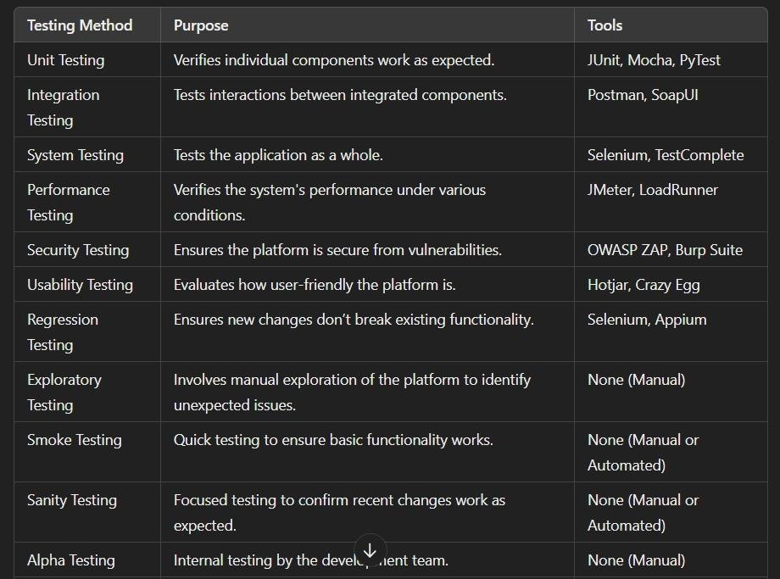

These testing methods will ensure that your farmer online selling platform is reliable, secure, and user-friendly before going live.

##### 4.3 Output ScreenShots

**i. Home page:**

This page is the website home page, where you can find the Features Products Farmers and Reviews Sections all about us section etc., more over we can go to shop now page from this, and where user can register and login from this page.

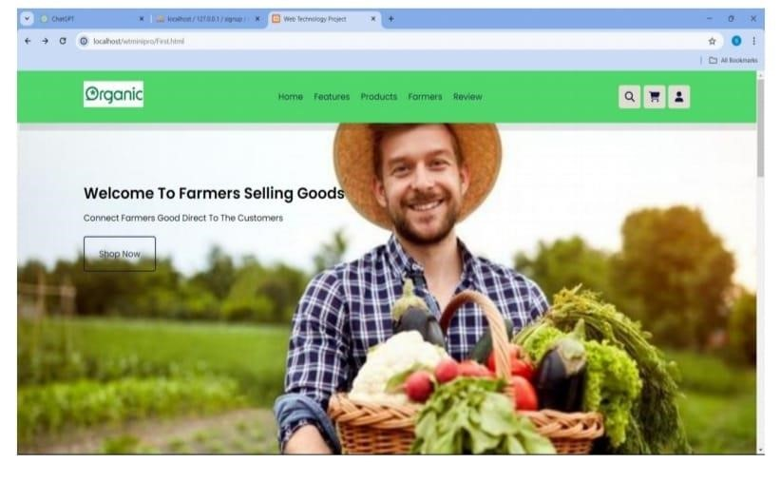

**ii.Features section:**

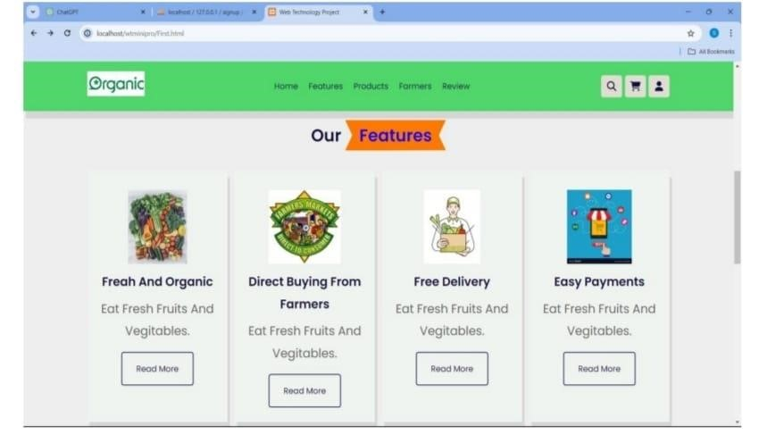

1. **Products section:**

This section provides products in this application.

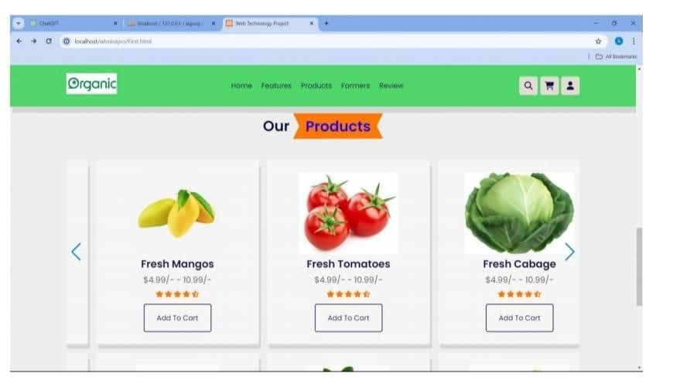

1. **Registration Page:**

In this page where user and farmers can register them self to this application for buying and selling the goods once registration successful it direct to login page.

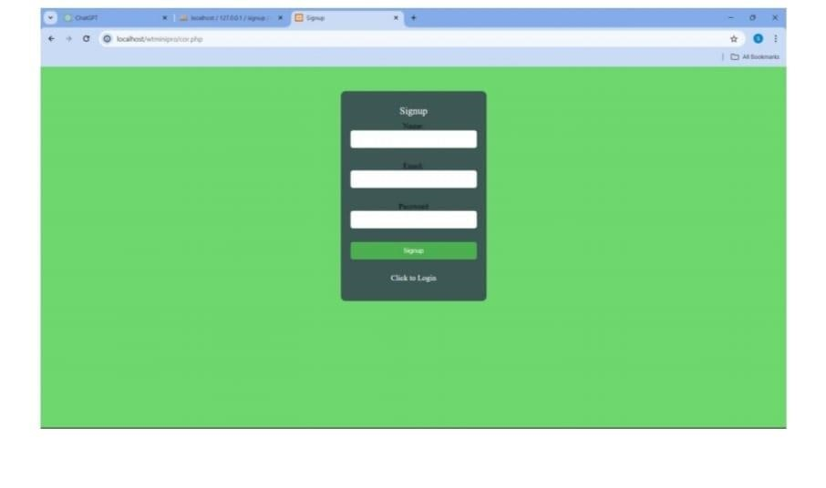

1. **Login page:**

This page is used for login purpose where after entering details it direct to main page .

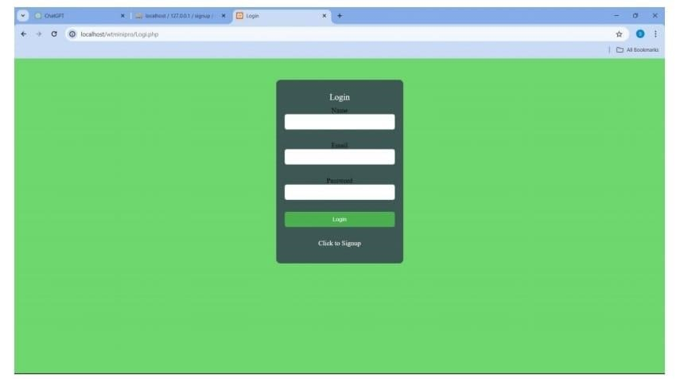

**Vi. Products List:**

In this page we can shop the vegetables and fruits after clicking on shop now button in main page it shows list of products in this page.

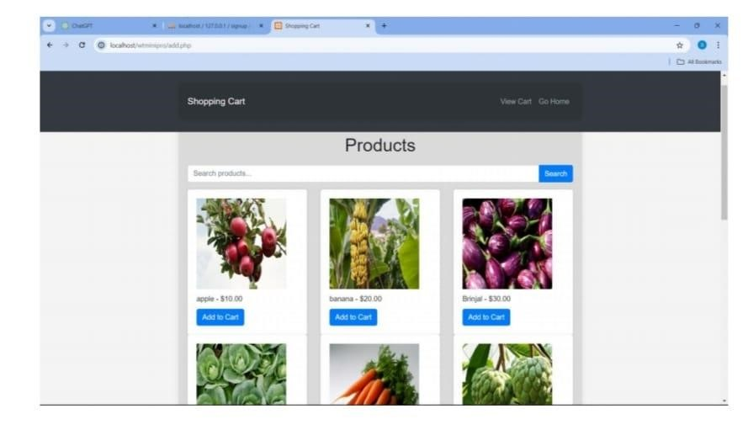

**Vii. Searching Item in Product list:**

In this page we can search the item what ever vegetables we want in search bar.

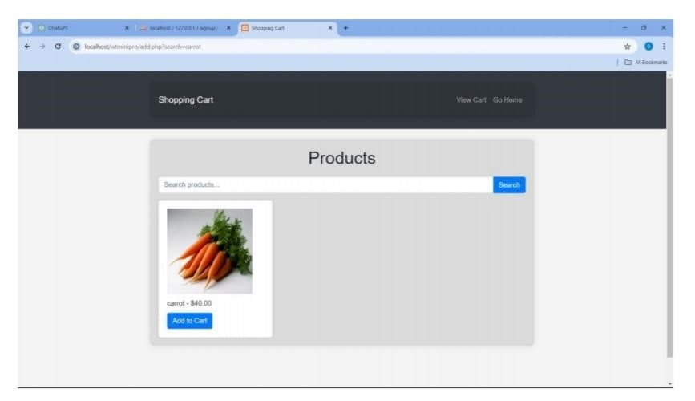

**Viii. Cart Page:**

In this page we can add products to carts and view them

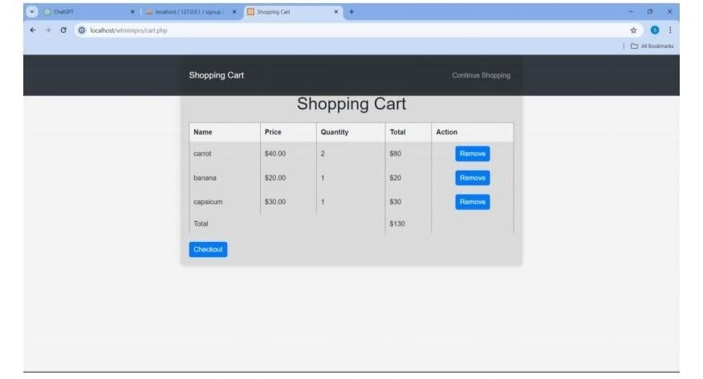

**Ix. Checkout Page:**

In this page we can calculate total amount of products that we added to cart and proceed to payment

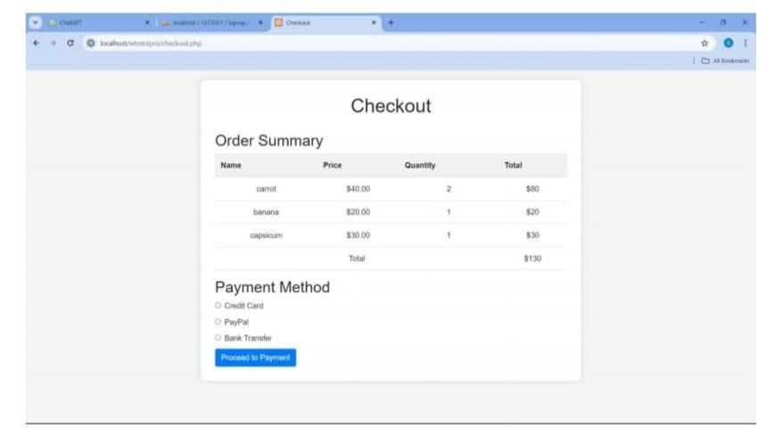

**X. Order Successful page**:

After successfully payment over the order confirmation page will shown like this

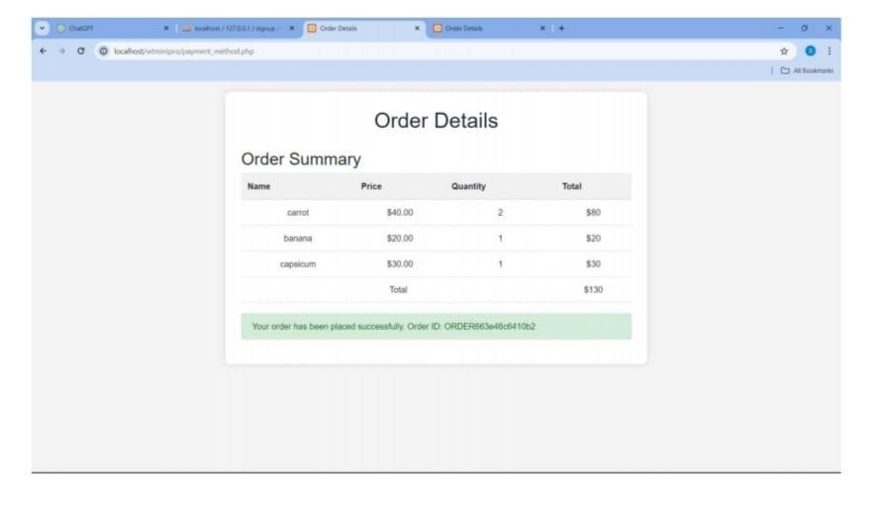

**Xi. Farmers Table:**

In this section where farmers details are shown.

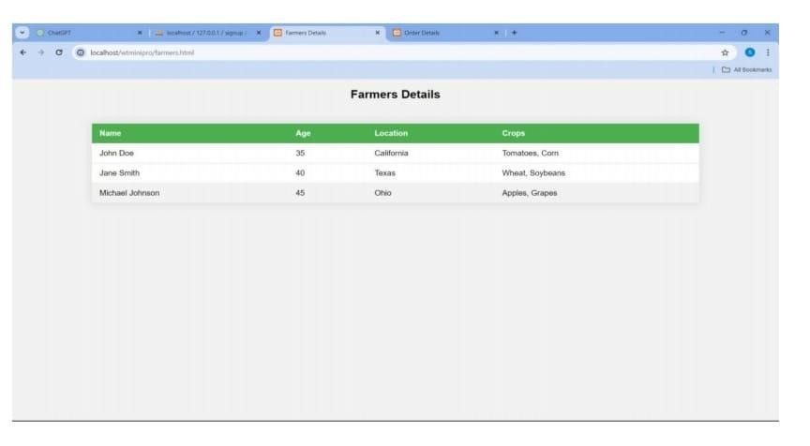

**Xii. About Us Page:**

1. In this page the details about this web site and how they are visiting farmers and how they are selling
2. from whom are explained detailed.

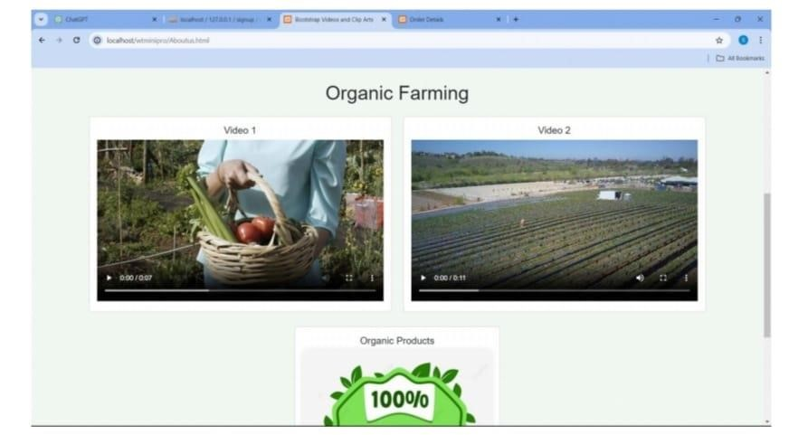

### 4.4 Analysis of Results

Analysis of Results refers to evaluating the outcomes of the various tests conducted during the software development process to determine if the system meets the required specifications and user expectations. In the context of a farmer online selling goods platform, this analysis will focus on interpreting the results from functional, non-functional, and security tests to identify areas of success and areas for improvement.

**Key Steps in Analyzing Test Results**

1. Test Result Categorization

* Passed Tests: Tests that meet the expected outcomes and indicate that the feature or functionality works as intended.
* Failed Tests: Tests that did not meet the expected outcomes and indicate issues that need to be addressed.
* Blocked Tests: Tests that could not be executed due to issues such as missing dependencies or environmental setup problems.
* Not Run Tests: Tests that were skipped or not executed due to time constraints or prioritization.

1. Identification of Critical Issues
   * High Severity: Critical failures such as payment gateway not working, users unable to register or log in, or cart and checkout issues. These must be resolved immediately before proceeding.
   * Medium Severity: Non-critical failures like minor UI glitches or incorrect data formatting that do not impact the core functionality but need fixing.
   * Low Severity: Cosmetic issues such as UI alignment problems that do not affect user experience or functionality.

-Impact Assessment: Analyzing how each failure affects the overall user experience. A failed payment integration test, for example, would have a significant impact on customer satisfaction.

1. Trend Analysis

* Test Coverage: Review the tests run and ensure all critical functionalities have been tested (e.g., user registration, product listing, payment processing, order history).

-Test Pass Rate: Calculate the percentage of tests passed. A high pass rate indicates the system is stable, while a low pass rate suggests major functionality issues.

* Repetitive Failures: If specific features repeatedly fail across different testing phases, this points to a deeper issue in those areas (e.g., payment processing failures or inconsistent inventory management).

4. Root Cause Analysis

-Defect Patterns: Grouping failed tests based on similar issues helps identify whether failures are isolated or systemic. For example, multiple failures in the payment module may indicate issues with integration or security.

-Development Process Review: Analyzing whether defects were caused by code issues, testing gaps, or misunderstandings of requirements.

- Tools and Environment Issues: Sometimes issues arise from incorrect test environments or tools. It’s important to ensure the tests were executed in the correct environment with the right configurations.

5. Impact on the Product

* User Experience (UX): Based on usability and exploratory testing results, identify if the platform is intuitive for users. For instance, if navigation and purchase flows are too complicated or confusing, adjustments are needed.
* Business Goals Alignment: Assess how the results of testing align with business goals such as conversion rates (from browsing to buying), customer retention, and satisfaction.

6. Prioritization of Fixes

* Critical Bugs: Address high-severity issues first, such as login failures, missing product listings, and payment issues.
* Performance Issues: If performance testing reveals slow load times during peak traffic, prioritize optimizing server capacity or front-end performance.
* User Interface Adjustments: If usability testing shows the design is difficult to navigate, focus on improving the UI for a smoother customer experience.

7. Documentation and Reporting

* Test Execution Report: Document the results of all test cases, including passed and failed tests. This report should also include a summary of issues identified, their severity, and suggested fixes.
* Defect Report: A detailed report of each defect, including steps to reproduce, screenshots, logs, and any related testing evidence.
* Test Coverage Report: A breakdown of which areas of the platform were tested and which were not, to ensure complete test coverage.

Example of Analyzing Results for the Farmer Online Selling Goods Platform

1. Functional Testing Results

-Test Case 1: User Registration

* Result: Passed
* Analysis: The user registration form is working correctly, and new users can successfully create accounts without issues.

* Test Case 2: Add Product to Cart
* Result: Failed
* Analysis: Adding a product to the cart fails when the customer tries to select quantity. This might be related to a front-end issue where the JavaScript is not updating the quantity correctly.

* Test Case 3: Payment Processing
* Result: Failed
* Analysis: The payment gateway returned an error. This is a high-severity issue that must be addressed immediately as it directly impacts customers' ability to complete purchases. Root cause analysis may point to an issue with the integration of the third-party payment service.

2. Performance Testing Results

* Test Case 4: Load Testing (Simulate 500 Concurrent Users)
* Result: Passed
* Analysis: The platform successfully handled 500 concurrent users without significant performance degradation. The server response time remained within acceptable limits (under 2 seconds).

* Test Case 5: Stress Testing (Simulate 1000 Concurrent Users)
* Result: Failed
* Analysis: The system failed under 1000 concurrent users, showing high response times and crashing after 800 concurrent users. This suggests the need for scaling the infrastructure or optimizing database queries.

3. Security Testing Results

* Test Case 6: SQL Injection Test
* Result: Passed
* Analysis: The platform was successfully protected against SQL injection attacks. All input fields (e.g., search bar, login) were sanitized, and invalid inputs were rejected. Conclusion from the Analysis

Based on the above analysis, the following conclusions can be made:

* High Priority:
* The checkout flow should be simplified based on user feedback to improve the user experience.
* Stress testing results indicate a need for better scalability to handle larger numbers of concurrent users.

* Medium Priority:
* Performance under stress testing needs to be improved, especially to handle peak traffic, suggesting infrastructure optimization.
* Minor UI improvements related to product filtering and cart UI are suggested.

By following this structured approach to analyzing test results, you ensure that you can identify the most critical issues, prioritize them appropriately, and plan for future improvements before the platform goes live.

**Conclusion**

##### 5.1 Summary of Findings

The Summary of Findings is a concise overview of the key issues and insights gathered during the testing phase of the farmer online selling goods platform . This summary highlights the critical and high-priority problems, areas for improvement, and successes based on the test results across various testing methods (functional, non-functional, performance, security, and usability).

**Summary of Findings for Farmer Online Selling Goods Platform 1. Critical Issues**

* **Payment Gateway Failure:**

During functional testing, the payment gateway integration failed, preventing users from completing their purchases. This is a high-severity issue that directly impacts revenue generation. Immediate attention is required to fix the integration and ensure seamless transaction processing.

* **Cart Functionality Issue:**

The functionality to add products to the cart failed when users attempted to select product quantities. This issue is high-severity because it disrupts the basic user experience of purchasing goods. Root cause analysis suggests a possible issue with the front-end JavaScript or API integration. Resolving this bug is a top priority.

* **Cross-Site Scripting (XSS) Vulnerability:**

The platform was found to be vulnerable to XSS attacks, particularly in user-generated content sections like product reviews. This is a *high-severity* security flaw, as it can lead to malicious code execution and data theft. Immediate sanitization and validation of user input are required.

**2. Performance and Scalability Issues - Stress Testing Results:**

During stress testing, the platform failed to handle 1000 concurrent users, leading to system slowdowns and crashes after 800 users. This suggests that the current infrastructure may not be able to handle large traffic spikes during peak times. *Scalability* improvements, such as database optimization or server load balancing, are needed to ensure that the platform can perform well under heavy traffic.

**- Load Testing Success:**

The platform successfully handled 500 concurrent users with no significant performance degradation. Response times remained under 2 seconds, which indicates that the system is capable of managing moderate traffic levels effectively. However, improvements are still needed for higher loads.

**3. Usability Concerns**

* **Checkout Flow Confusion:**

Users reported difficulty navigating the checkout process, particularly when selecting the payment method. This medium-priority issue impacts the user experience but does not prevent users from completing purchases. The user interface (UI) for the checkout page needs to be simplified, with clearer instructions and options for payment selection.

* **User Registration Process:**

The user registration process passed all usability tests, with no major issues reported. It was easy for users to navigate and complete the registration. This indicates that the onboarding experience for new customers is functioning well.

**4.Security Issues**

* **SQL Injection Protection:**

The platform successfully passed the SQL injection tests, indicating that user inputs are properly sanitized, and database queries are secure. This suggests that the platform has implemented good security practices to protect against data breaches and unauthorized access.

**5. Minor Cosmetic and Functional Improvements - UI Alignment Issues:**

Minor cosmetic issues were identified during testing, such as misaligned buttons and inconsistent spacing in product listings. While these issues don’t affect functionality, they can impact the aesthetic appeal of the platform and should be addressed to improve the overall user experience.

**- Product Filter and Search Functionality:**

Some users experienced issues when filtering products based on categories or search terms. The filter logic may need refinement to ensure more accurate and faster results. This is a medium-priority issue for improving usability.

**6. Test Coverage and Execution**

* **Comprehensive Test Coverage:**

The testing covered all major features, including user registration, product listing, cart functionality, checkout, payment processing, and security. However, some areas like advanced user preferences or mobile-specific issues may not have been fully tested and should be prioritized in subsequent testing cycles.

* **High Test Pass Rate:**

The majority of the test cases passed successfully, indicating that most of the platform’s functionality is working as expected. The test pass rate was above 85%, which is generally a positive sign for the platform’s stability.

**Conclusion and Next Steps**

1. Immediate Actions:

* Fix the payment gateway integration and cart functionality issues to ensure users can complete purchases smoothly.
* Address the XSS security vulnerability by implementing proper input sanitization and validation.

2. Performance Enhancements:

- Investigate infrastructure improvements to better handle higher loads (e.g., optimize database queries, add server scalability features).

3. Usability Enhancements:

* Simplify the checkout process for better user flow.
* Resolve UI alignment and filter issues to enhance the user experience.

4. Security and Compliance:

- Conduct further penetration testing to ensure no additional vulnerabilities are present, especially for sensitive data like user information and payment details.

5. Post-Launch Considerations:

- Plan for continuous testing and monitoring after the platform goes live to quickly address any user-reported issues or new vulnerabilities.

This summary provides a clear overview of the current state of the platform based on test results, highlighting critical issues that need immediate resolution and areas for improvement.

### 5.2 Future Enhancements

**Future Enhancements for the Farmer Online Selling Goods Platform**

As the farmer online selling goods platform continues to evolve, several enhancements can be implemented to improve its functionality, user experience, and scalability. Below is a list of future enhancements that can be prioritized based on feedback, testing results, and business goals.

**1. Performance and Scalability Improvements - Cloud Infrastructure Scaling**:

To ensure the platform can handle increased traffic during peak seasons (e.g., harvest season), implement cloud-based solutions such as auto-scaling and load balancing. This will allow for better resource allocation as user demand fluctuates, especially during high-volume shopping periods.

* **Database Optimization:**

As product listings and customer data grow, optimizing the database for faster query responses and reducing page load times is crucial. This could include implementing caching mechanisms, indexing strategies, and database sharding to manage data more efficiently.

* Performance Monitoring Tools:

Integrate performance monitoring and alerting tools (such as New Relic or Datadog) to continuously track system performance, identify bottlenecks, and proactively address issues before they affect users.

**2. User Experience (UX) Enhancements - Mobile Optimization:**

Given that many users will access the platform via smartphones, enhance the mobile responsiveness of the site. This includes optimizing the checkout process, product pages, and registration forms for mobile screens to ensure a seamless experience across all devices.

* **Personalized Recommendations:**

Implement AI-driven recommendation engines that suggest products based on users' browsing history, preferences, and purchasing behavior.

* User Profiles and Preferences:

Allow customers to create profiles where they can save preferred products, frequently used payment methods, and shipping addresses for faster checkout. Adding a *wish-list* feature will also enhance user convenience and satisfaction.

**3. Advanced Features for Vendors (Farmers) - Real-Time Inventory Management:**

Implement real-time inventory tracking for farmers to easily update their stock levels. This will help avoid stockouts and manage product availability efficiently, especially for timesensitive produce. Integration with warehouse management systems could help with this.

* **Sales Analytics for Farmers:**

Provide farmers with advanced analytics tools that give them insights into sales trends, customer behavior, and product performance. This data could help them make informed decisions about pricing, marketing, and stock replenishment.

* **Multi-Language Support**:

To expand the platform's reach, offer multi-language support, especially for farmers from different regions who may not speak the same language. This feature will improve accessibility and engagement for a wider audience.

**4. Payment and Transaction Features**

* **Support for Multiple Payment Methods:**

Expand the payment options to include digital wallets, cryptocurrency, and direct bank transfers. Offering diverse payment methods can cater to a broader user base, especially in regions with less traditional payment infrastructure.

* **Subscription and Membership Options:**

Implement subscription models that allow customers to receive regular deliveries of their favorite products (e.g., weekly or monthly boxes of fresh produce). Farmers could benefit from steady revenue streams while consumers enjoy the convenience of automated orders.

**5. Security and Privacy Enhancements - Two-Factor Authentication (2FA):**

Enhance the security of user accounts by implementing 2FA during login. This will add an extra layer of protection against unauthorized access, especially for sensitive accounts like farmers managing their products and finances.

**- Data Encryption and GDPR Compliance:**

To ensure the protection of customer and transaction data, continue to use end-to-end encryption and ensure the platform is GDPR-compliant (if operating in Europe) or compliant with relevant privacy laws in other regions. Regular audits and security patches should also be scheduled.

**6. Marketing and Customer Engagement - Loyalty Program:**

Implement a loyalty program where users earn points for purchases, referrals, and reviews, which can be redeemed for discounts or special offers. This will increase customer retention and encourage more frequent purchases.

* Social Media Integration:

Enable users to share their favorite products, discounts, and reviews directly on social media platforms. This can help boost brand visibility and attract new customers through word-ofmouth marketing.

* Email and SMS Notifications:

Develop a robust notification system to alert customers about *new product arrivals, special offers, and order updates via email and SMS. Personalizing these notifications based on customer behavior can significantly improve customer engagement.

**7. Sustainability and Ethical Sourcing - Sustainable Product Tagging:**

Introduce a system that allows farmers to tag products as organic,fair trade, or sustainably sourced. This feature will help attract environmentally conscious consumers and differentiate products in the marketplace.

- Carbon Footprint Tracking:

As part of the platform’s long-term sustainability goals, integrate a carbon footprint calculator for each product, showing the environmental impact of the goods being sold. This feature can appeal to environmentally aware customers and encourage greener practices in farming.

**8. Advanced Analytics and AI**

* **AI-Powered Fraud Detection:**

Implement AI algorithms that can detect fraudulent transactions by analyzing patterns in payment behavior, product returns, and user activities. This can help prevent fraud and secure transactions.

* **Predictive Analytics for Demand Forecasting:**

Use machine learning to forecast product demand based on factors such as seasonality, local trends, and historical sales data. This will help farmers plan their production and inventory more effectively, reducing waste and ensuring availability of high-demand products.

**9. Community Building and Social Impact - Farmer Community Forums:**

Create a space on the platform for farmers to connect, share advice, and exchange best practices. This community can help foster collaboration and knowledge sharing among producers, leading to better farming practices and improved products for consumers.

**- Donation Features:**

Implement features that allow customers to donate funds or purchase products that are donated to local communities or food banks, promoting social impact and supporting farmers in need.

**10. Continuous Testing and Improvement - A/B Testing for UX/UI:**

Regularly conduct A/B testing on key user interface elements (e.g., buttons, navigation menus, product displays) to optimize the user experience. Data-driven design changes will ensure the platform is always evolving based on real user feedback.

- Post-Launch User Feedback:

After the platform is live, encourage users to provide ongoing feedback via surveys, reviews, and direct communication channels. Use this data to continuously enhance the platform’s features and functionalities.

**Conclusion**

By implementing these future enhancements, the farmer online selling goods platform will become a more robust, user-friendly, and scalable solution that meets the evolving needs of both consumers and farmers. The focus on performance, security, user experience, and advanced features like AI and sustainability will not only improve the platform's competitive edge but also foster long-term growth and customer loyalty.

# References

[https://www.google.com/url?sa=t&source=web&rct=j&opi=89978449&url=https://www.rese archgate.net/publication/356217307_A_Study_on_Ecommerce_Agriculture&ved=2ahUKEw jhhpSEo9yJAxWPqFYBHdzMKfUQFnoECCEQAQ&usg=AOvVaw0Lj__wjUTIGrNIr25O q4Yy](https://www.google.com/url?sa=t&source=web&rct=j&opi=89978449&url=https://www.researchgate.net/publication/356217307_A_Study_on_Ecommerce_Agriculture&ved=2ahUKEwjhhpSEo9yJAxWPqFYBHdzMKfUQFnoECCEQAQ&usg=AOvVaw0Lj__wjUTIGrNIr25Oq4Yy) <https://www.pnrjournal.com/index.php/home/article/download/10155/14181><https://www.irjet.net/archives/V8/i4/IRJET-V8I4956.pdf><https://www.jetir.org/papers/JETIRFX06023.pdf>[https://ijaem.net/issue_dcp/E%20Commerce%20Portal%20for%20Selling%20the%20Agricu ltural%20Products%20Using%20Mobile%20Application.pdf](https://ijaem.net/issue_dcp/E%20Commerce%20Portal%20for%20Selling%20the%20Agricultural%20Products%20Using%20Mobile%20Application.pdf)