# Project Requirements

University of South Australia

UniSA STEM

IT Projects

**DECLARATION OF CONTRIBUTION**

**Project No:** 2022-SP2-33

The following is a declaration of your individual contributions towards this group assessment. If any contribution does not meet the assessment requirements, the course coordinator may adjust individual marks up or down, depending on the level of contribution made.

**Team Member 1**

Name: Fan Yinuo

I contributed 1000 words towards this assessment.

I worked on the following sections/questions (select whichever is appropriate).

* 1.3.1 Project Objectives and Success Criteria

**Team Member 2**

Name: Munyaradzi Magura

I contributed 1500 words towards this assessment.

I worked on the following sections/questions (select whichever is appropriate).

* 1.3.2 Constraints
* 1.3.3 Assumptions
* 1.3.4 Preliminary Scope Statement
* 1.4 RISKS
* 1.6 SUMMARY MILESTONE SCHEDULE
* 1.9.1 Project Manager Responsibilities
* 1.9.2 Project Management Plan

**Team Member 3**

Name: Minh Pham

I contributed 1700 words towards this assessment.

I worked on the following sections/questions (select whichever is appropriate).

* 1.5 Project Deliverables
* 1.7 Summary Budgets
* 1.8 Project Approval Requirements

**Team Member 4**

Name: Zackary Anderson

I contributed 1553 words towards this assessment.

I worked on the following sections/questions (select whichever is appropriate):

* 1.1 Project Description
* 1.2 Project Purpose/Justification
  + 1.2.1 Business Objectives
* 1.3 Requirements
* 1.4 Risks
* 2.0 Appendices

# ****Student Attendance System Requirements Document****

**Date:** 7/03/22

**Prepared by:**

2022-SP2-33

* Yinuo Fan ([fanyy041@mymail.unisa.edu.au](mailto:fanyy041@mymail.unisa.edu.au))
* Munyaradzi Magura ([magmy020@mymail.unisa.edu.au](mailto:magmy020@mymail.unisa.edu.au))
* Minh Pham ([phamq001@mymail.unisa.edu.au](mailto:phamq001@mymail.unisa.edu.au))
* Zackary Anderson ([andzy006@mymail.unisa.edu.au](mailto:andzy006@mymail.unisa.edu.au))

# ****Contents****

* Student Attendance System Requirements Document
* 1. BUSINESS REQUIREMENTS
  + 1.1 PROJECT DESCRIPTION
  + 1.2 PROJECT PURPOSE/JUSTIFICATION
    - 1.2.1 Business Objectives
  + 1.3 Requirements
    - 1.3.1 Project Objectives and Success Criteria
    - 1.3.2 Constraints
    - 1.3.3 Assumptions
    - 1.3.4 Preliminary Scope Statement
  + 1.4 RISKS
  + 1.5 PROJECT DELIVERABLES
  + 1.6 SUMMARY MILESTONE SCHEDULE
  + 1.7 SUMMARY BUDGET
  + 1.8 PROJECT APPROVAL REQUIREMENTS
  + 1.9 PROJECT MANAGEMENT
    - 1.9.1 Project Manager Responsibilities
    - 1.9.2 Project Management Plan
  + 1.10 AUTHORISATION
* 2. Appendices

# ****1. BUSINESS REQUIREMENTS****

## ****1.1 PROJECT DESCRIPTION****

The following project aims to deliver a student attendance system that will be used initially on the University of South Australia Mawson Lakes campus, with the potential to be expanded to other campuses. This system will be developed as a React Native application for both Android and iOS devices, with a QR component that will serve as the main form of interaction between the users and the system. From this QR code, students will be able to scan their generated code where the data embedded within the QR code will be collected and used to mark their attendance for classes. Teachers will also be provided the convenience of being able to view student information at any time.

QR codes have the characteristics of large information capacity, strong error correction ability, and low printing requirements, and are now widely used in various fields such as logistics, marketing, and food industry. The design for our QR code attendance system can generate QR codes randomly, allowing students to use their mobile phones to scan the QR code to collect the data in the attendance card. The multi-terminal collection of student attendance data is realized, and it is also convenient for teachers to check student information at any time. The student attendance system will consist of two parts, a React Native application on student devices and a terminal to scan the student QR codes. It will be possible to have multiple QR code terminal at the one time, and have them all connected to the attendance management system through the local area network. The system will not require a fixed office location. Staff will be able to log into the system and complete the task of attendance management anytime and anywhere. This flexibility allows student information to be viewed and exchanged in a timely and smooth manner.

Settlement on this solution came from an ongoing multiphase approach of conducting research into varying technologies, figuring out what possible solutions could be provided from each, and determining if whether that technology could adequately fulfil the requirements of the system. More information on this approach and the steps for the future development of the system is outlined in section **1.3.4 Project Preliminary Scope Statement**.

The overall goal of the system is to remove older manual forms of student attendance taking such as pen and paper and roll call, replacing it with a streamlined system for both students and lecturers to attend and manage classes.

## ****1.2 PROJECT PURPOSE/JUSTIFICATION****

Reasoning behind the project stems from needing to find a solution to current student attendance taking processes, due to being both time consuming and not providing an accurate reflection of student attendance. According to the client, one major driving factor for this system comes from wanting to accurately capture the attendance of students, as this information is valuable in gauging the quality of the course and filtering out false attendance from students who either:

* Manually mark off more students than just themselves for in person classes, or
* Attend online classes but do not actively participate or engage with the course content

Additional concerns raised by the client with recent attempts at taking student attendance comes from students being able to circumvent the system in various ways to falsely appear as having attended their classes. Such attendance taking processes for in person classes have been the projection of a link that students can access to mark their attendance when the class starts. Similarly, an implementation of QR codes has also been used but did not meet requirements.

This issue with attendance taking has not arisen due to the ongoing COVID-19 pandemic but has only been perpetuated through the addition of online classes, increasing the need for a more streamlined and less circumventable system.

### ****1.2.1 Business Objectives****

The following are the business objectives highlighted as being of the most importance to the project after taking into consideration the needs of the client organisation and the standards they aim to uphold.

**Accurately record the attendance of students, and maintain the university standards for the quality of course content**

The purpose of this business objective is to recognize that the main business objective to be achieved from the development of the system is to ultimately provide a solution to accurately recording the attendance of students across both in person and online classes. In tandem with this has been the point raised by the client to ensure that the university is providing quality content for the students and keeping them actively engaged.

The by-product of obtaining the accurate data of student attendance will allow university staff to observe the performance of students that are actively attending classes and determine if current teaching methods and content is effective. If performance of students that are actively engaging with course content and attending classes is low, it can then be investigated by university staff that the issue with student understanding may be in the approach to teaching course content.

Alternatively, if student performance is within or exceeding university staff expectations the data collected by the system can indicate that current teaching methods and content is effective. Ultimately, the university will have accurate data to base the restructuring and changing of teaching methods on.

**Provide a reliable and usable service for staff and students**

This business objective is focused on ensuring that when students and university staff arrive on campus, they are going to have the tools and services they require immediately available to them. For a system focused on student attendance, one of the major factors that contributes to its effectiveness comes down to whether it is reliable and ready to be used when needed.

**Safely and securely handle sensitive information relating to students and staff**

Due to the severe restrictions and rules surrounding the transmission, storing, and accessing of private information, another business objective highlighted has been to ensure that the relevant measures are taken to prevent the incorrect usage student and staff information by internal or external users. To ensure that this does not happen, the university ISTS team have been contacted (see figure A in appendices) for their recommendations on what needs be considered while developing the system to uphold the universities guidelines and standards for student and staff information.

**Continuously improve upon and adapt existing university processes to engage students**

Like the first business objective listed, the purpose of this objective is focused on the university as an organisation aiming to adapt and improve its current processes to improve the learning and teaching experiences of its students and teaches. This objective can be seen through the initiation of this current project to allow the university to deliver higher quality education by equipping staff and students with the necessary tools.

## ****1.3 Requirements****

**High Level Functional Requirements**

|  |  |  |
| --- | --- | --- |
| **Functional Requirement No.** | **Requirement** | **Category** |
| FR1 | Students should be able to scan their QR code to attend classes | Technical |
| FR2 | Lecturers must be able to view class attendance for a specific class | Technical |
| FR3 | Lecturers must be able to list the students in their class | Technical |
| FR4 | Students shall be able to view only their own details | Technical |
| FR5 | A unique QR code needs to be re-generated after set intervals | Technical |
| FR6 | The QR codes must be dynamic | Technical |

**High Level Non-Functional Requirements**

|  |  |  |
| --- | --- | --- |
| **Non-Functional Requirement No.** | **Requirement** | **Category** |
| NFR1 | The system must be highly available and reliable | Technical |
| NFR2 | Student information must be securely handled and stored | Technical |
| NFR3 | The application must be available across both iOS and Android devices | Technical |
| NFR4 | Expand the use of attendance system to other campuses after Mawson Lakes | Business |

### ****1.3.1 Project Objectives and Success Criteria****

The QR attendance system has two parts: attendance management center and QR code terminal attendance equipment. It can have multiple QR code terminal attendance devices at the same time, and then connect them to the attendance management center through the local area network. The QR code attendance management center system adopts the design of B/S structure. With the help of advanced technology and advantageous resources in the Internet era, the QR code attendance system can effectively manage the collected student information in a centralized manner, and can be distributed in a distributed manner. to control. Regardless of whether the students' office locations are gathered or scattered, and the office hours are fixed or random, after the strict authorization of the local area network, the attendance administrator only needs to carry out the daily centralized management of the attendance management center, and can manage the complicated student attendance management work. become amortizable. The attendance manager does not need a fixed office location, just by logging into the system, he can complete the duty of attendance management anytime and anywhere, so that the student information can be exchanged in a timely and smooth manner, and the query and statistics can be portable and accurate. Using this system can also make the previous complex attendance management work. Administrative work becomes easy and convenient.

**QR code attendance design**  
The QR code attendance management system applies advanced digital image processing technology and information coding technology, which can accurately and efficiently collect QR codes in various environments and process the uploaded data in real time. Teachers can set a fixed time period for attendance. Students can punch in by scanning the generated QR code. The attendance system will automatically collect the information of the students punched in. After correct verification, the data will be recorded at the same time and uploaded to the database of the management center synchronously in real time. , so that students' attendance is displayed more clearly and intuitively. The QR code attendance management system also needs to use an open Internet protocol, so that the attendance points in various places are not affected by the network and are always connected to the system terminal, which makes the QR code attendance of students very convenient. Improved the network congestion system crash caused by centralized punch-in.

**QR code format design**  
The QR code attendance management system uses a unified format of QR code for unified use in attendance. First, the formatted pre-coded information is converted into a data code word stream, and then displayed in the form of a QR code. For example, first select a piece of information to be compiled in the barcode from the student information database, and then generate a corresponding QR code data stream according to the uniformly set QR code format encoding, and finally the corresponding QR code image can be generated.

### ****1.3.2 Constraints****

Constraints are restrictions or limitations that the project manager must deal with pertaining to people, money, time, or equipment.  It is the project manager’s role to balance these constraints with available resources in order to ensure project success.

Project will most likely cost money to purchase the QR code scanner.

Limited and or restricted access to facilities

Limited and or restricted access to internal systems, which may help in development

Legal, laws, regulations, and agreements may restrict specific implementations of the project

The University and client may not want to take extensive risk in the development to the project i.e., allowing the project team to access sensitive data or giving an adsorbent amount of funds.

Project must be completed within the allocated time frame of 13 weeks

Each team member must work a minimum of 2-2.4 hours per day or roughly 10-12 hours per week.

Team members are not required, nor advised, to work on week-ends or public holidays

### ****1.3.3 Assumptions****

Resources:

·       Student/s will be available for testing of the student side application

·       Teaching staff will be available for testing of the teaching side application

·       A training/testing room will be made available at UNISA Mawson Lakes as needed

·       Resources and people will be available to be assigned to all tasks

·       Client will be available to attend demos

·       Online meetings will remain consistent for the duration of the project

·       COVID lock down may occur during the project

·       Team members will have access to the tools required to execute their respective tasks within the schedule, including and not limited to people in specific key areas of the university whom may need to be contacted as part of a task; However we acknowledge some tools and people may not be always available and may not be available for all team members at once.

·       Team members involved at the beginning of the project will remain through out the project until its conclusion; However it is worth noting there maybe an instance where a team member may drop the project.

Delivery:

·       Prebuilt software will arrive pre-configured

·       Correct number of QR code reader will be implemented as needed

Budget & Finances:

·       Currency conversions will remain levelled

·       Recourses will cost the same through out the project

·       Services with contractual billing rates will not fluctuate

·       Cost of materials will not increase by 3.5% per year

·       Total project budget will not exceed that offered by the university

Scope:

·       Project scope will remain consistent once the client signs the system requirements document

·       We will follow current regulatory practices, in legality and software standards

·       Milestones will be met

Schedule:

·       Materials (QR code scanners) will arrive on time

·       Vendors will be selected and orders places within a week of vendor selection

·       Facilities will be open on weekends to allow the team to work on the project if needed

·       All team members will complete their tasks in the allocated time

Methodology:

·       Agile

Technology:

Software

The team will use the following software, framework and packages to research implement the product solution.

·       JavaScript because react native is a JavaScript based mobile framework

·       React Native

·       Expo for React native

·       Packages

o   react-native-qrcode-scanner

o   react-native-svg

Hardware

·       Physical QR code scanner for lecture and tutorial rooms will be available upon full deployment of the software however a QR code scanner or equivalent temporary software alternative will be made available for testing purposes

·       All students have a mobile phone capable of reading QR codes

Architecture and design:

·       The solution will be written in react native for cross platform compatibility

·       The solution will RESTful API architecture

·       The solution will reside mostly on the cloud

·       The solution will utilise an established architectural pattern

·       The solution will implement modern device fingerprinting tactics

·       The solution will utilise current UNISA design practices to better integrate with UNISA software (i.e. colour scheme & layout)

Quality/specification:

·       Throughout the life cycle of the project the quality of equipment and materials is in good working condition.

·       Programming Libraries implemented within the project do not have any problems which will affect the direction of the project

·       Physical goods (QR scanners) are in the best preferable quality upon arrival

·       Team members possess good problem-solving skills to promptly adapt to and resolve problems within the project

### ****1.3.4 Preliminary Scope Statement****

The preliminary scope statement is a general paragraph which highlights what the project will include, any high-level resource or requirement descriptions, and what will constitute completion of the project.  This preliminary scope statement is exactly that: preliminary.  All of this information will be expanded upon in greater detail as the project moves forward and undergoes progressive elaboration.

This ICT project as of semester one will include, researching, designing and paper prototyping of a Student Attendance System which will be implemented throughout UNISA campus. The project Team will manage all personal, software and hardware resources. Research of potential solutions will be split into three key phases; Phase one is the research of four or more independent technology solutions.  Phase two, will be deciding which technology will best meet the clients requirements and the final phase will be researching the feasibility of implementation this technology and differing ways the chosen technology could be implemented after which each phase will require a report to be written by the project team.

Funding of the project will be managed by the Academic Supervisor, client and other UNISA staff based on research and prototyping developed by the project team. It is worth noting, funding is very limited and additional funding if needed may be difficult to access.

This Project will conclude when one: A solution is decided on by the project team, two: An implementation report is written about this solution, three: Paper prototypes are developed; within the allocated time frame of thirteen weeks used by study period two of the UNISA calendar.

As the project progresses more information which related to implementation and deployment will be researched and added as needed by the project team.

## ****1.4 RISKS****

The risks that have been highlighted as being relevant to the project are the following:

|  |  |  |
| --- | --- | --- |
| **Risk No.** | **Risk Name** | **Risk Description** |
| R1 | COVID-19 | On going effects of pandemic could prevent the completion of the project, or affect the level of quality of the project due to reduced face to face interaction with project stakeholders and project members |
| R2 | Integration Risk | Integration with the developed system and existing university architecture could potentially cause issues and prevent effectiveness of the system |
| R3 | Service Outage | An outage of the developed system or any required university systems can cause downtime for testing/development |
| R4 | Scope Creep | The initial requirements made by the project team could expand throughout the duration of the project as hidden aspects or requirements are discovered |
| R5 | Communication Risk | Communication channels could potentially break down, reducing the effectiveness of developing the system |
| R6 | Force Majeure | Potential that an individual that is part of the project team is not able to fulfil their duties (i.e. drop IT Project 1 course) |
| R7 | Quality Risk | The overall quality of the system fails to meet the expectations of the project team and client |
| R8 | Project Assumptions | Initial project assumptions do not take take into consideration all aspects of the project, leaving the possibility for issues to arise in the future |
| R9 | Benefit Shortfall | The end benefits provided by the system do not meet what was initially proposed at the beginning of the project |
| R10 | Legal Risk | Aspects of the project such as data privacy will be subject to the adherence to privacy laws. There is a potential risk that these laws may be infringed upon |
| R11 | Schedule Risk | Scheduling conflicts between project members could hinder or prevent the development of key milestones |
| R12 | Change Resistance | As the project progresses, required changes specified by the project team or client could arise. Depending on the change required, there is the possibility that it will not be feasible due to current project direction and development of the system |
| R13 | Project Complexity | Initial complexity of the project could expand over time, as the requirements of the system are more realised when development begins |
| R14 | Skills Risk | Success of the project could be affected by the level of skill demonstrated by project members |
| R15 | Time Risk | Time constraints can arise when initial development time windows are exceeded due to the underestimation of time required to complete a task. This can also be affected due to unforeseen external events |
| R16 | Project Cancellation | Unforeseen circumstances either directly relating to the project or circumstances relating to the organisation could cause termination of the project |

**Risk Matrix**

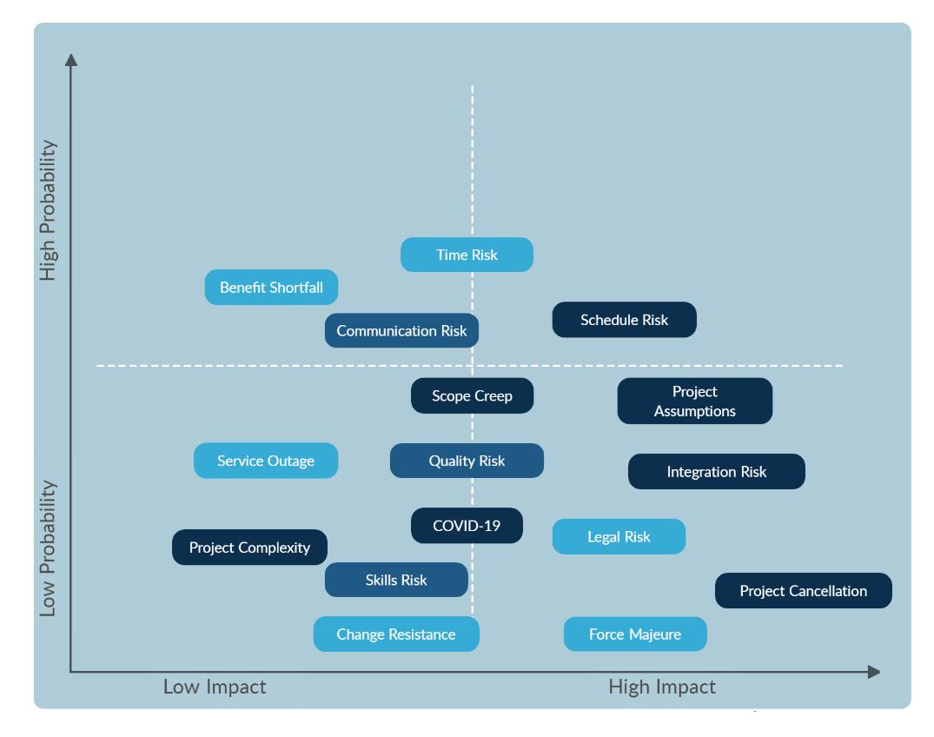

## ****1.5 PROJECT DELIVERABLES****

1. **System design:** The project of attendance system will be based on the technology of QR code, and it is aimed to design a workflow that reduces the possibility that students impersonate others to sign in to class. The QR code will be static for every student, and the system is aimed to collect the fingerprint of each student's device to solve the problem of impersonation.
2. **User Interface/UI:** There are two types of interfaces for the attendance system. The first interface will be running on the PC/Mac devices, and this interface will be used by academic staff members to run the application of class attendance with a QR reader or camera. The second interface is based on a mobile application where students sign in with their UniSA credentials to get their personal QR Codes. The academic staff members will be able to access all the student profiles on their interface. On the other hand, the student only can view their personal profile and not the others.
3. **System prototype:** The prototype of the attendance system will contain 3 pieces of hardware which are: a laptop representing a classroom computer, a QR Code Reader/Camera connecting to the laptop, and an IOS phone representing a student’s mobile device. The development team will create customised software that generates and authenticate the QR code and integrates it with all these hardware devices.
4. **Desktop Application:** The development team is aimed to make the software run on the Windows OS, and Mac OS platforms due to the commonality of the computer within the lecture, tutorial, practical and workshop rooms. The software will require access permission from the Academic Staff level and is not available for anyone to use or modify the contents. The only computer designed for Academic Staff member to use within the room have this software and is not available on other computers.
5. **Mobile Application:** The original plan for this project is to create a QR Code generator as a function within the UniSA App from the university. However, the university’s application required an extensive security factor and proper system architect that students are not yet capable of working on top of those existing foundations. Therefore, the development team planned to create a separate mobile application that has some similar aspects of database schema from the university and use it for the student mobile application prototype.
6. **Risk Monitoring and Backup Solution:** The biggest risk that the attendance system is facing that the risk of students taking a screenshot of their personal QR and sharing it with other people. The development team and system designer are trying to solve this problem via the dynamic QR code; however, the team is currently in the phase of design of the direction of dynamic QR code. In the case of hardware errors risk, the developer planned to design a backup system that allows the academic staff member to manually perform taking roll on their interface. In the case of the worst risk, the DoS application, the developer planned to mitigate the Attendance System to the current system that UniSA has been running for class attendance.
7. **Frontend development:** Multiple syntaxes will be used for the frontend development due to the different types of interfaces of each user. The development team are currently waiting for the response from the UniSA cyber-security team and DevOp team and getting more specifications of what language has been used to develop the current UniSA internal system. From there, the development team can pick up the syntax and develop the software with this language. By that means, it will take less time to integrate the new system with an existed system and do not have to convert from one syntax to another syntax. With the mobile application, the development team decided to develop the interface by using Native React.js and this syntax allows the developer to render the source code on multiple mobile OS rather than stick to IOS only.
8. **Backend development:** The backend of the attendance system are still in progress of delay due to the same reason with frontend development. However, the attendance system backend aims to collect data for classes, students and create a new data schema for student attendance records. For the QR authenticating function, the development team is deciding whether it should be frontend or backend located but it should be clearer where it is going to be in the next few weeks of the planning. With the backend of mobile applications, Node.js and Nest.js are two of the options that the development team aims to integrate with Native React. Node.js and Nest.js are very supportive for the SQL server or cloud server, and it has a very dynamic library that easily integrates with other syntaxes.
9. **Product testing and penetrating testing:** The software and mobile application will be tested before performing a final demo in front of the client. Manual testing and penetrating testing are the two types of tests that are going to be applied throughout the development stage. Manual testing is a general test that reflects on the requirement of the customers in terms of functionality, interface, integration and finding bugs. The type of testing will be performed by the QA from the development team and the QA will verify outcomes of the project match with the acceptance criteria from the client. With the penetrating testing, the QA will be responsible to perform a few simple tests that list on the top 10 OWASP. However, the development team and QA will not be guaranteed that the software is 100% secure after the penetrating test because none of the team members is professionally certified for penetrating testing.
10. **User Training:** This is a process of training the academic staff members in using the system when they have a class session with students. Parallelly, the students will be shown how to use their application on their phone to sign in to the attendance system as the new method of “taking roll”.

## ****1.6 SUMMARY MILESTONE SCHEDULE****

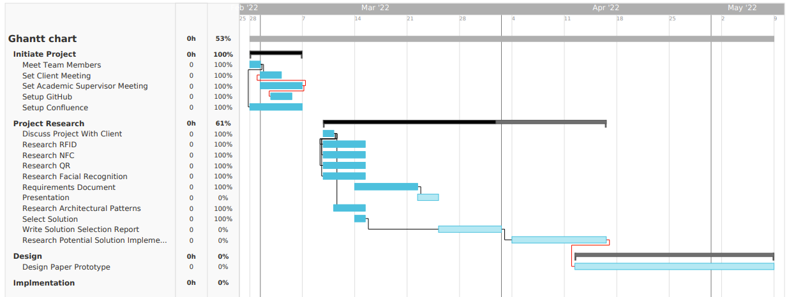

## ****1.7 SUMMARY BUDGET****

|  |  |  |  |  |  |  |  |  |  |  |
| --- | --- | --- | --- | --- | --- | --- | --- | --- | --- | --- |
| **Project Budget** | | | | | | | | | | |
| **Summary Cost of the Project** | | | **Amount (in AUD$)** | |  | **Details of the Project** | | |  | |
| Total budgeted Cost during the period | | | 100 | |  | **Name of the Company** | | | University of South Australia | |
| Total Actual Cost during the period | | | 67.60 | |  | **Project Name or ID** | | | 2022-SP2-33 | |
| Total Variance during the period | | | + 32.40 | |  | **Project Lead** | | | David Harris | |
|  | | |  | |  | **Start Date** | | | 28/02/2022 | |
|  |  | | | | | | | | | |
| **S.No.** | **Particulars** | **Material** | | **Labour** | | **Fixed Cost** | **Miscellaneous Cost** | **Budgeted Amount (in AUD$)** | **Actual Amount (in AUD$)** | **Variance (in AUD$)** |
| **Units** | **Cost per Unit** | **Hours** | **Cost per Hour** |
|  | **Task 1 - Building Prototype** |  |  |  |  |  |  |  |  |  |
| 1 | [QR Code Scanner](https://www.alibaba.com/pla/MINJCODE-Wireless-2D-3-in-1-High-Quality_1600338646300.html?mark=google_shopping&biz=pla&searchText=Scanners&product_id=1600338646300&pcy=AU&src=sem_ggl&from=sem_ggl&cmpgn=15507598789&adgrp=130399874349&fditm=&tgt=pla-1545918019116&locintrst=&locphyscl=9070851&mtchtyp=&ntwrk=u&device=c&dvcmdl=&creative=568030162520&plcmnt=&plcmntcat=&p1=&p2=&aceid=&position=&localKeyword=&pla_prdid=1600338646300_uplift&pla_country=AU&pla_lang=en&gclid=CjwKCAjwlcaRBhBYEiwAK341jT1PXBq9hqBCcZIhMeh_8RTNJLexSB5tvjF2pDRV97S4XBHRXKvh-RoCiRAQAvD_BwE) | 1 | $67.60 | 0 | 0 | $67.60 | 0 |  |  |  |
| 2 | Laptop/Computer | 1 | 0 | 0 | 0 | 0 | 0 |  |  |  |
| 3 | Mobile | 1 | 0 | 0 | 0 | 0 | 0 |  |  |  |
| 4 | Server | 1 | 0 | 0 | 0 | 0 | 0 |  |  |  |
| 5 | Syntax Library | N/A | N/A | N/A | N/A | N/A | N/A |  |  |  |
| (A) | Total Task 1 |  |  |  |  |  |  | 100 | 67.60 | +32.40 |
|  |  |  |  |  |  |  |  |  |  |  |
| (B) | Total of Project (A) |  |  |  |  |  |  | 100 | 67.60 | +32.40 |

## ****1.8 PROJECT APPROVAL REQUIREMENTS****

The Attendance System’s project is currently running the methodology of Scrum Agile, and the whole methodology is serving “Getting the work done” rather than completing everything by the end of a certain date like a Prince2 methodology. Instead of getting final approval for high-level requirements, the development team is interacting with the client to find the definition of acceptance criteria and promising to cover those aspects by the end of the certain Sprint. The client will have an opportunity to discuss changing the requirement or adjusting little elements during the sprint reviews. The development team will take input from the clients and allow them to decide which tasks, bugs, user stories or update requirements to be prioritised in the Jira backlog. However, the development team cannot promise to empty the backlog by the end of the project period. Although, the Scrum Master and project owner (Academic Supervisor) will make sure the workload and the number of tasks are equally and fairly distributed to each individual in each sprint in order to meet the expectation of ICT Project 1 requirements. Besides the high-level approval, many several low-level approvals have a solid structure that can help the client to identify how it has been approved. Here is the low-level approval:

**Sprint Success:** The product owner will be responsible to decide whether the last sprint has been successful or failed. This type of approval is not something where the team has to pause and fix the problem until it is successful. By that means, this type of approval notifies the Scrum Master for the next sprint need to explain the user stories and requirements more carefully so the development team can have a better estimation of the task story points. Here are some reasons that can cause Sprint to be successful or failed:

**Success**

* The percentage of completed tasks must be higher than 75% of tasks that have been promised to be done (Reflecting with Sprint Goal).
* The number of story points must meet the expectation of the number of working hours from ICT Project 1 for 2 weeks (1 sprint = 2 weeks).

**Failed**

* The percentage of completed tasks is lower than 75% of tasks that have been promised to be done (Reflecting with Sprint Goal).
* The remaining story point is over 10% of the commitment story point.
* The number of story points is lower than the expectation of the number of working hours from ICT Project 1 for 2 weeks (1 sprint = 2 weeks).

**Verify the requirement for the User Stories and get approval from the clients:** Business analysts and product owners will be responsible to create user stories on Jira and designing the requirement for each user story. However, the product owner does not represented on the behalf of the customer, the business analyst will be in charge of having a meeting with the clients and getting approval for each user story’s requirement. The business analyst has to make sure that these user stories need to be approved by the clients before allowing the Scrum Master to move the story into the current sprint.

**User Story mark as “Done”:** There are several processes of checking whether the sub-task has been completed in order for the Scrum Master to mark the user story as Done. Here are the processes:

1. Create a frontend code
2. Create a backend code
3. Integrate the frontend and backend.
4. Code review and running the JUnit Test. (The lead developer will responsible for this sub-task)
5. Check if the user story meets the acceptance criteria. (The lead developer will responsible for this sub-task)
6. Verify the requirements and test the user story as a whole application (QA will responsible for this sub-task)
7. [Optional] Create a bug that associates with this user story if they have one (QA or lead developer will do this sub-task)
8. Perform a Demo to Product Owner (Doing as a team)

## ****1.9 PROJECT MANAGEMENT****

This section explicitly states who is assigned as the PM, their responsibility, and authority level.  Depending on the organization and scope of the project, the project manager may have varying levels of responsibility and authority for personnel, project expenditures, and scheduling.  Highlight all the responsibilities of the project manager.  In the 2nd section indicate how the manager will undertake these responsibilities and ensure the project remains on track and staff remain on task.

### ****1.9.1 Project Manager Responsibilities****

A strong project manager must effectively set stringent, flexible, and clear goals which play to the strengths of each and every member of the project team; They must focus on the long term vision for the project. The Project manager must trust in the team to complete their assigned tasks—not doing so and instead, managing the team may result in diminished team moral and productivity; Periodic check-ins and goal setting with strongly maintained and enforced open lines of communications should instead be employed. Initiate collaborative communication between the Client and Stakeholders should be recorded for future reference. The project managers will be selected on a weekly or fortnightly basis; When a new manager is inaugurated a ‘honeymoon’ period is established during which the new manager should establish authority and if needed introduce changes.

### ****1.9.2 Project Management Plan****

Project Managers must effectively set stringent, flexible, and clear goals. This can be accomplished by following the four R’s; Reaction, Resilience, Recovery, and recognise new reality. The former (Reaction) refers to ensuring clarity about the roles and responsibility of the project team and stake holders and addressing imminent challenges. Resilience, refers to adapting sustainable delivery and research models plus restoring and maintaining disrupted initiatives. Recovery, refers to the project aligning with new and establish business models. Recognise, refers to creating flexible scenarios and strategic options which will deliver long-term project growth.

The project manager must focus on the long-term vision for the project, which means they must have a high level understanding of the trajectory of the project including the final state of the project, using this information they should be able to create stones to the project end.

The project manager must trust in the team to complete their assigned tasks. Ensuring strong team moral should be of high concern to the project manager hence giving team members some autonomy over their work is ideal with minimal over site. The project manager should task allocate and record dead lines then check up at the end of each week where the team is and why they are there.

In order to initiate collaborative communication between the team and stakeholders the project manager must first, obtain a list of times key team members are available (its best there is at least three on different days) after which this list should then be sent the stakeholders, where they can select the best time. After time selection is complete the Project manager must create a zoom link and or book a venue at the selected time for the meeting to commence; Finally the Project manager must create and send out a calendar invite to all involved parties.

The project manager will be selected by in the current order, Minh Pham, Zackary Anderson, Munyaradzi Magura & Fan Yinuo, after whom Mr. Pham will take the mantel. As Project managers transfer, we give the new manager a few days to get their head around the whole project and where everyone is currently situated; To do this the previous project manager will either give the new project manager a progress report this will be transferred either through a written report or verbal communication.

## ****1.10 AUTHORISATION****

This section provides the names and authorization, once signed, for the project to move forward in accordance with the information contained in this charter.

Approved by the Project Sponsor:________________________        Date:                   /      /

Project Sponsor Name: ___________________________

Project Sponsor Title:    ___________________________

# ****2. Appendices****

Fig A:

