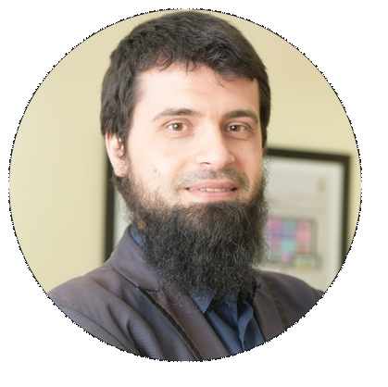

Name: Afrim Trelak
E-mail (Personal): afrimafo@gmail.com
E-mail (Work): Afrim.Trelak@govcio.com
Phone: 0550766265
Nationality: British
D.O.B: 14/02/1988

EDUCATION:

Degree: BSc Honours in Economics, Politics and Public Policy - Goldsmiths University of London. (2008 – 2011)

CELTA: Cambridge ESOL Level 5* Certificate in Teaching English to Speakers of Other Languages (2013)

A-level Studies (UK): History, Politics and Psychology. (2005 - 2007)

Secondary Education: Preston Manor High School (2000 - 2005)

Employment & Experience:
Current: GovCIO (RSNF) July 2022 - Using DLI curriculum to conduct English Language Training (ELT) for members of the Royal Saudi Naval Forces (Jubail, Eastern Province).
(Military)
KBR (NGSS) September 2019 – May 2022 General English (Headway) and ESP (Telecommunications) language instructor. Classes are comprised of 8 or 12 students who are members of the Saudi Arabian National Guard (sergeants/privates). Created and implemented learning management systems activities (Edmodo/Oxford Learn) on a weekly basis and managed exam data. Directly involved in creating a bespoke technical coursebook (ESP) consisting of 40 units covering telecommunications, electrical, and networking terms in simple and graded English.

(Military)
International Aviation Technical College at Riyadh: September 2017 – January 2018:
Worked as an EFL instructor (35 contact hours a week) at a technical college in Riyadh (IATC), operated by Aviation Australia. I had 6 contact hours on a daily basis. Classes were comprised of students aged between 18 – 25 and students were mostly taught General English and ESP (English Unlimited).
KSU CFY (February 2018 – July 2019): Rejoined CFY (previously known as KSU PY) as an ESL instructor and Assessment Coordinator. Taught Medical English to pre-intermediate students (English for Medicine) and Academic English (Q: Skills for Success) to intermediate/advanced students.
Responsibilities also included: exam piloting, item writing, organizing exam events, marking events, teacher training, database management, auditing data and ensuring overall standardization is met by teachers. In many cases I also lead the above operations.

KSU PY (SBC) October 2016 – August 2017: I continued contributing to the PY programme at King Saud University as an ESL instructor and partly as an item writer. Since joining the programme in 2012, I have had the pleasure of teaching many classes that consisted of different levels each semester. I also greatly benefited from my managerial role at KSU and positively contributed towards the success and standardization (quality assurance) of our English programme.

KSU PY (Education Experts) March 2013 – June 2016: Worked as a Lead Teacher in the department of assessment at King Saud University, KSA. We dealt with exam logistics, item writing, exam pilots, training teachers for exam and assessment operations, management of student databases, database auditing, grade inquiries, quality control, KPIs etc. I also had a supervisory role for other members in our department and saw to their queries on a daily basis. I have not hesitated to share ideas and suggestions within our department – which have consequently made some of our operations much more efficient and less arduous.

KSU PY (Education Experts) September 2012 – March 2013: Worked as an English Instructor. I was responsible for teaching General English (Headway, Oxford) to numerous classes throughout the Academic year. This included students of different levels and abilities, from beginner levels to intermediate.

Education Experts (EDEX Co.): April 2012 – July 2012
Assigned the role of Coordinator and English Instructor for a private project with the Ministry of Interior (Saudi Arabia) inside the EDEX headquarters. Besides gaining invaluable experience from teaching Saudi learners on a daily basis, I was part of the team that was involved in creating a fresh syllabus for the project. I also supported the programme by writing appropriate exams and weekly quizzes. Teaching and assessment was carried out by myself and three other colleagues.
Personal Profile:
I am self-organised, a quick learner, and I strive to complete tasks efficiently. I enjoy working both as an individual and within a team. I look forward to challenges that allow me to be innovative and add to my skills portfolio. I am a strong supporter of a positive work environment: one that holds communication, efficiency and work ethic in high regard.
My career in education began in 2012 and since then I have gained priceless experience over the years. As an ESL Instructor, I have worked with students of varying age groups, abilities and backgrounds. I have successfully adapted my teaching to the standards of every institute I worked for, following their expectations and curriculum framework. I have taught Medical, Academic and General English. As a Lead Teacher in KSU, our thorough auditing procedures stimulated me to keep an eye on details that are both big and small. I gained the confidence to think critically about operations/processes that can otherwise be improved upon.
As an Assessment Coordinator I have played an important role in organizing vast exam operations (consisting of thousands of students and hundreds of teachers). I have also given training and presentations to management bodies and teachers on numerous assessment-related operations. This has had a positive impact on a competency I highly esteem: effective communication.
References available upon request

