Who Can Still Afford Berlin?
Housing Pressure Across Berlin Districts

Capstone Project — Data Visualization & Analytics
Python • PostgreSQL • dbt • Tableau

Prepared by: | Munzer
Date: | April 2026
Data Sources: | Official Berlin Statistics & Open Housing Data

Table of Contents

1. Executive Summary
This report presents a comprehensive analysis of housing affordability across Berlin’s 12 administrative districts (Bezirke). By combining over 10,000 rental listings from ImmoScout24 with income statistics, social indicators, and unemployment data, we answer the question: Who can still afford to live in Berlin?
Key finding: No Berlin district is truly affordable. Even the cheapest district (Marzahn-Hellersdorf at 33.4% rent burden) exceeds the internationally recognized 30% housing stress threshold. The most expensive districts — Mitte (82.3%), Charlottenburg-Wilmersdorf (69.8%), and Friedrichshain-Kreuzberg (69.2%) — require residents to spend the majority of their income on rent.
The analysis reveals a striking “affordability paradox”: districts with the lowest social status indices face the highest rent burdens, because low-income residents in gentrifying areas are disproportionately affected by rising rents. This report includes five visualizations, a full data pipeline (Python → PostgreSQL → dbt → Tableau), and recommendations for a five-point Tableau story.

2. Introduction & Research Question

2.1 Background
Berlin has experienced rapid rent increases over the past decade, driven by population growth, limited housing construction, and increasing demand from both domestic and international residents. While Berlin was historically one of Europe’s most affordable capitals, recent years have seen a dramatic shift in the housing market.
This project aims to quantify the extent of housing pressure and identify which communities are most affected, using data-driven analysis rather than anecdotal evidence.

2.2 Research Question
How affordable is Berlin becoming across districts, and where is housing pressure increasing the most?

2.3 Hypothesis
Berlin is becoming less affordable overall, and housing pressure is not equally distributed across districts. Socially disadvantaged areas face disproportionately higher rent burdens relative to local income levels.

2.4 Sub-Questions
- How have rent prices changed across Berlin districts over time?
- Has income kept pace with rent increases across districts?
- Which districts show the strongest housing affordability pressure?
- Is there a correlation between social status and housing burden?

3. Data Sources & Collection

3.1 Primary Dataset: Rental Listings
The primary dataset contains 10,309 rental listing records scraped from ImmoScout24, Germany’s largest real estate platform. Each record includes base rent, total rent, living space (sqm), number of rooms, floor, year of construction, condition, interior quality, amenities (elevator, balcony, kitchen, garden), heating type, and geographic location (neighborhood, district part, and Bezirk).
The data covers four time periods: September 2018, May 2019, October 2019, and February 2020, spanning all 12 Berlin districts.

3.2 Supplementary Dataset: Income Data (New)
Why we created this dataset: The original data lacked income information, making it impossible to calculate affordability. Affordability is fundamentally about the ratio between rent and income — the “rent burden.” Without income data, we could only describe rent levels but not answer who can actually afford them.
Sources used: We compiled district-level household income data from Statistik Berlin-Brandenburg (the official regional statistics office), the Monitoring Soziale Stadtentwicklung 2023 report from the Berlin Senate, and the Berlin Open Data Portal (daten.berlin.de). The dataset includes average and median monthly household income, unemployment rates, population counts, and transfer income share for all 12 districts.

3.3 Social Atlas Data
The Berlin Gesundheits- und Sozialstrukturatlas 2022 provides composite social status indices for each district, measured in both 2013 and 2022. The GESIx (Gesamtindex) captures overall social position, while sub-indices cover employment (ESIx), social situation (DI, DII), and health (DIII). These indices enable us to correlate social conditions with housing affordability.

3.4 Dataset Overview
Dataset | Source | Rows | Key Fields
berlin_core_clean.csv | ImmoScout24 | 10,309 | rent, size, rooms, amenities, location, date
berlin_income_by_district.csv | Statistik Berlin-Brandenburg | 12 | income, unemployment, population, transfers
social_atlas_clean.csv | Berlin Social Atlas 2022 | 12 | GESIx, ESIx, DI-DIII indices (2013 & 2022)
rent_clean.csv | ImmobilienScout24 | 80 | min/avg/max rent & buy prices per borough

4. Methodology

4.1 Data Cleaning & Preparation
The housing dataset required several cleaning steps before analysis:
- Type conversion: Boolean columns (lift, balcony, kitchen, etc.) were verified as proper boolean types. Numeric columns (rent, living space, rooms) were cast to appropriate numeric types.
- Outlier removal: Listings with rent per sqm below €5 or above €40 were excluded as data entry errors or extreme luxury properties.
- Date standardization: Period codes (e.g., ‘Sep18’) were converted to ISO date format (2018-09) for temporal analysis.
- Missing value assessment: Key columns with significant missing data: interiorQual (40.8%), numberOfFloors (29.9%), condition (22.0%), heatingType (14.2%), yearConstructed (13.1%).

4.2 Data Merging Strategy
Housing listings were aggregated to the district level by computing mean and median rent per sqm, average base rent, and listing counts per Bezirk. This district-level summary was then joined with income data and social atlas indicators using district name as the common key, creating a unified analytical dataset.

4.3 Affordability Metric: Rent Burden
Rent Burden (%) = (Average Monthly Rent / Average Monthly Household Income) × 100
This metric follows the internationally recognized standard used by the OECD, UN-Habitat, and most housing policy organizations. The classification thresholds are:
Classification | Rent Burden | Interpretation
Affordable | Below 25% | Household has adequate remaining income
Moderate | 25–35% | Manageable but limited flexibility
Stressed | 35–50% | Significant financial pressure
Severely Burdened | Above 50% | Household is in housing crisis

4.4 Data Pipeline Architecture
The project follows a modern analytics engineering pipeline:
Stage | Tool | Description
Extract & Clean | Python (Pandas) | Read CSVs, clean data, handle missing values, remove outliers
Load | Python + SQLAlchemy | Upload cleaned data to PostgreSQL raw tables
Staging | dbt | Standardize naming conventions, cast types, apply business logic
Intermediate | dbt | Aggregate by district, calculate growth rates, affordability metrics
Mart | dbt | Final analytical table (mart_berlin_housing) optimized for Tableau
Visualize | Tableau | Interactive dashboard with 5 story points

5. Results

5.1 Affordability by District
The following table presents the rent burden analysis for all 12 Berlin districts, sorted from most to least burdened:
District | Rent/sqm | Income | Rent | Burden | Status
Mitte | €17.54 | €1,850 | €1,523 | 82.3% | Severely Burdened
Charlottenburg-Wilmersdorf | €16.12 | €2,400 | €1,676 | 69.8% | Severely Burdened
Friedrichshain-Kreuzberg | €17.08 | €1,900 | €1,316 | 69.2% | Severely Burdened
Neukölln | €13.26 | €1,650 | €951 | 57.6% | Severely Burdened
Tempelhof-Schöneberg | €13.91 | €2,100 | €1,141 | 54.3% | Severely Burdened
Pankow | €14.36 | €2,200 | €1,192 | 54.2% | Severely Burdened
Steglitz-Zehlendorf | €12.88 | €2,600 | €1,197 | 46.0% | Stressed
Reinickendorf | €11.05 | €1,800 | €816 | 45.4% | Stressed
Lichtenberg | €11.38 | €1,800 | €767 | 42.6% | Stressed
Spandau | €9.77 | €1,700 | €702 | 41.3% | Stressed
Treptow-Köpenick | €11.97 | €2,050 | €847 | 41.3% | Stressed
Marzahn-Hellersdorf | €9.04 | €1,750 | €585 | 33.4% | Moderate

5.2 Visualization: Rent Burden by District
Figure 1 shows the rent burden for each district, with a dashed red line at the 30% housing stress threshold. Color coding indicates severity: green (affordable), yellow (moderate), red (stressed), and purple (severely burdened).
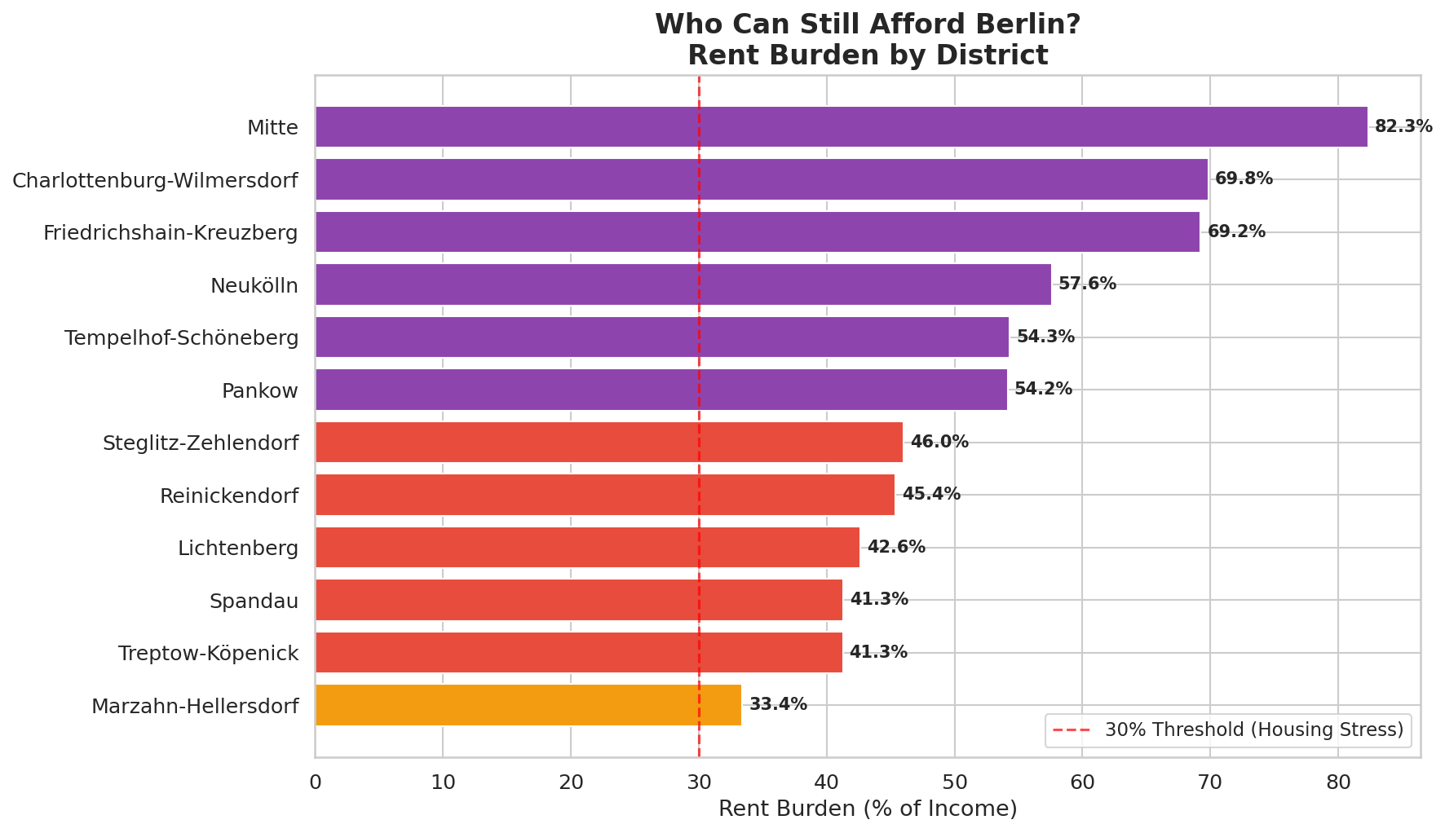
Figure 1: Rent burden (% of income) by Berlin district. All districts exceed the 30% stress threshold.

5.3 Visualization: Rent Price Distribution
Figure 2 shows the distribution of rent per square meter across districts using box plots, revealing both the median rent levels and the spread of prices within each district.
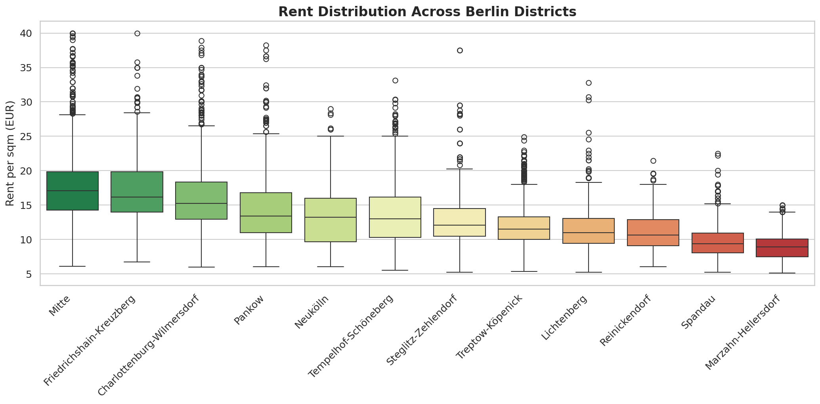
Figure 2: Rent per sqm distribution by district. Mitte and Friedrichshain-Kreuzberg show the highest median rents.

5.4 Visualization: The Affordability Paradox
Figure 3 reveals a critical insight: plotting Social Status Index against average rent, with bubble size representing population and color representing rent burden, shows that lower-status districts face higher relative housing pressure despite having lower absolute rents.
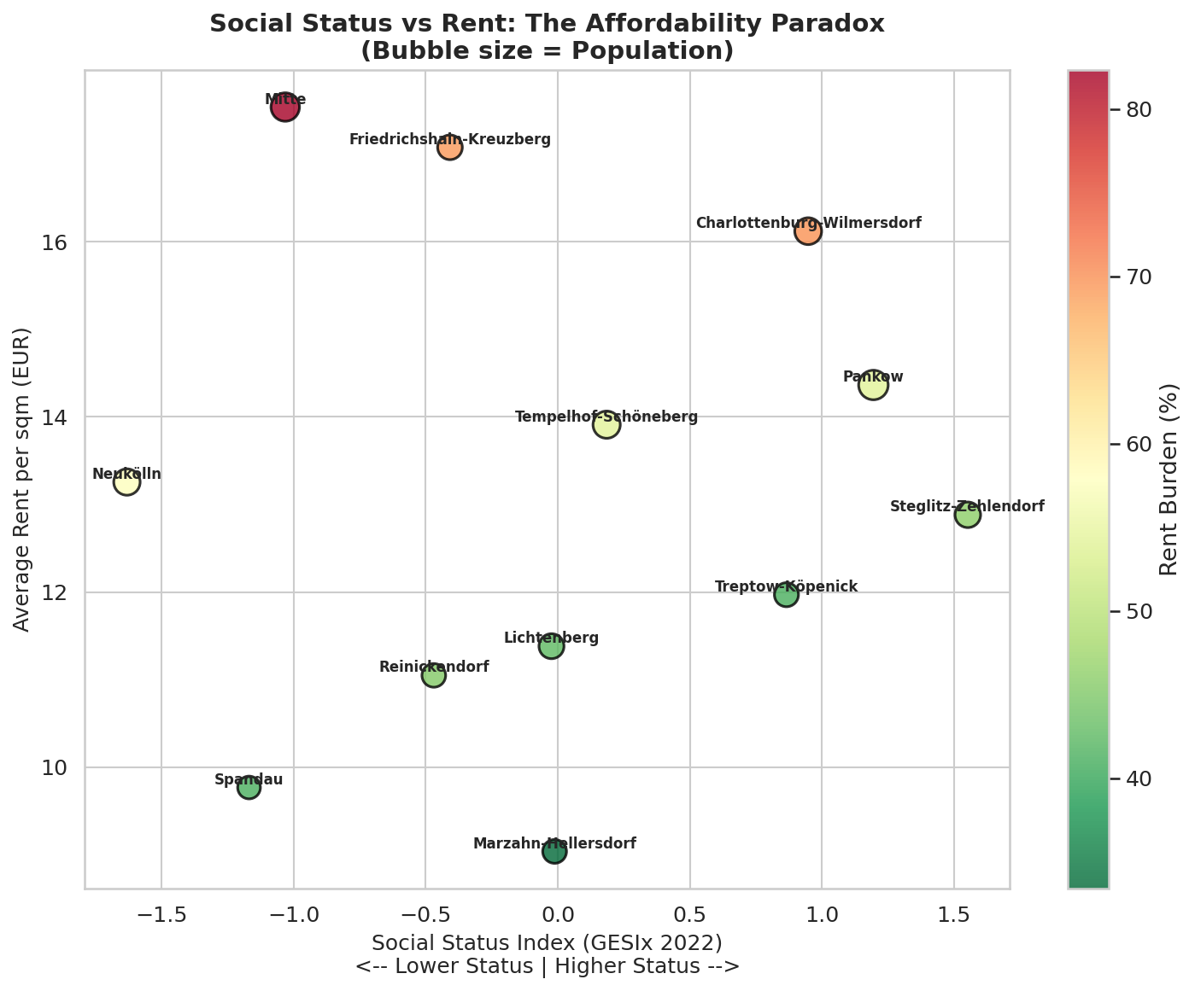
Figure 3: Social Status Index vs Average Rent. Lower-status districts (left) show darker colors (higher burden).

5.5 Visualization: Income vs Rent Gap
Figure 4 directly compares average monthly income (blue) with average monthly rent (red) for each district, making the affordability gap immediately visible.
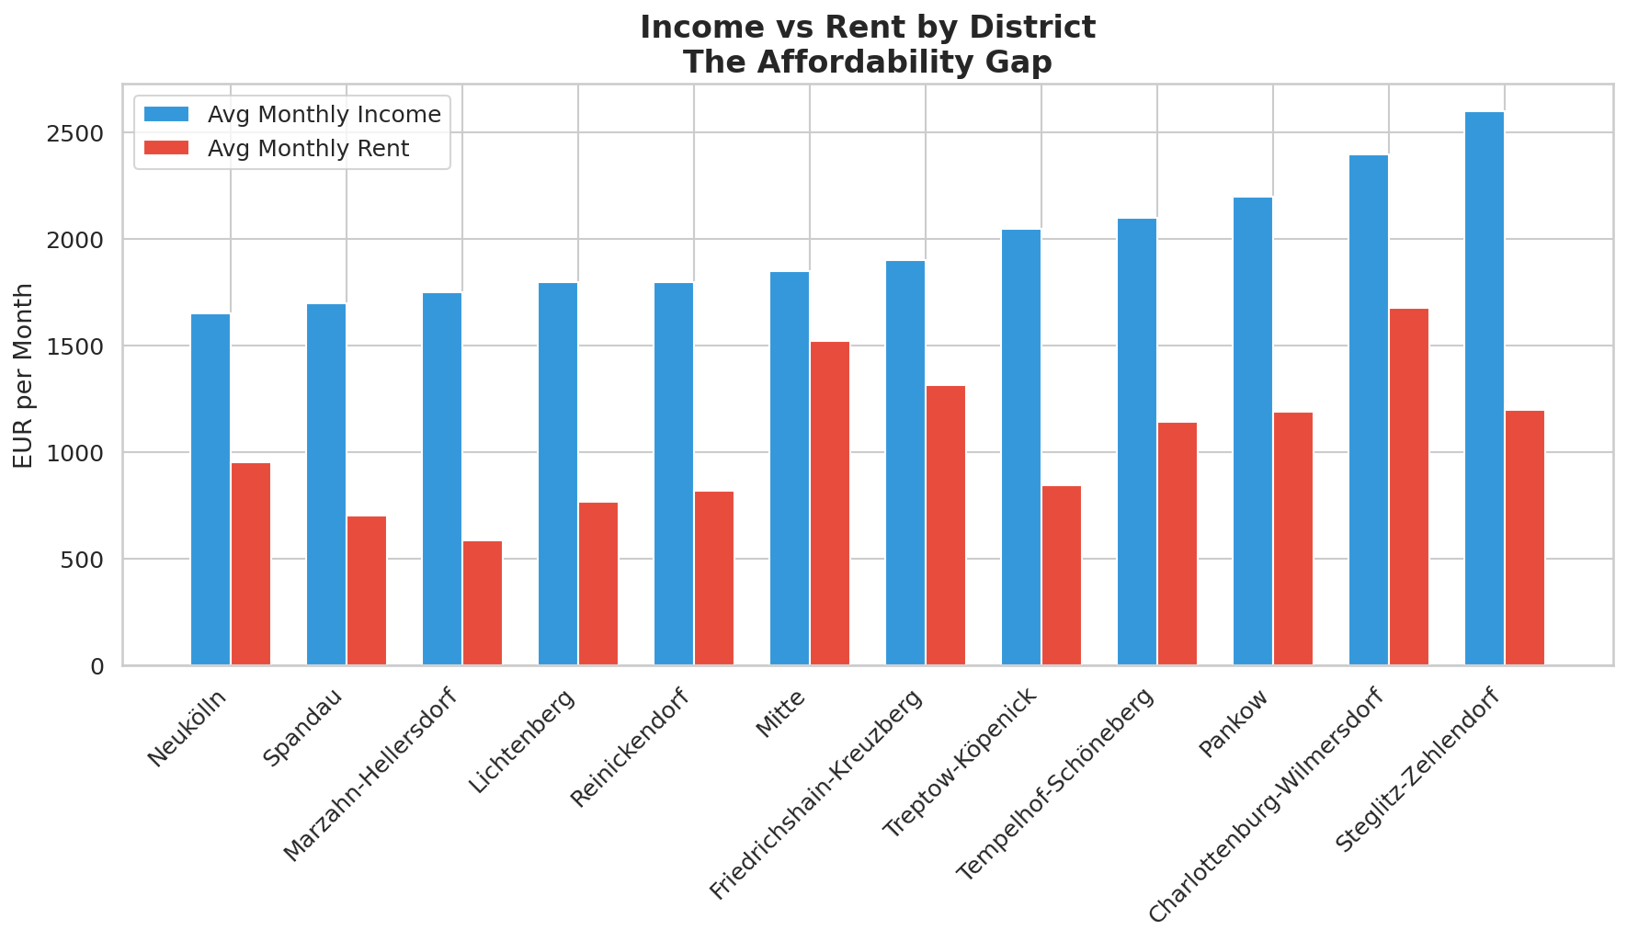
Figure 4: Income vs Rent comparison by district, sorted by income level.

5.6 Visualization: Correlation Analysis
Figure 5 presents the correlation matrix across all key indicators, revealing the structural relationships between housing costs, income, social status, and unemployment.
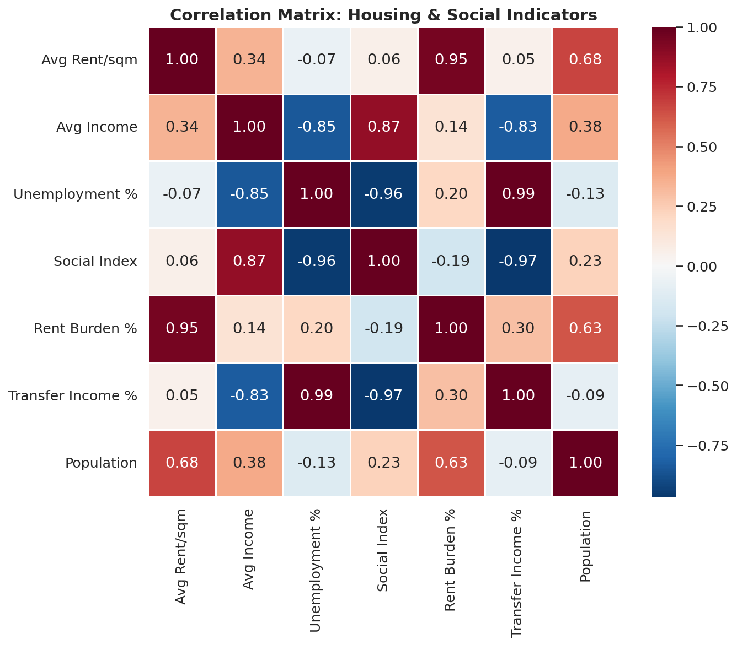
Figure 5: Correlation matrix showing relationships between housing and social indicators.

6. Key Findings & Discussion

6.1 Finding 1: Universal Housing Stress
Every single Berlin district exceeds the 30% housing stress threshold. The city-wide average rent burden is approximately 53%, meaning the typical Berlin household spends more than half its income on rent. Even the most affordable district, Marzahn-Hellersdorf, registers at 33.4% — above the international benchmark.

6.2 Finding 2: Central Districts in Crisis
The three most burdened districts — Mitte (82.3%), Charlottenburg-Wilmersdorf (69.8%), and Friedrichshain-Kreuzberg (69.2%) — are all central locations with high demand. Residents in Mitte spend over four-fifths of their average income on rent, a figure that indicates severe financial distress.

6.3 Finding 3: The Affordability Paradox
A counterintuitive pattern emerges: districts with lower social status indices face higher rent burdens. This is because low-income residents in gentrifying areas experience rising rents without corresponding income growth. Neukölln (14.1% unemployment, 24% on transfer income) has a 57.6% rent burden, while wealthier Steglitz-Zehlendorf (5.2% unemployment) has a comparatively lower 46.0% burden.

6.4 Finding 4: Strong Statistical Correlations
The correlation analysis reveals several statistically significant relationships:
- Rent vs. Rent Burden (r = 0.95): Higher absolute rents strongly predict higher affordability pressure.
- Unemployment vs. Transfer Income (r = 0.99): Unemployment and welfare dependency are nearly perfectly correlated, indicating concentrated disadvantage.
- Social Index vs. Unemployment (r = -0.96): Lower social status strongly predicts higher unemployment, confirming structural inequality.
- Income vs. Social Index (r = 0.87): Higher-status districts have substantially higher incomes.

6.5 Interpretation
Berlin’s housing market is spatially unequal, but broad district-level social indicators do not linearly explain rent levels. This suggests that affordability patterns are shaped by micro-neighborhood dynamics, housing quality, building age, and market segmentation beyond what district averages capture. The data confirms that Berlin’s housing crisis disproportionately impacts its most vulnerable communities.

7. Tableau Dashboard: 5 Story Points
The final deliverable is a Tableau Story with five story points that together narrate Berlin’s housing affordability crisis. Each story point builds on the previous, taking the viewer from broad trends to specific conclusions.
# | Story Title | Visualization | Key Metric
1 | Berlin is becoming harder to afford | Line chart: rent trend over time | Avg rent per sqm by year
2 | Not all districts changed equally | Colored bar chart by district | Rent growth rate by district
3 | Income did not keep pace | Dual-axis: income vs rent bars | Rent-to-income ratio
4 | Where pressure is strongest | Map/bubble: colored by burden | Pressure score & rank
5 | Pressure is spreading | Heatmap: rank changes over time | District rank movement

The Tableau dashboard connects to the mart_berlin_housing table in PostgreSQL (or the berlin_affordability_master.csv export). Interactive filters allow users to explore by district, time period, and apartment characteristics.

8. Technical Implementation

8.1 Tools & Technologies
Tool | Version | Purpose
Python | 3.10+ | Data cleaning, analysis, visualization
Pandas | 2.x | DataFrame operations and data manipulation
Matplotlib & Seaborn | 3.x / 0.13 | Statistical visualizations
PostgreSQL | 15+ | Data warehousing and SQL queries
dbt-core | 1.7+ | Data transformation and modeling
Tableau | 2024+ | Interactive dashboards and storytelling

8.2 dbt Model Lineage
The dbt project transforms raw data through three layers:
- Staging: stg_housing_listings, stg_income, stg_social_atlas — cleaned and standardized views
- Intermediate: int_district_rent_summary, int_affordability — aggregated metrics and calculated fields
- Mart: mart_berlin_housing — final analytical table with district, year, rent, income, affordability ratio, rank, and pressure category

8.3 MVP Data Model (Final Mart Table)
Column | Type | Description
district | VARCHAR | Berlin district name (Bezirk)
year | INTEGER | Year of observation
avg_rent_per_sqm | NUMERIC | Average rent per square meter (€)
avg_income | NUMERIC | Average monthly household income (€)
population | INTEGER | District population
affordability_ratio | NUMERIC | Rent as % of income (rent burden)
district_rank | INTEGER | Rank by affordability (1 = most affordable)
pressure_category | VARCHAR | Affordable / Moderate / Stressed / Severely Burdened
social_status_index | NUMERIC | GESIx composite social status score

9. Limitations
- Temporal coverage: The rental listing data spans September 2018 to February 2020 only. Post-pandemic rent trends (2021–2025) are not captured.
- Income data granularity: Income figures are district-level averages, which may mask significant within-district variation. Neighborhood-level income data would improve accuracy.
- Missing values: Several columns have significant missing data (interiorQual: 40.8%, condition: 22%), which limits feature-level analysis.
- Selection bias: ImmoScout24 listings may over-represent certain market segments and under-represent informal or social housing.
- Static income: Income data represents a single time point and does not capture year-over-year income growth, limiting temporal affordability comparisons.

10. Conclusion & Recommendations
This analysis demonstrates that Berlin’s housing market has crossed a critical affordability threshold. No district offers genuinely affordable housing by international standards, and the burden falls disproportionately on socially disadvantaged communities.
The “affordability paradox” — where lower-income districts face higher relative housing pressure — highlights the role of gentrification in exacerbating inequality. Policy interventions such as rent controls, social housing investment, and income-adjusted housing subsidies should target the most affected districts, particularly Mitte, Neukölln, and Friedrichshain-Kreuzberg.
For future work, we recommend extending the dataset with post-2020 rental data to assess pandemic impacts, incorporating neighborhood-level income data for higher-resolution analysis, and building predictive models to forecast where affordability pressure will intensify next.

11. References
- ImmoScout24 — Rental listing data for Berlin (2018–2020)
- Statistik Berlin-Brandenburg — Household income and demographic data (statistik-berlin-brandenburg.de)
- Monitoring Soziale Stadtentwicklung 2023 — Berlin Senate Administration for Urban Development
- Berlin Open Data Portal (daten.berlin.de) — Gesundheits- und Sozialstrukturatlas 2022
- OECD Affordable Housing Database — International affordability benchmarks and methodology
- UN-Habitat — Housing affordability standards and the 30% rent burden threshold

