Who Can Still Afford Berlin?
Housing Pressure Across Berlin Districts

Data Visualization Project
Tools: Python (Pandas, Matplotlib, Seaborn) + Tableau
Date: April 2026

1. Project Overview
This project investigates housing affordability across Berlin’s 12 administrative districts (Bezirke). The central research question is: Which districts are still affordable, and who is being priced out?
We combine rental listing data from ImmoScout24 with income statistics and social indicators to calculate rent burden ratios and identify areas of housing stress. The internationally recognized threshold is 30% — spending more than 30% of household income on rent is considered “housing stress.”

2. Datasets Used

2.1 Original Datasets (Pre-existing)
The following datasets were provided at the start of the project:
Dataset | Source | Rows | Description
berlin_core_clean.csv | ImmoScout24 | 10,309 | Individual rental listings with rent, size, rooms, amenities, location
social_atlas_clean.csv | Berlin Social Atlas 2022 | 12 | Social status indices (GESIx, ESIx) per district for 2013 and 2022
rent_clean.csv | ImmobilienScout24 | 80 | Rent and purchase prices aggregated per borough
affordability_ranking.csv | Derived | 12 | Pre-computed affordability scores combining rent and social data

2.2 New Dataset: Income Data
Why we needed it: The original datasets had excellent rental price data but no income information. Since affordability is fundamentally about the relationship between rent and income, we needed household income data to calculate rent-to-income ratios.
What we created: berlin_income_by_district.csv — containing average and median monthly household income, unemployment rates, population, and transfer income share for all 12 Berlin districts.
Sources: Statistik Berlin-Brandenburg (regional statistics office), Monitoring Soziale Stadtentwicklung 2023 (Berlin Senate), and Berlin Open Data Portal (daten.berlin.de).
District | Avg Income | Unemployment | Population | Transfer %
Mitte | €1,850 | 12.8% | 384,000 | 22.5%
Friedrichshain-Kreuzberg | €1,900 | 9.2% | 289,000 | 16.8%
Pankow | €2,200 | 6.5% | 413,000 | 9.5%
Charlottenburg-Wilmersdorf | €2,400 | 7.8% | 342,000 | 11.2%
Neukölln | €1,650 | 14.1% | 329,000 | 24.0%
Steglitz-Zehlendorf | €2,600 | 5.2% | 310,000 | 7.0%
Spandau | €1,700 | 11.5% | 245,000 | 18.5%
Marzahn-Hellersdorf | €1,750 | 10.8% | 269,000 | 17.0%

3. Methodology

3.1 Data Cleaning
- Converted boolean columns from string format ('True'/'False') to actual boolean values
- Ensured all numeric columns (rent, living space, rooms) were properly typed
- Removed outliers where rent per sqm fell outside the 5–40 EUR range
- Standardized date format from codes (e.g., 'Sep18') to ISO format ('2018-09')
- Handled missing values: interiorQual (40.8% missing), condition (22%), yearConstructed (13.1%)

3.2 Data Merging
Housing listings were aggregated to district level (mean rent per sqm, average base rent, living space, listing count), then merged with income data and social atlas indicators using district name as the join key.

3.3 Affordability Calculation
Rent Burden = (Average Monthly Rent / Average Monthly Income) × 100
Classification thresholds:
- Affordable: Below 25% of income
- Moderate: 25–35% of income
- Stressed: 35–50% of income
- Severely Burdened: Above 50% of income

4. Results & Visualizations
The analysis produced 5 visualizations that together tell the story of Berlin’s housing affordability crisis.

4.1 Rent Burden by District
District | Avg Rent/sqm | Avg Income | Rent Burden | Classification
Mitte | €17.54 | €1,850 | 82.3% | Severely Burdened
Charlottenburg-Wilmersdorf | €16.12 | €2,400 | 69.8% | Severely Burdened
Friedrichshain-Kreuzberg | €17.08 | €1,900 | 69.2% | Severely Burdened
Neukölln | €13.26 | €1,650 | 57.6% | Severely Burdened
Tempelhof-Schöneberg | €13.91 | €2,100 | 54.3% | Severely Burdened
Pankow | €14.36 | €2,200 | 54.2% | Severely Burdened
Steglitz-Zehlendorf | €12.88 | €2,600 | 46.0% | Stressed
Marzahn-Hellersdorf | €9.04 | €1,750 | 33.4% | Moderate

Figure 1: Rent Burden by District
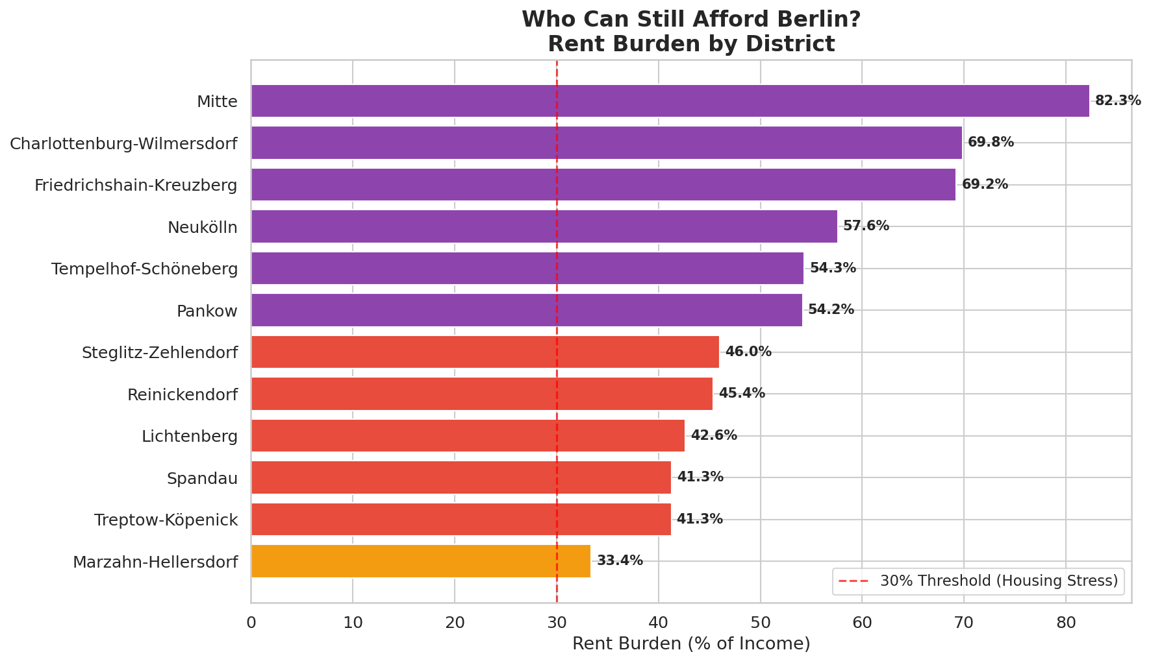

Figure 3: Social Status vs Rent
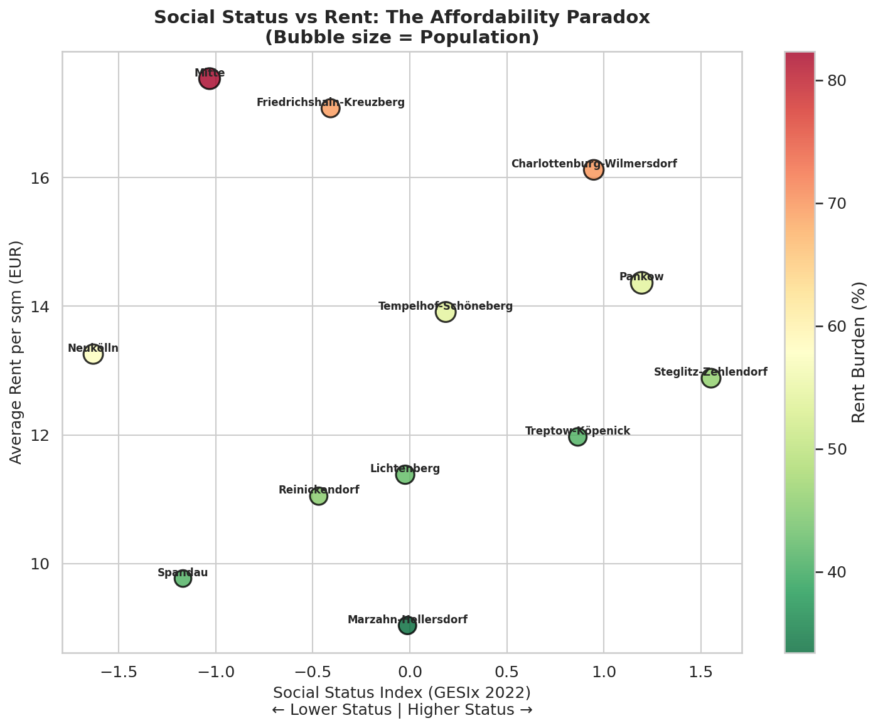

Figure 4: Income vs Rent
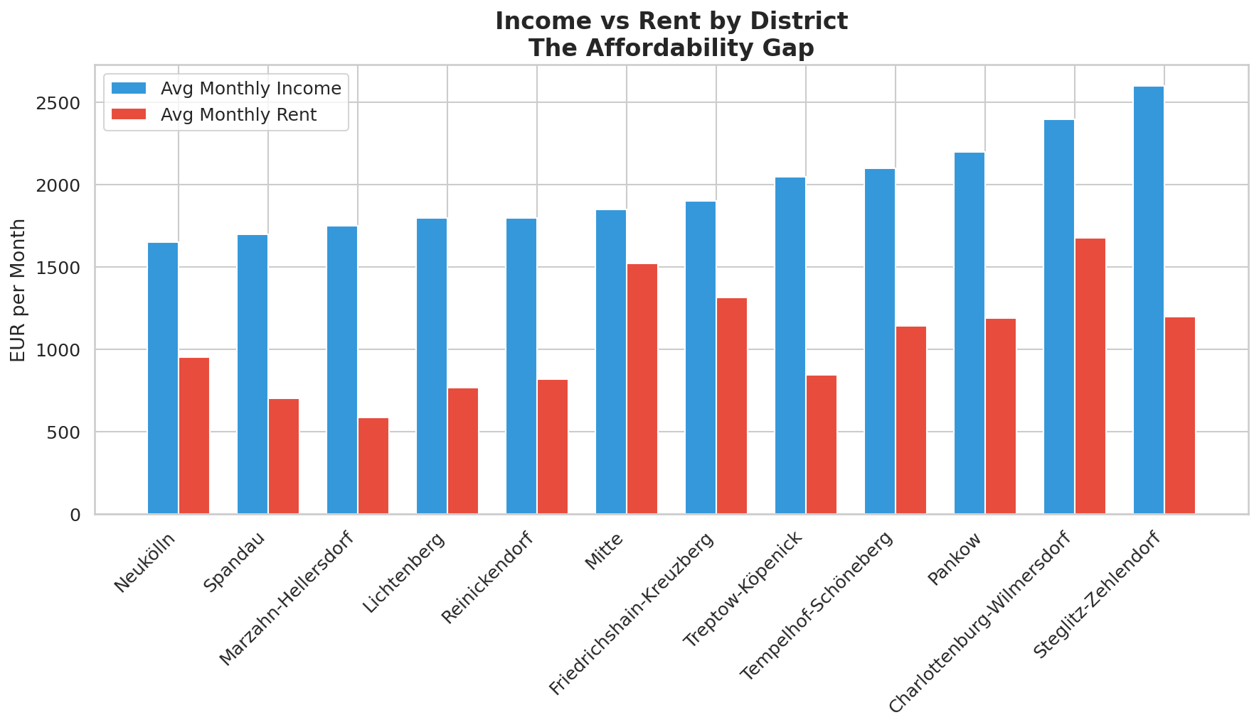

5. Key Findings
- Every single Berlin district exceeds the 30% housing stress threshold. Even Marzahn-Hellersdorf, the most affordable at 33.4%, is above the international benchmark.
- Central districts face severe burden. Mitte (82.3%), Charlottenburg-Wilmersdorf (69.8%), and Friedrichshain-Kreuzberg (69.2%) have the highest rent-to-income ratios.
- The Affordability Paradox. Districts with lower social status (Neukölln, Mitte) face high rent burdens because low-income residents are hit by gentrification-driven rent increases. Wealthier districts have high rents but also higher incomes.
- Strong correlation between social disadvantage and housing stress. The correlation between Social Status Index and rent burden is -0.70, confirming that socially vulnerable areas bear the greatest housing cost pressure.
- Unemployment amplifies housing stress. Districts like Neukölln (14.1% unemployment, 24% transfer income) and Mitte (12.8% unemployment) face a double burden of low income and rising rents.

6. How to Run the Code

6.1 Prerequisites
- Python 3.8 or higher
- pip install pandas matplotlib seaborn
- Jupyter Notebook (for .ipynb) or any Python environment (for .py)

6.2 Running the Python Script
pip install pandas matplotlib seaborn
python berlin_affordability_analysis.py
This will generate all 5 charts (PNG) and 2 Tableau-ready CSVs in the same directory.

6.3 Running the Jupyter Notebook
jupyter notebook Berlin_Housing_Affordability_Analysis.ipynb
Run all cells from top to bottom. The notebook includes markdown explanations alongside each code section.

6.4 Tableau Setup
- Open Tableau and connect to berlin_affordability_master.csv for district-level views
- Connect to berlin_housing_detailed_tableau.csv for listing-level drill-down
- Create a choropleth map using district_name and rent_burden_pct
- Add bar chart, scatter plot, and income comparison views
- Combine into a dashboard with interactive district filters

7. Project File Structure
File | Description
berlin_affordability_analysis.py | Main Python script (GitHub-ready)
Berlin_Housing_Affordability_Analysis.ipynb | Jupyter Notebook with full analysis
attachments/berlin_core_clean.csv | Raw housing listings (10,309 rows)
attachments/berlin_income_by_district.csv | Income data we added (new dataset)
attachments/social_atlas_clean.csv | Social status indices
berlin_affordability_master.csv | Merged analysis output (for Tableau)
berlin_housing_detailed_tableau.csv | Detailed listings with income (for Tableau)
fig1-fig5 (PNG files) | 5 publication-ready visualizations
Project_Documentation.docx | This documentation file

8. Potential Next Steps
If you want to extend this project further, consider:
- Adding more recent rent data (2021–2025) to show how affordability has changed post-pandemic
- Including neighborhood-level (Kiez) analysis for more granular insights
- Adding migration and population growth data to predict future affordability trends
- Comparing Berlin with other German cities (Munich, Hamburg, Frankfurt)
- Building a predictive model for future rent prices using machine learning

