Luxury Goods Sales Analysis – Work Log
This document summarizes the steps followed during the luxury goods sales analysis, from identifying the columns of interest and cleaning the data to creating pivot tables and preparing the dashboard.

1. Identifying the Columns of Interest
The first step was to identify the columns that were relevant to the analysis questions. These columns were then reviewed and cleaned before carrying out the analysis.

2. Data Cleaning
The following cleaning methods were applied to the relevant columns:
- Order: TRIM and UPPER.
- Order Date: Already clean, so no further cleaning was required.
- Customer ID: TRIM and UPPER.
- Customer Name: Used CONCAT to create another column, then applied TRIM and PROPER. After cleaning, the results were copied and pasted as values. The original uncleaned column was then deleted.
- Consumer Type: Applied TRIM and PROPER, then copied and pasted as values.
- Acquisition Date: Applied TRIM and PROPER, then pasted as values.
- Purchase Type: Applied TRIM and PROPER, then pasted as values.
- Product Name: Applied TRIM and PROPER, then pasted as values.
- Product ID: Applied TRIM and UPPER, then pasted as values.
- Product Category: Used Find and Replace (Ctrl + H), followed by TRIM and PROPER. The cleaned results were pasted as values and the uncleaned column was deleted.
- Brand: Used Find and Replace and applied TRIM/PROPER.
- Luxury Tiers: Applied TRIM and PROPER.
After completing the cleaning process, the dataset was converted into an Excel Table using Ctrl + T. This made it easier to create and manage the Pivot Tables.

3. Business Questions
- Which consumer types account for the most orders and units purchased?
- Which age groups place the most orders?
- Which product categories and brands does each consumer type prefer?
- What percentage of customers place more than one order during the six years?
- Which acquisition channels bring in the most customers who later make repeat
- purchases?
- How do customer preferences and repeat purchasing change each year?
- Which consumer types give the lowest average ratings, and what improvements
should management consider?

4. Pivot Table Analysis
- Question 1: Consumer Type was placed in Rows, Quantity was placed in Values and Order ID was also placed in Values.
- Question 2: Age was placed in Rows and Order ID was placed in Values.
- Question 3: Consumer Type and Brand were placed in Rows while the Product Category was place in the Column and Quantity Sold in Values
- Question 4: Consumer Type was placed in Rows and Repeat customers in Values
- Question 5: Acquisition Channel was placed in Rows; Customer ID and repeat customer were placed in Values.
- Question 6 – Table 1: Order Year was placed in Columns, Purchase Type was placed in Rows and Quantity was placed in Values.
- Question 6 – Table 2: Order Year was placed in Columns, Brand was placed in Rows and Quantity was placed in Values.
- Question 7: Consumer Type in Row and Average Customer Rating in Values

5. Dashboard
After creating the required Pivot Tables, a new worksheet was created for the dashboard and renamed. The dashboard will be used to present the important findings from the analysis in a clear and easy-to-understand visual format.

6. Overall Workflow
Identify the columns of interest → Clean and standardize the data → Convert the cleaned data into an Excel Table → Create the required Pivot Tables → Create a new Dashboard worksheet → Present the key findings clearly.

7. Excel Shortcuts Used
- Ctrl + H: Find and Replace
- Ctrl + Shift + Down Arrow: Select data down a column
- Ctrl + C: Copy
- Ctrl + V: Paste
- Ctrl + T: Convert the data range into an Excel Table

Customer and Buying Behaviour Analysis
Executive Summary
Overview
The analysis covers 8,647 recorded orders from 2020 to 2025, representing 1,704 distinct customers and ₦9.41 billion in recorded revenue. The evidence indicates strong repeat purchase activity and substantial sales growth over the period. However, the corporate-buyer segment combines the largest revenue contribution with a notably lower customer rating than every other consumer type, making satisfaction in this segment a priority for management.
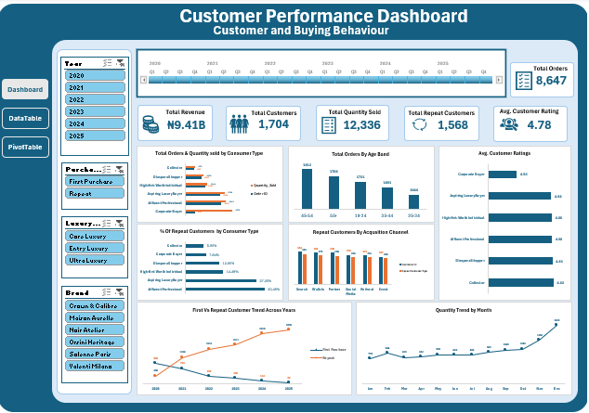

Three Key Findings
1. Revenue and order volume grew substantially between 2020 and 2025.
Recorded annual revenue increased from ₦581.9 million in 2020 to ₦2.97 billion in 2025 - an increase of approximately 411%. Over the same period, annual orders rose from 922 to 1,846, while units sold increased from 1,331 to 2,557. The 2025 revenue figure represents about 31.6% of the ₦9.41 billion recorded across the full dataset. This indicates that the business expanded materially over the period, although the figures alone do not establish what caused the growth.
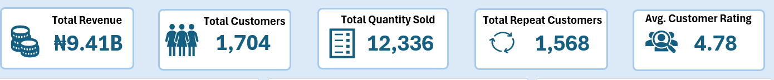
2. Repeat purchasing accounts for most recorded purchasing activity and Search brings in the largest number of repeat customers.
Of 1,704 distinct customers, 1,568 are classified as repeat customers (92.0%). The PivotTable also shows that repeat-purchase quantities increased from 366 units in 2020 to 2,505 in 2025, while first-purchase quantities declined from 965 to 52. By acquisition channel, Search has the highest number of customers (304) and the highest number of repeat customers (283), followed by Walk-In and Partner, each with 298 customers and 270 and 266 repeat customers respectively. These are counts, not repeat-conversion rates; the results identify where the largest numbers of repeat customers come from, but do not prove which channel is most efficient.
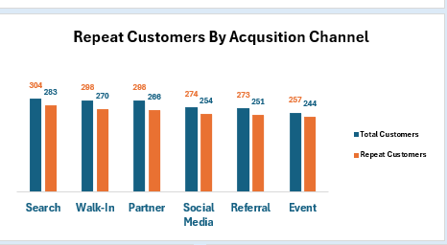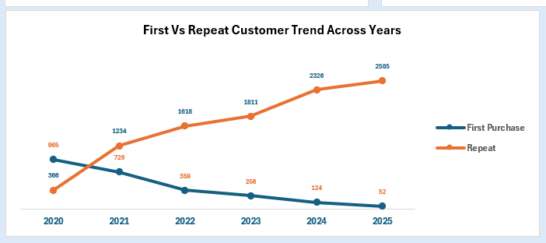
3. Corporate buyers are the largest revenue segment but have the lowest average customer rating.
Corporate buyers generated approximately ₦2.43 billion in revenue, the highest of the six consumer types, yet their average rating was 4.53 out of 5, below the overall average of 4.78. The other consumer types recorded average ratings of approximately 4.80–4.82. The gap of about 0.26 rating points suggests a potential satisfaction issue among a commercially important segment. The dataset identifies the difference in ratings but does not show the specific reasons behind it.
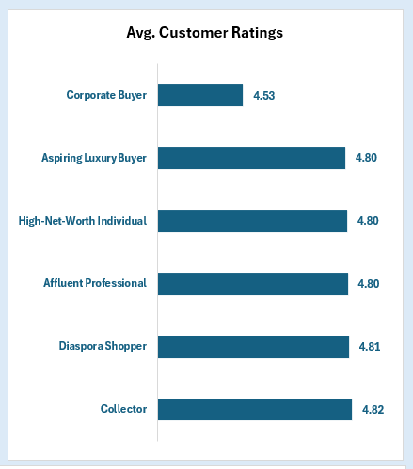

Two Practical Recommendations
1. Protect and build on repeat purchasing, with targeted investment in acquisition channels.
Maintain a structured retention programme for existing customers, including timely follow-ups, relevant product recommendations and loyalty or referral offers. Use Search as a priority channel for further testing because it currently brings in the largest absolute number of repeat customers (283). Before shifting more budget to any channel, compare channel-level repeat rates, revenue per customer and acquisition costs; the current counts alone cannot establish the best return on marketing spend. Track these measures monthly so management can distinguish volume from channel effectiveness.
2. Make corporate-buyer satisfaction a priority and address the causes of lower ratings.
Assign responsibility for a focused review of corporate-buyer feedback and recent orders. Collect short, structured feedback from corporate buyers and categorise concerns (for example, fulfilment, product quality, communication, pricing or after-sales support) rather than assuming a cause from the rating alone. Use the findings to implement specific corrective actions, then monitor the corporate-buyer rating and repeat-purchase behaviour monthly against the current baselines of 4.53 average rating and ₦2.43 billion in revenue.
Limitations
The analysis is based on recorded order, customer, product, revenue, acquisition-channel and rating fields for 2020–2025. It does not include profit margins, marketing or acquisition costs, reasons for customer ratings, or detailed service/fulfilment feedback. Consequently, revenue growth cannot be attributed to a particular business action, channel efficiency cannot be judged from customer counts alone and the cause of corporate buyers’ lower ratings cannot be confirmed. The repeat-customer figure is based on the workbook’s customer classification; repeat-purchase quantities and repeat-customer counts are different measures and should not be treated as interchangeable.

