Website corrections

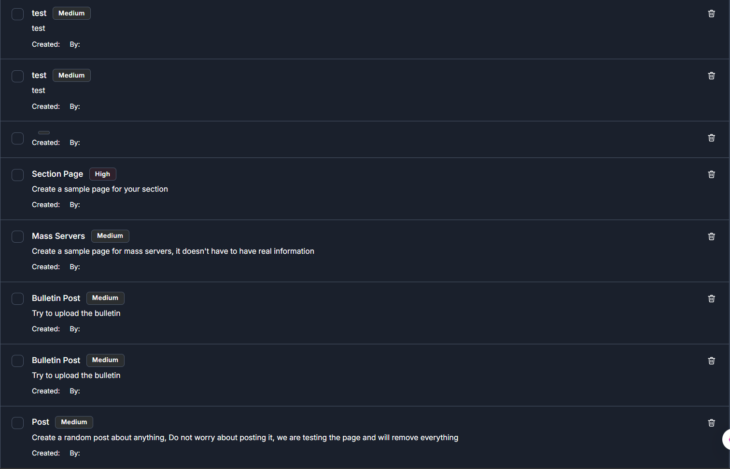
I can create tasks, but I don’t see who it’s assigned to, and I think pakanzi created by should likely have a name? Also, tasks aren’t editable, I think if something changes on a specific task we would like to be able to edit, but I guess creator maybe should be the only one able to edit. Another thing, does it show a do by date? I wrote in a deadline, but can the assigned person see the deadline?

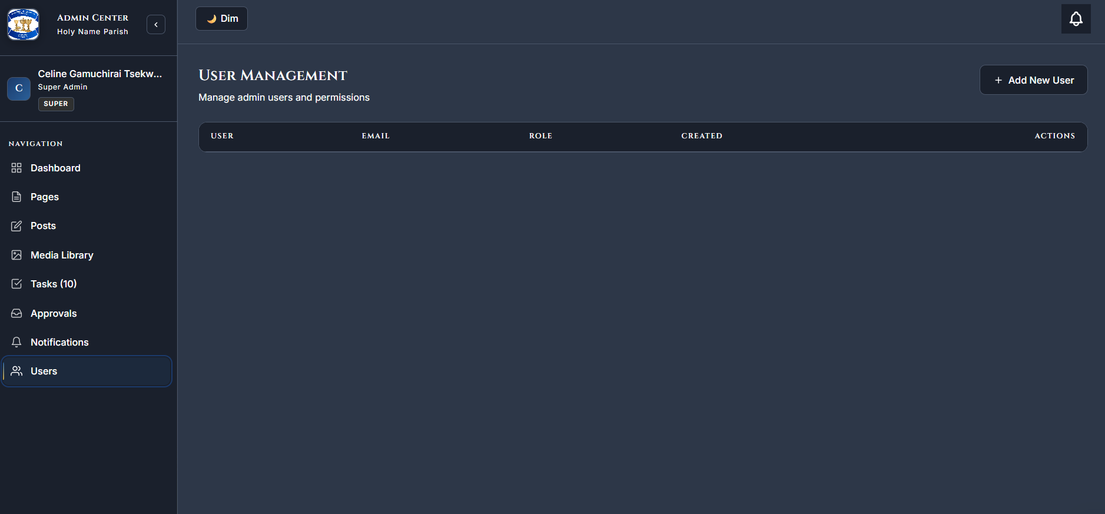
I was assigning tasks in Superadmin, when I went back to users I don’t see any of the users anymore.
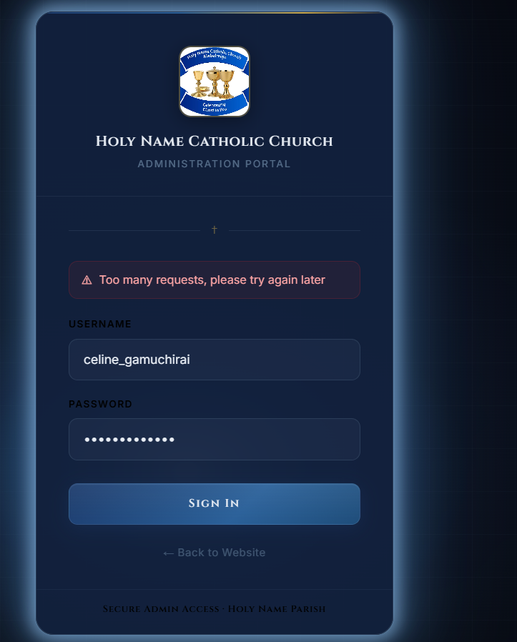
My 1st sign in attempt with this account today, might it be affected by too many people logging in?
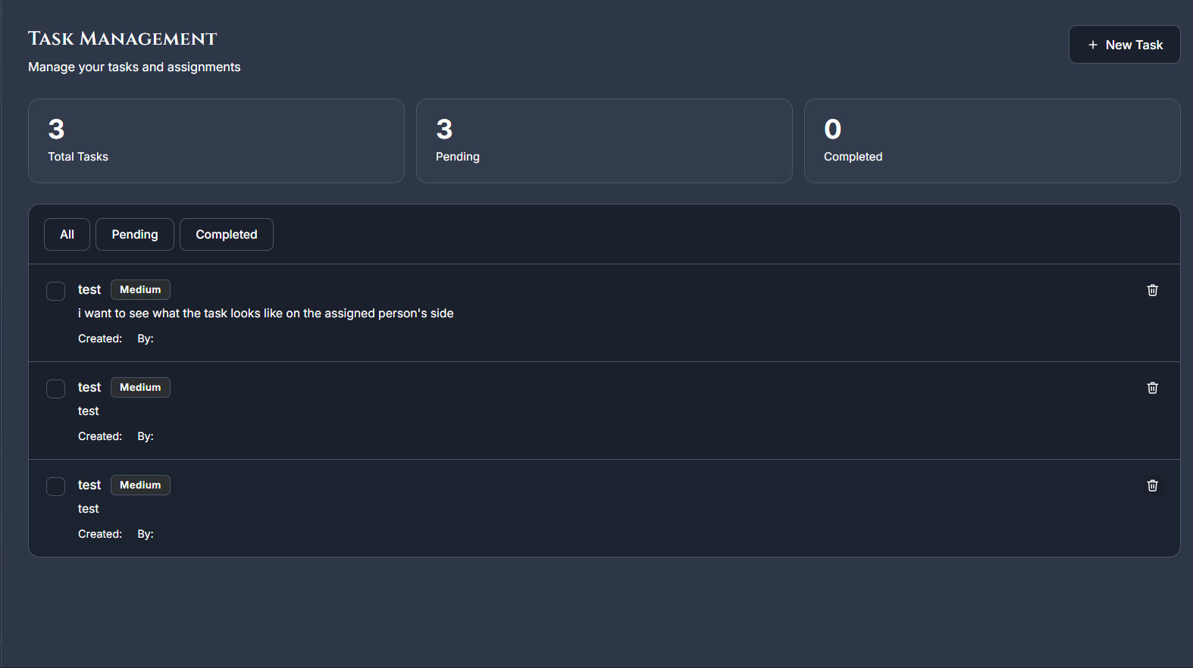
As the assigned person I see what I was assigned, I don’t see when it’s due. Having a visible due date and pamusoro apo adding due or overdue tasks I think should help us see faster who’s doing their tasks and who’s not. Also, how do I mark task as completed?
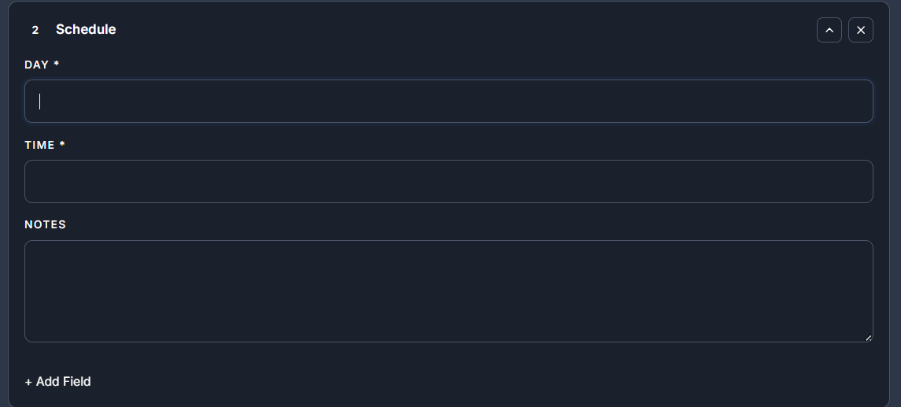
When creating events day and time selectable using calendar and clock instead of typing? Would likely reduce typing errors?
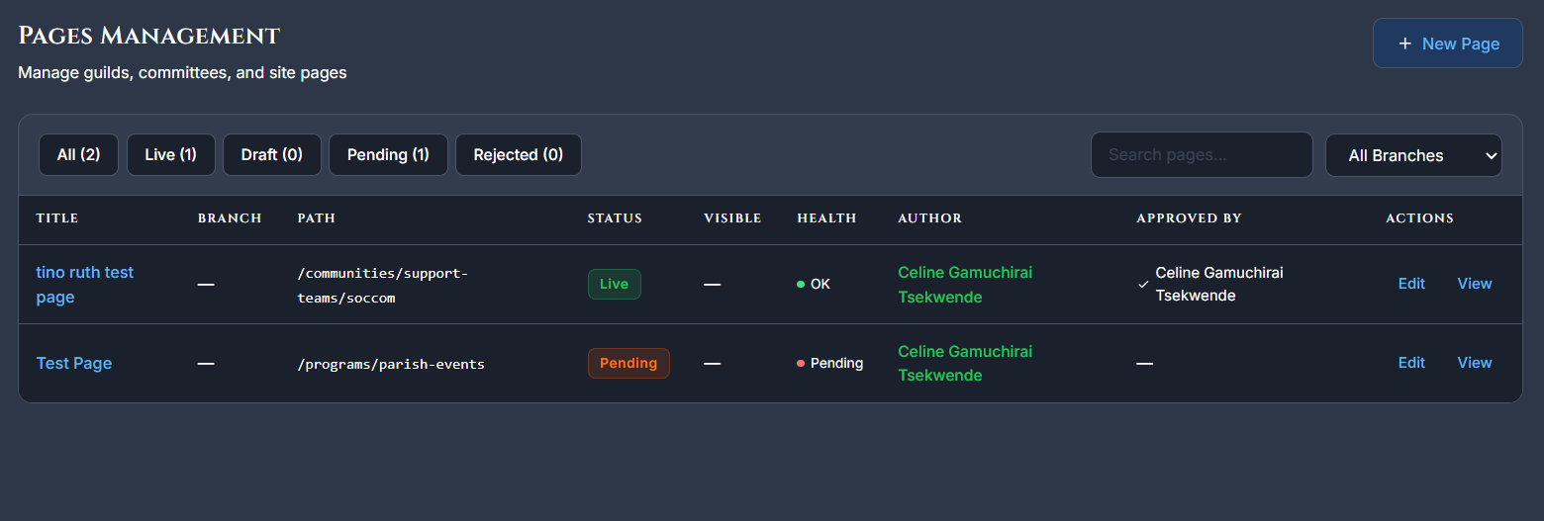
The page I submitted and then later deleted riya is showing as active from the profile I created it from.
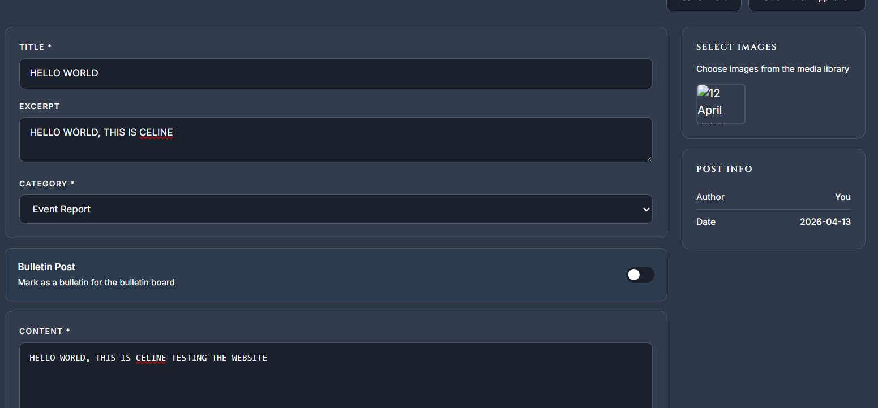
Not seeing the option to add media to my post, can only add media from media centre and not from post.
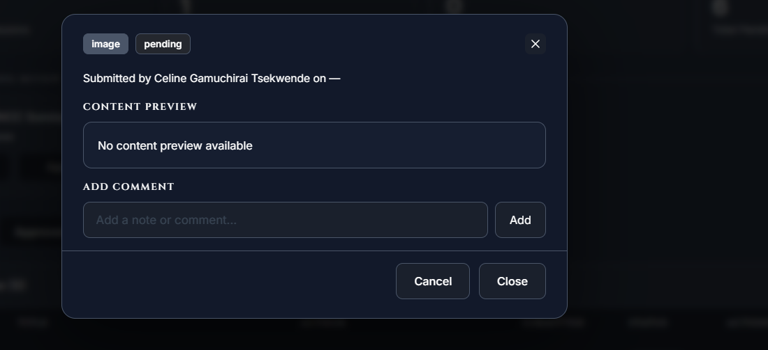
Super Admin cannot preview independent image uploads before approving. I’m not seeing where I can view it from
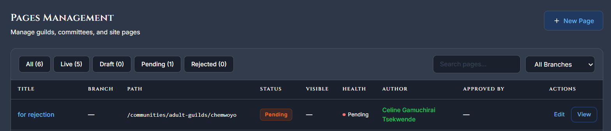
I tried rejecting this, it’s just going back into drafts, but it’s not giving the writer the reason I rejected it.

